Flask_and_MongoDB Assignment
GitHub:- https://github.com/ShravanSM/Devops

Task 1: JSON API Route
A Flask application was created with an /api route. The route reads JSON data from the backend data.json file and returns the data as a JSON response.
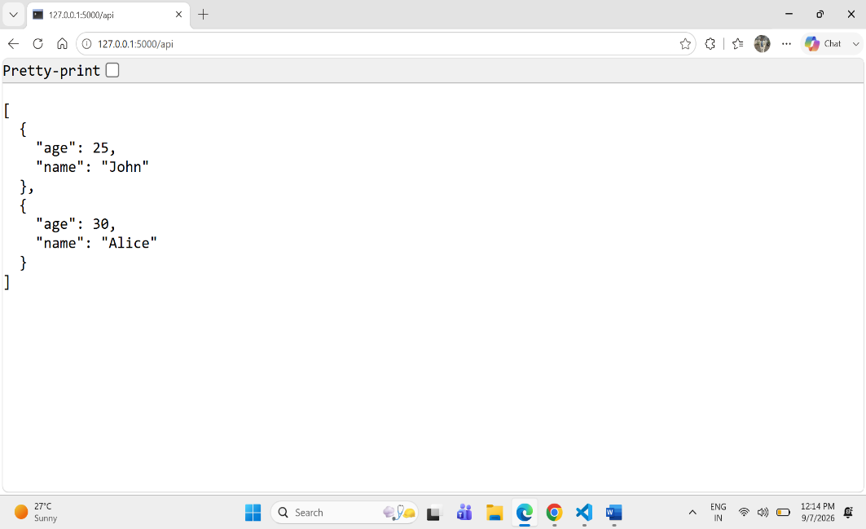
Code:
@app.route('/api')
def api():
with open('data.json','r')as file:
data=json.load(file)
return jsonify(data)

Task 2: Frontend Form with MongoDB Atlas
A frontend form was created using HTML. When the form is submitted, the entered data is received by the Flask application and inserted into MongoDB Atlas.
Code:

@app.route('/submit',methods=['POST'])
def submit():
try:
if request.method=='POST':
name=request.form.get('name')
age=request.form.get('age')
data={
'name':name,
'age':age
}
collection.insert_one(data)
return redirect(url_for('success'))
except Exception as e:
return render_template('index.html',error=str(e))

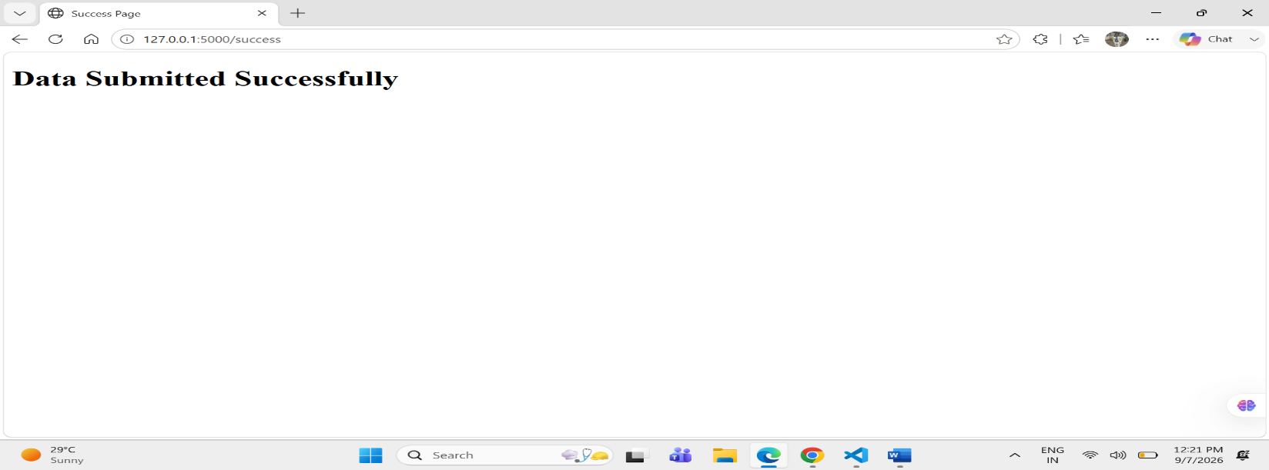
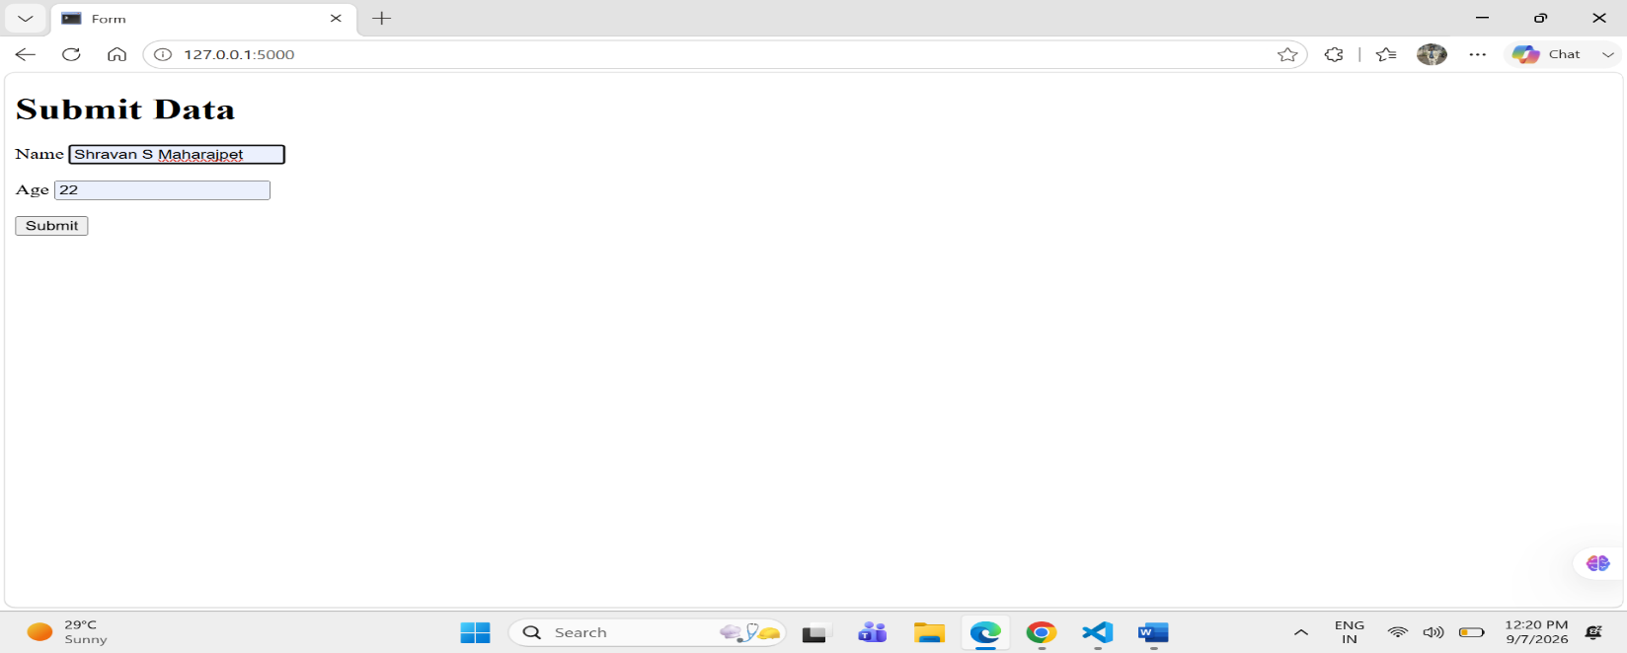

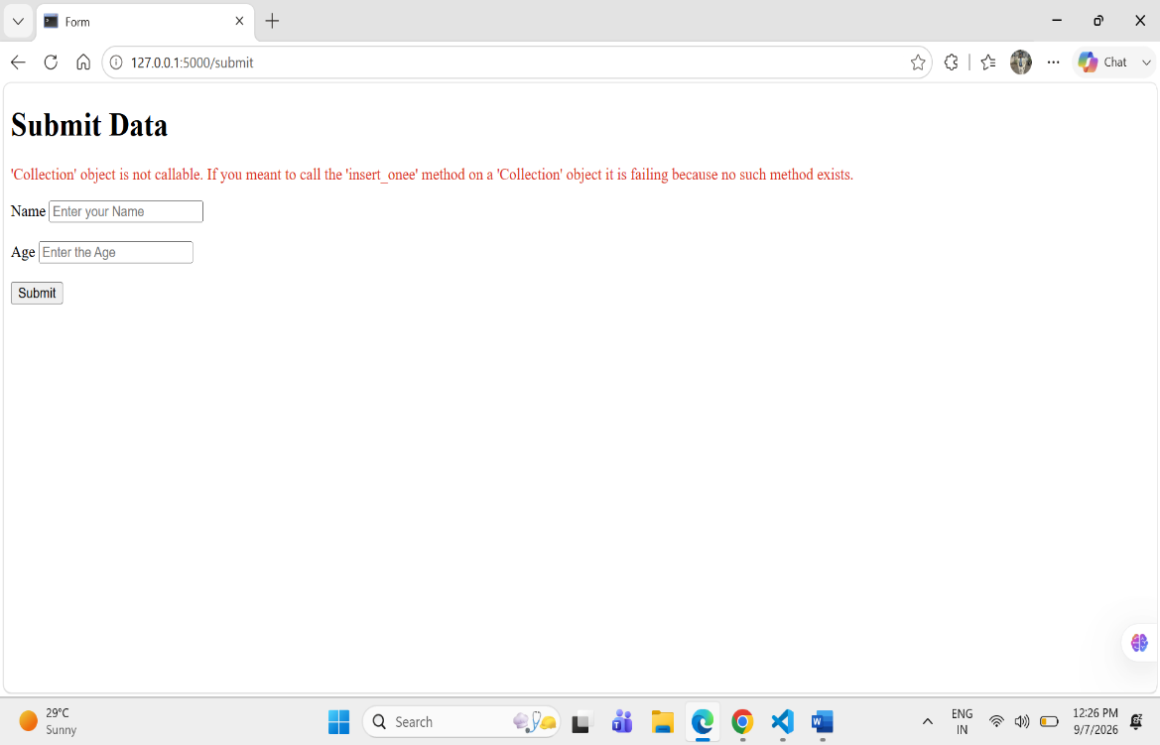
Error Handling
If an error occurs while processing the submitted data, the error is displayed on the same form page without redirecting the user.

the MongoDB Atlas result
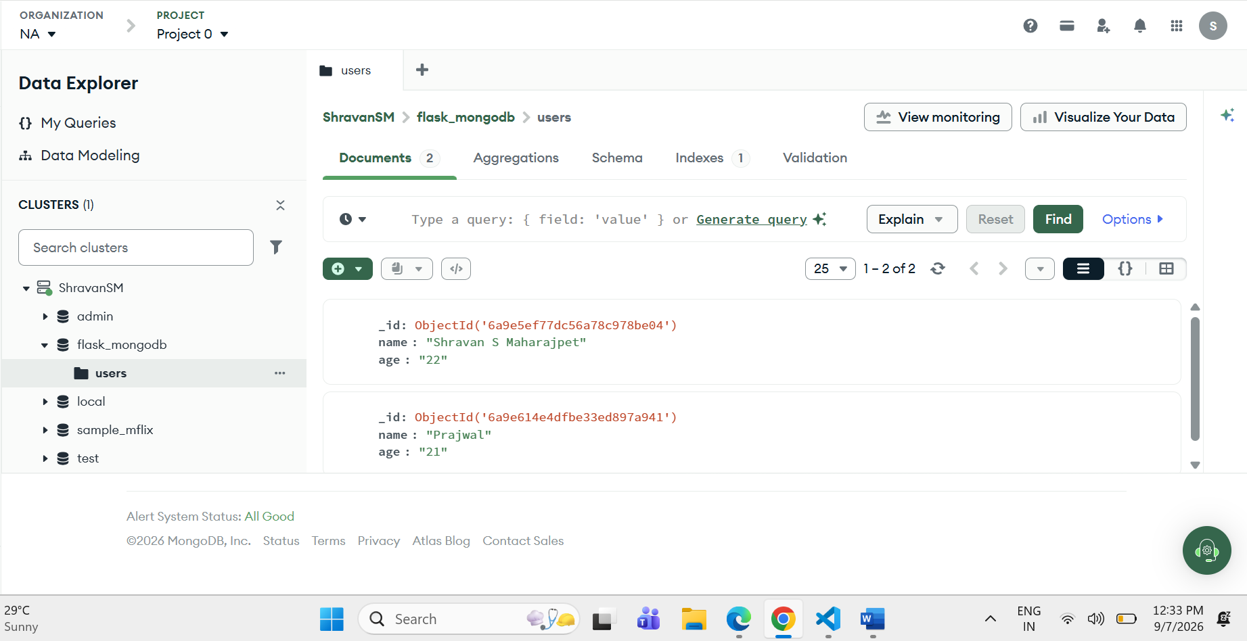
The data submitted through the frontend form was successfully inserted into the MongoDB Atlas users collection.

