Python Bash Assignment
GitHub:- https://github.com/ShravanSM/Devops
Output:
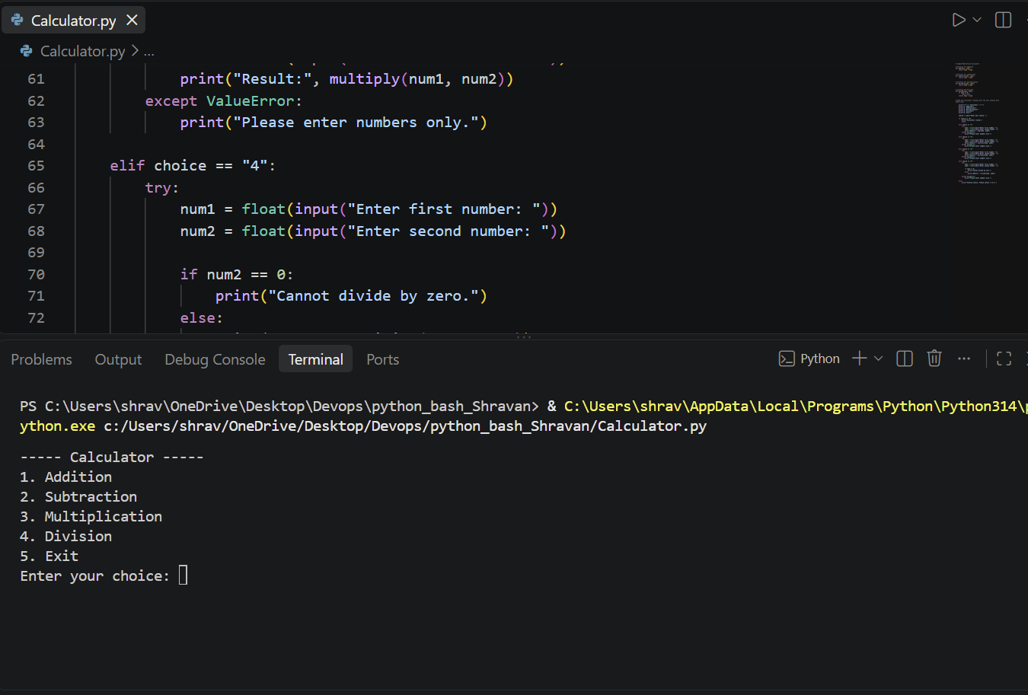

Test-Case-1 Addition
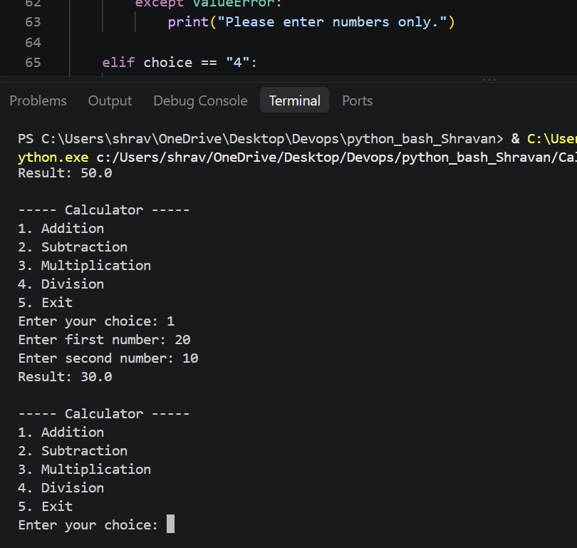
Enter your choice: 1
Enter first number: 20
Enter second number: 10
Result: 30.0

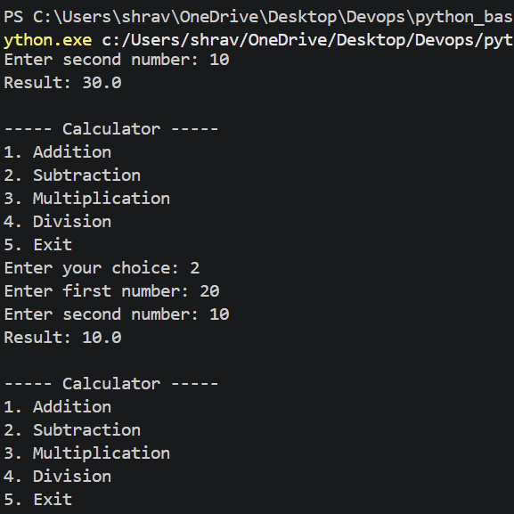
Test-Case-2 Substraction
Enter your choice: 2
Enter first number: 20
Enter second number: 10
Result: 10.0

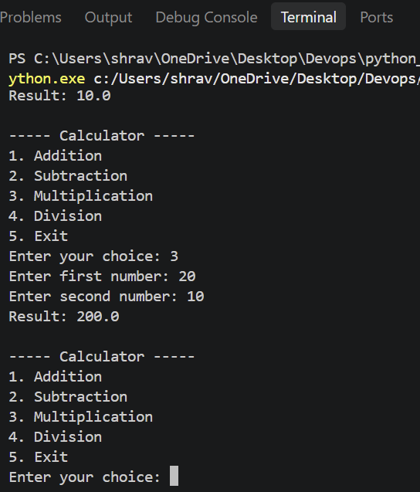
Test-Case-3 Multiplication
Enter your choice: 3
Enter first number: 20
Enter second number: 10
Result: 200.0

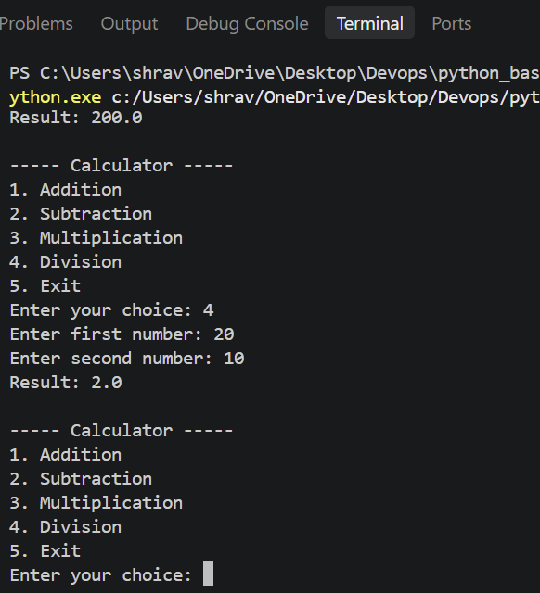
Test-Case-4 Division
Enter your choice: 4
Enter first number: 20
Enter second number: 10
Result: 2.0

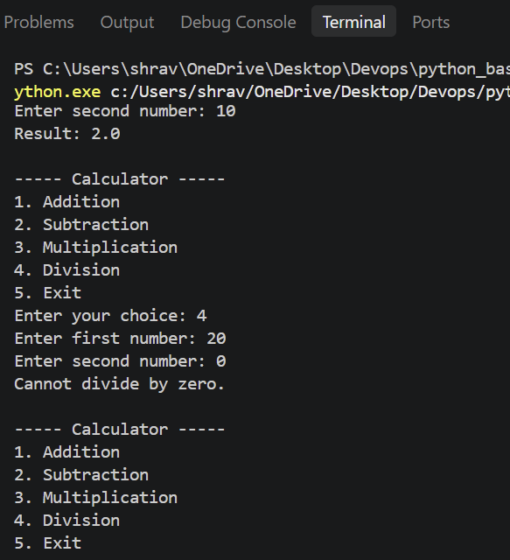
Test-Case-5 Division with zero
Enter your choice: 4
Enter first number: 20
Enter second number: 0
Cannot divide by zero.

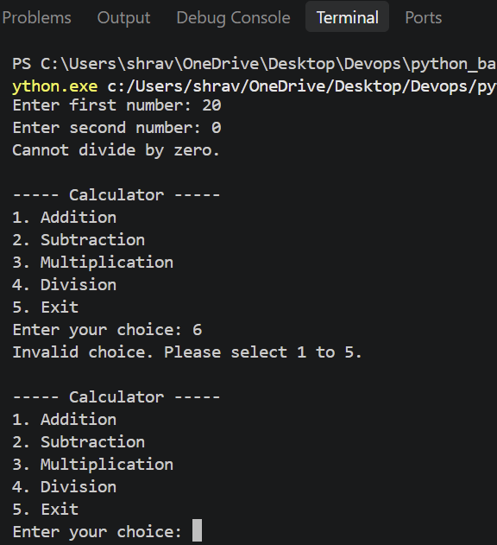
Test-Case-5 Invalid Choice
Enter your choice: 6
Invalid choice. Please select 1 to 5.

