Terraform Assignment
Github:- https://github.com/ShravanSM/Devops

Task 1 — Flask Backend and Express Frontend on a Single EC2 Instance
Objective: deploy the Flask API and Express frontend on one EC2 instance.
Key steps
- Created the EC2 infrastructure with Terraform.
- Installed and ran Flask on port 5000 and Express on port 3000.
- Tested the application through the instance public address.
- Destroyed the Task 1 resources after verification.

Terraform commands
terraform init
terraform validate
terraform plan
terraform apply
# After testing and screenshots:
terraform destroy

Application ports: Flask — 5000; Express — 3000.

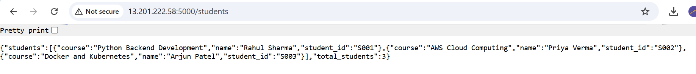

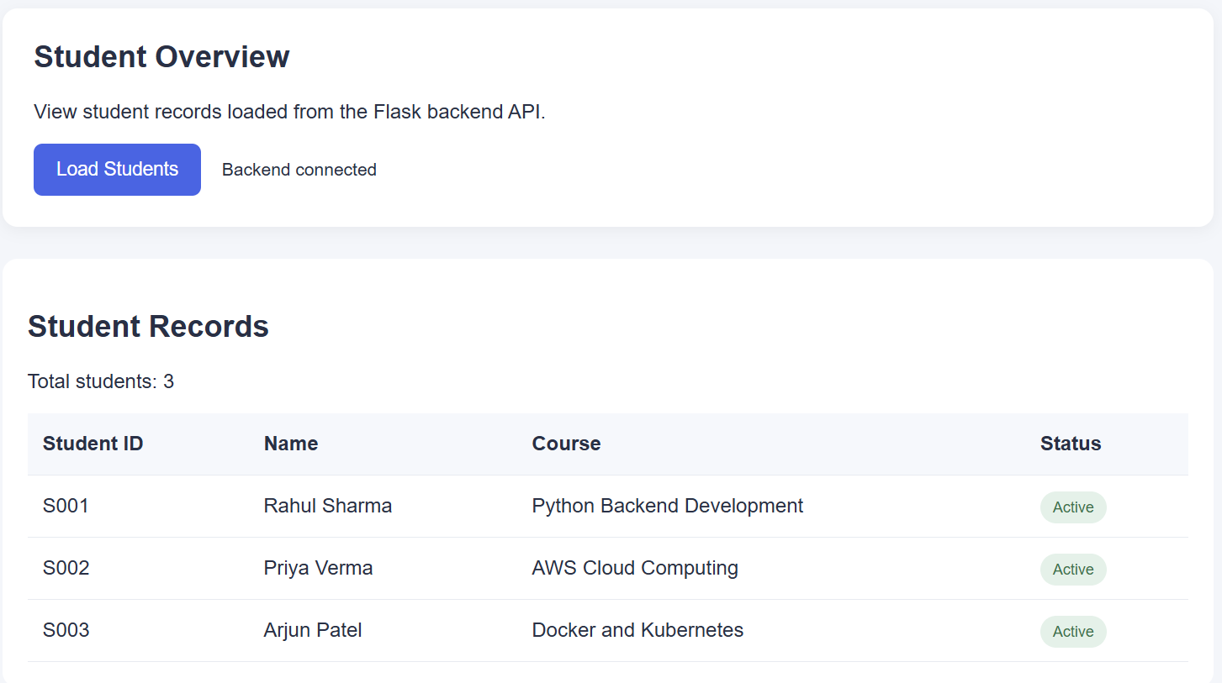

Task 2 — Flask Backend and Express Frontend on Separate EC2 Instances
Objective: run the backend and frontend on separate EC2 instances, with the frontend calling the backend using its reachable address.
Key steps
- Created separate frontend and backend EC2 infrastructure with Terraform.
- Configured Express to call the Flask backend address.
- Restricted backend access through security-group rules.
- Verified the frontend and backend health endpoints.
- Destroyed the Task 2 resources after testing.

Terraform commands
terraform init
terraform validate
terraform plan
terraform apply
# After testing and screenshots:
terraform destroy

The Flask port was not exposed publicly; access was allowed from the frontend security group.

Task 3 — Docker, ECR, ECS Fargate, VPC and ALB
Objective: containerize the Flask API and Express frontend, push both images to Amazon ECR, and deploy them to ECS Fargate behind an Application Load Balancer.

Build the Docker images
docker build -t terraform-assignment-8-flask:latest .\flask_backend
docker build -t terraform-assignment-8-express:latest .\express_frontend

Authenticate and push to ECR
cmd.exe /c "aws ecr get-login-password --region ap-south-1 | docker login --username AWS --password-stdin 377114445063.dkr.ecr.ap-south-1.amazonaws.com"
docker tag terraform-assignment-8-flask:latest 377114445063.dkr.ecr.ap-south-1.amazonaws.com/terraform-assignment-8-flask:latest
docker push 377114445063.dkr.ecr.ap-south-1.amazonaws.com/terraform-assignment-8-flask:latest
docker tag terraform-assignment-8-express:latest 377114445063.dkr.ecr.ap-south-1.amazonaws.com/terraform-assignment-8-express:latest
docker push 377114445063.dkr.ecr.ap-south-1.amazonaws.com/terraform-assignment-8-express:latest

Terraform deployment
terraform init
terraform validate
terraform plan
terraform apply
# Enable the ECS services using variables.tf:
# enable_services = true
terraform plan
terraform apply

The deployment included an ECS cluster, two Fargate services, ECR repositories, VPC networking, security groups, target groups and an Application Load Balancer.
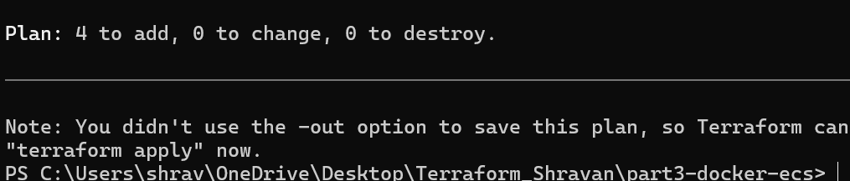

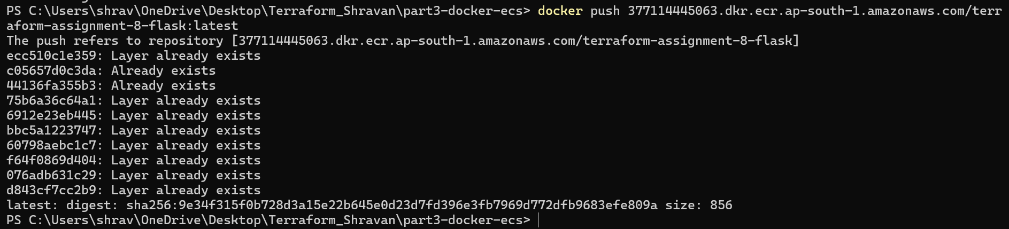
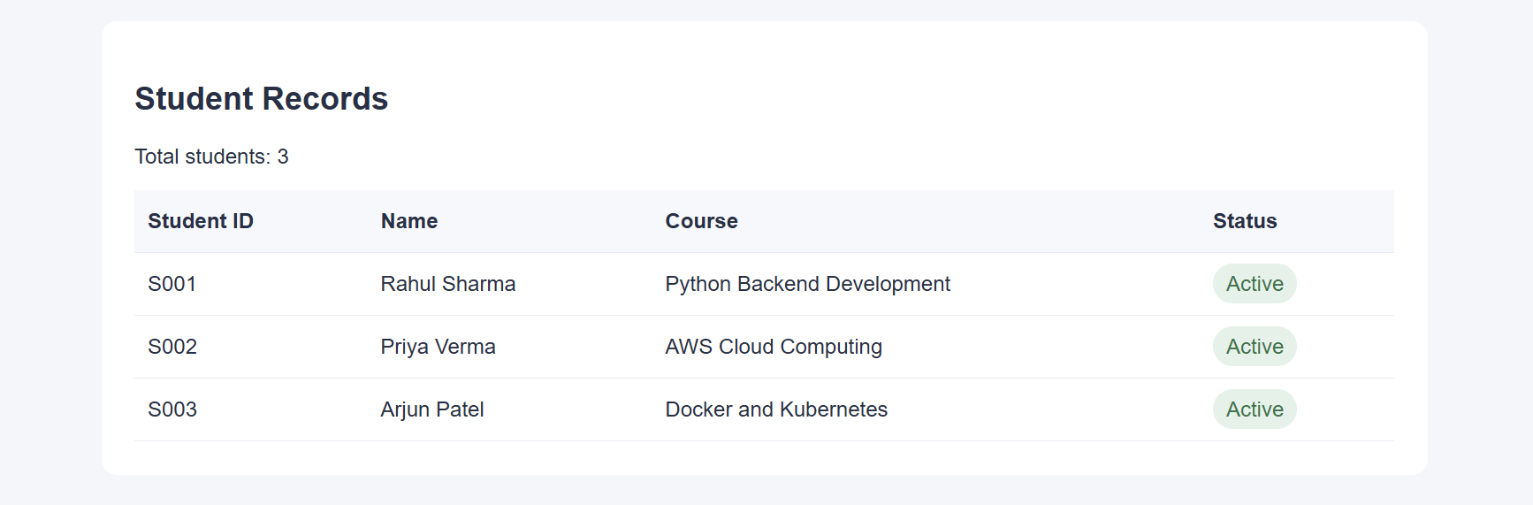
Screenshot 3.3 — Student Management dashboard with three records and backend connected.
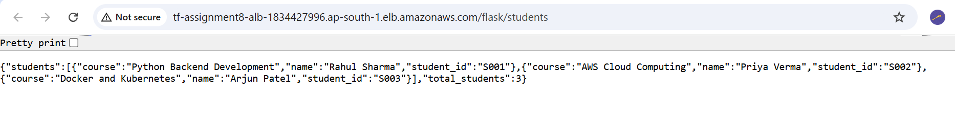

Verification

