AWS ASSIGNMENT
GitHub Repository Link: https://github.com/ShravanSM/Devops/tree/main/AWS-Shravan
__________________________________________________________________

Task 1 — Flask Backend and Express Frontend on a Single EC2 Instance
Objective: deploy both components on one EC2 instance in ap-south-1 (Mumbai).
- Launch an EC2 instance and configure its key pair and security group.
- Connect to the instance using SSH.
- Create a Python virtual environment, install Flask and run the backend on port 5000.
- Install Express dependencies and run the frontend on port 3000.
- Test the application through the instance's reachable address.
ssh -i <key-name>.pem ec2-user@<PUBLIC-IP>
python3 -m venv venv
source venv/bin/activate
pip install flask
python app.py
npm install
node server.js
Flask serves backend requests on port 5000; Express serves the portal on port 3000. Nginx was also checked during the EC2 practical and discussed as a reverse proxy for HTTP traffic on port 80.
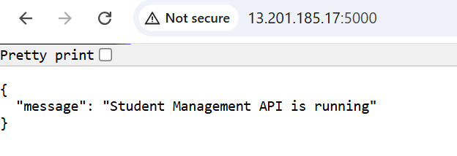
Screenshot 1.1 — Flask API responding on the EC2 public address.
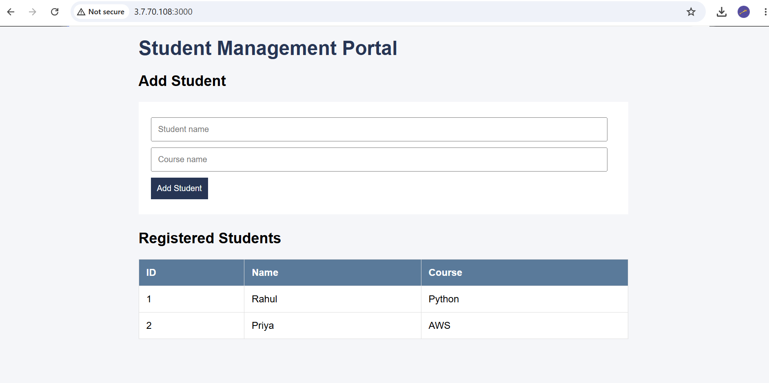
Screenshot 1.2 — Student Management Portal frontend.

Task 2 — Flask Backend and Express Frontend on Separate EC2 Instances
Objective: run Flask on a backend EC2 instance and Express on a separate frontend EC2 instance.
- Launch and configure the backend instance; install Flask and run it on port 5000.
- Launch and configure the frontend instance; install Node.js and Express.
- Configure the frontend backend URL to use the backend instance address.
- Verify that a frontend submission reaches Flask and the result is displayed.
# Backend
python app.py
# Frontend
npm install
node server.js
The frontend must call the reachable backend address rather than localhost. Security groups should allow only the required traffic between the instances.
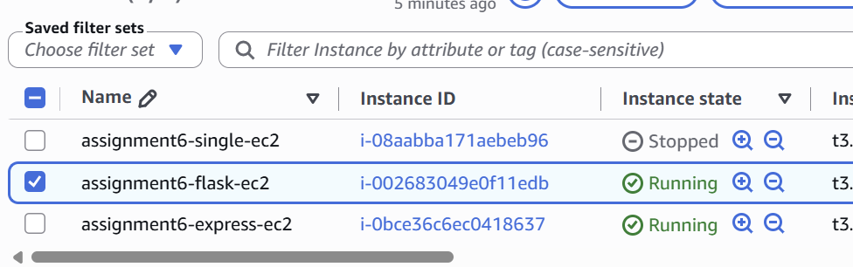
Screenshot 2.1 — EC2 instances used for the deployment.
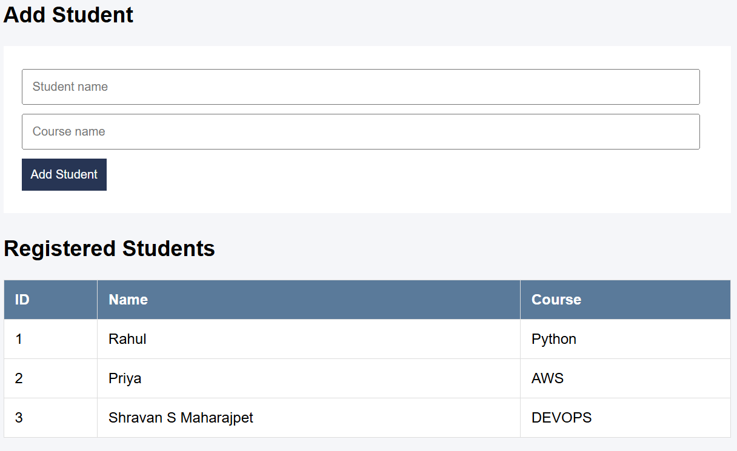
Screenshot 2.2 — Student records shown in the portal.

Task 3 — Docker Containers using ECR, ECS and VPC
Objective: containerize both applications, push images to Amazon ECR, and run them using ECS/Fargate with VPC networking.

Dockerfiles
Flask backend:
FROM python:3.11-slim
WORKDIR /app
COPY requirements.txt .
RUN pip install --no-cache-dir -r requirements.txt
COPY . .
EXPOSE 5000
CMD ["python", "app.py"]
Express frontend:
FROM node:18-slim
WORKDIR /app
COPY package*.json ./
RUN npm install --omit=dev
COPY . .
EXPOSE 3000
CMD ["npm", "start"]

Build and push images
docker build -t flask-backend .
docker build -t express-frontend .
docker images
docker ps
aws ecr get-login-password --region ap-south-1 | docker login --username AWS --password-stdin <ACCOUNT_ID>.dkr.ecr.ap-south-1.amazonaws.com
docker tag flask-backend:latest <ACCOUNT_ID>.dkr.ecr.ap-south-1.amazonaws.com/flask-backend:latest
docker push <ACCOUNT_ID>.dkr.ecr.ap-south-1.amazonaws.com/flask-backend:latest
docker tag express-frontend:latest <ACCOUNT_ID>.dkr.ecr.ap-south-1.amazonaws.com/express-frontend:latest
docker push <ACCOUNT_ID>.dkr.ecr.ap-south-1.amazonaws.com/express-frontend:latest
The repositories used were flask-backend and express-frontend. The ECS cluster was assignment6-cluster, with flask-backend-service and express-frontend-service. The Express image was rebuilt and redeployed after configuring its backend address.
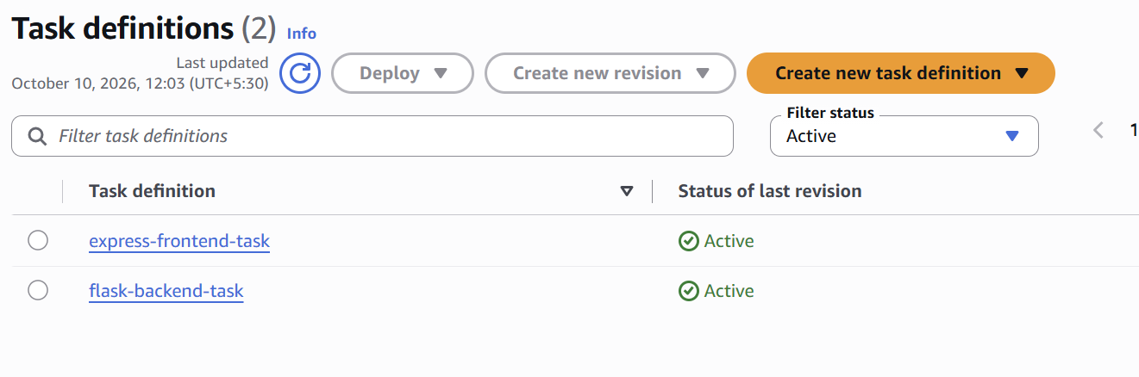
Screenshot 3.1 — ECS task definitions.
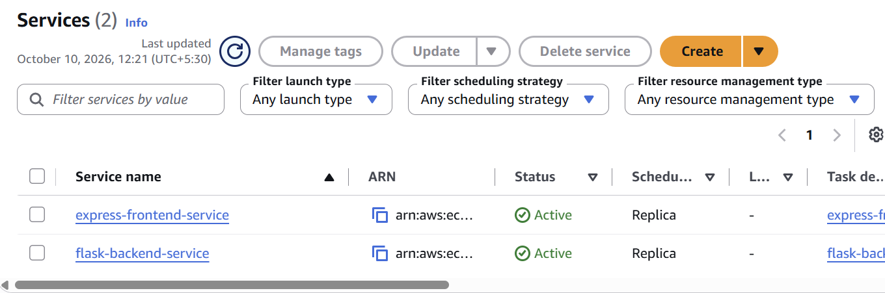
Screenshot 3.2 — ECS services.
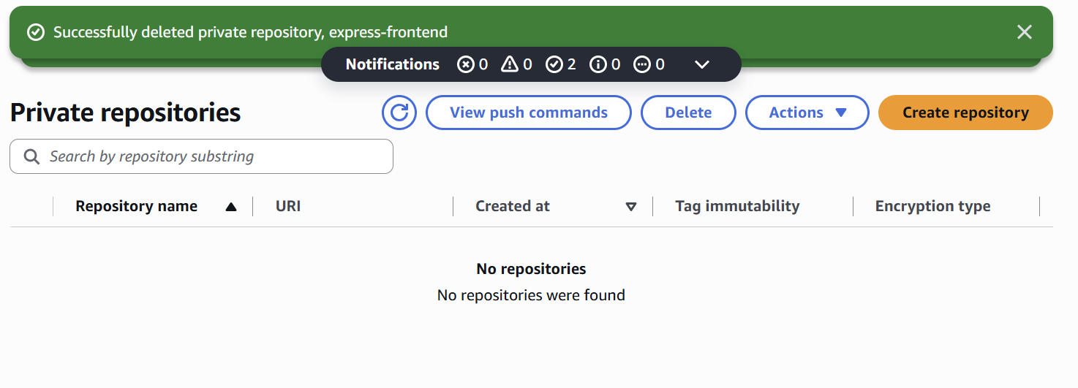
Screenshot 3.3 — ECR repositories before cleanup.
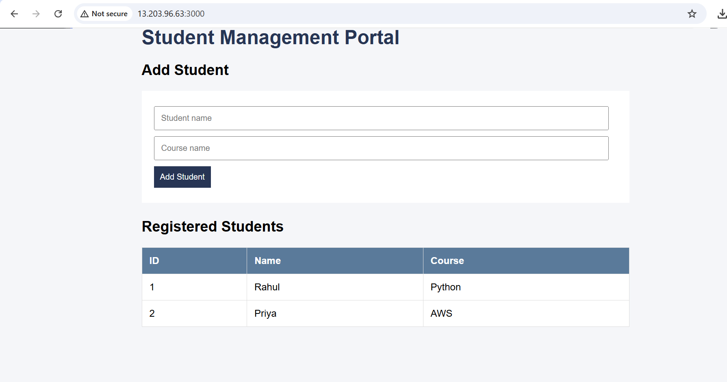
Screenshot 3.4 — Deployed Student Management Portal.
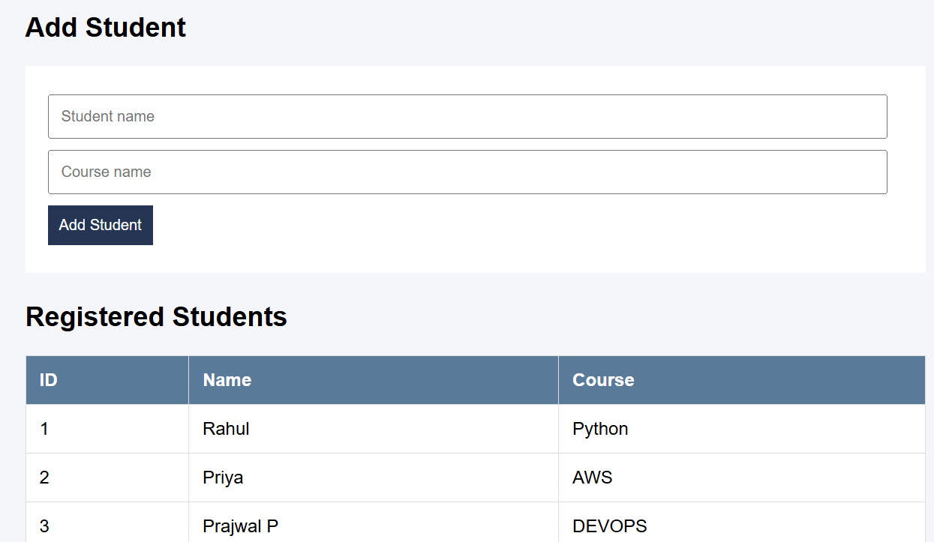
Screenshot 3.5 — Student record added successfully.
Verification: while deployed, the frontend was tested at http://13.203.96.63:3000. The portal loaded and the student record Prajwal P — DEVOPS was added. This public IP was temporary and the deployment has since been cleaned up.

