Kubernetes Assignment 7
GitHub: https://github.com/ShravanSM/Devops

Project Structure
I kept the existing application code and added a separate k8s folder for the Kubernetes manifests. This kept the application files separate from the deployment configuration.
Kubernates/
├── express_frontend/
│ ├── Dockerfile
│ ├── package.json
│ └── server.js and frontend files
├── flask_backend/
│ ├── Dockerfile
│ ├── requirements.txt
│ └── app.py
└── k8s/
├── flask-deployment.yaml
├── flask-service.yaml
├── express-deployment.yaml
└── express-service.yaml

Building the Docker Images
I checked that Docker Desktop was running, then built one image for each part of the application. I used versioned tags so the Kubernetes manifests could refer to the images consistently.
docker build -t flask-backend:1.0 .\flask_backend
docker build -t express-frontend:1.0 .\express_frontend
After building the images, I checked them with docker images. I removed older, unused local tags and kept the two images needed for this practical at that stage.

Starting Minikube and Loading Images
I started Minikube with Docker Desktop as the driver. I checked minikube status and kubectl get nodes to make sure the cluster was ready before deploying the application.
minikube start --driver=docker
minikube status
kubectl get nodes
Next, I loaded the two local images into Minikube. This was important because the images had been built on my machine and were not being pulled from a remote registry.
minikube image load flask-backend:1.0
minikube image load express-frontend:1.0
minikube image ls

Kubernetes YAML Files
I created four YAML files in the k8s folder: one Deployment and one Service for Flask, and one Deployment and one Service for Express. Before applying them, I used kubectl apply --dry-run=client to check each file.

Flask Deployment and Service
The flask-backend Deployment runs one replica of flask-backend:1.0 on container port 5000. I set imagePullPolicy: Never because the image was already loaded into Minikube. The flask-service Service uses ClusterIP, so it is intended for internal cluster communication.
kubectl apply -f k8s\flask-deployment.yaml
kubectl apply -f k8s\flask-service.yaml

Express Deployment and Service
The express-frontend Deployment runs one replica on container port 3000. I configured the FLASK_API environment variable as http://flask-service:5000, allowing Express to reach Flask through the Kubernetes Service name. The express-service Service uses NodePort 30080 to expose the frontend for local testing.
kubectl apply -f k8s\express-deployment.yaml
kubectl apply -f k8s\express-service.yaml

Final Verification
I used the following commands to verify the final state of the Kubernetes resources:
kubectl get pods
kubectl get services
kubectl get deployments
- Express Pod: 1/1 Running, zero restarts.
- Flask Pod: 1/1 Running, zero restarts.
- Express Deployment: 1/1 available replica.
- Flask Deployment: 1/1 available replica.
- express-service: NodePort, service port 3000 mapped to nodePort 30080.
- flask-service: ClusterIP, port 5000.

Screenshots and Practical Evidence
I captured screenshots at the main checkpoints rather than only at the end. Together, they show the build, setup, deployment, browser test, logs, and final verification.

Figure 1 — Docker images built
I built separate Docker images for the Flask backend and Express frontend. I kept the tags flask-backend:1.0 and express-frontend:1.0 for the Kubernetes deployment.
Figure 1. Docker images built.
Figure 2 — Minikube cluster ready
Before deploying the application, I checked Minikube's status and confirmed that the cluster components were running and the node was Ready.
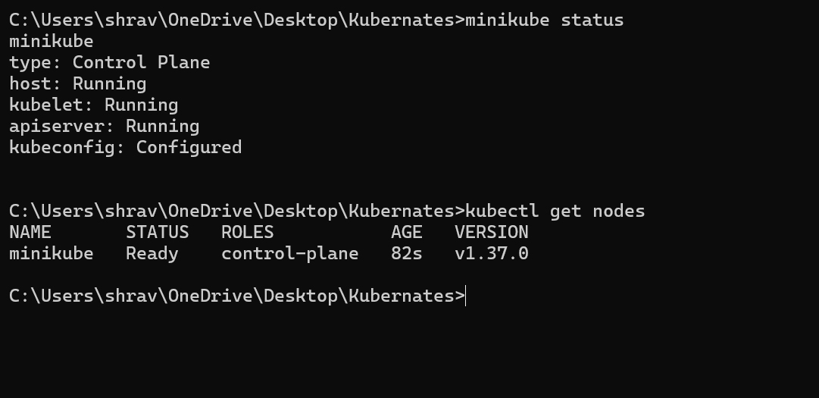
Figure 2. Minikube cluster ready.
Figure 3 — Images available in Minikube
I loaded both application images into Minikube so Kubernetes could use the local images instead of trying to download them from a registry.
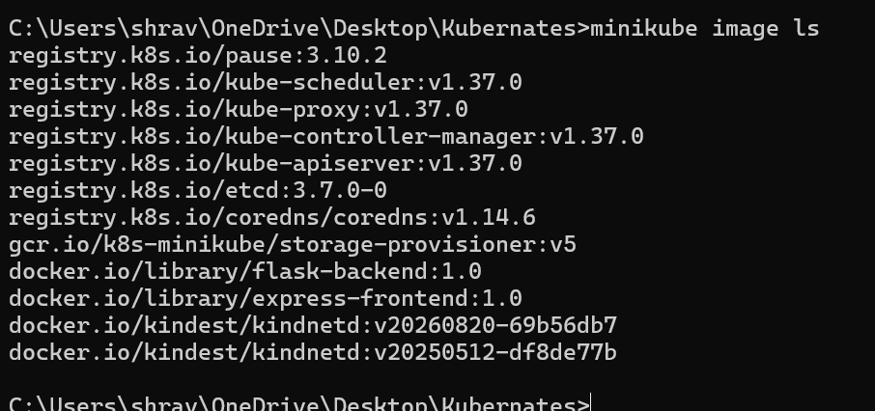
Figure 3. Images available in Minikube.
Figure 4 — YAML files validated
I ran a client-side dry run on all four YAML files. Each manifest passed this validation before I created the Kubernetes resources.
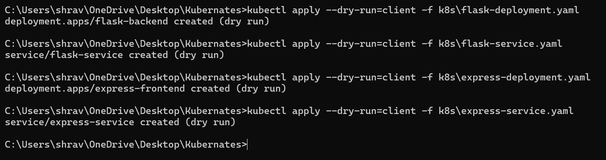
Figure 4. YAML files validated.
Figure 5 — Flask resources created
I applied the Flask Deployment and Service manifests. Kubernetes confirmed that both resources were created.
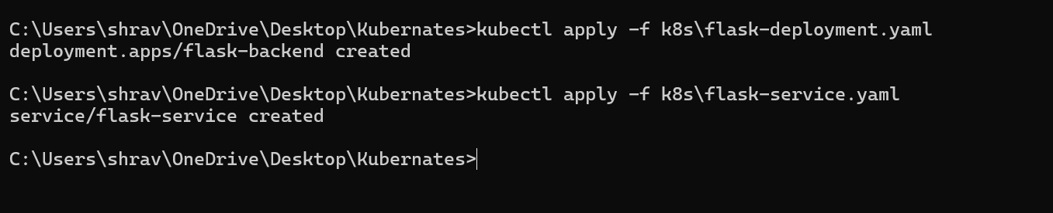
Figure 5. Flask resources created.
Figure 6 — Flask Pod and Service running
The Flask Pod reached 1/1 Running. The flask-service Service was available internally on port 5000.
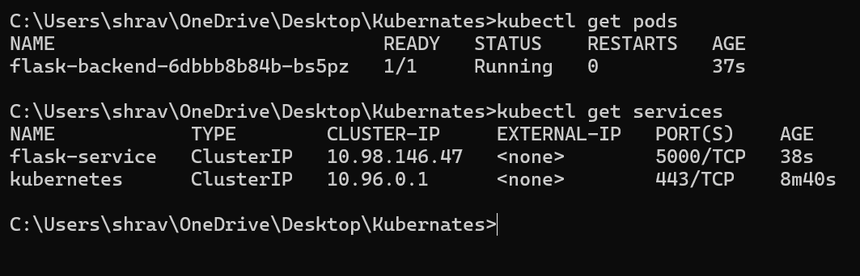
Figure 6. Flask Pod and Service running.
Figure 7 — Express resources created
After the Flask backend was running, I applied the Express Deployment and Service manifests.
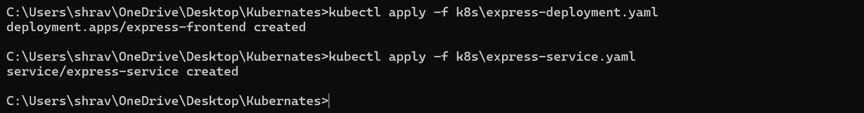
Figure 7. Express resources created.
Figure 8 — Both Pods and Services verified
I checked the Pods and Services together. Both application Pods were Running, and Express was exposed through NodePort 30080.
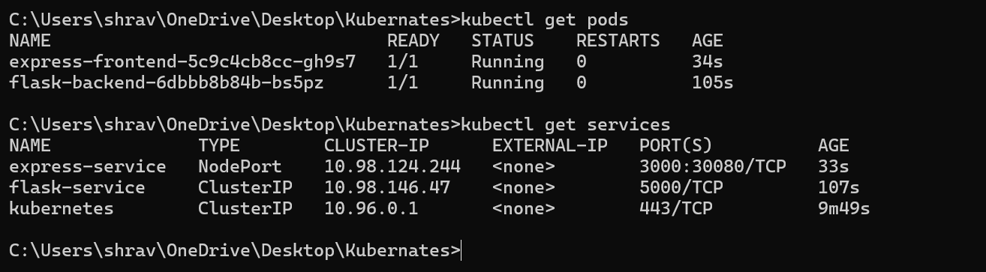
Figure 8. Both Pods and Services verified.
Figure 9 — Student portal opened in browser
I opened the URL returned by Minikube and confirmed that the Student Management Portal loaded in the browser.
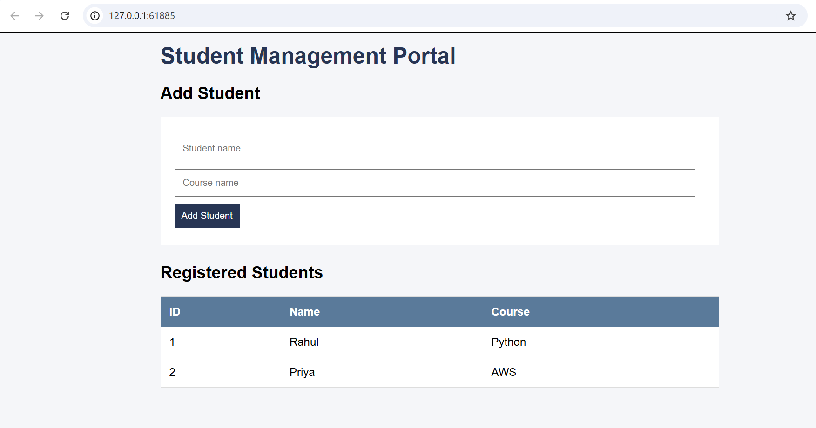
Figure 9. Student portal opened in browser.
Figure 10 — Minikube service URL
The command printed a local URL for the Express Service. With the Docker driver on Windows, I kept this terminal open while using the URL.
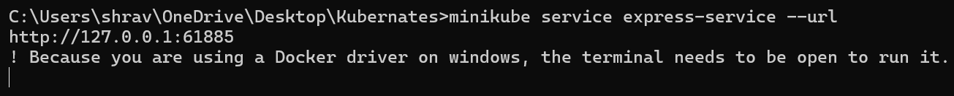
Figure 10. Minikube service URL.
Figure 11 — Student record added
I submitted a new student through the form. The new record appeared in the Registered Students table.
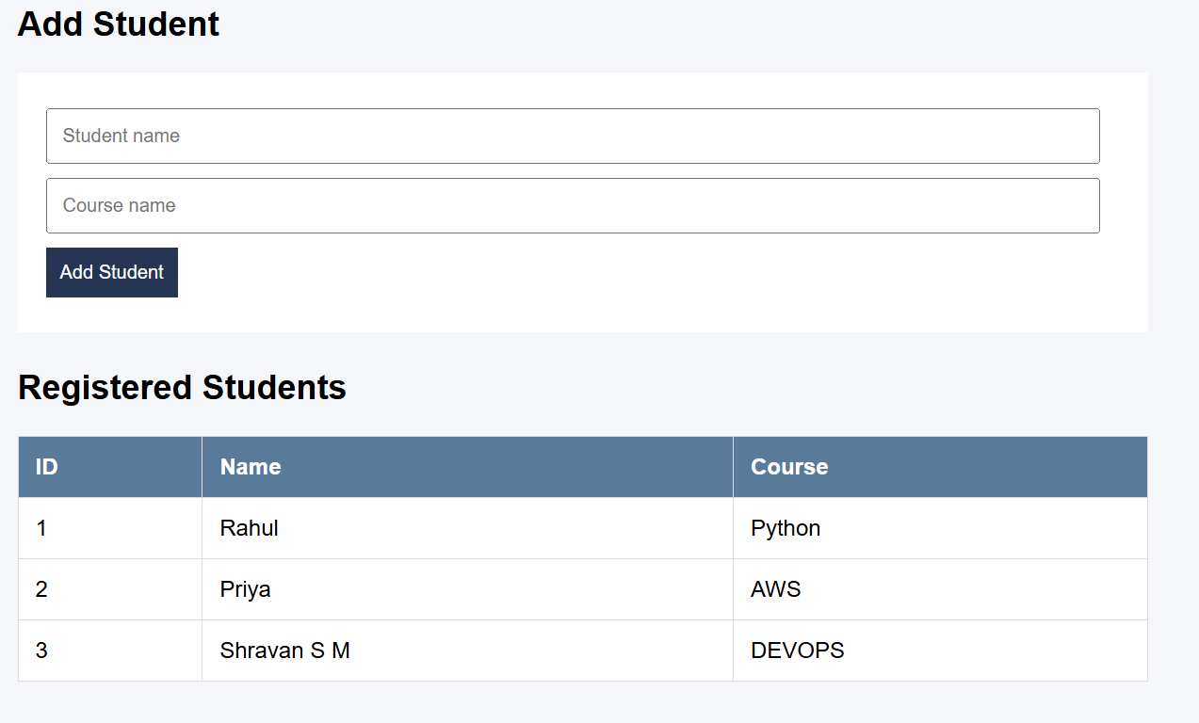
Figure 11. Student record added.
Figure 12 — Flask API logs
The Flask logs showed GET /students requests returning 200 and POST /students returning 201. This confirmed that the backend handled the frontend's requests.
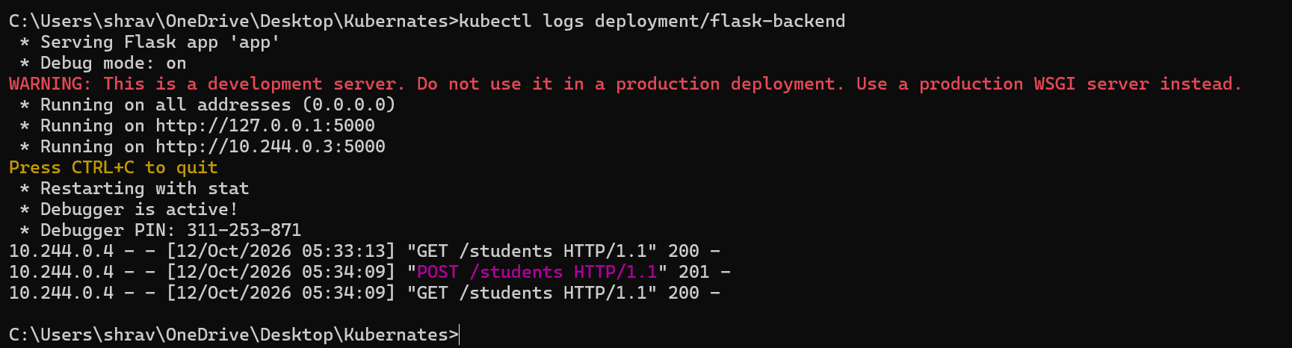
Figure 12. Flask API logs.
Figure 13 — Express startup logs
The Express logs showed npm start running node server.js and confirmed that the frontend was listening on port 3000.
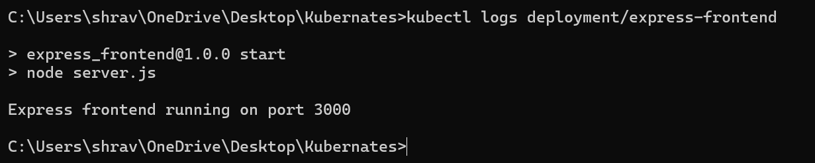
Figure 13. Express startup logs.
Figure 14 — Final Kubernetes verification
For the final check, I verified Pods, Services, and Deployments. Both Pods were 1/1 Running, and both Deployments had one available replica.
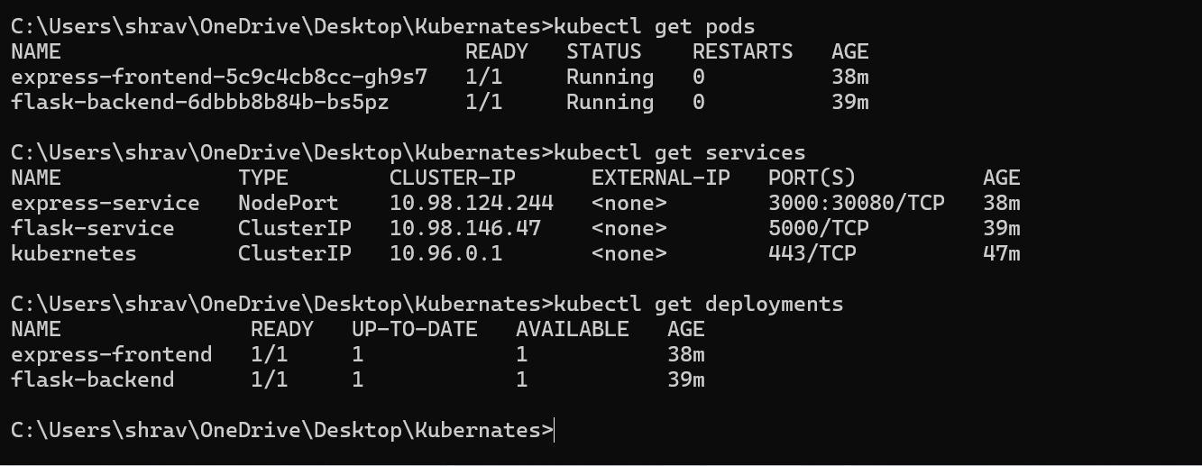
Figure 14. Final Kubernetes verification.

