Linux Commands
Github:- https://github.com/ShravanSM/Linux_commands
1. Creating & Renaming
- Create test_dir using mkdir
Command:- mkdir test_dir
Creates a Directory named test_dir
- Inside it, create an empty example.txt
Command:- touch example.txt
Creates a file named example.txt inside folder test_dir
- Rename it to renamed_example.txt using mv
Command:- mv example.txt renamed_example.txt
Renames the file name example.txt to renamed_example.txt
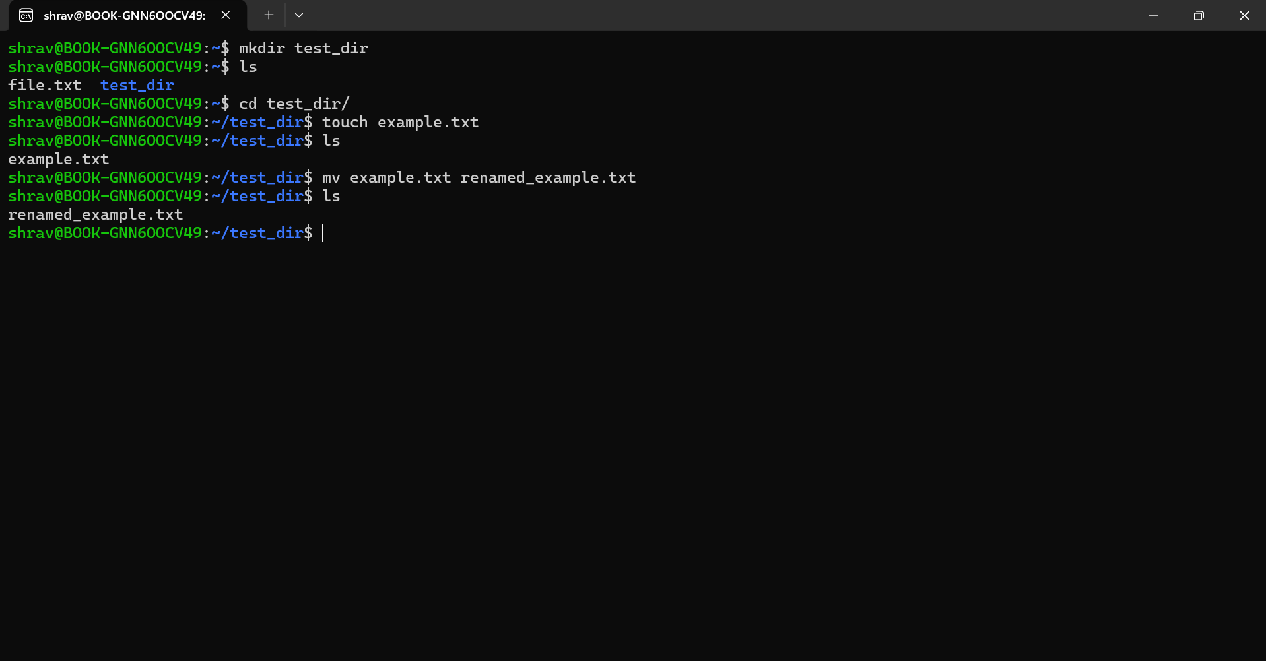

2. Viewing Files
4. Use cat to display /etc/passwd
Command:-mkdir etc & touch passwd.txt & cat passwd
Displays content inside passwd file
5. Use head to display the first 5 lines
Command:- head -n 5 passwd.txt
Display top 5 text lines inside passwd.txt
6. Use tail to display the last 5 lines
Command:- tail -n 5 passwd.txt
Display bottom 5 text lines inside passwd.txt
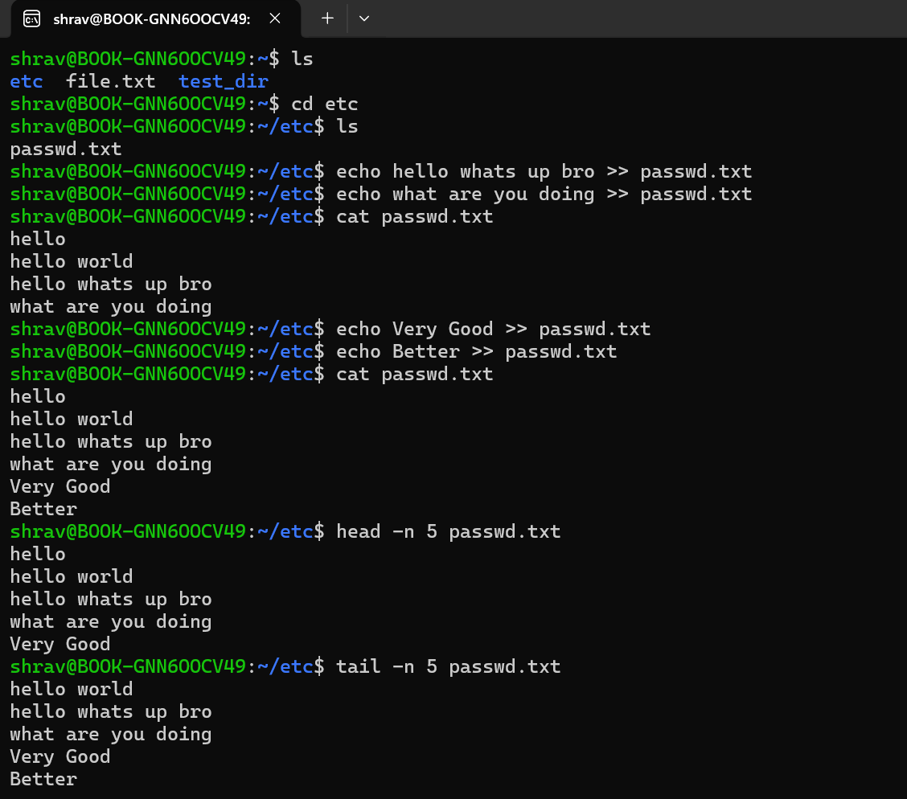
3. Searching for Patterns
- Use grep to find all lines containing the word “root” in /etc/passwd
Command :-grep ‘root’ passwd.txt
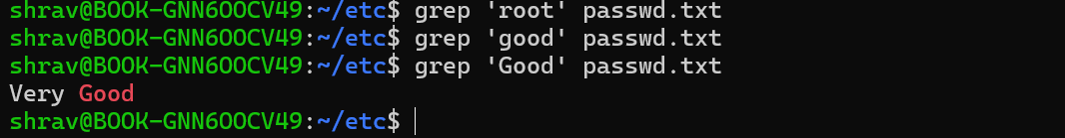
Checks for root word in passwd file

4. Zipping and Unzipping
- Compress the test_dir directory into a file named test_dir.zip using zip.
Command:- zip -r test_dir.zip test_dir
test_dir folder directory is zipped as test_dir.zip
- Unzip test_dir.zip into a new directory named unzipped_dir.
Command:- unzip test_dir.zip -d unzipped_dir
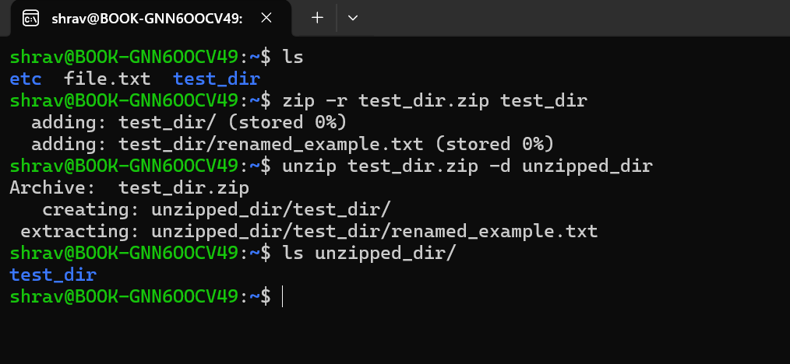
test_dir zip file is unzipped as unzipped_dir file

5. Downloading Files
- Use wget to download a file from a URL (e.g., https://example.com/sample.txt).
Command: wget https://example.com/sample.txt
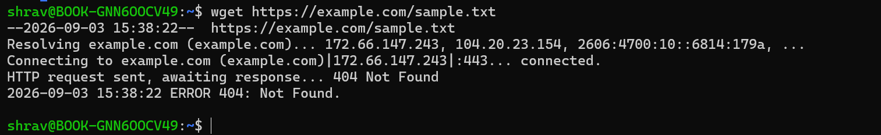
It helps to get the content of website on the terminal for now the website reached the destination
no file called sample.txt in that wesite

6. Changing Permissions
- Create a file named secure.txt and change its permissions to read-only for everyone using chmod.
Command :-touch secure.txt & chmod 444 secure.text
chmod 444 gives read permission to user, group, and everyone else, with no write or execute
permission.

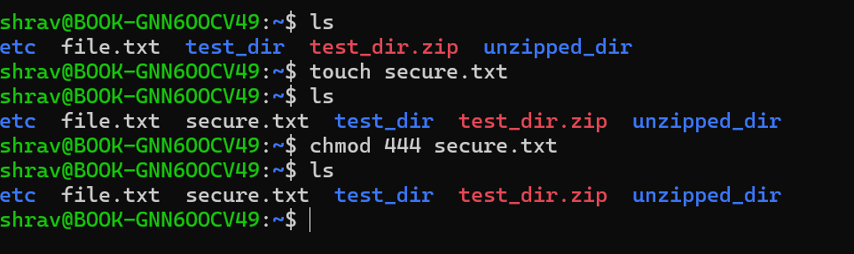

7. Working with Environment Variables
- Use export to set a new environment variable called MY_VAR with the value “Hello, Linux!”.
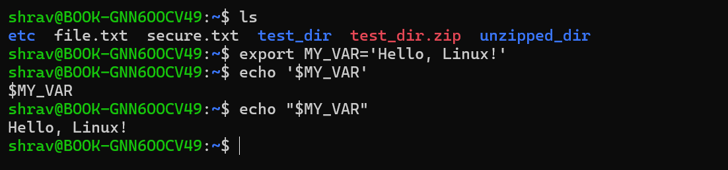
Command:-export MY_VAR=’Hello, Linux!’
echo “$MY_VAR”

