Docker Assignment
GitHub: https://github.com/ShravanSM/Devops
Project: Docker_Assignment

1. Project Structure
The final project is organized into separate Backend and Frontend folders:
Docker_Assignment/
├── .gitignore
├── docker-compose.yml
├── Backend/
│ ├── app.py
│ ├── Dockerfile
│ └── requirements.txt
└── Frontend/
├── .dockerignore
├── Dockerfile
├── package.json
├── package-lock.json
├── server.js
└── public/
└── index.html
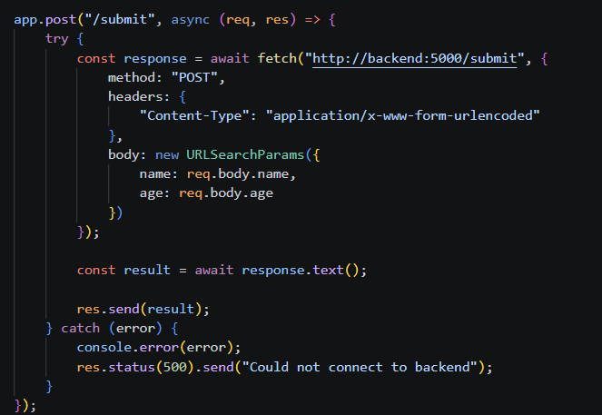
Figure 1 – Docker container cleanup before starting the Compose version.

2. Frontend Setup
const express = require("express");
const app = express();
app.use(express.urlencoded({ extended: true }));
app.use(express.static("public"));
app.post("/submit", async (req, res) => {
try {
const response = await fetch("http://backend:5000/submit", {
method: "POST",
headers: {
"Content-Type": "application/x-www-form-urlencoded"
},
body: new URLSearchParams({
name: req.body.name,
age: req.body.age
})
});
const result = await response.text();
res.send(result);
} catch (error) {
console.error(error);
res.status(500).send("Could not connect to backend");
}
});
app.listen(3000, () => {
console.log("Frontend running on port 3000");
});
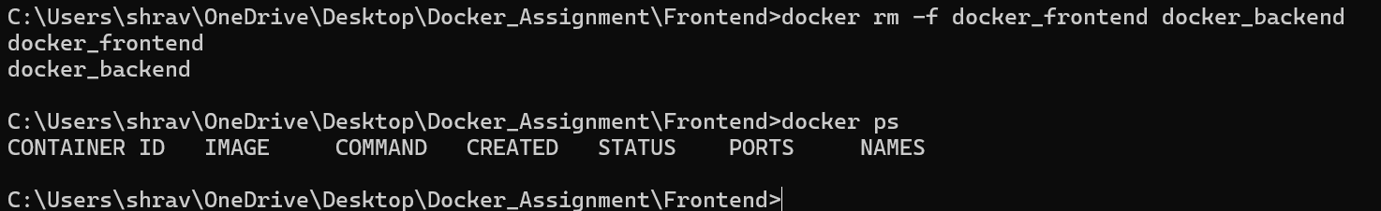
Figure 2 – Express code forwarding the form request to the backend service.

3. Flask Backend
from flask import Flask, request
app = Flask(__name__)
@app.route("/submit", methods=["POST"])
def submit():
name = request.form.get("name")
age = request.form.get("age")
print("Name:", name)
print("Age:", age)
return "Data received successfully!"
if __name__ == "__main__":
app.run(host="0.0.0.0", port=5000)

4. Dockerfiles

Frontend Dockerfile
FROM node:20
WORKDIR /app
COPY package*.json .
RUN npm install
COPY . .
EXPOSE 3000
CMD ["node", "server.js"]

Backend Dockerfile
FROM python:3.12-slim
WORKDIR /app
COPY requirements.txt .
RUN pip install -r requirements.txt
COPY app.py .
EXPOSE 5000
CMD ["python", "app.py"]

5. Docker Compose
I used Docker Compose to run both services together. Compose creates a shared network, which lets the frontend reach the backend using the service name backend.
services:
backend:
build: ./Backend
ports:
- "5000:5000"
frontend:
build: ./Frontend
ports:
- "3000:3000"
depends_on:
- backend
The application was built and started with:
docker compose up -d --build
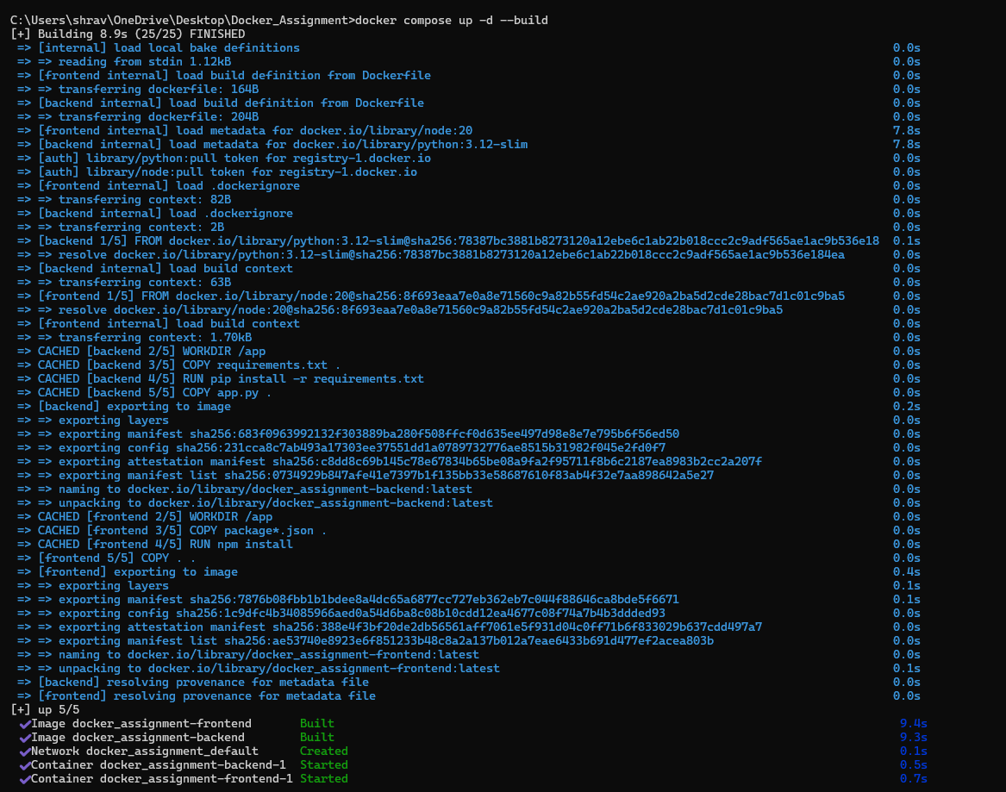
Figure 3 – Docker Compose building both images and starting both services.

6. Compose Verification
I verified that both services were running with:
docker compose ps
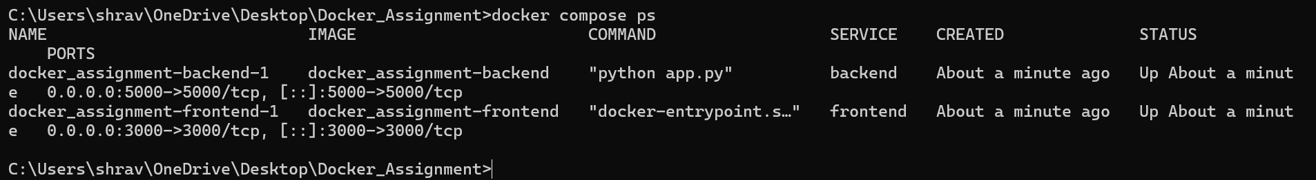
Figure 4 – Both frontend and backend Compose services running with the expected port mappings.

7. Application Testing
I opened http://localhost:3000 in the browser and confirmed that the form was available. I entered a name and age and submitted the form.
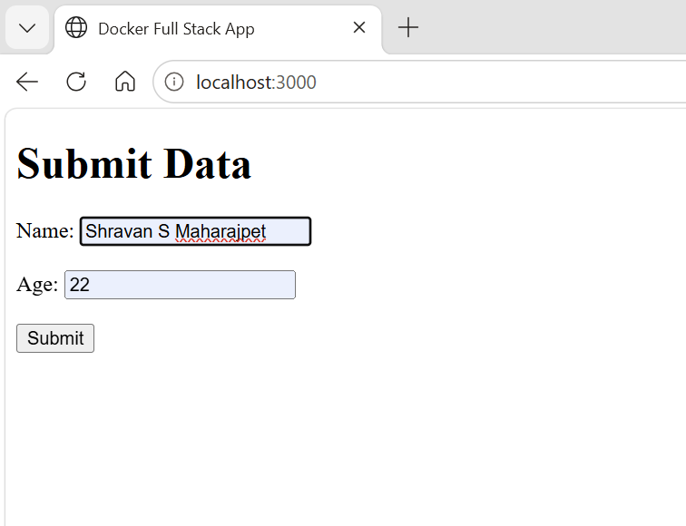
Figure 5 – Frontend form running on localhost:3000.
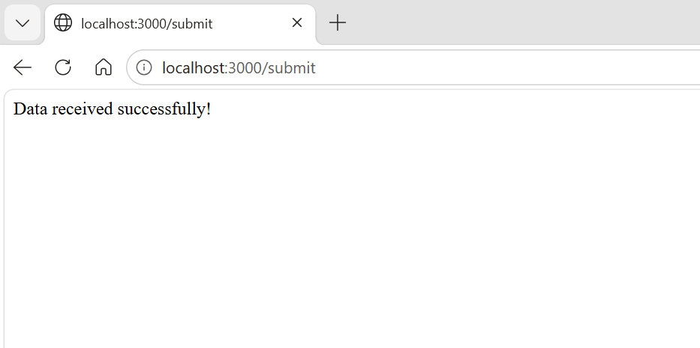
Figure 6 – Successful form submission through the frontend.
The browser submitted to localhost:3000/submit. Express handled that request and forwarded the form data to http://backend:5000/submit inside the Compose network.

8. Backend Log Verification
I checked the backend logs using docker compose logs backend. Flask reported a successful POST request with HTTP status 200. This confirmed that the request reached the backend successfully.
docker compose logs backend
Important result: "POST /submit HTTP/1.1" 200 -

9. Git Configuration
I created a project-level .gitignore so local dependencies, editor settings, Python cache files, and environment files are not committed to GitHub.
node_modules/
.vscode/
__pycache__/
*.pyc
.env
