INSURANCE PURCHASE PREDICTION USING MACHINE LEARNING
Project Report
Name: Shravana S
Project: Comparison of ML Classification Algorithms for Insurance Purchase Prediction

Abstract
This project studies whether a customer's age and estimated salary can be used to predict insurance purchase behavior. Five supervised classification algorithms were implemented: Logistic Regression, K-Nearest Neighbors (KNN), Support Vector Machine (SVM), Decision Tree, and Random Forest. The dataset was divided into training and testing sets, the required features were preprocessed, and the models were evaluated using accuracy, precision, recall, and F1-score. Graphical analysis and predictions for specified test cases were also performed.

1. Introduction
The aim of this project is to apply machine learning classification techniques to an insurance purchase dataset. The input variables used are Age and EstimatedSalary, while Purchased is the target variable. The project compares several classification methods instead of depending on a single model.

2. Literature Review
Machine learning classification algorithms can solve many problems, such as predicting insurance purchase. In particular, for each classification task, there is a set of algorithms that can be applied. The choice of the best algorithm depends on several factors; therefore, comparing different approaches helps find the most accurate one.The first algorithm that I will compare is Support Vector Machine (SVM). This approach was introduced by Cortes and Vapnik in 1995, and it solves classification tasks by finding the best boundary between classes. Later, in 2001, Leo Breiman developed a classification method called Random Forest. It uses an ensemble of decision trees, and the results of their work are combined to achieve higher accuracy. Both algorithms are effective in solving various classification problems, but they have some drawbacks specific to the tasks of this study.The main issue that I have found is that Age and EstimatedSalary variables have different ranges; therefore, some algorithms require special preprocessing. Also, if the data are not linearly separable, the accuracy of SVM decreases significantly. Finally, most classification algorithms, including Random Forest, have a drawback of overfitting, which results in high accuracy of the training sample and low accuracy of the test sample.
In summary, I have found several algorithms that can be used to predict whether a customer will buy insurance. Each of them has its own advantages and disadvantages, and I decided to compare them to find the best among them. All the algorithms mentioned above were tested on the same data set, which allows me to compare their performance and select the most accurate one for the given task.

3. Problem Statement
The main objective of the project is to predict whether the customer is going to purchase the insurance policy based on the information about their age and the estimated salary. For the purpose of the project, the Social Network Ads dataset was used, and various classification algorithms were trained on the data to predict the target variable. The major purpose of the project is to observe how different classification algorithms perform on the same dataset.The major limitation and assumption of the current project is that only two variables, Age, and EstimatedSalary, are considered for the prediction. In reality, more variables may be required for such prediction, and the current project only uses the data provided in the CSV file. For the records with “No Salary”, the value of 0 was substituted in the algorithm, which could significantly affect the result due to the absence of such data. The test results are also limited because different results could be obtained if the train-test split was different. Finally, the test results are only indicative of the algorithm’s performance on the given data and should not be considered as an accurate depiction of the tendency in reality.The project should only be seen as the proof of concept for using classification algorithms for prediction. It cannot be taken as a reliable source for calculating the likelihood of a customer to purchase insurance.

4. Dataset and Preprocessing
For this project, I used the Social Network Ads dataset provided for the project. The dataset is in CSV format and contains information about customers. The main columns used in this project are Age, EstimatedSalary, and Purchased. Age and estimated salary are used as the input values, and Purchased is the output that we want to predict. In the Purchased column, 0 means that the customer did not purchase the insurance and 1 means that the customer purchased it.
The dataset contains 400 records. Before training the models. I divided the dataset into two parts: 80% for training and 20% for testing. The training data was used to train the machine learning models, while the testing data was used to check how well the models could make predictions on new data. Since Age and EstimatedSalary have very different values, I used StandardScaler for Logistic Regression, KNN, and SVM. This helped put the values on a similar scale before giving them to these models. After preprocessing, the data was ready to be used.

5. Methodology

Logistic Regression: A linear classification method that estimates the probability of the target class.
KNN: Classifies a sample using the classes of nearby training samples.
SVM: Finds a decision boundary that separates the classes; an RBF kernel was used.
Decision Tree: Uses a sequence of feature-based decisions to classify observations.
Random Forest: Combines predictions from multiple decision trees.

6. Implementation
I implemented the insurance purchase prediction project using Python. I used Pandas for loading and handling the dataset, while Matplotlib was used to create the required graphs.I started by loading the Social_Network_Ads.csv dataset. From the dataset, I selected Age and EstimatedSalary as the input features and Purchased as the target column.Next, I divided the dataset into training and testing sets using an 80:20 split. Before training the models, I used StandardScaler to scale the input values for Logistic Regression, KNN, and SVM.I implemented five classification models: Logistic Regression, K-Nearest Neighbors (KNN), Support Vector Machine (SVM), Decision Tree, and Random Forest. I trained each model using the training set and checked its performance on the test set.To compare the models, I calculated accuracy, precision, recall, and F1-score for each one. I also plotted graphs to understand the dataset and to make the accuracy comparison between the models easier.After checking the results, I used the selected model to predict whether a person would purchase insurance based on the age and salary values given in the project questions. I also generated a confusion matrix to check how many predictions were correct and where the model made mistakes
Github: https://github.com/Shravana95/AI_Insurance-Purchase-Predicyion

7. Results
Algorithm | Accuracy | Precision | Recall | F1-Score
Logistic Regression | 0.8375 | 0.8636 | 0.6552 | 0.7451
KNN | 0.9000 | 0.8621 | 0.8621 | 0.8621
SVM | 0.9000 | 0.8387 | 0.8966 | 0.8667
Decision Tree | 0.8625 | 0.7647 | 0.8966 | 0.8254
Random Forest | 0.9000 | 0.8387 | 0.8966 | 0.8667
With the selected 80:20 split, KNN, SVM and Random Forest each produced 90.00% test accuracy. The program uses KNN as the selected model because it is the first model among the tied highest-accuracy models in the comparison.
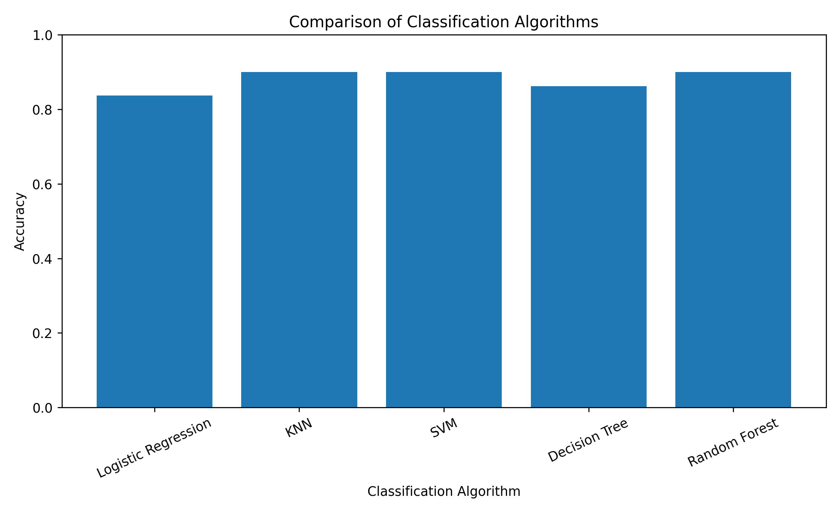

8. Graphical Analysis
The scatter plot shows the relationship between age, estimated salary and the purchase label in the supplied dataset. It is a descriptive visualization and does not by itself prove causation.
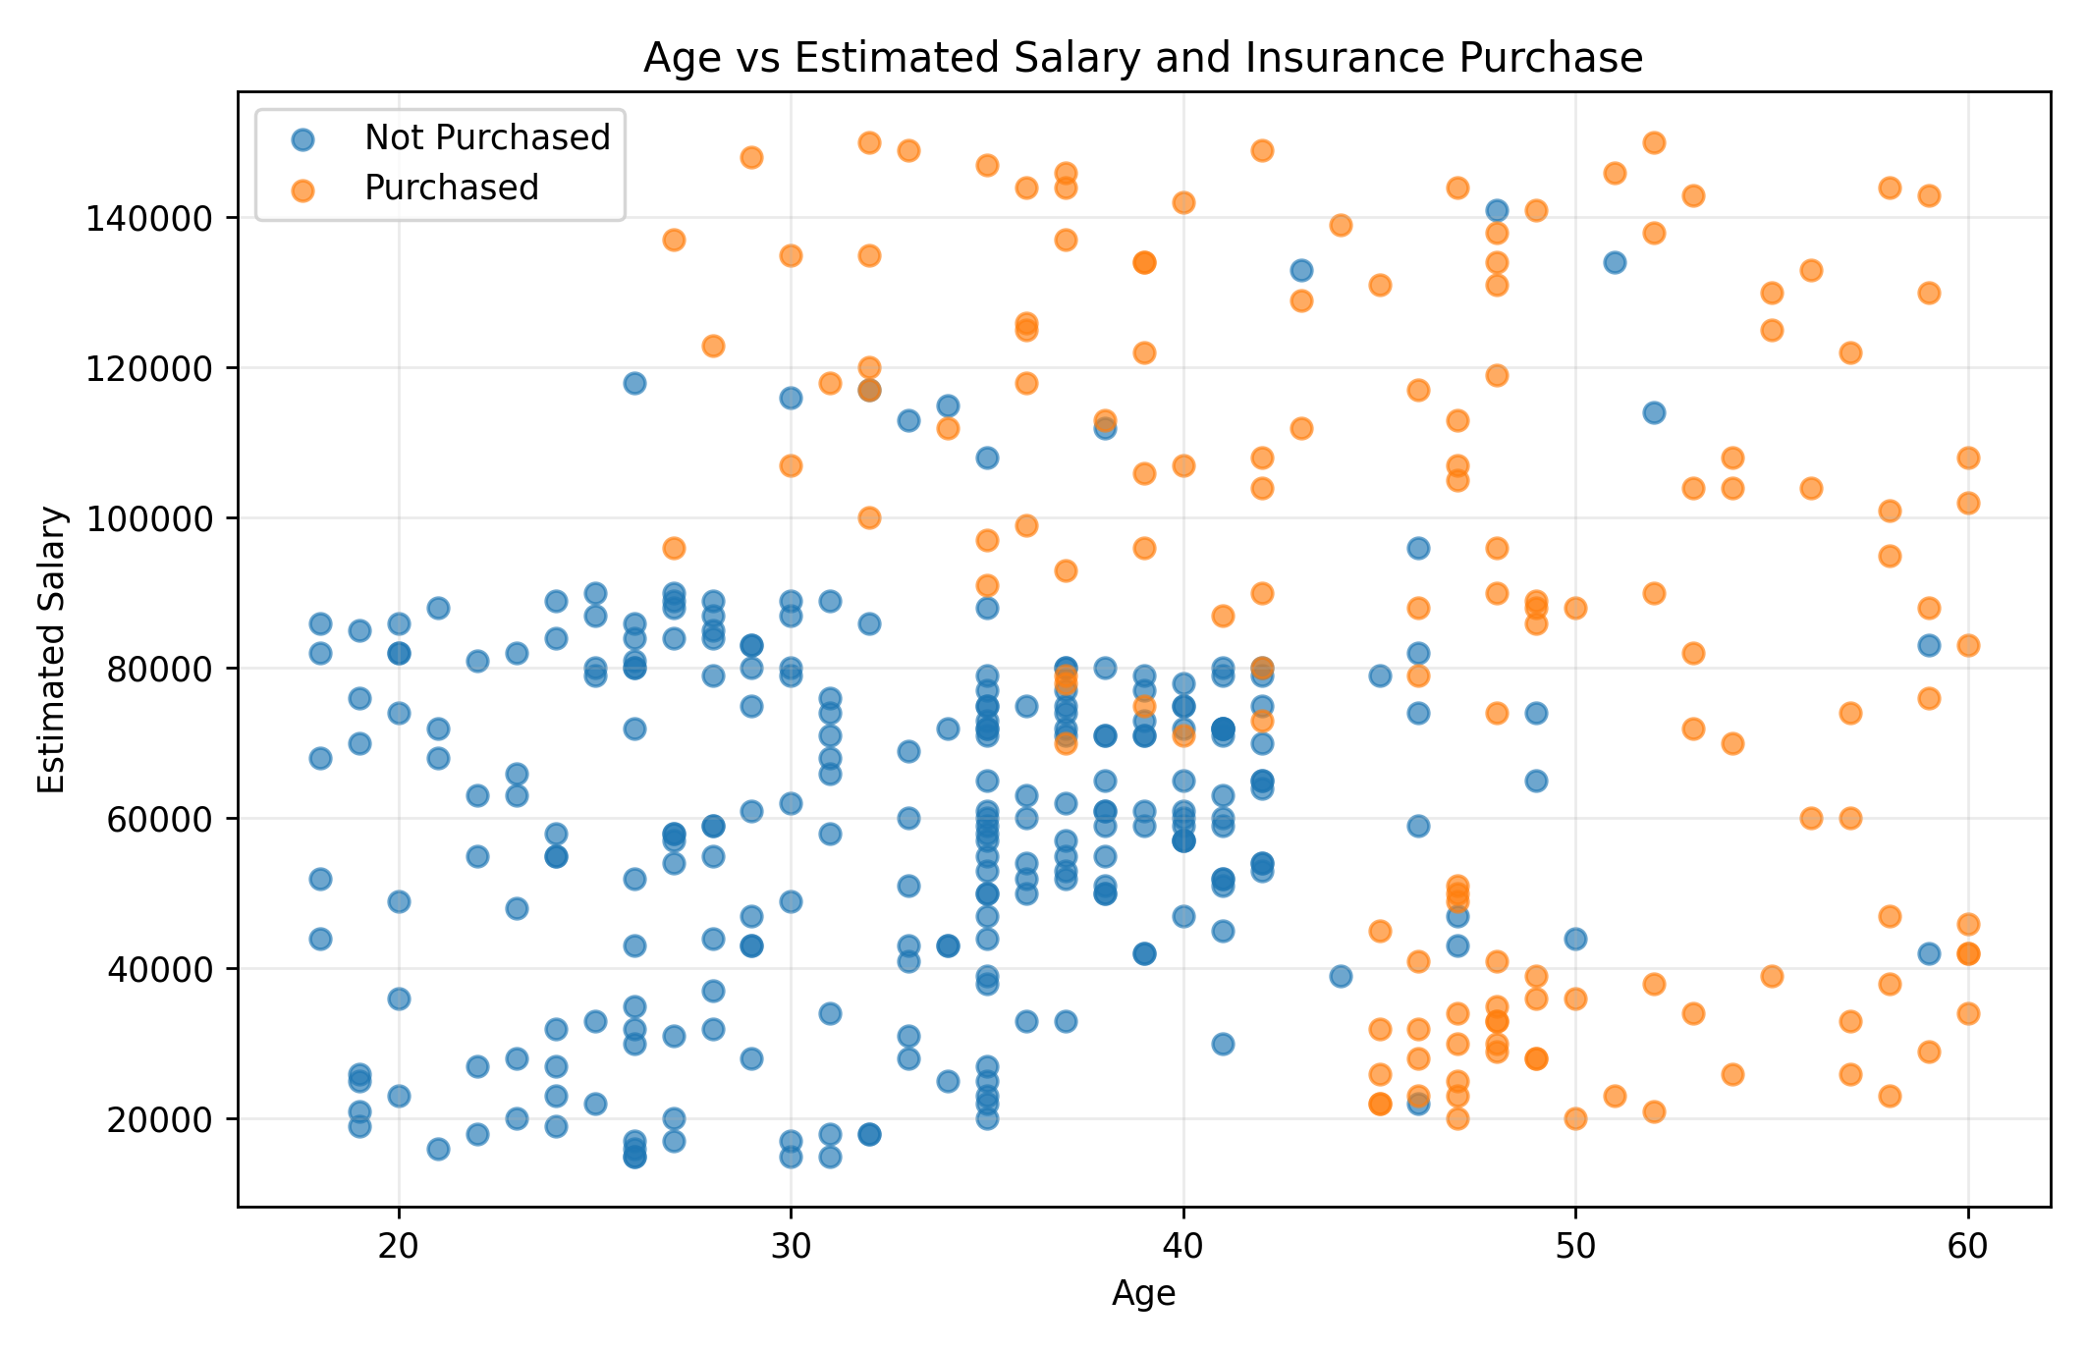

9. Required Predictions
The project brief asks for predictions for eight age/salary combinations. For cases described as 'No Salary', salary was represented as 0 so that the trained numerical model could accept the input. This is an assumption and should be interpreted carefully.
Age | Estimated Salary | Prediction | Result
30 | 87,000 | 0 | Not Purchased
40 | 0 | 0 | Not Purchased
40 | 100,000 | 1 | Purchased
50 | 0 | 1 | Purchased
18 | 0 | 0 | Not Purchased
22 | 600,000 | 1 | Purchased
35 | 2,500,000 | 1 | Purchased
60 | 100,000,000 | 1 | Purchased

10. Confusion Matrix
For KNN, the confusion matrix on the test set was [[47, 4], [4, 25]]. This means the model produced true negatives, false positives, false negatives and true positives as shown in the matrix below.
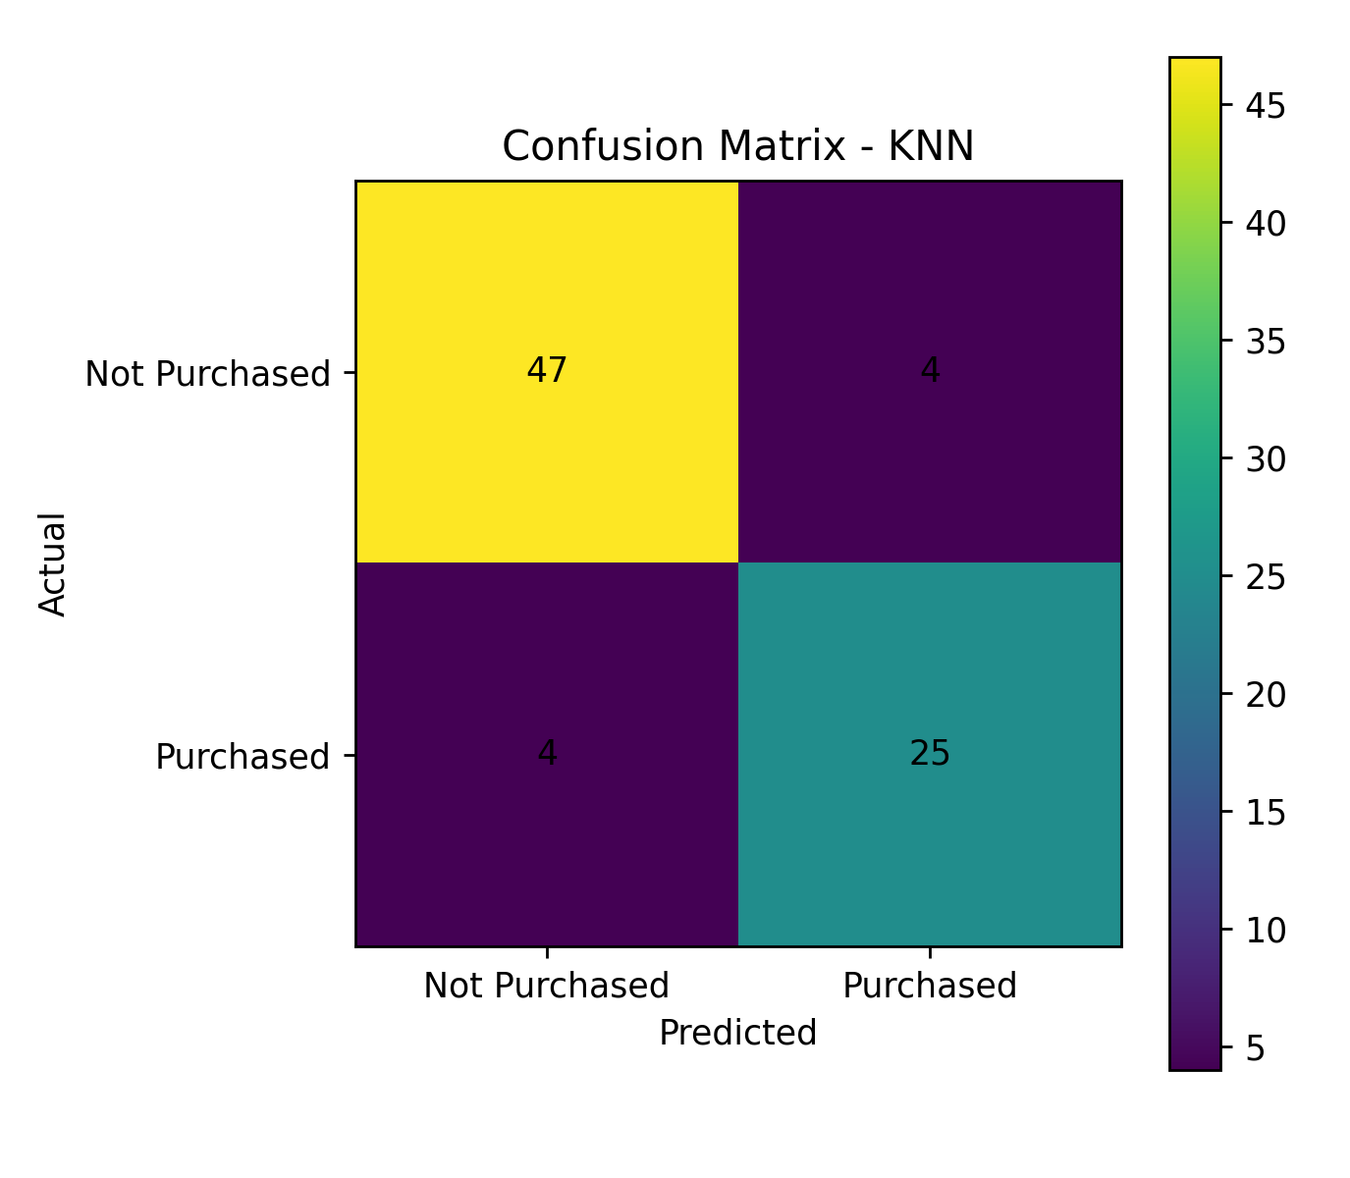

11. Discussion
The three highest test-accuracy models in this run were KNN, SVM and Random Forest, each at 90%. Logistic Regression achieved 83.75% and Decision Tree achieved 86.25%. Accuracy alone does not describe every aspect of model performance, so precision, recall and F1-score were also calculated. The results depend on the particular train/test split and model settings used in the experiment.

12. Assumptions and Limitations
The project uses only two input features, so other factors that may influence insurance purchasing are not represented. The requested 'No Salary' cases were encoded as salary = 0, although the original dataset contains positive salary values. Therefore, those predictions are model experiments rather than real-world customer assessments. The model should be considered a decision-support experiment and not a complete insurance decision system.

13. Real-Life Applications
One possible application is customer segmentation, where an insurer could identify groups with different predicted purchase behavior and design appropriate communication. Another application is campaign planning, where predictions could help estimate which customer groups may be more responsive to a particular insurance product. In practice, additional features, privacy protections, fairness checks and human review would be required.

14. Conclusion
This project demonstrated the use of five machine learning classification algorithms for insurance purchase prediction. Using the supplied dataset and the selected 80:20 train/test split, KNN, SVM and Random Forest reached 90% test accuracy. The experiment also demonstrated model comparison, graphical analysis, prediction of new cases and confusion-matrix evaluation.

15. References
Project brief supplied for the internship training assignment.
scikit-learn documentation: classification algorithms and model evaluation metrics.
Matplotlib documentation: plotting and visualization.
Literature review :
- Cortes, C. and Vapnik, V., Support-Vector Networks, Machine Learning, 1995.
- Breiman, L., Random Forests, Machine Learning, 2001.
- Scikit-learn documentation, Machine Learning in Python.

Appendix A – Files
The following supporting files are included with the project:
- Python source code
- Algorithm
- Project notes
- Model comparison results
- Prediction results
- Accuracy comparison graph
- Age and salary graph
- Confusion matrix
How to Reproduce the Results
- Keep the Python program and Social_Network_Ads.csv in the same folder.
- Install the required Python libraries: pandas, numpy, matplotlib and scikit-learn.
- Run the Python program.
- The program loads the dataset and divides it into training and testing data.
- The five classification algorithms are trained and tested.
- The program displays the evaluation results and generates the graphs.
- The model comparison and prediction results are also saved as CSV files.

