BREAST CANCER CLASSIFICATION USING
CONVOLUTIONAL NEURAL NETWORK

Project Report
Name: Shravana S
Date: 03 October 2026

Abstract
Breast cancer is one of the prominent health issues, where early and accurate detection plays a critical role. The task of histopathological image analysis helps to determine cancerous regions, which have valuable information for clinicians. This paper describes my personal project, where I trained a Convolutional Neural Network (CNN) to classify breast histopathology image patches into two categories: Invasive Ductal Carcinoma (IDC) and normal tissue.
The Breast Histopathology Images dataset was used for this experiment from Kaggle. It consists of 277,524 image patches of 50 × 50 pixels size. The initial number of images was reduced to 1,084 due to computational limitations of a free tier. The given sample included 576 class0 and 508 class1 images, which were divided into training (80%) and validation (20%) subsets.
An open-source framework TensorFlow with Keras library was utilized for creating an artificial neural network. The network’s architecture included convolutional layers, max-pooling, one fully connected layer, and dropout for reducing overfitting. The algorithm was trained for ten epochs and achieved eight validation accuracy. The obtained results demonstrated that 104 class0 and 85 class1 images were classified correctly, which was displayed in the confusion matrix below. The described experiment illustrates how CNN’s power can be used in medical science for automatic detection of cancerous tissue.

Table of Contents
Abstract 2
Table of Contents 3
1. Introduction 4
1.1 Objectives 4
2. Literature Review 4
3. Problem Statement 4
3.1 Assumptions 5
3.2 Limitations 5
4. Data Collection and Preprocessing 5
5. Methodology 5
6. Implementation 6
6.1 GitHub Link 6
7. Results 6
7.1 Confusion Matrix 7
7.2 Accuracy Graph 7
7.3 Loss Graph 8
8. Discussion 9
9. Conclusion 9
10. References 10
11. Appendices 10
11.1 Project Folder Structure 10
11.2 Reproducibility Instructions 10
11.3 Additional Technical Details 11
12. Acknowledgments 11

1. Introduction
Breast cancer diagnosis typically involves examining tissue samples to identify any abnormal regions. Histopathological images contain valuable information on the tissue structure, but visual examination of a great number of images can be a time consuming process. Using image classification techniques to identify patterns in the images using machine learning can be beneficial.
For this project, I chose to work with Convolutional Neural Networks to classify breast histopathology image patches. Convolutional Neural Networks (CNNs) are especially effective for image classification tasks since convolutional layers learn valuable visual features from the image.
For this project, I relied on Breast Histopathology Images from Kaggle. The original Kaggle dataset consists of 277,524 patches of 50 × 50 pixels each extracted from whole-mount breast cancer slide images.

1.1 Objectives
To understand how CNNs can be used in image classification
Preprocess the breast histopathology images to prepare them for CNN
Construct a simple CNN model using TensorFlow and Keras
Train the model using the selected image dataset
Evaluate the model using accuracy, precision, recall, and F1-score.

2. Literature Review
Deep learning methods are widely used for medical image analysis since they can learn visual features directly from image data. Convolutional Neural Networks (CNNs) are particularly suitable for image classification due to convolutional layers’ processing local patterns and pooling layers’ reducing the spatial dimensions of feature maps.
The Breast Histopathology Images (BHI) dataset contains 277,524 patches extracted from 162 whole-mount breast cancer slide images, scanned at 40× magnification. In total, 198,738 and 78,786 patches were labeled as IDC-negative and IDC-positive, respectively.
Prior research has investigated and utilized the BHI dataset for the task of automated identification of IDC using deep learning methods. Studies have explored standard CNNs, transfer learning, and other deep learning-based methods for classification of IDC-positive and IDC-negative patches.
While the original BHI dataset imbalances in-class distribution, as there are significantly more IDC-negative patches than positive ones, which is critical when interpreting classifier accuracy. For this project, a local subset of the data was used, as the entirety of the dataset would not be practical to work with given the limitations of storage and computational power. Thus, while the literature review provides context for the technique, the results reported are for the subset used for this project.

3. Problem Statement
Develop a CNN-based image classification system that predicts whether a breast histopathology image patch is IDC-negative or IDC-positive.

3.1 Assumptions
- The image files are correctly labelled according to their class folders.
- The selected images are suitable for training a basic image classification model.
- The selected subset is sufficient for demonstrating the CNN classification process.
- The model is an academic experiment and is not intended to be used as a medical diagnostic system.

3.2 Limitations
- Only 1,084 image patches were used instead of the complete dataset.
- The split was performed at image level rather than as a patient-level split.
- Multiple patches can originate from the same patient or slide, so the validation result may not represent performance on completely unseen patients.
- The experiment does not replace examination by a qualified medical professional.

4. Data Collection and Preprocessing
The dataset was obtained from the Breast Histopathology Images dataset on Kaggle. The original dataset contains 277,524 patches, each with a size of 50 × 50 pixels. The file labels use class0 for non-IDC patches and class1 for IDC-positive patches.
Instead of downloading the complete dataset, a smaller subset was collected using the Kaggle command-line tool. The final local dataset contained 1,084 images.
Class | Number of Images
Class 0 | 576
Class 1 | 508
Total | 1,084

The images were stored in separate folders:
dataset/
class0/
class1/
The images were loaded using TensorFlow's image_dataset_from_directory function. An 80:20 split was used, with 868 images used for training and 216 images used for validation. The images were rescaled by 1/255 before being passed to the CNN.

5. Methodology
The main AI technique used in this project was a Convolutional Neural Network. The model was built using TensorFlow and Keras. It contains three convolutional blocks followed by a dense classification section.
Layer | Configuration
Input | 50 × 50 × 3
Rescaling | 1/255
Conv2D | 32 filters, 3 × 3, ReLU
MaxPooling2D | 2 × 2
Conv2D | 64 filters, 3 × 3, ReLU
MaxPooling2D | 2 × 2
Conv2D | 128 filters, 3 × 3, ReLU
MaxPooling2D | 2 × 2
Flatten | —
Dense | 128 neurons, ReLU
Dropout | 0.5
Output | 1 neuron, Sigmoid

The model used the Adam optimizer and binary cross-entropy loss because the task has two output classes. A batch size of 16 was used and the model was trained for 10 epochs. A dropout layer with a rate of 0.5 was included to reduce the chance of overfitting.

6. Implementation
I implemented the project using Python, TensorFlow, Keras, NumPy, Matplotlib and scikit-learn. The dataset was first loaded from the class folders. TensorFlow was used to create the training and validation datasets.
The CNN was created using the Sequential model. The convolutional layers learn image features, while max-pooling reduces the spatial size of the feature maps. The output of the convolutional section is flattened and passed through a dense layer before the final sigmoid output.
The model was trained for 10 epochs. During training, both training accuracy and validation accuracy were recorded. Training and validation loss were also recorded so that the behaviour of the model could be checked.
After training, predictions were generated for the validation dataset. Accuracy, precision, recall and F1-score were calculated. A confusion matrix was also generated to see how many images were correctly and incorrectly classified.

6.1 GitHub Link

7. Results
The model was evaluated on 216 validation images. The final validation accuracy after 10 epochs was 87.5%. The classification report showed a macro-average precision of 0.89, recall of 0.88 and F1-score of 0.87.
Metric | Value
Validation images | 216
Final validation accuracy | 87.5%
Macro precision | 0.89
Macro recall | 0.88
Macro F1-score | 0.87
Weighted precision | 0.89
Weighted recall | 0.88
Weighted F1-score | 0.87

7.1 Confusion Matrix
The confusion matrix contains 104 correctly classified class0 images and 85 correctly classified class1 images. There were 3 class0 images predicted as class1 and 24 class1 images predicted as class0.
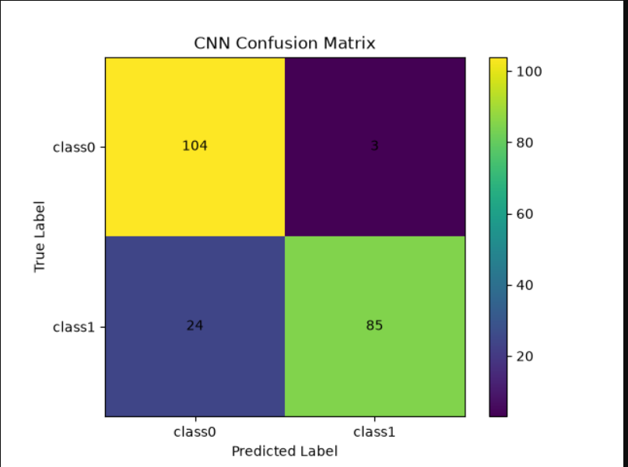
Figure 1: CNN confusion matrix

7.2 Accuracy Graph
The validation accuracy increased during the early epochs and reached its highest point of approximately 92% around epoch 7. It decreased slightly in the later epochs and ended at 87.5% in epoch 10.
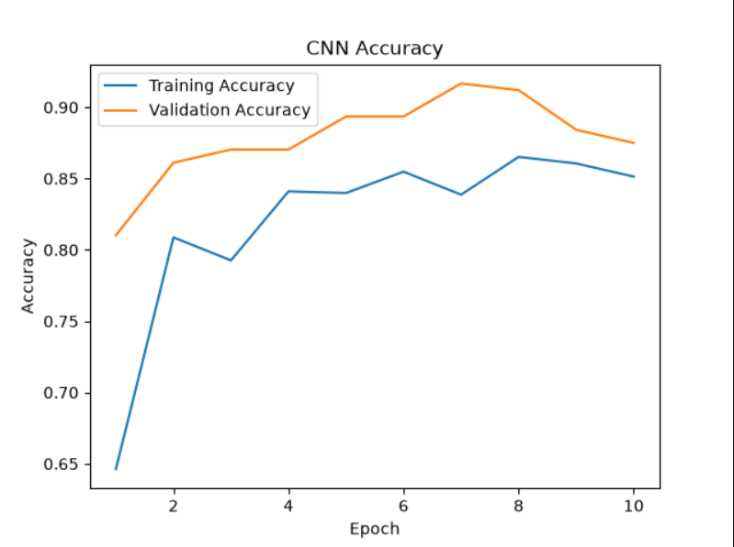
Figure 2: Training and validation accuracy

7.3 Loss Graph
The training loss generally decreased as the epochs increased. The validation loss reached its lowest point around epoch 7 and then increased slightly towards the final epochs.
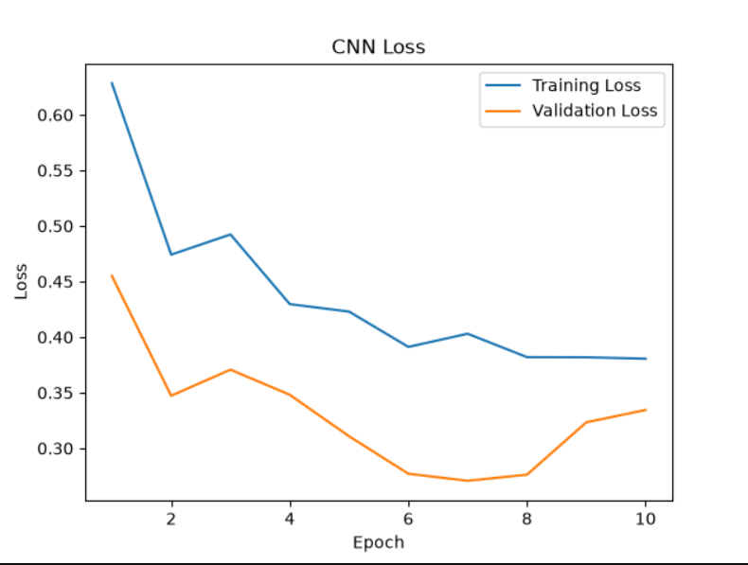
Figure 3: Training and validation loss

8. Discussion
The CNN achieved a final validation accuracy of 87.5% on the selected subset. The confusion matrix shows that the model classified most class0 images correctly, while some class1 images were predicted as class0.
For class1, the precision was approximately 96.6%, while the recall was approximately 78.0%. This means that when the model predicted class1, the prediction was usually correct, but the model missed a number of actual class1 images.
The accuracy graph shows that the validation accuracy was highest around epoch 7. After that point, validation accuracy decreased while the training accuracy remained relatively high. The validation loss also increased after reaching its lowest value around epoch 7. This suggests a possible onset of overfitting in the later epochs.
The main advantage of the approach is that the CNN can learn image features directly instead of requiring manual feature extraction. However, the experiment used only a small subset of the original dataset and used an image-level split. These limitations should be considered when interpreting the results.

9. Conclusion
In this project, a Convolutional Neural Network was developed to classify breast histopathology image patches into IDC-negative and IDC-positive classes. A subset of 1,084 images was collected and divided into training and validation sets. The CNN was implemented using TensorFlow and Keras and trained for 10 epochs.
The final validation accuracy was 87.5%, with a macro F1-score of 0.87. The model was able to correctly classify most of the images, although some IDC-positive images were classified as negative. The training graphs also showed a possible increase in overfitting during the later epochs.
The project demonstrated the workflow of an image classification problem, including data collection, preprocessing, CNN model creation, training and evaluation. Future work could use a larger subset, data augmentation, patient-level splitting, hyperparameter tuning and transfer learning with pretrained CNN models.

10. References
[1] Paul Mooney. Breast Histopathology Images. Kaggle.
[2] TensorFlow. Image classification.
[3] TensorFlow. Convolutional Neural Network (CNN).
[4] Deep Learning for the Early Detection of Invasive Ductal Carcinoma in Histopathological Images.
[5] Breast Cancer Classification with Various Optimized Deep Learning Methods.
[6] Performance analysis of seven Convolutional Neural Networks with transfer learning for IDC grading.

11. Appendices

11.1 Project Folder Structure
Project_2_Breast_Cancer_CNN/
├── dataset/
│ ├── class0/
│ └── class1/
├── output/
│ ├── cnn_accuracy.png
│ ├── cnn_loss.png
│ ├── confusion_matrix.png
│ ├── classification_report.txt
│ └── breast_cancer_cnn.keras
├── breast_cancer_cnn.py
└── download_dataset.py

11.2 Reproducibility Instructions
- Install Python and the required libraries including TensorFlow, NumPy, Matplotlib and scikit-learn.
- Place the class0 and class1 image folders inside the dataset folder.
- Run download_dataset.py if the dataset needs to be collected again.
- Run breast_cancer_cnn.py to train and evaluate the CNN.
- The graphs, confusion matrix, classification report and trained model are saved in the output folder.

11.3 Additional Technical Details
The experiment was carried out on a local Windows computer using Python and TensorFlow. The complete Kaggle dataset was not downloaded because of storage and computational limitations. The reported results are therefore specific to the 1,084-image subset used in this project.

12. Acknowledgments
I would like to thank the internship program for providing the project requirements and learning opportunity. I also acknowledge the publicly available dataset and software libraries that were used to complete this project.

