**Project Name : Netflix**

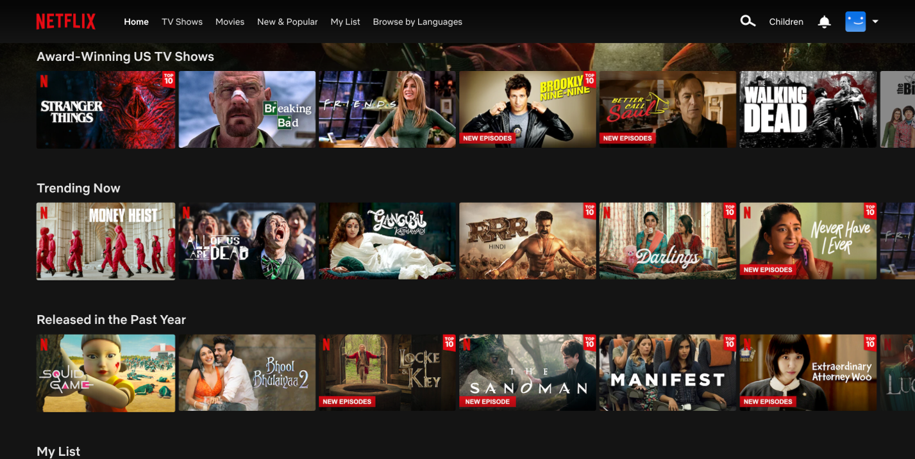

**Presented by :- Shravan Patil**

**Overview**

Netflix is one of the world's leading entertainment services with 221 million paid memberships in over 190 countries enjoying TV series, documentaries, feature films and mobile games across a wide variety of genres and languages. Members can watch as much as they want, anytime, anywhere, on any internet-connected screen. Members can play, pause and resume watching, all without commercials or commitments.

**Goals:-**

1. Login Page
2. Subscription Page
3. Payment page
4. Streaming page
5. Sign out page

**History**

History of Netflix has consistently innovated in streaming video. Over the history of Netflix, the company has maintained a content catalogue which would be delivered at first via mail. When the technology infrastructure became available Netflix pioneered video technology, which revolutionized home-based video entertainment. The technical decisions that Netflix takes often serve as guides for VdoCipher’s course of action, while the long-term vision that the company has executed in its two decades has helped it standout from competition. Netflix offers a fantastic glimpse into how long-term strategy and decision-making ensured the company crested the wave of vastly increased internet connectivity in recent years.

**Technologies used in Netflix**

**Front-End:**

1. Html
2. CSS
3. Bootstrap
4. JavaScript

**Framework:**

1. ReactJs

**Database:**

1. MongodB

**Code Compilers:**

1. Visual Studio Code
2. Git Bash
3. Git Hub

**Github json link:**