**DeStorage System** IPFS

BlockChain Lab project report submitted in partial

Fulfilment of the requirements of the degree of **Information Technology**

by

**Amey Pandit(19) [BEIT2]**

**Shubham Dhopat (21) [BEIT1]**

**Sakshi Jaiswal (45)[BEIT1]**

**Shravani Jeurkar (47)[BEIT1]**

Under the guidance of

**Ms. Charmi Chaniyara**



**Department of Information Technology**

**Atharva College of Engineering, Malad(W)**

**University of Mumbai**

2023–2024

**CERTIFICATE**

This is to certify that the B.E. mini-project entitled **“DeStorage System”** is a bonafide work of **“Amey Pandit” (19) [BEIT2], “Shubham Dhopat” (21) [BEIT1],**  **“Sakshi Jaiswal” (45) [BEIT1]** and **“Shravani Jeurkar” (47) [BEIT1]**submitted to University of Mumbai in partial fulfilment of the requirement for the award of the degree of **“Information Technology”** during the academic year 2023–2024.

**Ms. Charmi Chaniyara**

Guide Name

**Dr. Ulhaskumar Gokhale** **Dr. Ramesh Kulkarni** Head of Department Principal

**Blockchain Project Report Approval**

This Blockchain Lab project synopsis entitled ***DeStorage System IPFS*** by ***Amey Pandit, Shubham Dhopat, Sakshi Jaiswal ,Shravani Jeurkar*** is approved for the degree of ***Information Technology*** from ***University of Mumbai***.

**Examiners**

1.

2.

Date:

Place: Mumbai

**Declaration**

We declare that this written submission represents our ideas in our own words and where others’ ideas or words have been included, we have adequately cited and referenced the original sources. We also declare that we have adhered to all principles of academic honesty and integrity and have not misrepresented or fabricated or falsified any idea/data/fact/source in our submission. We understand that any violation of the above will cause disciplinary action by the Institute and can also evoke penal action from the sources which have thus not been properly cited or from whom proper permission has not been taken when needed.

Signature

Amey Pandit (19)

Signature

Shubham Dhopat(21)

Signature

Shravani Jeurkar (47)

Signature

Sakshi Jaiswal (45)

Date:

# Index

|  |  |  |
| --- | --- | --- |
| **SR NO** | **CONTENT** | **PAGE NO** |
| 1 | Introduction | 8 |
| 2 | Review of Literature | 10 |
| 3 | Report on the Present Investigation | 12 |
| 4 | Aim and Objectives | 13 |
| 5 | Problem Statement | 14 |
| 6 | Proposed System | 15 |
| 7 | Requirement Analysis | 16 |
| 8 | Feasibility Study | 18 |
| 9 | Design Details | 19 |
| 9.1 | Context Level diagram | 19 |
| 9.2 | DFD Diagram | 20 |
| 9.3 | Sequence Diagram | 21 |
| 9.5 | Control Flow Diagram | 22 |
| 10 | Implementation Plan | 23 |
| 11 | Gantt Chart | 25 |
| 12 | Conclusion | 26 |
|  | Acknowledgement | 27 |
|  | References | 28 |

**List of Figures**

|  |  |  |
| --- | --- | --- |
| **Figure No** | **Name of Figure** | **Page No** |
| 6.1 | Block Diagram | 14 |
| 9.1 | Context Level diagram | 19 |
| 9.2 | DFD Diagram | 20 |
| 9.3 | Sequence Diagram | 21 |
| 9.4 | Control Flow Diagram | 22 |
| 11.1 | Gantt Chart | 25 |

**Abstract**

In recent years, the rise of digital data has led to an unprecedented demand for secure and efficient file storage solutions. Traditional centralized storage systems pose several challenges including single points of failure, susceptibility to data breaches, and high operational costs. In response to these challenges, blockchain technology has emerged as a promising solution, offering decentralization, immutability, and transparency. DeStorage is a novel blockchain project designed to address the shortcomings of traditional file storage systems by leveraging the InterPlanetary File System (IPFS) and blockchain technology to create a decentralized and secure file storage platform.

DeStorage utilizes the decentralized nature of blockchain technology to ensure data integrity and reliability. By distributing file storage across a network of nodes, DeStorage eliminates the risks associated with centralized storage, such as data loss and unauthorized access. Each file uploaded to the DeStorage platform is broken down into smaller chunks and encrypted before being distributed across multiple nodes in the network. This ensures that even if some nodes fail or are compromised, the integrity and availability of the data remain intact.

DeStorage leverages the capabilities of IPFS to store files in a decentralized manner, ensuring that no single entity has control over the storage infrastructure. Additionally, IPFS facilitates faster file retrieval by allowing users to access files from the nearest or most available node in the network, reducing latency and improving overall performance.

***Keywords—*** *Attribute-based Encryption (ABE), Blockchain, data integrity, decentralized storage, digital trust, InterPlanetary File System (IPFS), privacy, scalability, security, user-friendly interface.*

**Chapter 1**

1. **Introduction**
   1. **Need and Motivation:**

The surge in digital data creation has highlighted the urgent requirement for reliable, efficient file storage solutions. Conventional centralized storage systems are beset with vulnerabilities like single points of failure, data breaches, and high operational costs. These limitations threaten data security, accessibility, and scalability. DeStorage, driven by these challenges, seeks to revolutionize file storage by leveraging blockchain technology and IPFS. By addressing these challenges, DeStorage aims to enhance data security, improve accessibility, reduce operational costs, and foster trust and transparency.

DeStorage's decentralized architecture mitigates risks associated with single points of failure and data breaches. Through encryption and fragmentation techniques, it ensures data confidentiality and tamper-proofing. Accessibility and reliability are bolstered by eliminating reliance on a single entity. Users can access files from any network node, enhancing performance even during disruptions or node failures. Moreover, decentralized storage infrastructure reduces operational costs by optimizing resource utilization and incentivizing storage resource contribution.

Moreover, our project emphasizes the development of a user-friendly interface that simplifies user interactions, promoting accessibility and ease of use. This approach not only encourages widespread adoption but also fosters a seamless and intuitive user experience, making the system more inclusive and user-centric. Additionally, the scalability of our system has been meticulously engineered to accommodate the growing demands of data storage, thereby ensuring its adaptability and longevity in a rapidly evolving technological landscape.

* 1. **Basic Concept:**

The basic concept of this project centers on the development of an advanced data storage system that responds to the critical requirements of data security, privacy, integrity, and availability in the rapidly evolving digital era. This is achieved through the integration of three pivotal technologies: the InterPlanetary File System (IPFS), Attribute-based Encryption (ABE), and Blockchain. DeStorage emerges as a pioneering blockchain project, poised to revolutionize the landscape of file storage. By harnessing the power of InterPlanetary File System (IPFS) and blockchain technology, DeStorage offers a decentralized, secure, and transparent platform for storing digital assets. This introduction provides a glimpse into the innovative features and capabilities of DeStorage, setting the stage for a deeper exploration of its architecture and functionality.

Central to DeStorage's value proposition is its use of blockchain technology to establish trust and transparency. The immutable blockchain ledger provides verifiable proof of file storage and access activities, fostering accountability and confidence among users. Ultimately, DeStorage aims to revolutionize the file storage landscape by offering a decentralized, secure, and transparent platform for storing digital assets.

**Chapter 2:**

1. **Review of Literature**

|  |  |  |  |  |
| --- | --- | --- | --- | --- |
| **Year** | **Name** | **Conference/ Journal** | **Author** | **Description** |
| 2023 | D-Drive: Decentralized Storage Space using Blockchain and IPFS Protocol | IJRASET | Smita Shinde  , Anuj Srivastava  , Dr. Piyush Samant | This paper addresses centralized cloud storage limitations due to growing data volumes. It introduces decentralization as a solution for improved security and privacy. Using IPFS, the proposed "D-Drive" system aims to enhance data control and security. |
| 2022 | Decentralized Cloud Storage Using Blockchain | IJRASET | G. Richa Shalom  ,Ganesh Rohit   Nirogi | This paper addresses the critical challenges of data storage in the digital age, focusing on the risks and drawbacks of current methods such as cloud storage and data centers. |
| 2022 | Centralize storage system with encryption vs decentralize storage system  using blockchain | ICCIDS | Ms. Kritika  Dr. Himanib  Abhay Kumar Singh | This paper addresses cloud computing layers (IaaS, SaaS, PaaS) and their benefits, while underlining data security challenges. It introduces a hybrid file security model as a solution to enhance cloud data security. |
| 2022 | Research on Decentralized Storage Based on a Blockchain | Sustainability | Lu Meng  and Bin Sun | This paper explores blockchain-based decentralized storage, enhancing security and availability by combining blockchain, IPFS, and encryption. It introduces a novel file copy allocation function for improved data protection. |

**Chapter 3**

1. **Report on the Present Investigation**
   1. **Existing System**

In the landscape of existing data storage systems, Amazon Web Services (AWS) stands as a leading and widely adopted solution, renowned for its reliability and versatility. AWS offers an array of storage services, including Amazon S3 and Amazon EBS, catering to the diverse data storage needs of individuals and organizations. These services are underpinned by essential features, such as scalability, data security, redundancy, and user-friendly interfaces. AWS's scalability is a standout feature, allowing users to dynamically adjust their storage capacity to match evolving requirements. This adaptability is vital in a world where data demands can fluctuate significantly. Moreover, AWS places a strong emphasis on data security, with robust measures including data encryption, access controls, and compliance certifications to protect data assets. The system ensures data redundancy and high availability through global data center distribution and data replication, reducing the risk of data loss due to unforeseen events. However, while AWS and similar services are known for their reliability and extensive feature sets, our project offers several distinct features that set it apart from traditional cloud storage systems: First, the incorporation of Attribute-based Encryption (ABE) is a remarkable addition. ABE provides a level of granular access control that goes beyond the standard role-based access control. It allows data access to be granted based on specific attributes, such as job roles, age, or department, adding an extra layer of data security and privacy. This capability ensures that data can only be accessed by individuals or systems with the precise attributes, enhancing data protection.

Additionally, the integration of Blockchain technology is another distinctive feature. Our project leverages Blockchain to create an immutable ledger of data transactions. This ledger ensures that every interaction with the stored data is accurately recorded and securely time stamped. It offers a transparent and tamper-proof history of data transactions, fostering trust and transparency in the data management process, which is not a standard feature in most data storage solutions. Furthermore, our project follows a decentralized data distribution model using the InterPlanetary File System (IPFS). This approach enhances data availability and resilience. By distributing data across a network of nodes, it reduces the risk of data loss due to network disruptions or hardware failures, offering an alternative to the centralized data center model prevalent in many traditional cloud storage systems. Lastly, the project places a strong emphasis on a user-centric design, with a highly intuitive and user-friendly interface. While many existing systems offer user interfaces, our project goes further in focusing on making data management accessible and straightforward.

**Chapter 4**

1. **Aim and Objectives**
   1. **Aim**

The aim of this project is to design, develop, and implement a cutting-edge data storage system that integrates the InterPlanetary File System (IPFS)` and Blockchain technologies. This system seeks to address the critical needs of data security, privacy, integrity, and availability in the ever-evolving digital landscape while providing a user-friendly and highly scalable data storage solution. It seeks to address the limitations of centralized storage systems by offering enhanced security, privacy, accessibility, and transparency to users. DeStorage aims to mitigate the risks associated with single points of failure and data breaches by distributing file storage across a decentralized network of nodes. By eliminating reliance on a single centralized entity, DeStorage enhances accessibility and reliability for users. DeStorage aims to empower users with greater control over their data by providing them with tools to securely store, access, and manage their digital assets.

* 1. **Objectives**

1. **Innovation in Data Storage:** The project aims to push the boundaries of data storage solutions by combining novel technologies in a unique and cohesive manner. It aspires to go beyond traditional storage methods and introduce an innovative approach that addresses contemporary data challenges.
2. **Enhanced Data Security:** Security is a paramount focus of the project. It aims to establish a robust security framework that safeguards data against cyber threats, unauthorized access, and data breaches. The integration of ABE ensures that access to data is strictly controlled, enhancing data protection.
3. **Preservation of Data Privacy:** The project places a strong emphasis on data privacy. It strives to give users greater control over their data, allowing them to manage and share it in a way that aligns with their privacy preferences. ABE plays a pivotal role in achieving this objective.
4. **Data Integrity Assurance:** By integrating Blockchain technology, the project aims to ensure the trustworthiness and integrity of data. All data transactions are securely and immutably recorded, eliminating the possibility of data tampering and enhancing the transparency of data management.
5. **Decentralized Data Distribution:** The use of IPFS is intended to decentralize data storage, reducing reliance on centralized data centers. This concept enhances data availability and resilience, even in the face of network disruptions, contributing to data reliability.
6. **User-Centric Design:** A significant aim is to provide an intuitive, user-friendly interface that simplifies data management, making it accessible to a broader audience. This design philosophy fosters a more inclusive approach to technology and encourages user adoption.
7. **Scalability for the Future:** The project is committed to ensuring the scalability of the data storage system. As data storage needs continue to expand, the system is designed to effortlessly accommodate the growing demands without compromising performance or security.

**Chapter 5**

1. **Problem Statement**

While centralized storage systems continue to dominate the market, the rise of decentralized solutions signals a shift towards more secure, transparent, and user-centric file storage options. With the potential to empower users with greater control over their data, decentralized storage solutions like DeStorage represent a significant step towards a more decentralized and resilient digital infrastructure.

Overall, the aim of the DeStorage project is to offer a decentralized, secure, and transparent file storage solution that addresses the shortcomings of centralized storage systems and empowers users with greater control over their digital assets. Through innovation and collaboration, DeStorage seeks to revolutionize the way data is stored and accessed, ushering in a new era of decentralized file storage.

**Chapter 6**

1. **Proposed System**

Our proposed system, "A DeStorage System IPFS," represents a transformative leap in addressing the limitations and vulnerabilities inherent in traditional centralized storage solutions. Leveraging the power of cutting-edge technologies, our system integrates the InterPlanetary File System (IPFS), offering a groundbreaking approach that distributes data across various nodes, effectively eradicating single points of failure and guaranteeing uninterrupted data availability. In conjunction with this, the implementation of Attribute-based Encryption (ABE) revolutionizes the data access landscape, ensuring that data is only accessible based on predefined attributes, thereby bolstering user control and fortifying data privacy measures.

Furthermore, the integration of Blockchain technology within our system lays the foundation for a transparent and immutable ledger, fostering a climate of trust and accountability within the data ecosystem. In tandem with these innovative technological components, our system boasts a user-friendly interface that simplifies the intricacies of data management and sharing, thereby enhancing accessibility and user experience. Moreover, the emphasis on enhanced data security through robust and layered security measures serves as a linchpin in fortifying the system's resilience against potential breaches and unauthorized access attempts. Complementing this, our system prioritizes privacy preservation by strictly granting access exclusively to authorized users possessing the requisite attributes, thereby ensuring stringent privacy safeguards and fortifying user confidence in the data management process.

**Chapter 7**

1. **Requirement Analysis**
   1. **Functional Requirements**

* **Data Storage:** The system must efficiently store and manage data, ensuring the integrity, availability, and security of stored information.
* **Blockchain Integration:** Utilize Blockchain technology to create an immutable ledger for recording and verifying data transactions.
* **Decentralization:** Employ the InterPlanetary File System (IPFS) for decentralized data distribution, reducing reliance on centralized storage.
* **User Interface:** Develop an intuitive and user-friendly interface for data management and interaction.
* **Scalability:** Ensure the system can scale to accommodate growing data storage needs effectively.
* **Security Measures:** Implement strong security measures, including encryption, access controls, and intrusion detection.
* **Data Backup:** Regularly backup data to prevent data loss in case of unforeseen events.
* **Performance Optimization:** Optimize system performance to ensure efficient data retrieval and storage operations.
* **Compliance:** Ensure compliance with relevant data protection and privacy regulations to protect user data and maintain legal and ethical standards.
  1. **User Interface**
* **Home screen:** The Homescreen contains all the documents of the users which are hosted on the client component as well as the server component.
* **Data Management:** Users can easily upload, download, and manage their data files through a user-friendly drag-and-drop interface. Data files are organized into folders, and users can navigate through their data hierarchy.
* **React Toast:** Users can get data validation check before uploading data to server, Empty or any null data cannot be pushed to server components.
* **Data Preview:** Users can preview data files directly within the interface. This includes document viewing, image previews, and quick file inspections.
* **Mobile Access:** The user interface is responsive and optimized for mobile devices to ensure access and management on the go.
  1. **Non-Functional Requirements**
     1. **Performance**
* Data retrieval and upload/download speed.
* Scalability to handle growing data demands.
* Efficient resource utilization and network efficiency.
* Security measures without significant overhead.
* Blockchain transaction speed and confirmation time.
* Responsive user interface for a positive user experience.
* Data backup and recovery speed.
* High system availability and minimal downtime.
* Load handling with concurrent users.
* To evaluate performance, rigorous testing, monitoring, and tuning are essential to ensure optimal system efficiency while balancing security and reliability.
  + 1. **Usability**

Usability focuses on user satisfaction and efficiency. Key elements include an intuitive interface, easy access control, efficient search and retrieval, mobile accessibility, support resources, customization, error handling, feedback options, accessibility, performance indicators, and user training. Continuous usability testing and user feedback drive interface improvements to ensure user-centric design.

* + 1. **Reliability**

Reliability for the system entails data integrity, high availability, redundancy, backup and recovery, resilience, security, monitoring, load balancing, fault tolerance, regular maintenance, data verification, a disaster recovery plan, user education, and compliance. These elements collectively ensure uninterrupted data access and system performance, safeguarding against data loss and disruptions.

**Chapter 8**

1. **Feasibility Study**
   1. **Operational Feasibility**

Operational feasibility for the project involves assessing the practicality of integrating advanced technologies, resource availability, data migration, user adoption, compatibility, legal compliance, data security, cost-benefit analysis, user support, and business continuity. Ensuring these aspects align with operational needs is essential to the project's success.

* **Resource Availability:** Adequate resources, including hardware, software, and skilled personnel, must be available to support the project throughout its development, deployment, and ongoing operation.
* **Data Migration:** The feasibility of migrating existing data to the new system should be considered, including the tools and processes required for a smooth transition.
* **Training and User Adoption:** Ensuring that users can readily adapt to the new system is crucial. The feasibility of providing necessary training and support to facilitate user adoption must be assessed.
* **Compatibility:** The project's compatibility with existing systems and software used by the organization or users is a key consideration. Ensuring that it can seamlessly integrate with current technology is essential.
* **Legal and Regulatory Compliance:**The project must align with legal and regulatory requirements, including data protection laws and industry-specific regulations. Ensuring compliance is both feasible and essential.
* **Data Security and Privacy:** The feasibility of implementing robust security measures, such as encryption and access controls, to protect data should be assessed.
  1. **Technical Feasibility**

Technical feasibility for this project involves assessing the practicality of implementing the specified technologies and ensuring that the necessary technical components are readily available and achievable. Here are key considerations:

* **Technology Availability:** Ensure that the technologies required for the project, including the InterPlanetary File System (IPFS) and Blockchain, are accessible, well-documented, and actively maintained.
* **Integration Complexity:** Evaluate the complexity of integrating these advanced technologies and verify that the necessary APIs and protocols are available for seamless integration.
* **Scalability:** The chosen technologies can scale effectively to accommodate growing data storage demands and increased user traffic.
* **Data Security Measures:** The chosen technologies can effectively implement data security features, such as encryption, access controls, and data integrity checks.
* **Performance and Efficiency:** The performance capabilities of the technologies are working great to ensure that data retrieval and storage operations can be carried out efficiently.
* **Interoperability:** The selected technologies can seamlessly interact with existing systems and software used by the organization or users.
* **Regulatory Compliance:** Ensure that the technologies and their implementation align with legal and regulatory requirements, particularly regarding data protection and privacy.
  1. **Economical Feasibility**

Economic feasibility evaluates the financial viability of the project, including cost analysis, potential savings, ROI, budget alignment, funding sources, financial projections, and cost-benefit analysis. This assessment ensures that the project is financially sustainable and offers a solid return on investment.

* 1. **Legal Feasibility**

Legal feasibility ensures the project complies with data protection laws, privacy regulations, and industry standards. It addresses data ownership, user consent, retention policies, encryption, and legal consultation, minimizing legal risks and ensuring compliance.

**Chapter 9**

1. **Design Details**
   1. **Context Level Diagram**

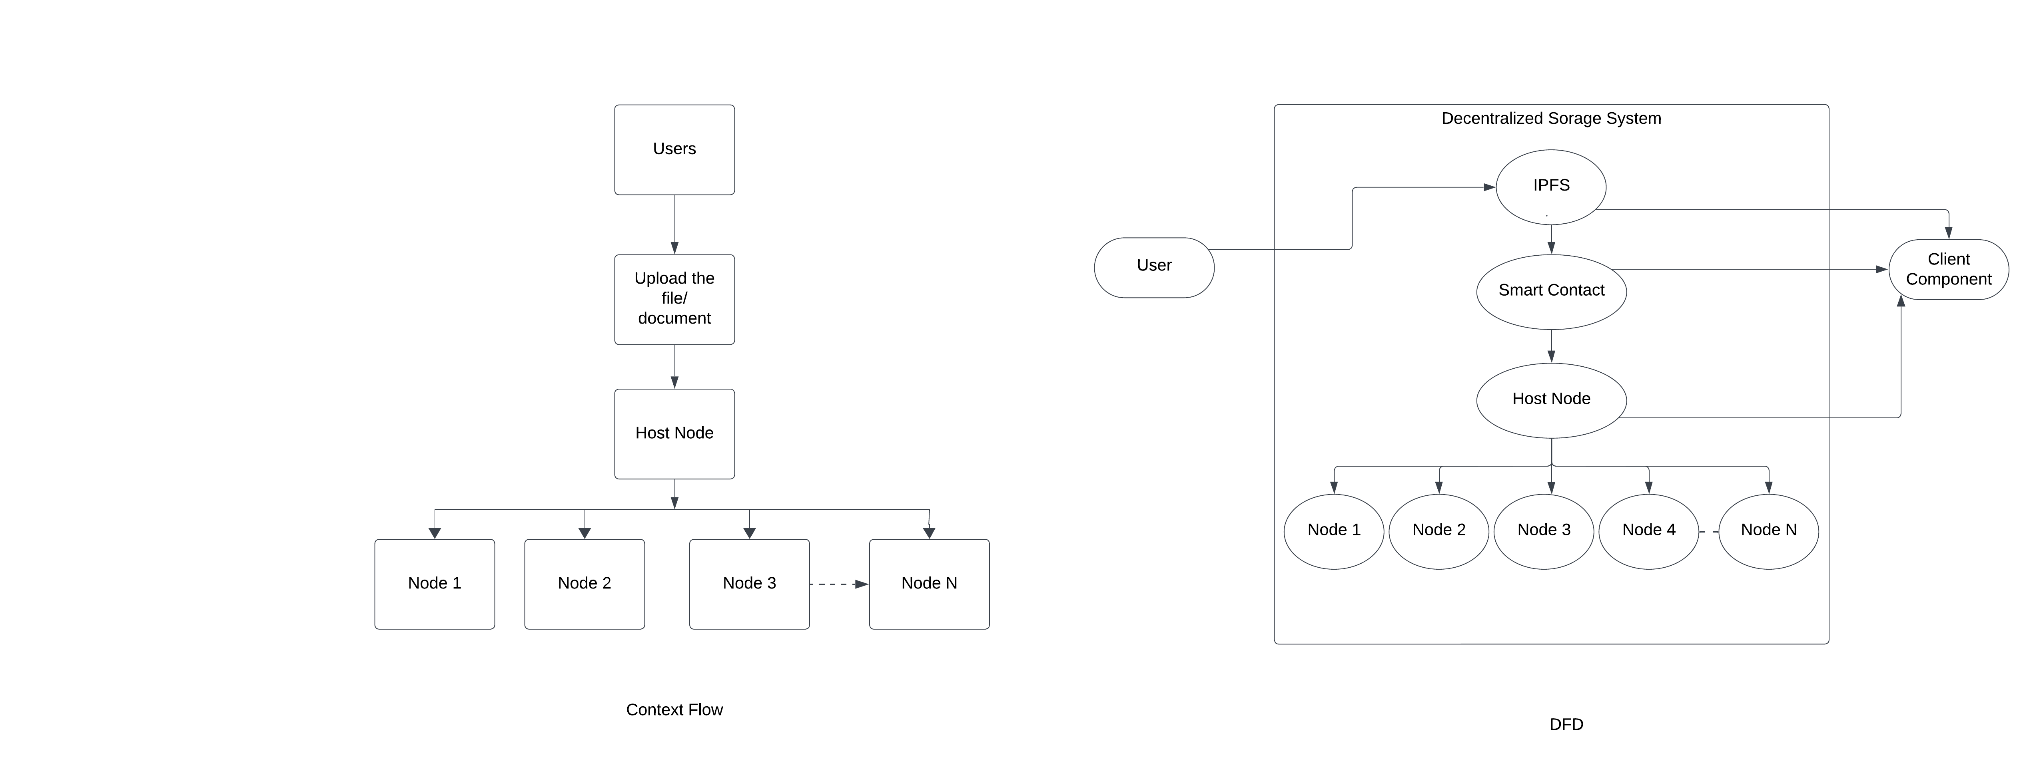

* 1. **DFD Diagram**



* 1. **Sequence Diagram**

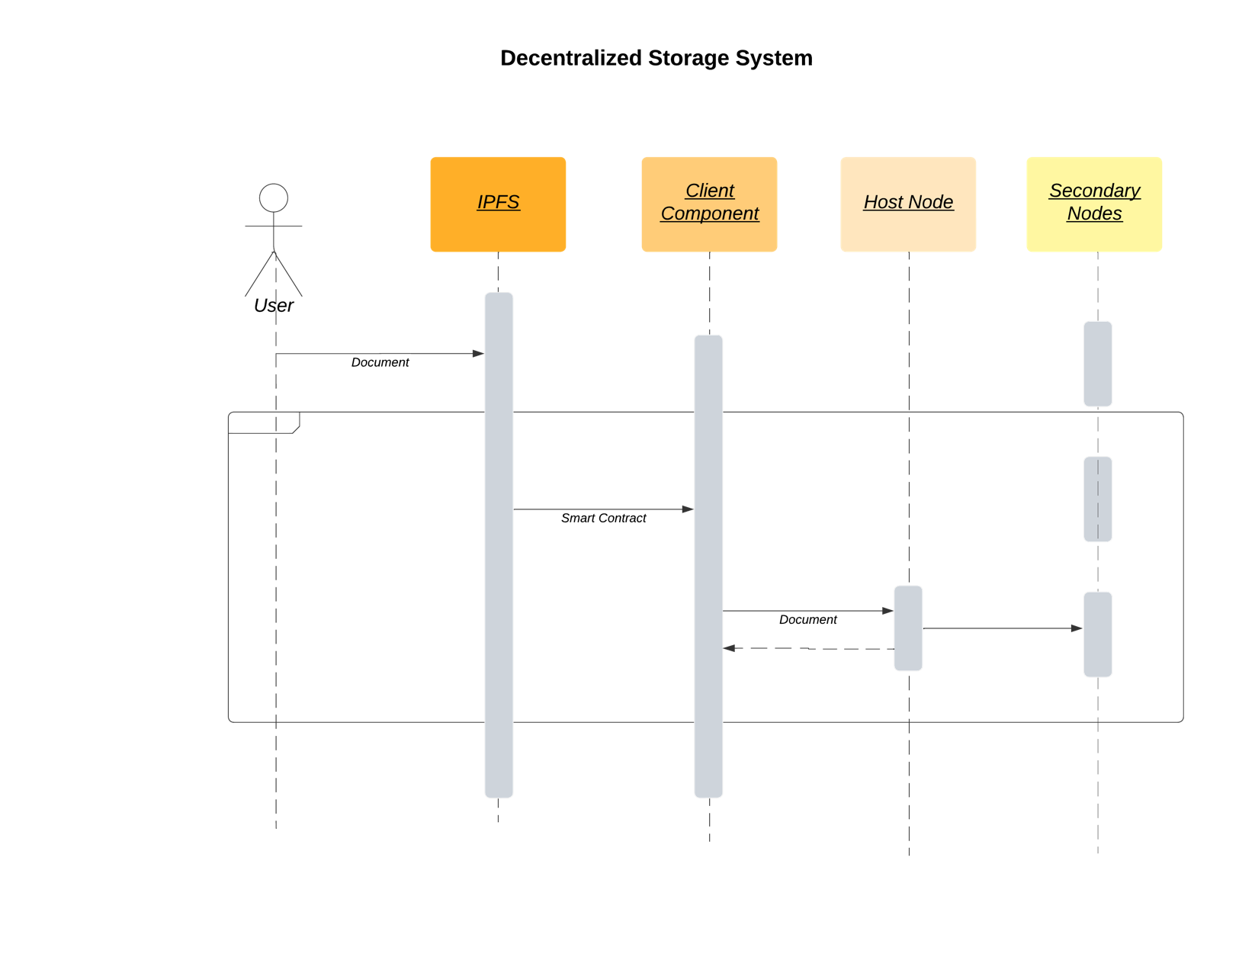

* 1. **Control Flow Diagram**

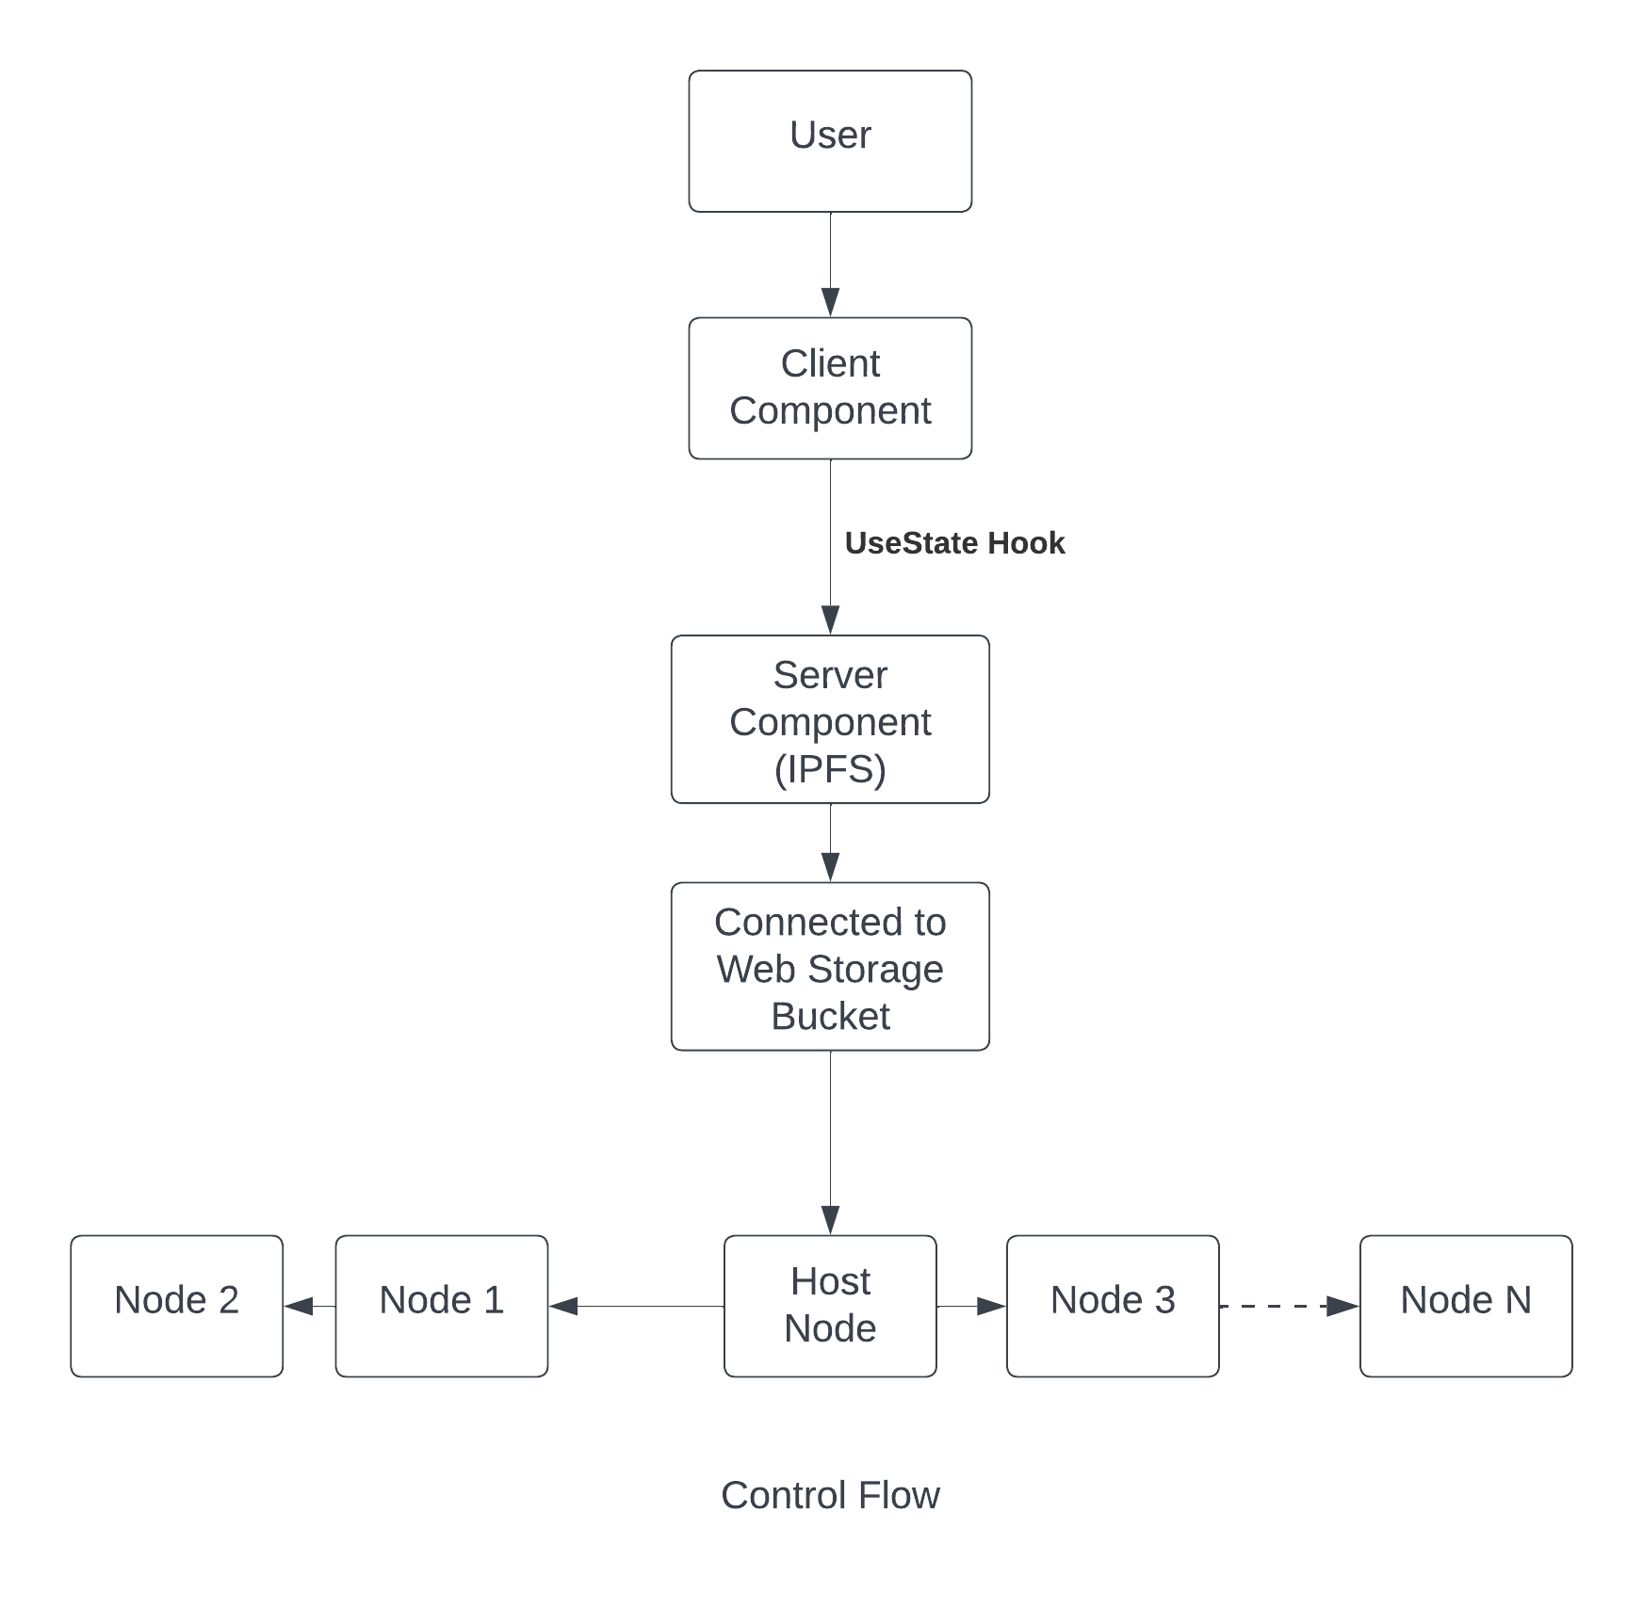

**Hardware/Software Interface**

* 1. **Hardware Requirements:**
     1. A Laptop/ Device
  2. **Software Requirements:**
     1. Web Browser.
     2. Internet Connection
  3. **Results Screenshots:**

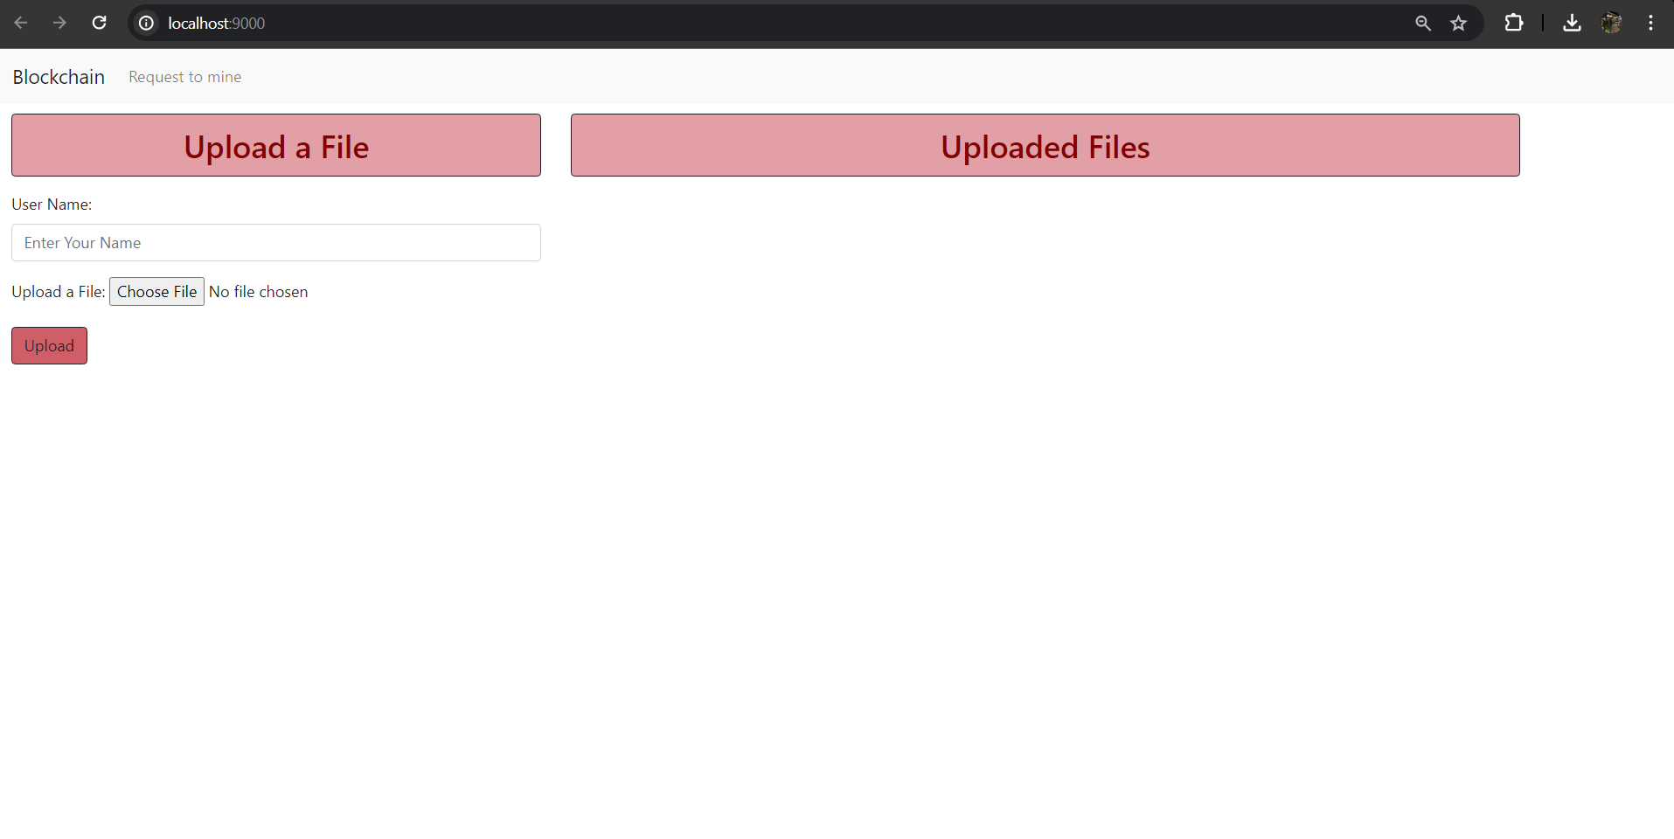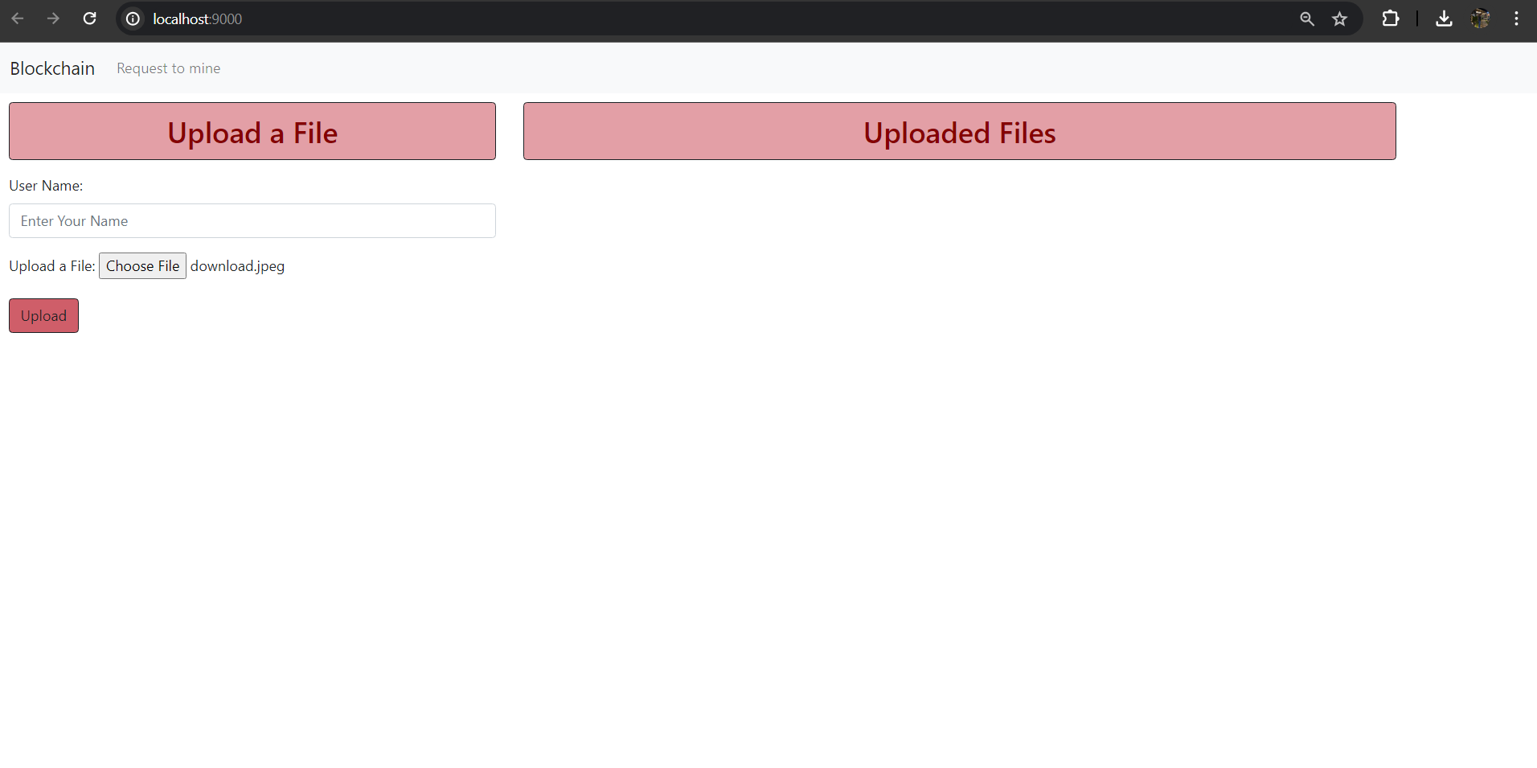

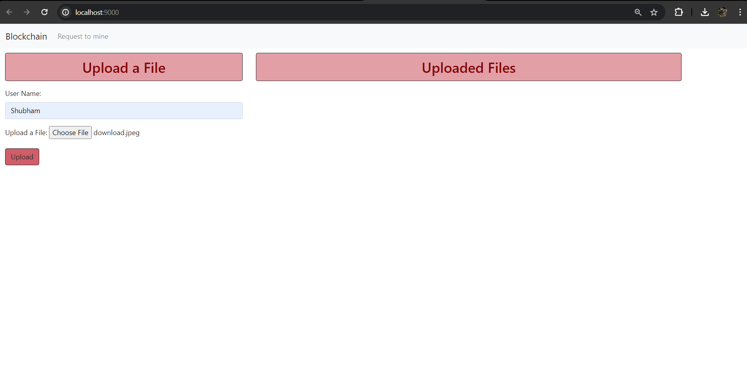

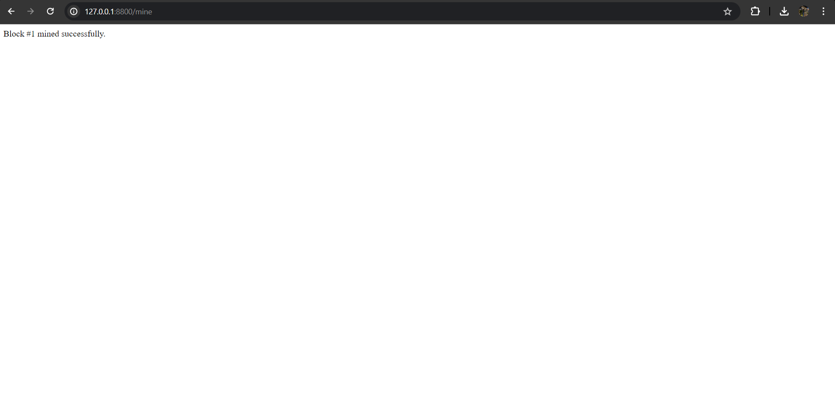

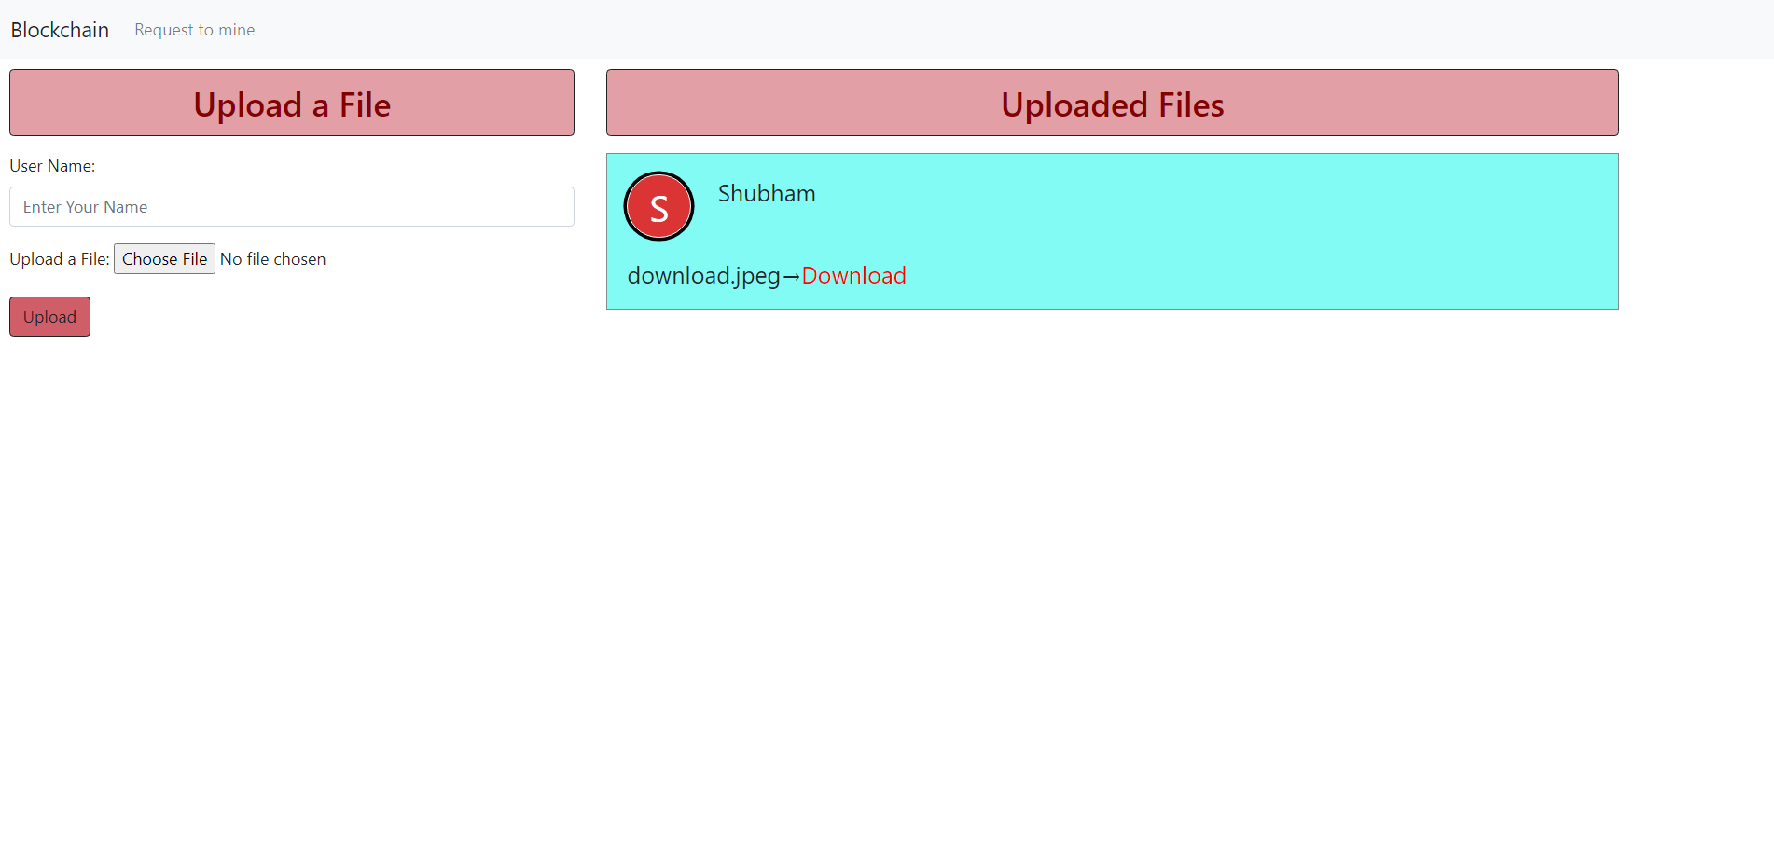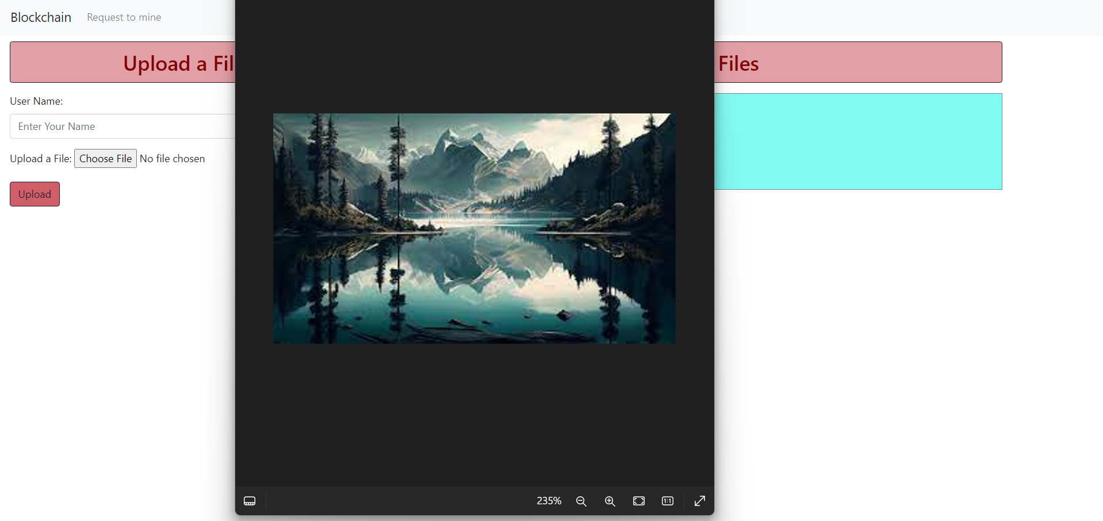

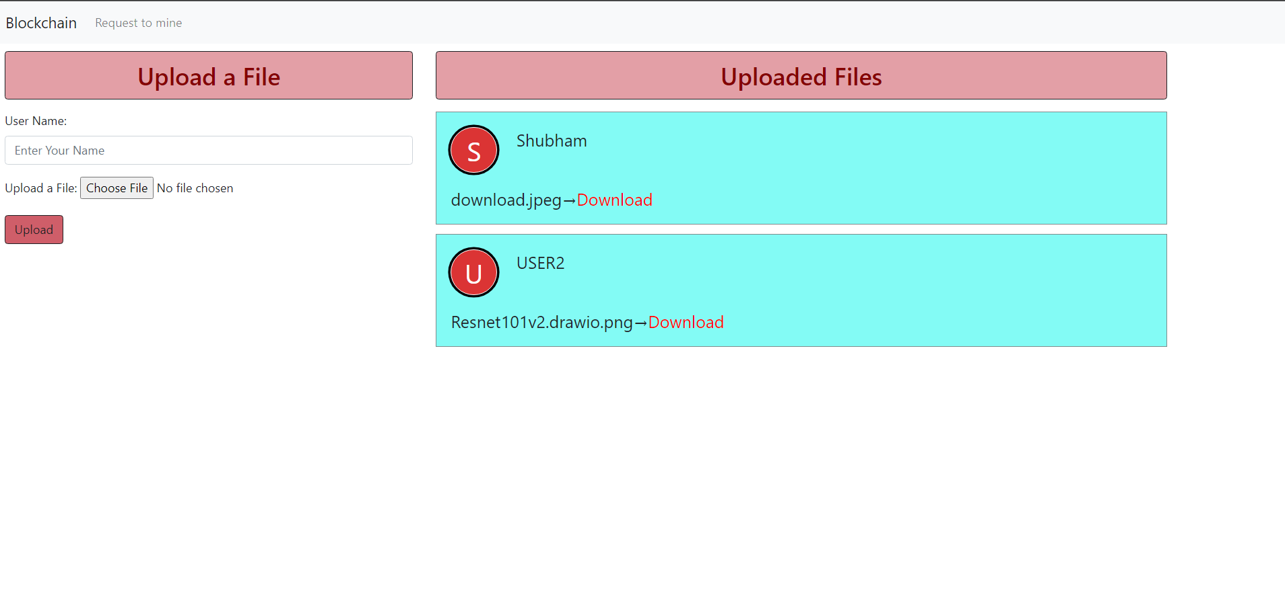

**Chapter 11**

**Gantt Chart**

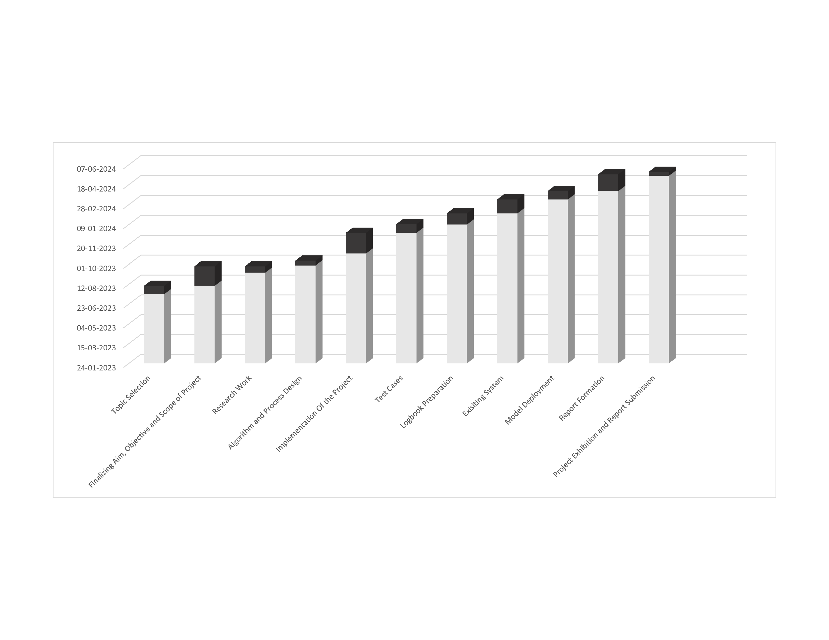

**Chapter 12**

**Conclusion:**

DeStorage aims to redefine the landscape of file storage by offering a decentralized, secure, and user-centric platform that addresses the shortcomings of traditional centralized storage systems. Through the integration of blockchain technology, InterPlanetary File System (IPFS), and innovative design principles, DeStorage embodies a paradigm shift towards a more resilient, transparent, and accessible storage infrastructure. By prioritizing performance, usability, and reliability, DeStorage strives to deliver a seamless user experience that empowers individuals and organizations to securely store, manage, and access their digital assets. Through its intuitive user interface, robust security measures, and commitment to scalability and fault tolerance, DeStorage sets a new standard for decentralized file storage solutions. In conclusion, DeStorage represents a transformative step towards a future where data sovereignty, privacy, and integrity are upheld, and users are empowered with greater control over their digital identities. With its innovative approach and unwavering dedication to user satisfaction, DeStorage is poised to revolutionize the way we store and interact with digital information in the decentralized era.

**ACKNOWLEGMENT**

We owe sincere thanks to our college Atharva College of Engineering for giving us a platform to prepare a project on the topic “**DeStorage System IPFS**” and would like to thank our Principal Dr. **Ramesh Kulkarni** for instigating within us the need for this research and giving us the opportunities and time to conduct and present research on the topic. We are sincerely grateful for having Dr. **Ulhaskumar Gokhale**, Head of Department of Information Technology and **Prof Pranoti Nage** as our guide, for their encouragement, constant support and valuable suggestions. Moreover, the completion of this research would have been impossible without the cooperation, suggestions and help of our friends and family.

**References:**

**[1] Smita Shinde, D-Drive: Decentralized Storage Space using Blockchain and IPFS Protocol, IJRASET, 2023.**

**[2] G. Richa Shalom, Decentralized Cloud Storage Using Blockchain, IJRASET, 2022.**

**[3] Ms. Kritika, Centralize storage system with encryption vs decentralize storage system, ICCIDS, 2022.**

**[4] Lu Meng, Research on Decentralized Storage Based on a Blockchain, Sustainability, 2022.**