PROJECT REPORT
Credit Card Customer Churn Prediction
Using Machine Learning
A Machine Learning Project Report

Domain | Data Science / Machine Learning
Dataset | Kaggle BankChurners (Credit Card Customers)
Records | 10,127 customers, 23 original attributes
Target Variable | Attrition_Flag (Existing / Attrited Customer)
Best Model | Gradient Boosting Classifier
Tools | Python, Scikit-learn, Pandas, NumPy, Matplotlib
Platform | Google Colab

1. Executive Summary
This project develops a machine learning solution to predict customer churn (attrition) for a credit card business, using the publicly available Kaggle BankChurners (Credit Card Customers) dataset. The dataset contains 10,127 customer records with 23 original attributes, of which 16.07% of customers had churned (Attrited Customer) at the time the data was collected.
Three classification models were trained and evaluated — Logistic Regression, Random Forest, and Gradient Boosting — using a structured pipeline covering data cleaning, feature engineering, preprocessing, and 5-fold stratified cross-validation. The Gradient Boosting classifier delivered the strongest performance on the held-out test set, achieving 96.45% accuracy, 95.02% precision, 82.15% recall, an F1-score of 88.12%, and a ROC-AUC of 99.10%.
Beyond model performance, the project identifies the transaction-related behavior of customers — particularly total transaction count, revolving balance, and total transaction amount — as the strongest predictors of churn, offering actionable insight for a targeted customer-retention strategy. A working prediction demonstration confirms the model's ability to distinguish low-risk from high-risk customers with a clear probability margin.

2. Introduction / Task Overview
Customer attrition, or churn, is one of the most pressing challenges faced by banks and financial institutions offering credit card services. Acquiring a new customer is significantly more expensive than retaining an existing one, which makes early identification of at-risk customers a high-value business capability.
This project frames churn prediction as a binary classification task: given a customer's demographic, account, and transaction-behavior attributes, predict whether that customer is likely to remain an Existing Customer or become an Attrited Customer. The task was carried out as a complete, end-to-end machine learning workflow — from raw data inspection through to model deployment-style prediction on new customer records.

3. Objectives
- Analyze the BankChurners dataset to understand customer demographics, account characteristics, and transaction behavior patterns.
- Engineer meaningful behavioral features that improve the predictive signal available to the models.
- Build and compare multiple machine learning classifiers for churn prediction.
- Evaluate model performance using metrics appropriate for an imbalanced classification problem (precision, recall, F1-score, ROC-AUC), not accuracy alone.
- Interpret the best-performing model to identify the key drivers of customer churn.
- Demonstrate the model's practical use by predicting churn risk for individual sample customers.

4. Business Problem
Credit card issuers lose recurring interest, fee, and transaction revenue whenever a customer closes or stops using their account. Retention teams typically have limited resources, so blanket retention campaigns targeting the entire customer base are inefficient and costly.
The core business problem addressed by this project is: how can the bank identify, in advance, which customers are at meaningful risk of attrition, so retention efforts (offers, outreach, relationship management) can be prioritized toward the customers most likely to leave, and away from customers who are not at risk?
Note: A reliable churn-probability score allows the business to rank customers by risk and allocate retention budget accordingly, rather than treating all customers uniformly.

5. Dataset Description
The project uses the BankChurners dataset (Credit Card Customers), sourced from Kaggle. It contains anonymized customer-level records combining demographic information, account attributes, and card-usage behavior.

5.1 Dataset Overview
Attribute | Value
Source | Kaggle — BankChurners / Credit Card Customers dataset
Total Records | 10,127
Original Columns | 23
Target Variable | Attrition_Flag
Target Classes | Existing Customer, Attrited Customer
Identifier Column | CLIENTNUM (removed prior to modeling)

5.2 Target Class Distribution
The dataset is notably imbalanced, with the majority of customers belonging to the Existing Customer class:
Class | Count | Percentage
Existing Customer | 8,500 | 83.93%
Attrited Customer | 1,627 | 16.07%

Because of this imbalance, accuracy alone is an insufficient evaluation metric; precision, recall, F1-score, and ROC-AUC were used to assess how well each model identifies the minority (Attrited) class, which is the class of primary business interest.

6. Methodology
The project followed a standard, structured machine learning pipeline, illustrated below and detailed in the sections that follow.
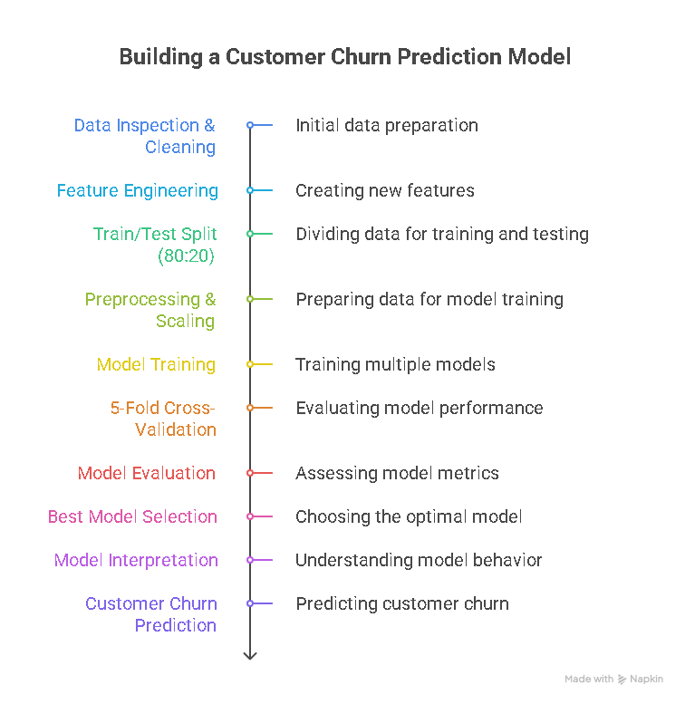
Figure 1. Overall workflow from raw dataset to churn prediction output.

7. Data Preprocessing
Before model training, the raw dataset was cleaned and prepared through the following steps:
- The CLIENTNUM column was removed, as it is a unique customer identifier with no predictive value.
- Two Naive Bayes classifier columns included in the original dataset were removed to prevent target leakage, since these columns were themselves derived from the target variable.
- The target variable was label-encoded: Existing Customer = 0, Attrited Customer = 1.
- The dataset contained no actual missing (NaN) values.
- "Unknown" values present in some categorical columns were retained as a valid category rather than being imputed, as they may carry information about non-disclosure behavior.
- Categorical features were encoded using OneHotEncoder.
- Numerical features were standardized using StandardScaler.
- All preprocessing steps were implemented using a Scikit-learn Pipeline combined with a ColumnTransformer, ensuring consistent, leak-free transformation of training and test data.

8. Feature Engineering
Two derived features were engineered from existing transaction attributes to better capture customer spending behavior:
Engineered Feature | Formula | Rationale
Avg_Transaction_Amount | Total_Trans_Amt / Total_Trans_Ct | Captures average spend per transaction
Transaction_Activity | Total_Trans_Ct / Months_on_book | Captures transaction frequency relative to tenure

After feature engineering, the dataset used for modeling consisted of 21 input features.

9. Train/Test Split
The dataset was split into training and testing sets using an 80:20 stratified split, preserving the original class ratio in both subsets. A fixed random_state of 42 was used to ensure reproducibility.

Subset | Records | Proportion
Training Set | 8,101 | 80%
Testing Set | 2,026 | 20%

10. Machine Learning Models
Three classification algorithms, representing a range of model complexity, were trained and compared:
- Logistic Regression — a linear baseline model, useful for interpretability.
- Random Forest — a bagging-based ensemble of decision trees.
- Gradient Boosting — a boosting-based ensemble that builds trees sequentially to correct prior errors.
All three models were trained on the preprocessed training set and validated using 5-fold stratified cross-validation to obtain a robust estimate of generalization performance prior to final evaluation on the held-out test set.

11. Model Evaluation
The three models were evaluated on the held-out test set (2,026 records) using accuracy, precision, recall, F1-score, and ROC-AUC. Note that the 99.10% figure for Gradient Boosting refers to ROC-AUC, not accuracy.
Model | Accuracy | Precision | Recall | F1-Score | ROC-AUC
Gradient Boosting | 96.45% | 95.02% | 82.15% | 88.12% | 99.10%
Random Forest | 95.51% | 95.00% | 76.00% | 84.44% | 98.87%
Logistic Regression | 91.46% | 81.67% | 60.31% | 69.38% | 93.18%

Gradient Boosting was selected as the best-performing model. It achieved the highest scores across every metric, most notably recall (82.15%) and ROC-AUC (99.10%), indicating a strong ability to correctly identify customers who are actually going to churn while maintaining high precision.

12. Confusion Matrix Analysis
Confusion matrices for all three models on the test set (2,026 records) are summarized below (rows = actual class, columns = predicted class).

12.1 Logistic Regression
Actual \ Predicted | Predicted Existing | Predicted Attrited
Actual Existing | 1,657 | 44
Actual Attrited | 129 | 196

12.2 Random Forest
Actual \ Predicted | Predicted Existing | Predicted Attrited
Actual Existing | 1,688 | 13
Actual Attrited | 78 | 247

12.3 Gradient Boosting
Actual \ Predicted | Predicted Existing | Predicted Attrited
Actual Existing | 1,687 | 14
Actual Attrited | 58 | 267

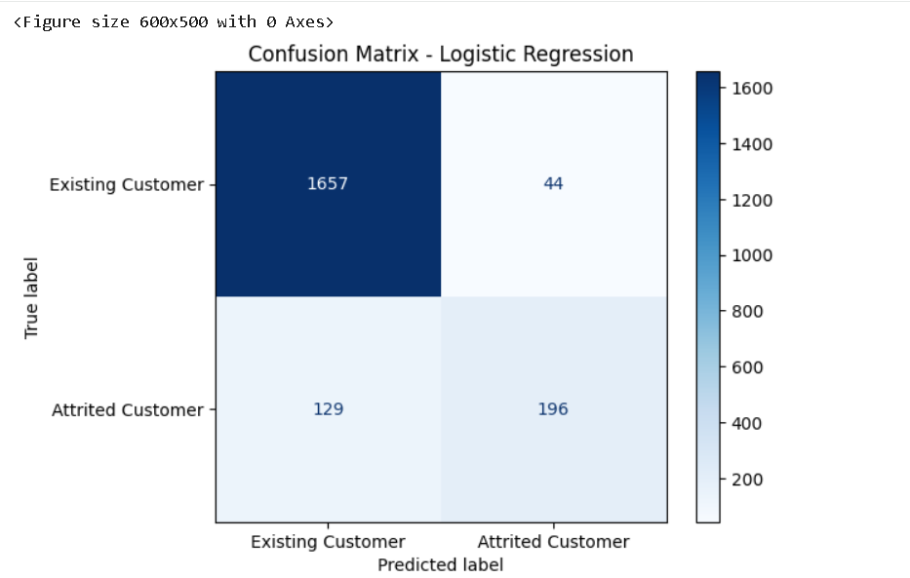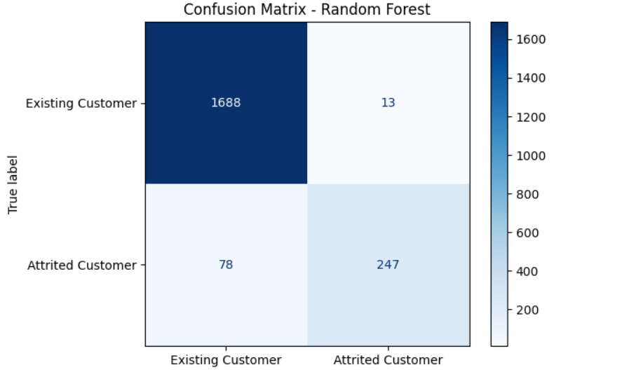

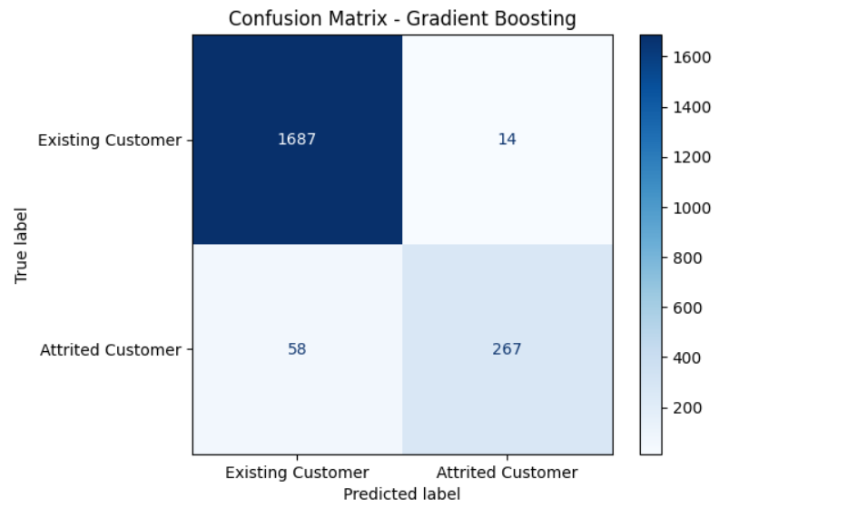
Figure 2. Side-by-side confusion matrix heatmaps for Logistic Regression, Random Forest, and Gradient Boosting.
Gradient Boosting recorded the lowest number of false negatives (58) among all three models — i.e., customers who actually churned but were predicted as remaining. From a business standpoint, false negatives are the more costly error type, since they represent churned customers who were never flagged for retention outreach. Gradient Boosting's low false-negative count directly supports its selection as the best-performing model for this task.

13. ROC Curve / ROC-AUC
The Receiver Operating Characteristic (ROC) curve plots the true positive rate against the false positive rate across classification thresholds, and the Area Under the Curve (ROC-AUC) summarizes overall separability between the two classes.
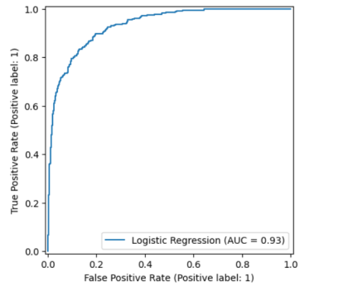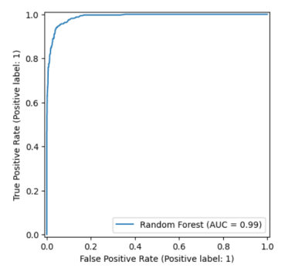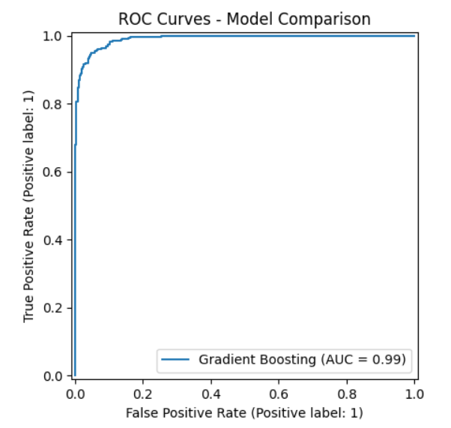
Figure 3. ROC curves for Logistic Regression, Random Forest, and Gradient Boosting.

Model | ROC-AUC
Gradient Boosting | 99.10%
Random Forest | 98.87%
Logistic Regression | 93.18%

Gradient Boosting's ROC-AUC of 99.10% indicates near-optimal separation between customers who churn and customers who remain, meaning the model's predicted probabilities rank at-risk customers reliably across almost the entire range of decision thresholds.

14. Feature Importance
Feature importances were extracted from the trained Gradient Boosting model to understand which attributes contributed most to its predictions.
Rank | Feature | Importance
1 | Total_Trans_Ct | 0.303007
2 | Total_Revolving_Bal | 0.187543
3 | Total_Trans_Amt | 0.175085
4 | Total_Ct_Chng_Q4_Q1 | 0.096195
5 | Total_Relationship_Count | 0.094218
6 | Total_Amt_Chng_Q4_Q1 | 0.036924
7 | Avg_Transaction_Amount | 0.036214
8 | Transaction_Activity | 0.020116
9 | Contacts_Count_12_mon | 0.016847
10 | Months_Inactive_12_mon | 0.012351

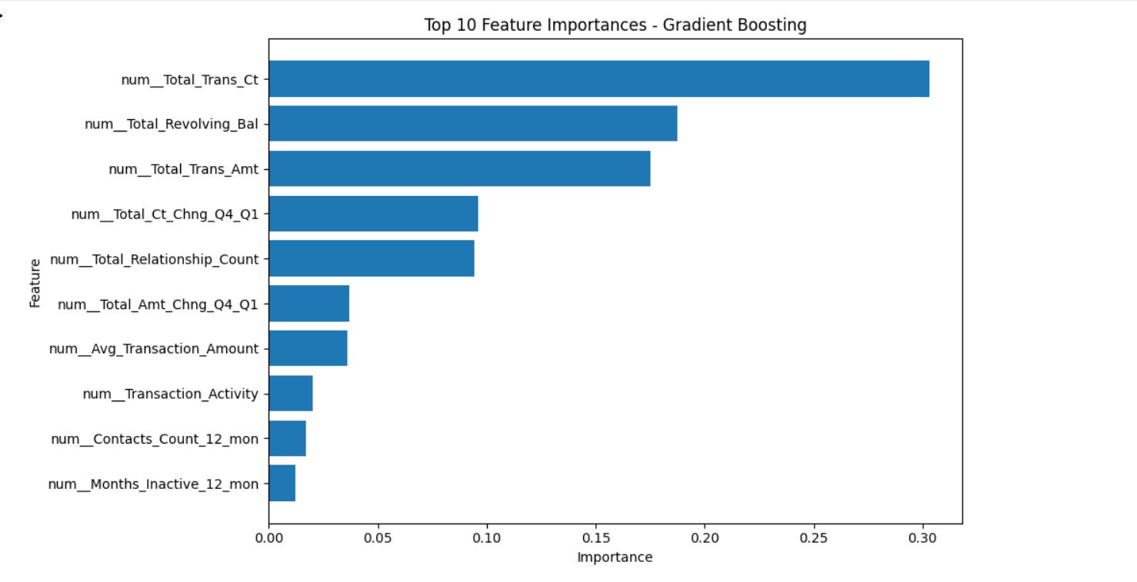
Figure 4. Top 10 features ranked by importance in the Gradient Boosting model.
Total transaction count, total revolving balance, and total transaction amount emerged as the three most influential features, together accounting for the majority of the model's total feature importance. This aligns with the intuitive expectation that reduced card usage and activity precede attrition.
Note: Feature importance reflects each variable's contribution to the model's predictions and does not imply a causal relationship between that variable and customer churn.

15. Customer Prediction Demonstration
To demonstrate the trained Gradient Boosting model in a practical setting, predictions were generated for two representative customer profiles — a low-risk customer and a high-risk customer.
Attribute | Low-Risk Customer | High-Risk Customer
Predicted Class | Existing Customer | Attrited Customer
Churn Probability | 0.71% | 91.53%
Retention Probability | 99.29% | 8.47%

In practical business terms, the low-risk customer's churn probability of 0.71% indicates that no retention intervention is currently warranted; resources are better directed elsewhere. In contrast, the high-risk customer's churn probability of 91.53% would trigger a high-priority alert in a retention workflow — this customer would typically be flagged for proactive outreach, a loyalty offer, or a relationship-manager check-in before they close their account. This kind of individual-level probability score is what allows the business to move from broad, untargeted retention campaigns to a ranked, prioritized retention strategy.

16. Technologies Used
Category | Technology
Programming Language | Python
Data Handling | Pandas, NumPy
Machine Learning | Scikit-learn
Visualization | Matplotlib
Development Environment | Google Colab
Dataset Source | Kaggle
Version Control | Git, GitHub

17. Results & Outcome
The project successfully delivered a working churn-prediction pipeline, with the Gradient Boosting classifier as the final selected model. Key outcomes include:
- Test-set accuracy of 96.45%, with a ROC-AUC of 99.10%, indicating strong overall discriminative performance.
- Precision of 95.02%, meaning the large majority of customers flagged as at-risk were genuinely churn cases.
- Recall of 82.15%, meaning the model correctly identified over four out of every five customers who actually churned.
- The lowest false-negative count (58) among all three models tested, minimizing missed at-risk customers.
- A clear, interpretable ranking of the behavioral drivers of churn, led by transaction count and revolving balance.

18. Business Insights
Several actionable insights emerge from the model's results and feature analysis:
- Declining transaction activity is the single strongest early warning sign of churn, suggesting that usage-monitoring alerts could form the basis of an early-intervention system.
- Revolving balance and total transaction amount are strong secondary indicators, pointing to overall account engagement as a key retention lever.
- Customers with fewer relationships/products with the bank (Total_Relationship_Count) appear more likely to churn, suggesting cross-sell of additional products may improve retention.
- Because the model outputs a calibrated churn probability rather than a binary label alone, the business can set risk-based thresholds — for example, prioritizing outreach only for customers above a chosen probability cutoff.

19. Challenges & Solutions
Challenge | Solution Applied
Class imbalance (83.93% vs 16.07%) | Used stratified train/test split and cross-validation, and evaluated models with precision, recall, F1-score, and ROC-AUC rather than accuracy alone.
Risk of target leakage from pre-existing Naive Bayes classifier columns | Identified and removed both leakage-prone columns before model training.
Mixed categorical and numerical feature types | Built a unified Scikit-learn Pipeline with a ColumnTransformer applying OneHotEncoder and StandardScaler appropriately.
"Unknown" categorical values | Retained as a distinct category instead of imputing, preserving potentially meaningful information.

20. Limitations
- The dataset is a static snapshot; it does not capture how customer behavior changes over time, which could improve early-warning capability.
- The dataset originates from a single anonymized source and geographic/institutional context, which may limit generalizability to other banks or regions.
- Feature importance reflects correlation-based contribution to the model and should not be interpreted as a causal explanation of why customers churn.
- The class imbalance, while addressed through appropriate metrics, means that even a well-performing model will occasionally misclassify minority-class (Attrited) customers.

21. Conclusion
This project demonstrates a complete, structured machine learning workflow for predicting credit card customer churn, from raw data through to an interpretable, evaluated, and demonstrated final model. Among the three models tested, Gradient Boosting was clearly the strongest performer, combining high accuracy, high precision, and the best balance of recall and false-negative minimization, backed by a ROC-AUC of 99.10%.
The resulting model is not only accurate but also interpretable and business-relevant: it identifies the specific behavioral signals — transaction count, revolving balance, and transaction amount — that most strongly precede churn, and it produces individual customer-level probabilities that can directly support a prioritized retention strategy.

22. Learning Outcomes
- Practical experience building an end-to-end supervised machine learning pipeline using Scikit-learn Pipelines and ColumnTransformer.
- Understanding of the risks of target leakage and how to identify and remove leakage-prone features.
- Hands-on application of feature engineering to derive behaviorally meaningful predictors from raw transaction data.
- Experience evaluating classification models on imbalanced datasets using precision, recall, F1-score, and ROC-AUC.
- Ability to interpret model outputs (feature importance, confusion matrices, ROC curves) in a business context rather than purely a technical one.

23. References
- Kaggle — BankChurners / Credit Card Customers Dataset.
- Scikit-learn Documentation — https://scikit-learn.org/
- Pandas Documentation — https://pandas.pydata.org/
- NumPy Documentation — https://numpy.org/
- Matplotlib Documentation — https://matplotlib.org/
- Google Colaboratory — https://colab.research.google.com/

