StudySwap

Name:- Shravani Balasaheb Kurkute
E-Mail :- shravani.22311926@viit.ac.in
Phone no. :- 7741032060
Address :- RX-3/8, Room no. 10, near jagrut hanuman mandir bajajnagar sambhajinagar
pin code – 431136

Name:- Yash Satyavijay Baraskar
E-Mail:- yash.22310284@viit.ac.in
Phone no. :- 9834578796
Address:- B-448, Karnik Nagar, Behind Walchand College, Solapur.
Pin Code- 413006

Title: StudySwap: Peer-to-Peer Study Material Exchange Platform

- Abstract:
In today’s interconnected educational landscape, collaboration and shared resources play a pivotal role in enhancing academic success. StudySwap is a pioneering online marketplace that connects students, and have been built specifically to fill this need through transactions of academic materials. With the idea of similar user-friendliness as our other apps, it allows fellow students to easily upload, share and exchange a wide variety of study resources. Lecture notes, text books, practice exams, video tutorials etc. By dismantling access barriers to resources, especially for students from varying socio-economic groups, the platform aims to create a collaborative learning ecosystem. Through its community focused approach to education, StudySwap is designed to fill holes in the availability of learning resources, thereby retaining a need for every student to have the means through which they can excel academically. In this paper, we explore the overall technical architecture and describes the implement of crafting functionalities like secure file sharing, resource categorization and a recommendation engine that customized content recommendations for individual users. It also contains code snippets that show how the basic functionality operates, describes expected output for high level user based workflows, and discusses the advantages of using StudySwap in schools. A mixture of next-gen web coding, solid database logic and friendly design leads to paving the way for a new learning experience that is StudySwap. An education system untethered by access, and connected through collaboration and shared knowledge.
- Language:
- Programming Language: Python
- FrameWork: Flask (for backend development)
- Fronted: HTML5, CSS3, javascript (Utilizing Bootstrap for responsive design)
- Database: SQLite (or PostgreSQL for a more robust solution)
- Version Control: GIT (for source code management)
- Steps to run the code:
- Organize Project Files:
Create a folder for your project and structure it as follows:
/StudySwap
index.html // HTML file
images/ // Folder for image assets (e.g., 1.jpg, 2.jpg, 3.jpg)
dashboard.html // Target page for redirection

- Save the Files:
    - HTML File: Copy the provided HTML code and save it as index.html.
    - CSS Code: If using external styles, save the CSS code into a file named styles.css and link it in the <head> section of the HTML:
<link rel="stylesheet" href="styles.css">
    - Image Assets: Place the slider images (e.g., 1.jpg, 2.jpg, 3.jpg) in the images/ folder. Ensure the image paths in the HTML match the folder structure.

- Set up a Local Development Server:
You need a local server to view the website in the browser. You can use either of the following methods:
i) Option A: Using VS Code with Live Server:
1. Open the project folder in Visual Studio Code.
2. Install the Live Server extension from the VS Code Marketplace.
3. Right-click on index.html in the Explorer and select "Open with Live Server".
4. Your browser will open, displaying the page.

ii) Option B: Using Python:
1. Open a terminal/command prompt in the project folder.
2. Run the following command:
python -m http.server
3. Open a browser and go to http://localhost:8000 to view the page.

- Test the Features:
- Sign-Up From Modal:
Fill out the form with test data and click the submit button. The data should be logged in the browser's console.
- Close Button:
Ensure that the close button redirects to dashboard.html (or another specified page). Adjust the redirection path if needed in the JavaScript.

- Redirect to dashboard.html:
Upon form submission, the user should be redirected to dashboard.html with the form data passed as URL query parameters. Example:
dashboard.html?fullName=John+Doe&email=john@example.com
On the dashboard.html page, use JavaScript to retrieve and display the query parameters.

- Deploy the Project:
After testing, you can deploy your project to make it accessible online:
Use GitHub Pages: Upload your project to a GitHub repository and enable GitHub Pages in the repository settings.
Use platforms like Netlify or Vercel for easy drag-and-drop deployment.

- Complete Code:
Below is a sample code snippet demonstrating the user registration feature in StudySwap, showcasing best practices for handling user input and database interaction.
1. index.html:
This file will contain the main structure of your sign-up page, including the modal for the form.

<!DOCTYPE html>
<html lang="en">
<head>
<meta charset="UTF-8">
<meta name="viewport" content="width=device-width, initial-scale=1.0">
<title>Sign-Up Page</title>
<link rel="stylesheet" href="styles.css">
</head>
<body>
<header>
<h1>Welcome to StudySwap</h1>
</header>
<main>
<div class="container">
<button class="open-modal-btn">Sign-Up</button>
</div>
</main>

<!-- Modal for Sign-Up Form -->
<div class="modal" id="sign-up-modal">
<div class="modal-content">
<span class="close-btn">&times;</span>
<h2>Sign-Up Form</h2>
<form id="sign-up-form">
<label for="full-name">Full Name:</label>
<input type="text" id="full-name" name="full-name" required>

<label for="email">Email:</label>
<input type="email" id="email" name="email" required>

<label for="password">Password:</label>
<input type="password" id="password" name="password" required>

<button type="submit">Submit</button>
</form>
</div>
</div>

<script>
// Get modal and buttons
const modal = document.getElementById("sign-up-modal");
const openModalBtn = document.querySelector(".open-modal-btn");
const closeModalBtn = document.querySelector(".close-btn");
const form = document.getElementById("sign-up-form");

// Open Modal
openModalBtn.addEventListener("click", () => {
modal.style.display = "block";
});

// Close Modal
closeModalBtn.addEventListener("click", () => {
modal.style.display = "none";
});

// Handle form submission
form.addEventListener("submit", function (e) {
e.preventDefault();

const fullName = document.getElementById("full-name").value;
const email = document.getElementById("email").value;
const password = document.getElementById("password").value;

// Redirect to dashboard.html with query parameters
window.location.href = `dashboard.html?fullName=${encodeURIComponent(fullName)}&email=${encodeURIComponent(email)}&password=${encodeURIComponent(password)}`;
});
</script>
</body>
</html>

2. Styles.CSS:
This CSS file will style the modal, the button, and the page layout.
body, h1, h2 {
margin: 0;
padding: 0;
font-family: Arial, sans-serif;
}
body {
background-color: #f4f4f4;
}

header {
background-color: #333;
color: white;
text-align: center;
padding: 20px;
}
.container {
display: flex;
justify-content: center;
margin-top: 50px;
}
.open-modal-btn {
padding: 10px 20px;
background-color: #007BFF;
color: white;
border: none;
cursor: pointer;
font-size: 16px;
}
open-modal-btn:hover {
background-color: #0056b3;
}
.modal {
display: none;
position: fixed;
top: 0; left: 0; width: 100%; height: 100%;
background-color: rgba(0, 0, 0, 0.5);
justify-content: center;
align-items: center;
}
.modal-content {
background-color: white;
padding: 20px;
border-radius: 5px;
width: 300px;
position: relative;
text-align: center;
}
.close-btn {
position: absolute;
top: 10px; right: 10px;
font-size: 20px;
cursor: pointer;
}
form {
display: flex;
flex-direction: column;
}
3. Dashboard.html:
<!DOCTYPE html>
<html lang="en">
<head>
<meta charset="UTF-8">
<meta name="viewport" content="width=device-width, initial-scale=1.0">
<title>Dashboard</title>
<link rel="stylesheet" href="styles.css">
</head>
<body>
<header>
<h1>Welcome to Your Dashboard</h1>
</header>
<main>
<div class="container">
<h2>User Information</h2>
<p><strong>Full Name:</strong> <span id="full-name"></span></p>
<p><strong>Email:</strong> <span id="email"></span></p>
<p><strong>Password:</strong> <span id="password"></span></p>
</div>
</main>
<script>
// Get query parameters from the URL
const urlParams = new URLSearchParams(window.location.search);
const fullName = urlParams.get('fullName');
const email = urlParams.get('email');
const password = urlParams.get('password');
// Display the user data on the page
document.getElementById("full-name").textContent = fullName;
document.getElementById("email").textContent = email;
document.getElementById("password").textContent = password;
</script>
</body>
</html>

- Output :

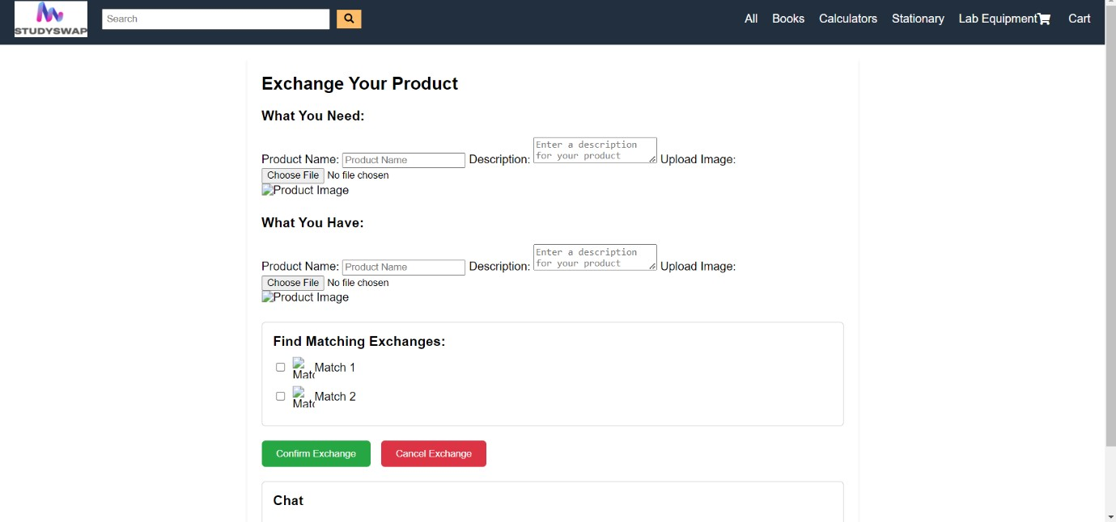
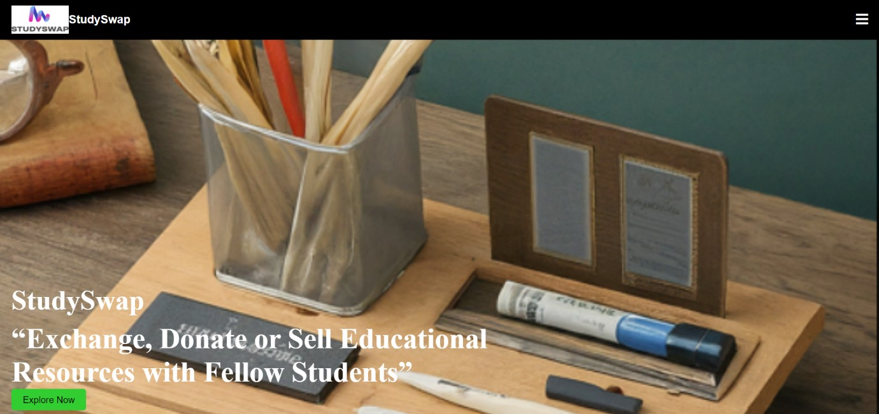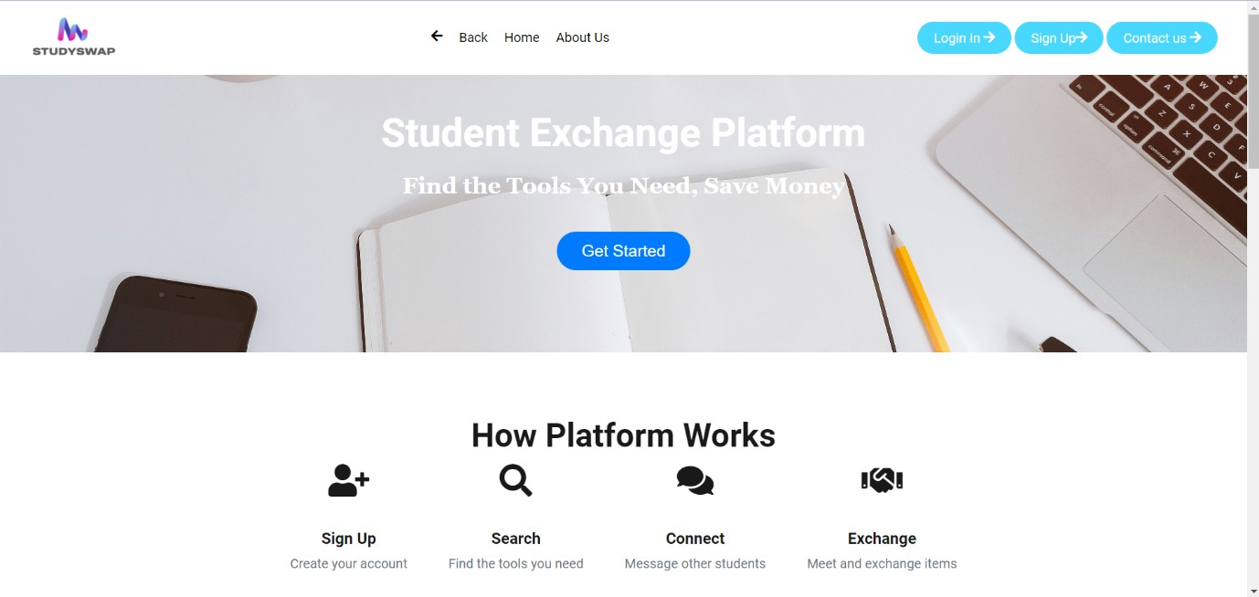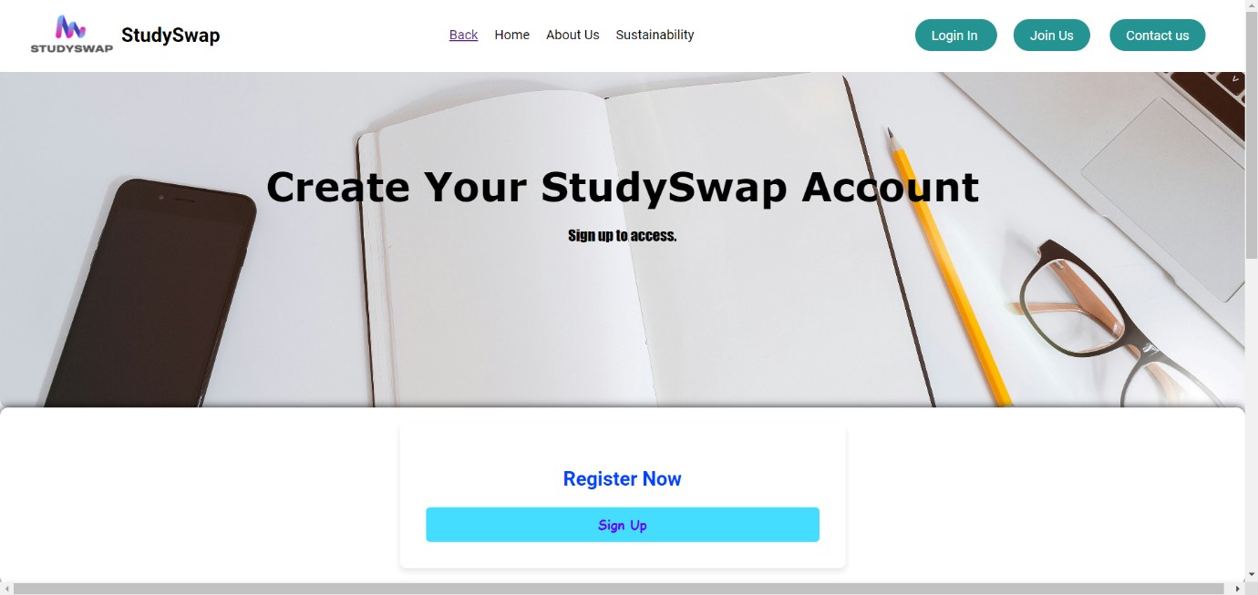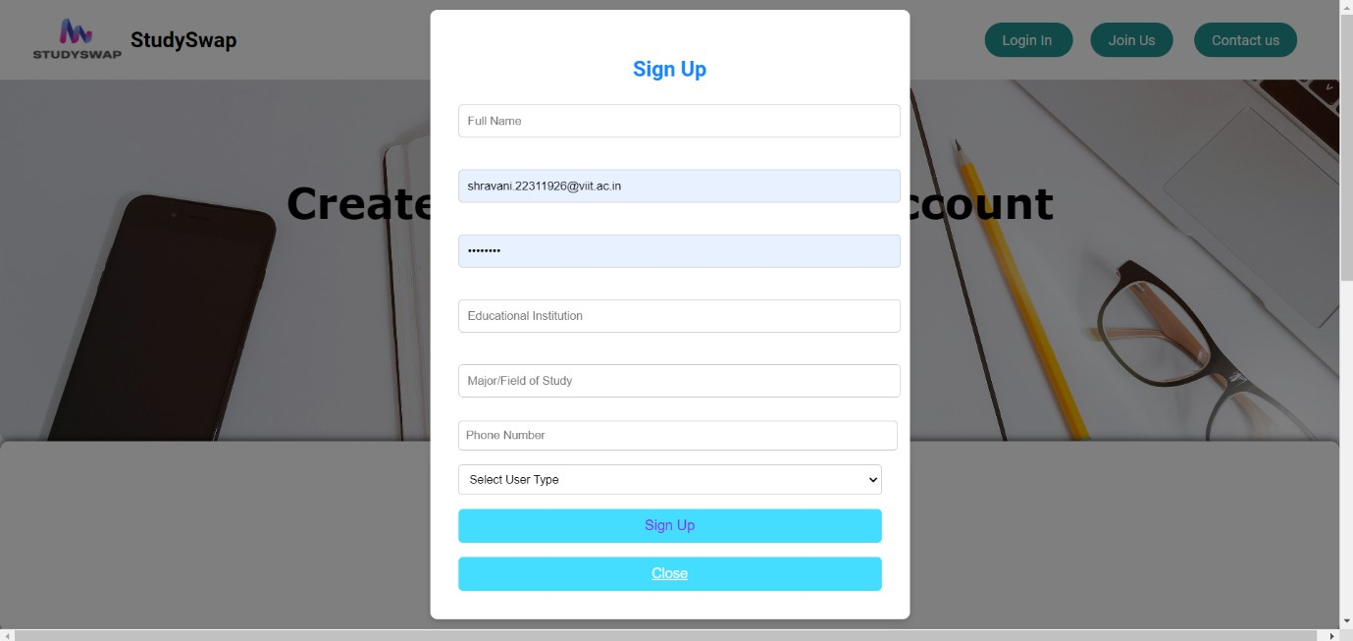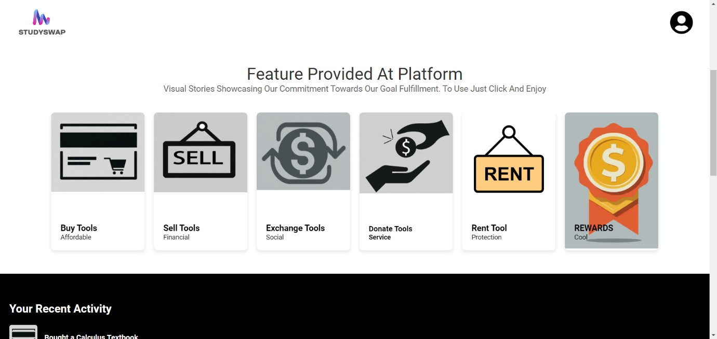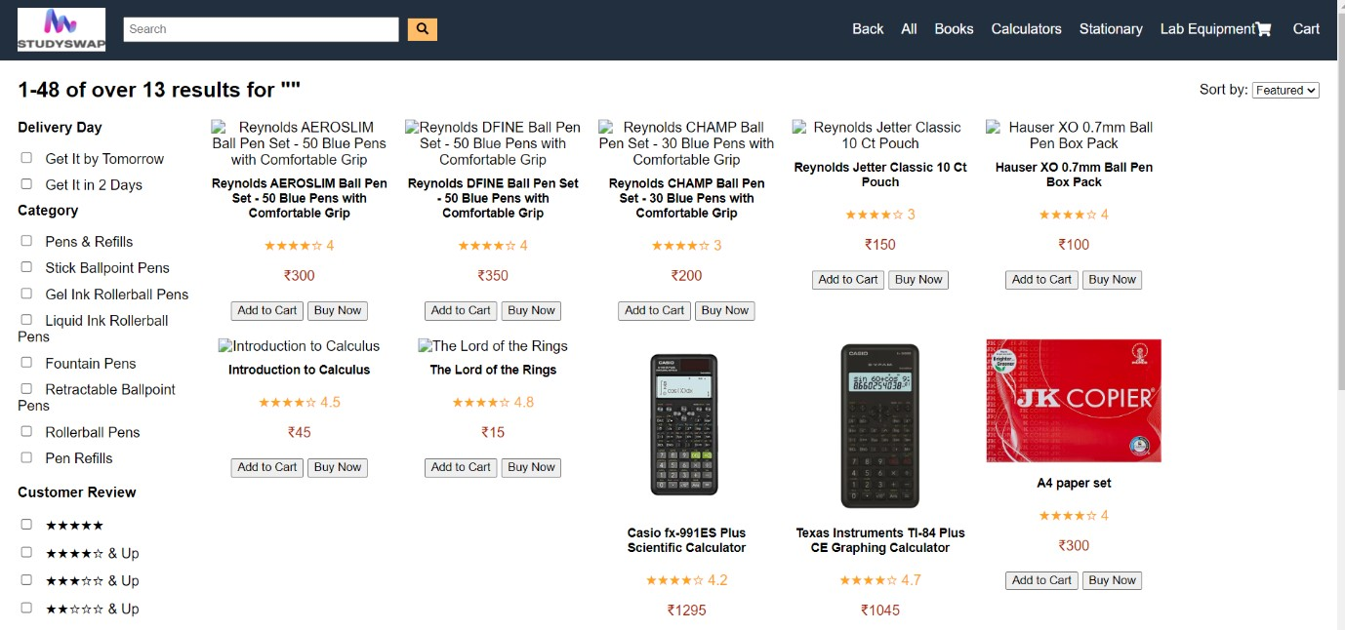

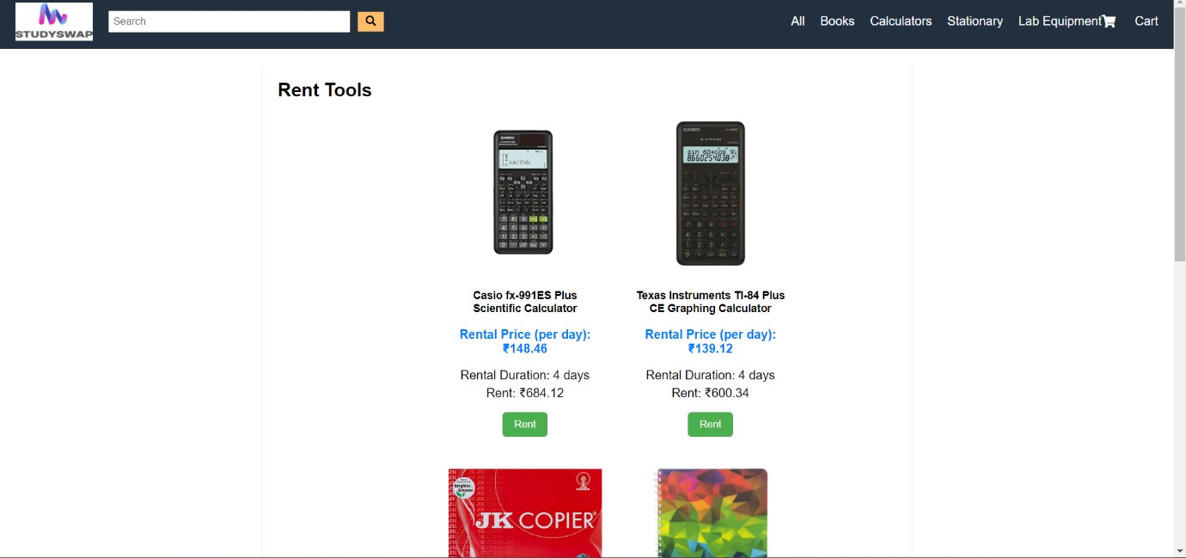
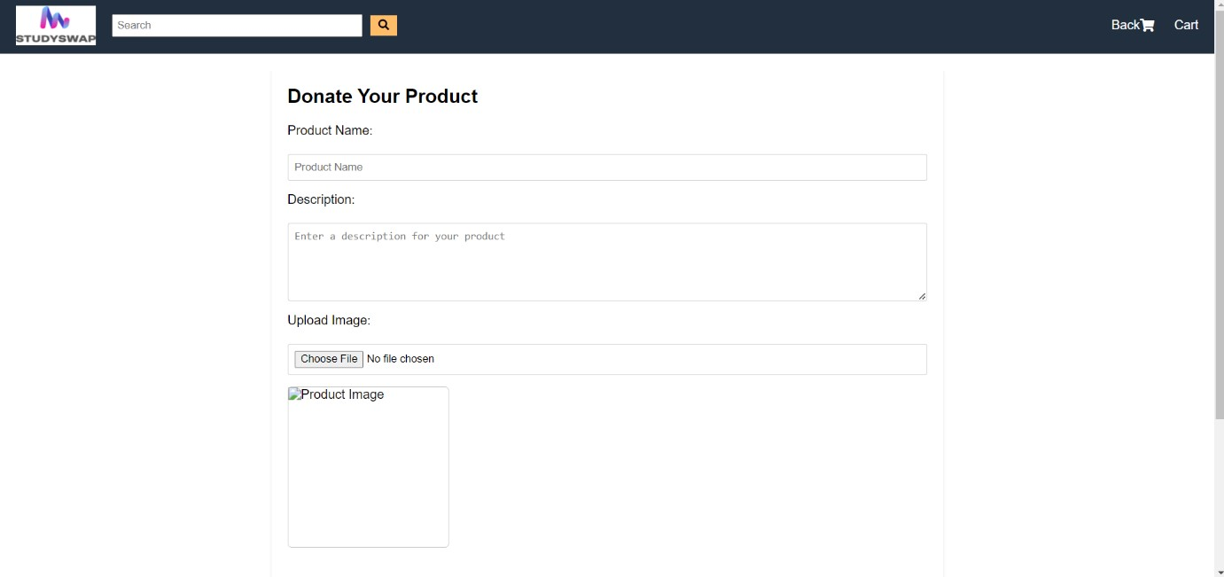
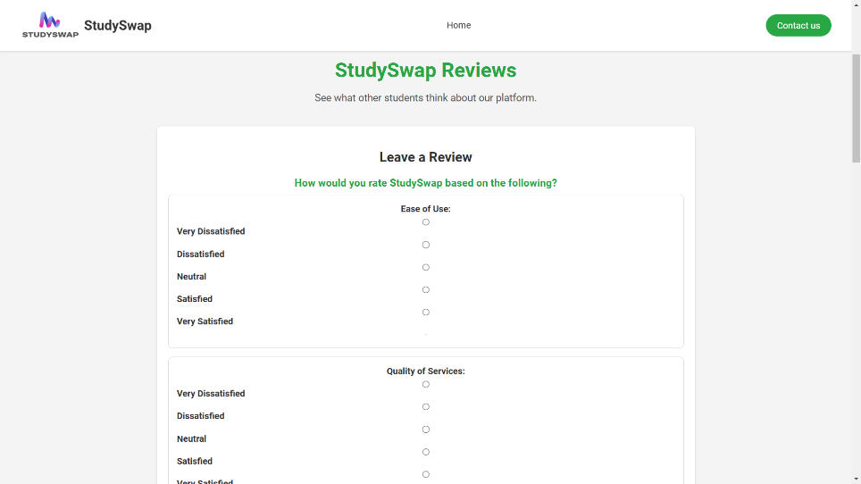
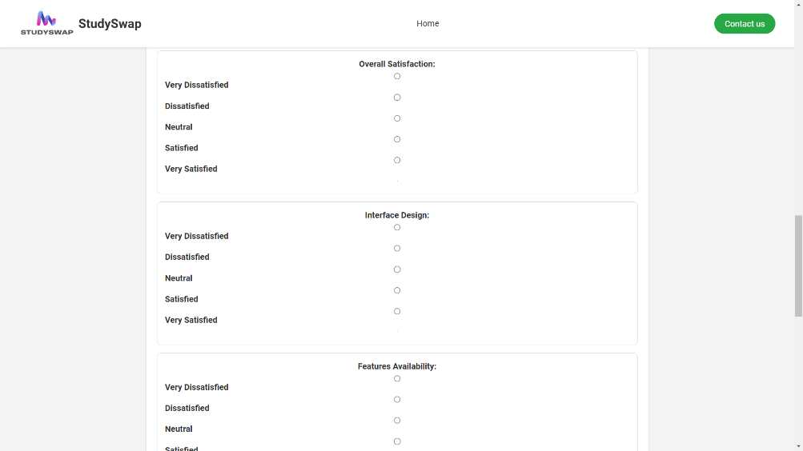
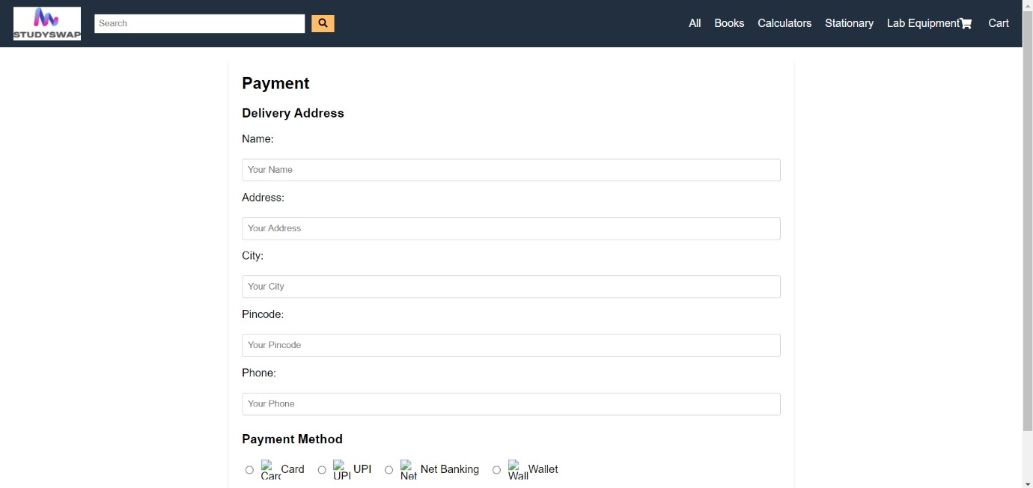
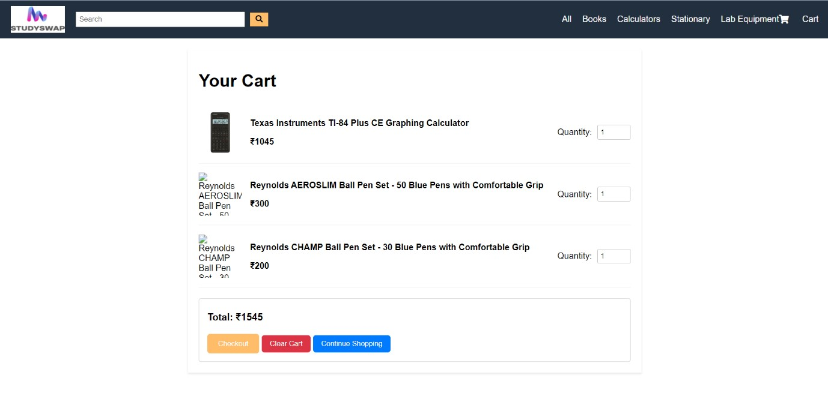
- Result:
Following the execution of the supplied code, the following features and results were noted:
1. Modal Popup Features Activating the Modal: The modal popup window opens when the user clicks the "Open Modal" button. A form requesting the user's name and email address is included in the modal.
Close Modal: You can close the modal by clicking outside the modal content area or by clicking the "Close" button, which is represented by a tiny "X" in the top right corner. The modal will smoothly vanish.
2. Validation of Forms Validation Behavior: The name and email fields' inputs are verified after the form is submitted in the modal: An alert alerting the user that the fields are necessary appears if they are left empty. A specific message asking the user to enter a valid email address is displayed if the email format is incorrect.
Success of Submission: The user is informed that the form has been successfully submitted once they have entered valid information. A console log message displaying the submitted data (name and email) appears next.
3. User Interface and Layout Responsive Design: The application works on a range of screen sizes, including desktop, tablet, and mobile devices, thanks to the responsive layout.
Center Alignment: A neat and polished appearance is produced by the modal and form elements being appropriately centered both horizontally and vertically.
Buttons and Form Controls: Every button and form control is designed using contemporary UI design principles, such as uniform spacing, rounded corners, and hover effects for buttons. When the submit button is hovered over, it turns green, indicating that it is interactive.
4. Experience of the User (UX) Straightforward and Intuitive Flow: Engaging with the modal is an easy process. The user can open the modal, complete the form, and submit it without any problems.
Feedback Mechanism: To improve user experience and avoid incomplete submissions, the form offers instant feedback on missing or incorrect inputs.
Smooth Transitions: The modal smoothly enters and exits the page, making it enjoyable for users to interact with it.

5. Aesthetic Design Color Scheme: The color scheme has a crisp, contemporary style. The buttons' blue and green hues denote actions (submit form, open modal), while the modal's white background features rounded corners.
Typography: Arial, a common sans-serif font, is used in this straightforward design to ensure readability and clarity.

- Conclusion:

To sum up, the modal popup form implementation effectively combines JavaScript, CSS, and HTML to provide an intuitive user experience. Real-time validation of the form guarantees that users enter correct information, enhancing user experience and data integrity. The responsive design improves usability and accessibility by adjusting nicely to different devices.
The code is easily extensible and manageable due to the distinct division of responsibilities between HTML structure, CSS styling, and JavaScript functionality. The application also offers instant user feedback, assisting users in fixing mistakes and verifying successful submissions.

