**BFS TRAVERSAL:**

#include<stdio.h>

voidbfs(int);

int a[10][10],vis[10],n;

int main()

{

inti,j,start;

printf("\nEnter the number of vertices:");

scanf("%d",&n);

printf("\nEnter the starting node:");

scanf("%d",&start);

printf("\nEnter the adjacency matrix:");

for(i=1;i<=n;i++)

{

for(j=1;j<=n;j++)

{

scanf("%d",&a[i][j]);

}

}

for(i=1;i<=n;i++)

{

vis[i]=0;

}

bfs(start);

return 0;

}

voidbfs(int v)

{

int q[10],f=0,r=0,u,i;

vis[v]=1;

q[r]=v;

printf("\nNodes reachable from node %d:",v);

while(f<=r){

u=q[f];

printf("%d\t",u);

for(i=1;i<=n;i++)

{

if(a[u][i]==1&&vis[i]==0)

{

r=r+1;

q[r]=i;

vis[i]=1;

}

}

f=f+1;

}

}

OUTPUT:

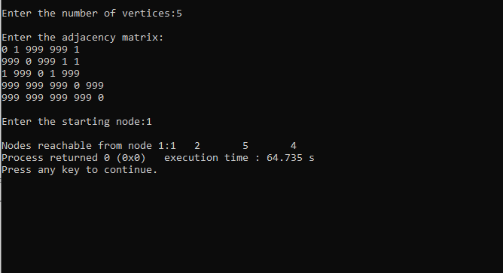

**TOPOLOGICAL ORDERING:**

#include<stdio.h>

#include<conio.h>

int a[10][10],n,exp[10],vis[10],J=0;

voiddfs(int);

void main()

{

intm,u,v,i,j;

printf("\nEnter the number of vertices:");

scanf("%d",&n);

for(i=1;i<=n;i++)

{

for(j=1;j<=n;j++)

{

a[i][j]=0;

}

}

printf("\nEnter the number of edges:");

scanf("%d",&m);

for(i=1;i<=m;i++)

{

printf("\nEnter an edge:");

scanf("%d%d",&u,&v);

a[u][v]=1;

}

for(i=1;i<=n;i++)

{

vis[i]=0;

}

for(i=1;i<=n;i++)

{

if(vis[i]==0)

{

dfs(i);

}

}

printf("\nTopological Order:");

for(i=n-1;i>=0;i--)

{

printf("%d\t",exp[i]);

}

getch();

}

voiddfs(int v)

{

inti;

vis[v]=1;

for(i=1;i<=n;i++)

{

if(a[v][i]==1&&vis[i]==0)

{

dfs(i);

}

}

exp[J++]=v;

}

OUTPUT:

