LAB-1

SETUP:

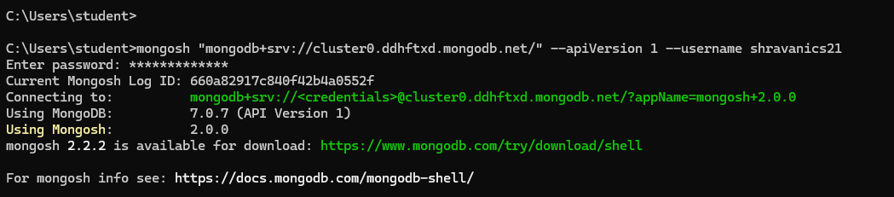

1. Create a database “Student” with the following attributes Rollno, Age, ContactNo, Email-Id.



1. Insert appropriate values(at least 5)

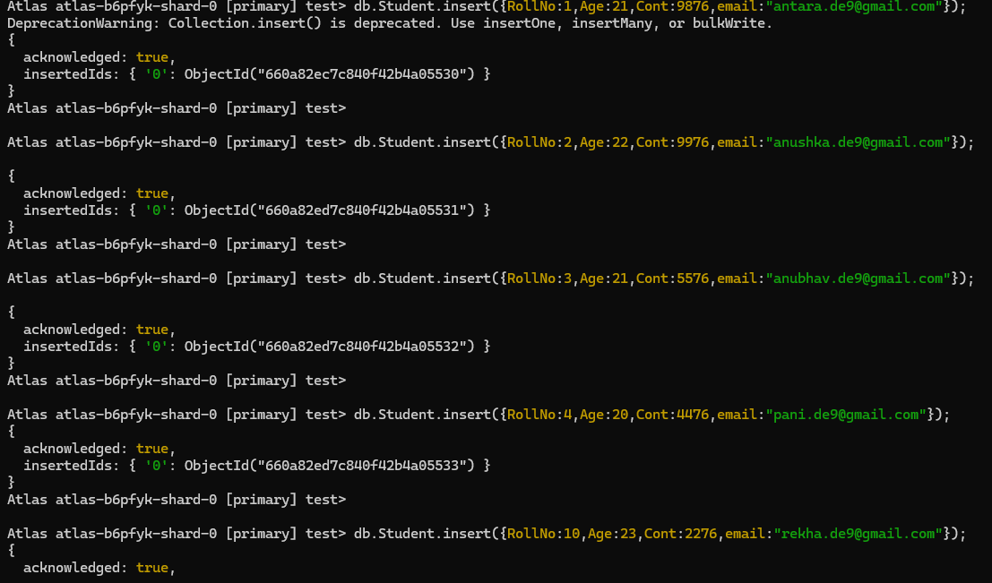



1. View the data

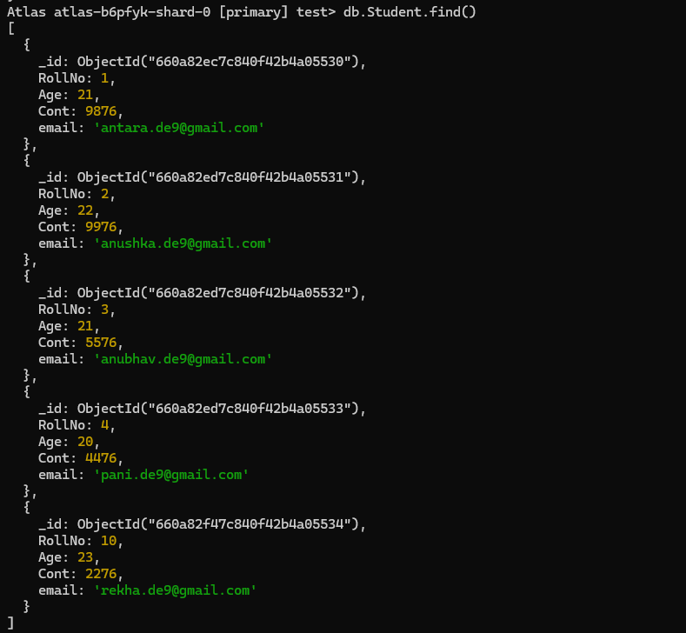

1. Write query to update Email-Id of a student with rollno 10.



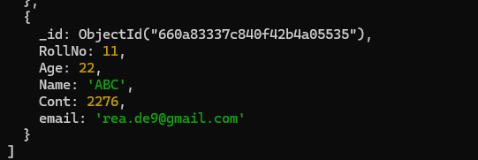

1. Replace the student name from “ABC” to “FEM” of rollno 11.

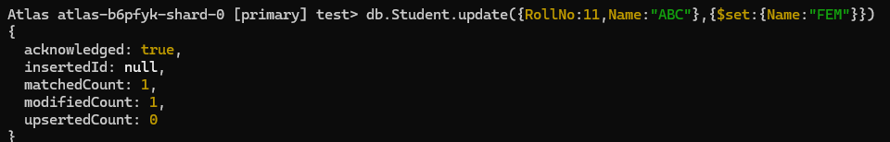

1. Drop the table



1. Create a collection by name Customers with the following attributes.

Cust_id, Acc_Bal, Acc_Type



1. Insert at least 5 values into the table

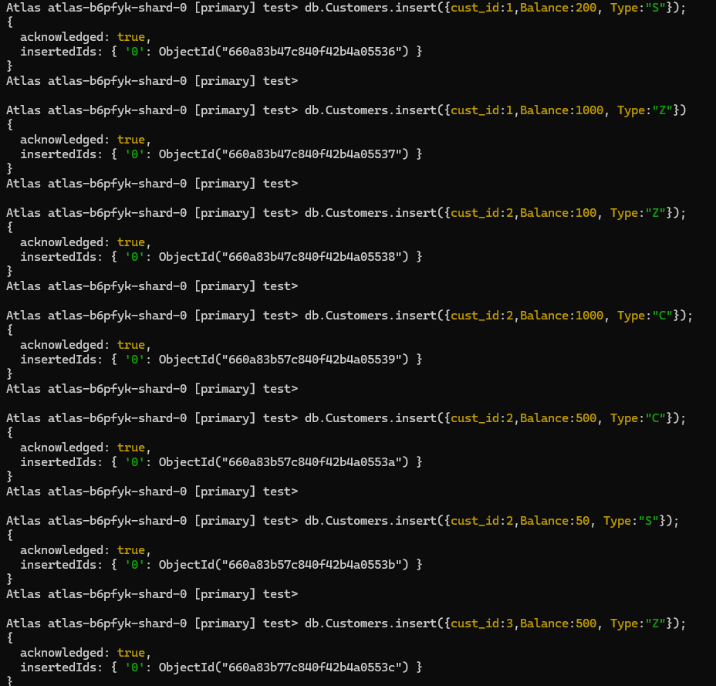

1. Write a query to display those records whose total account balance is greater than 1200 of account type ‘Z’ for each customer_id.

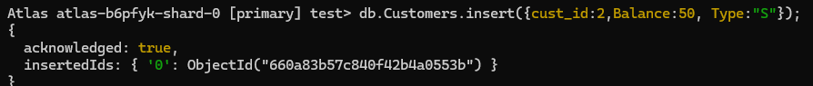

1. Determine Minimum and Maximum account balance for each customer_id.

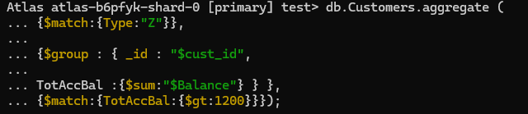

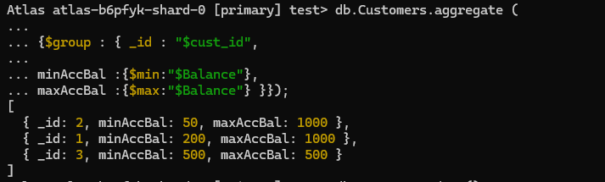

1. Drop the table

