**WEEK-2**

**NETWORK:**

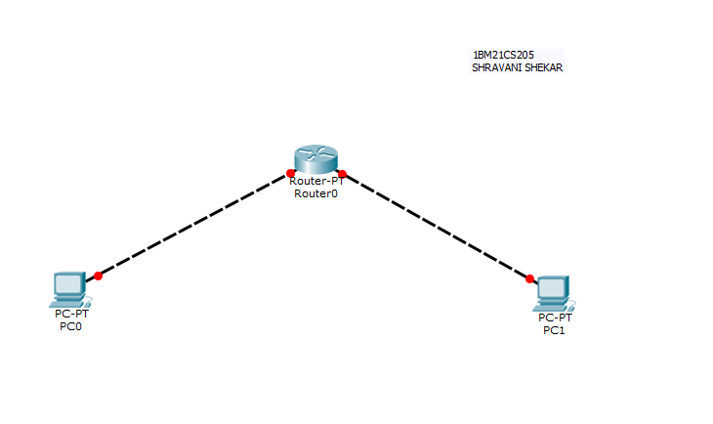

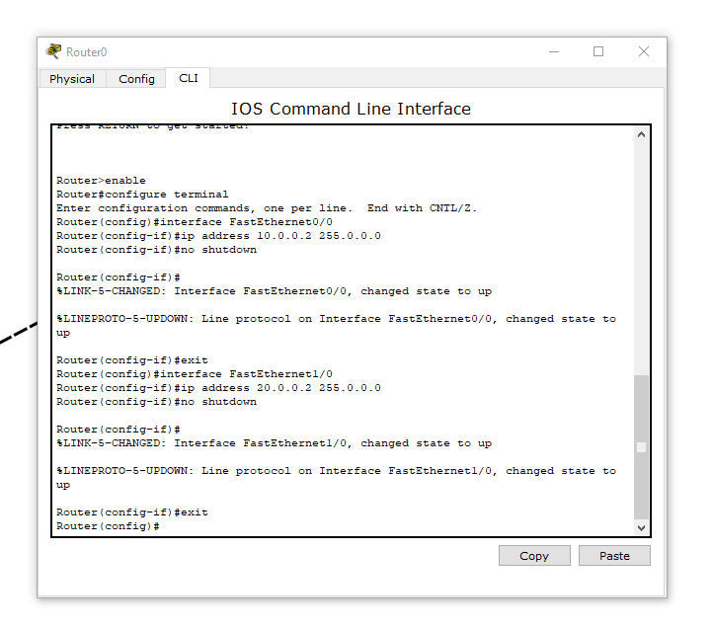

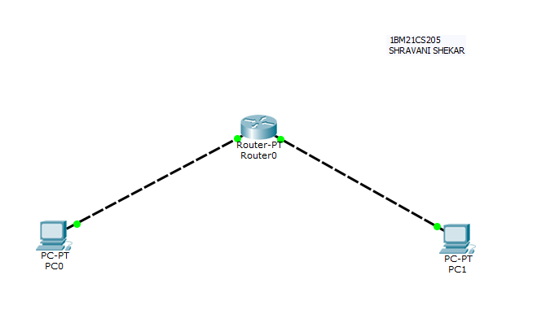

Before specifying the Gateway addresses:

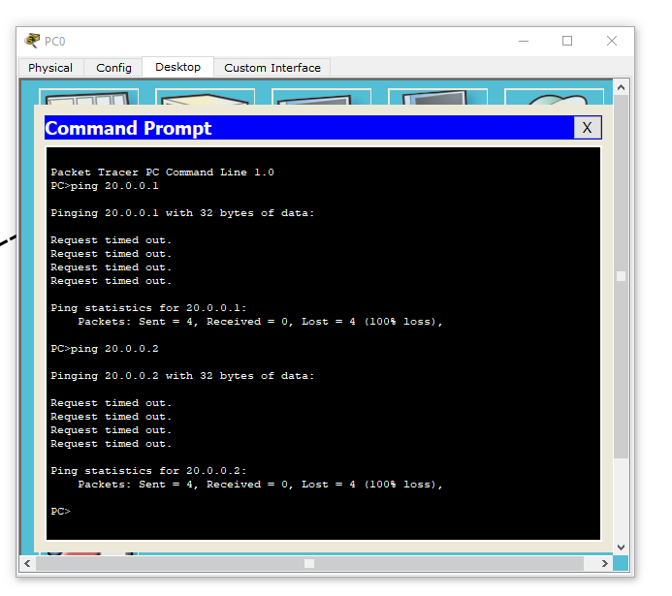

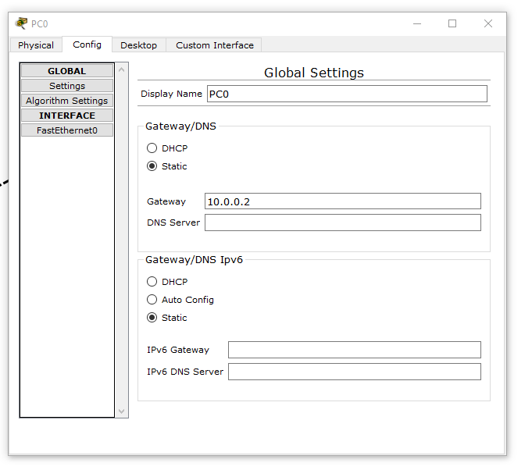

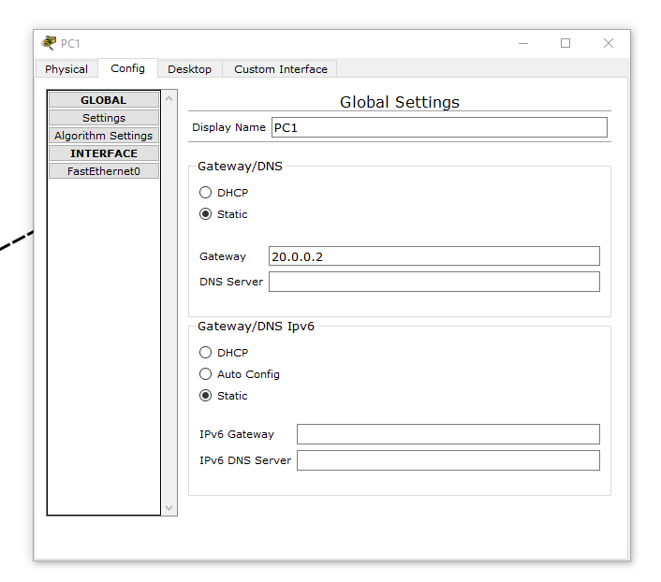

After specifying the gateway addresses of both the end devices:

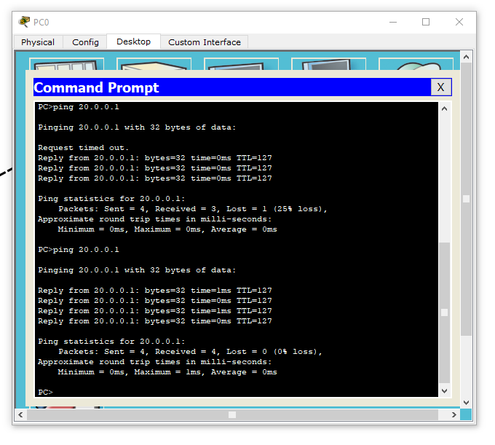

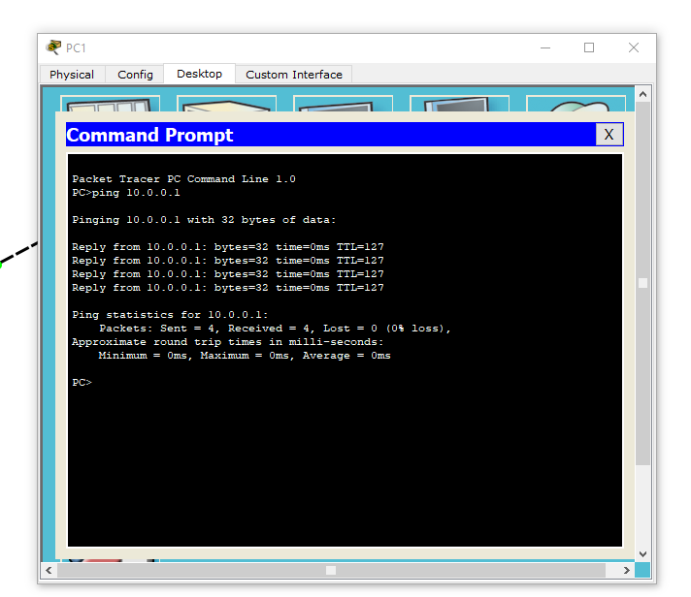

**OUTCOMES:**

* A router is a connecting device implemented at the Network Layer.
* Initially, when two end devices of different networks were connected to a router, we could observe that device 1 of one network couldn’t send a packet to device 2 of another network because the gateway addresses of device 1 and 2 weren’t specified.
* Later, after specifying the gateway addresses of both devices, we were able to send a packet from one device to another.
* Therefore, when using a router, it’s important to specify the gateway addresses of all the end devices connected to the router.
* The gateway address of a device connected to the router is the interface address of that router side (device and the router should be connected to the same network along a particular router side).