Week-1 Project

Step 1: Go to POWER BI

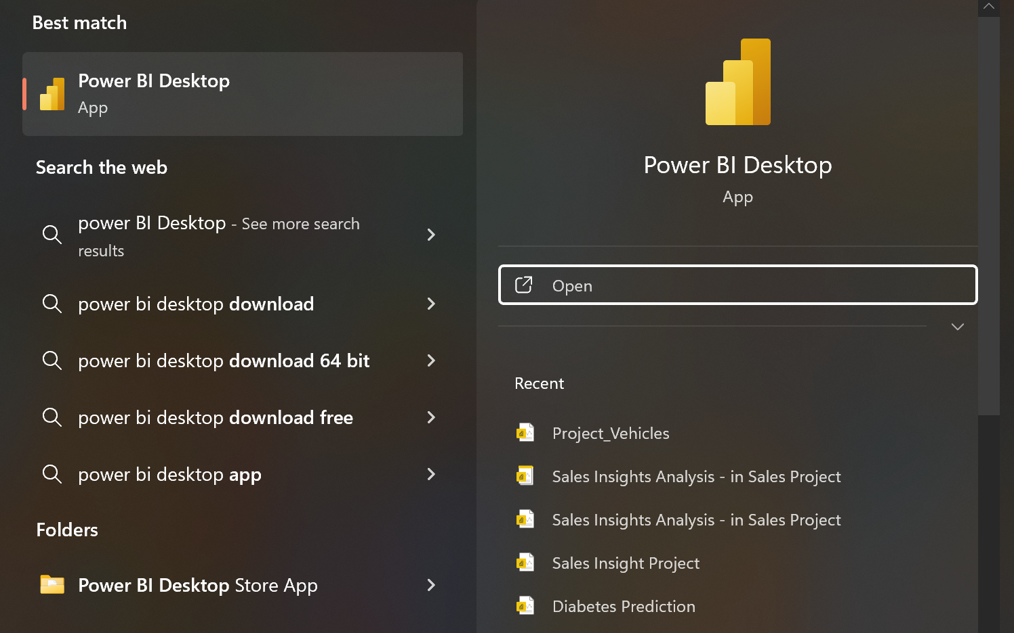

Step 2: To add csv file into Power BI, click on get data and add the csv file

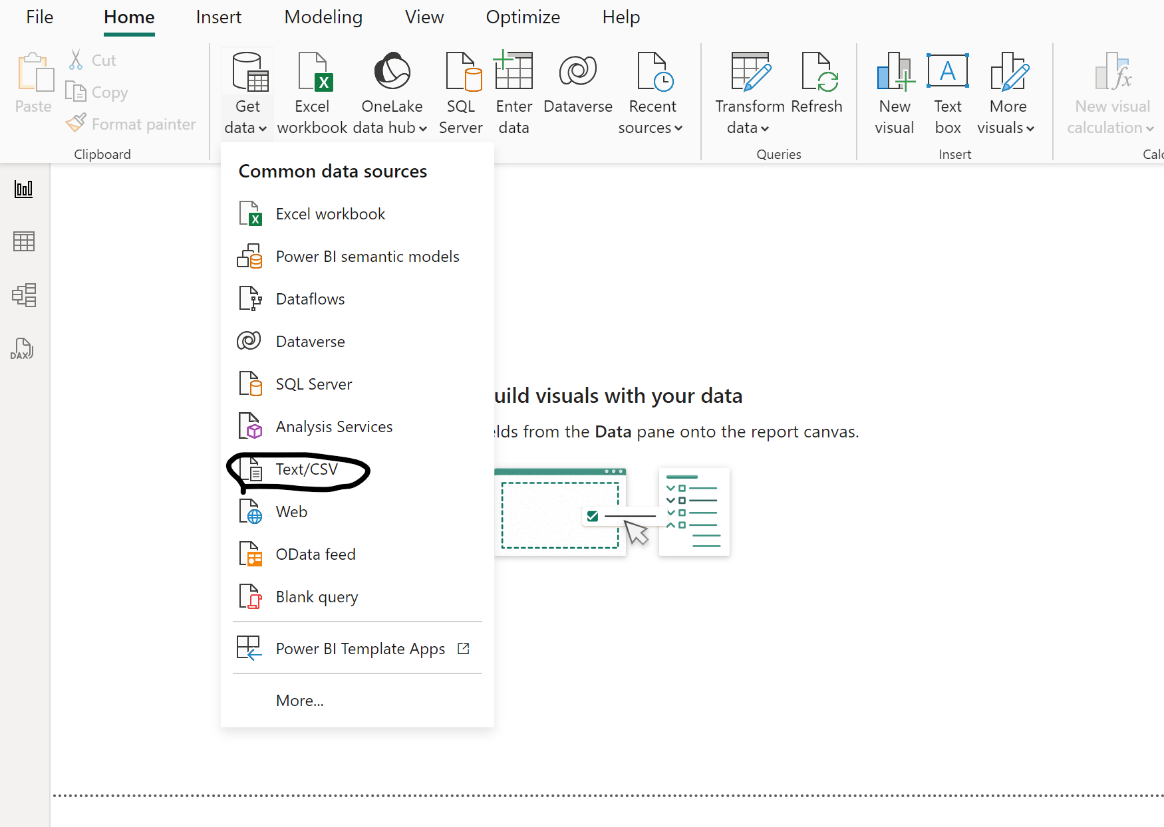

Step 3: Click on the Transform Data to clean the Dataset

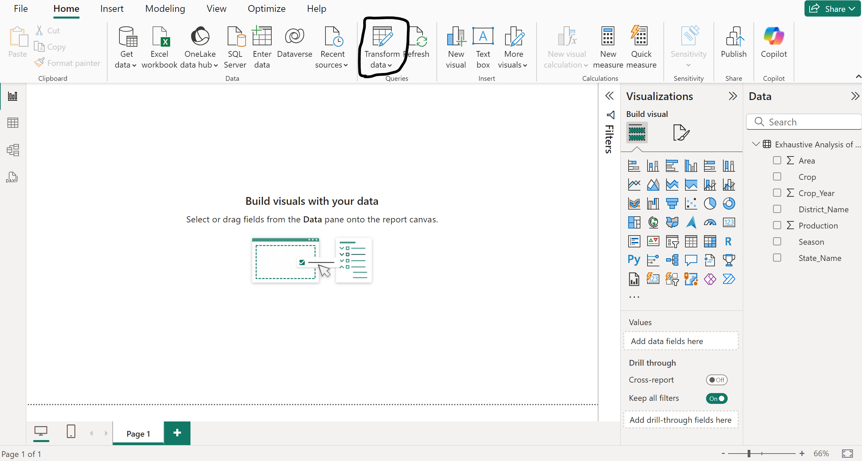

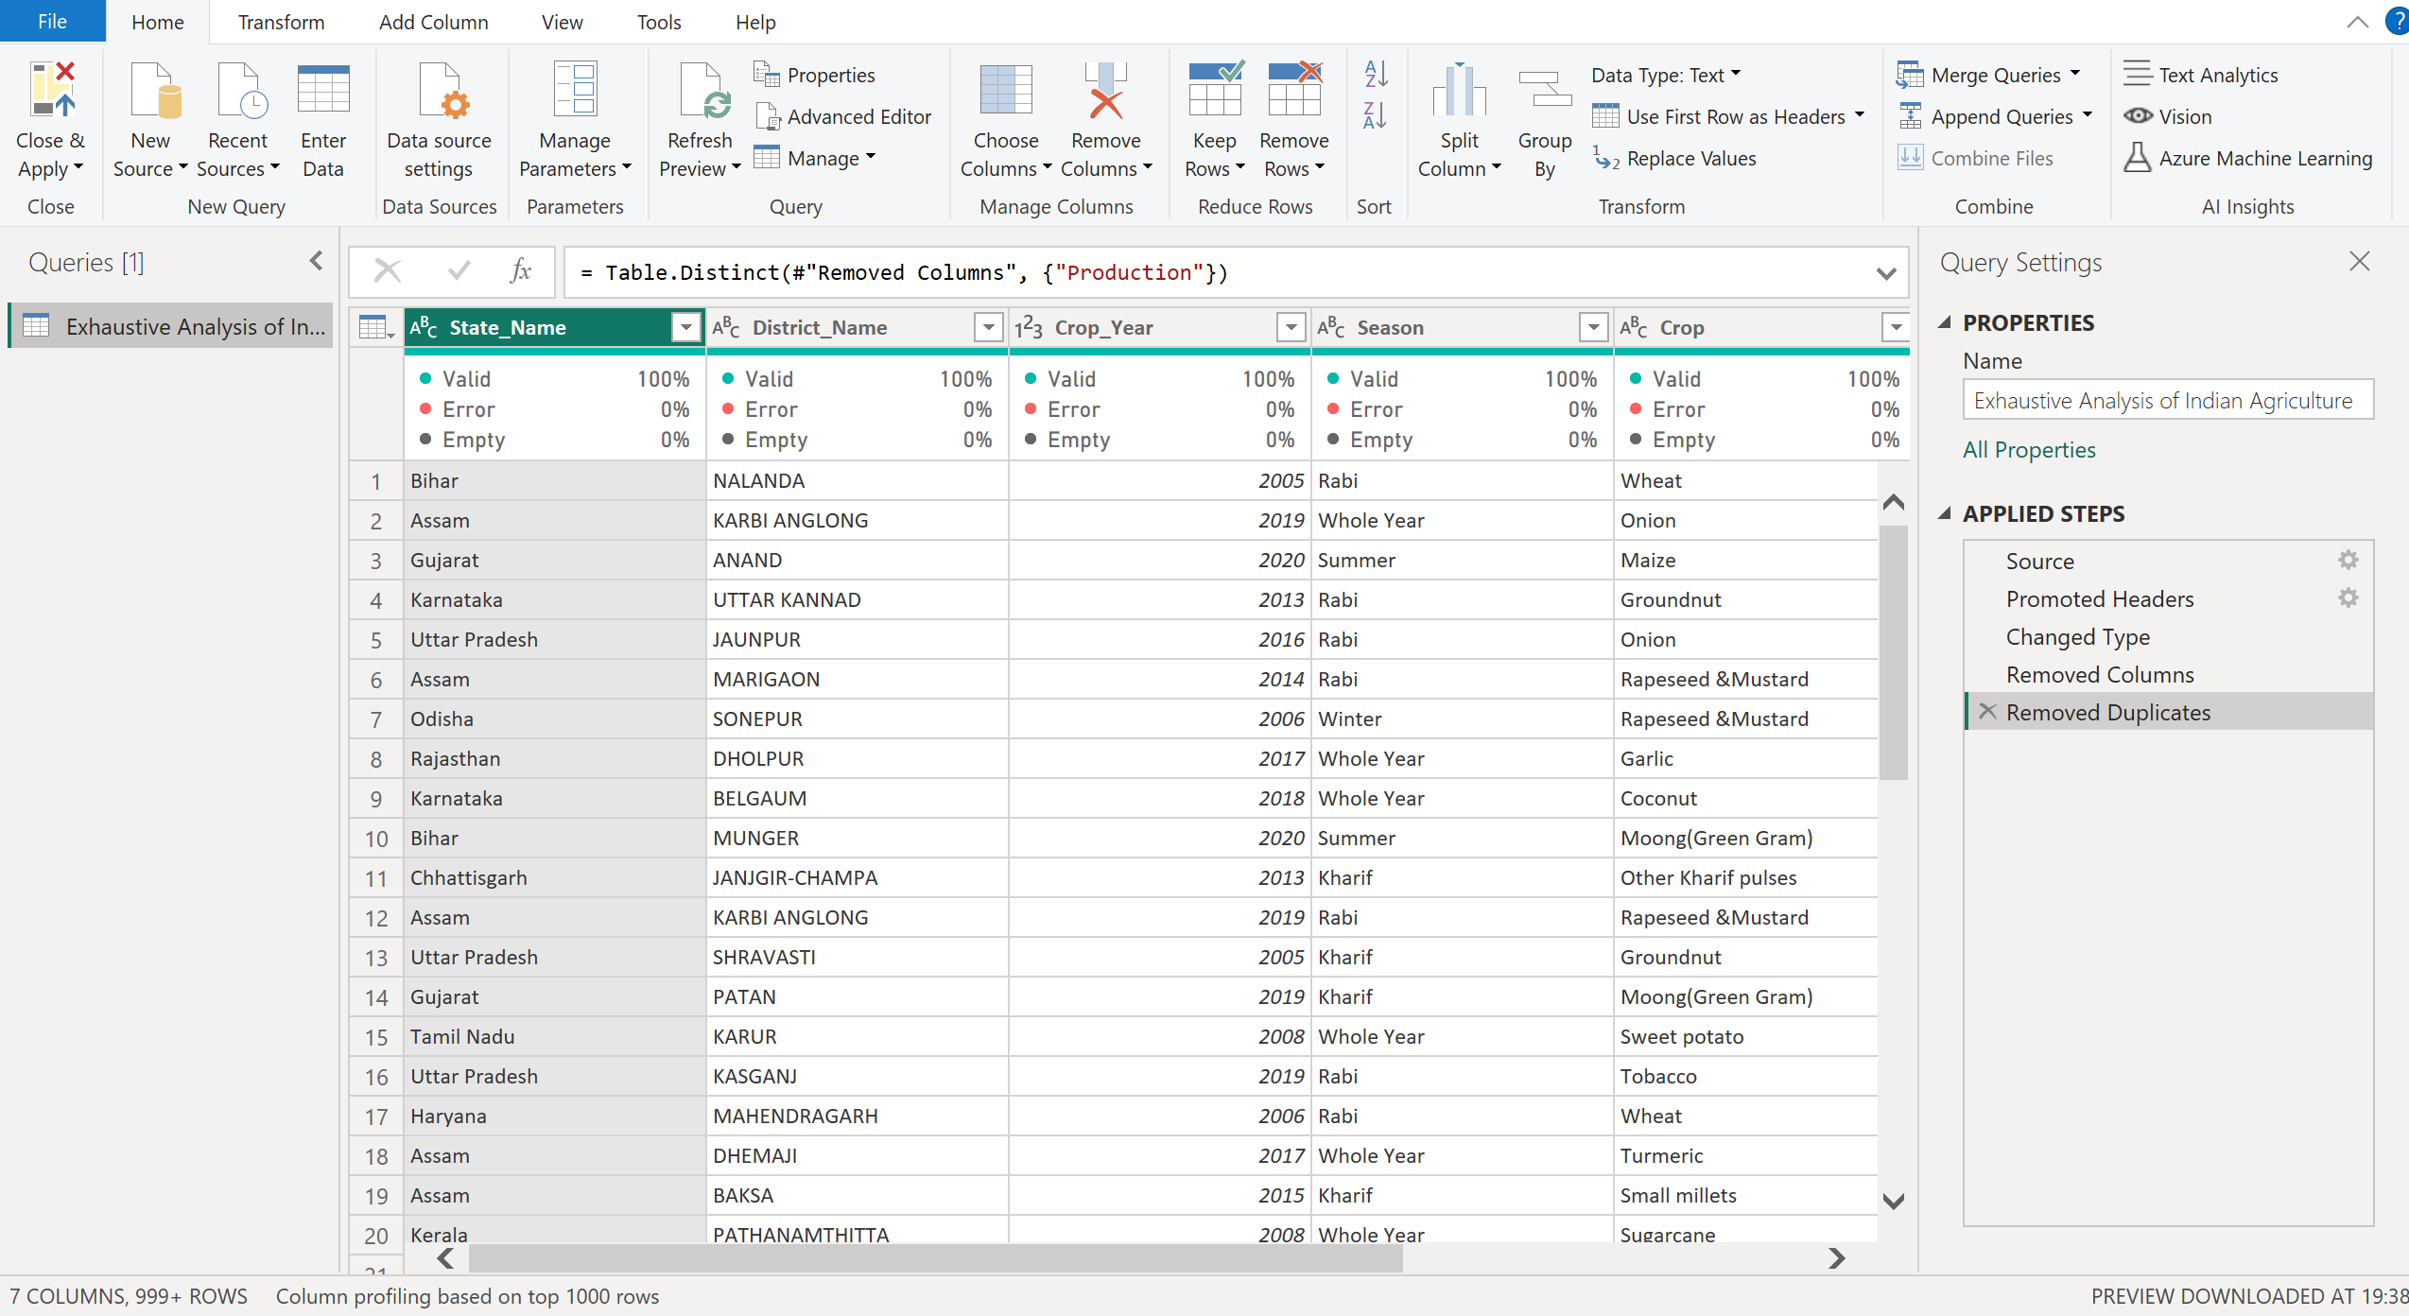

Step 4: To delete the empty columns

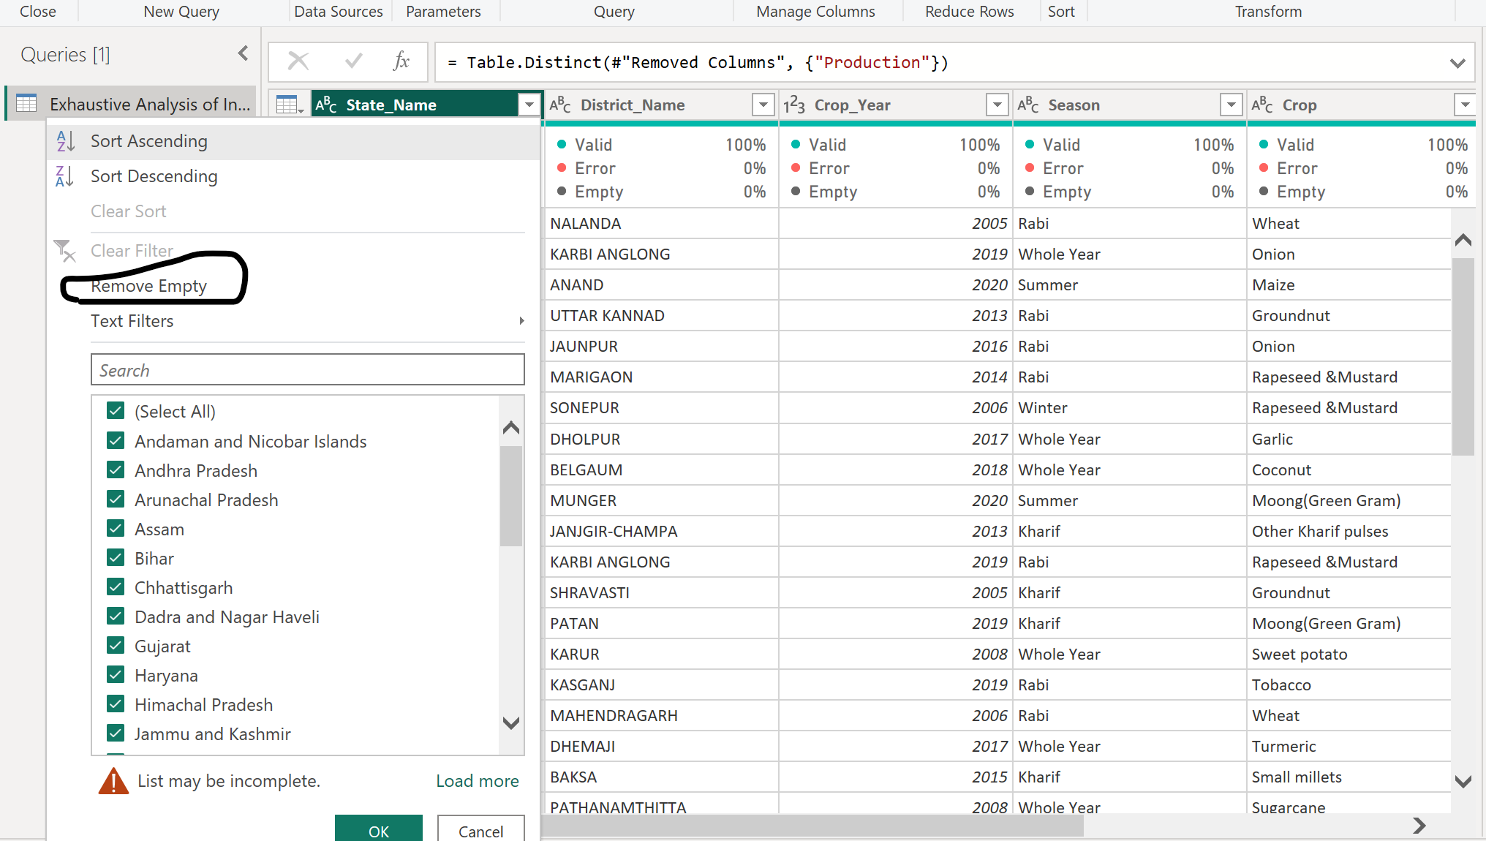

Step 5: To remove the Duplicates,remove blank rows, remove we can use ”REMOVE ROWS”.

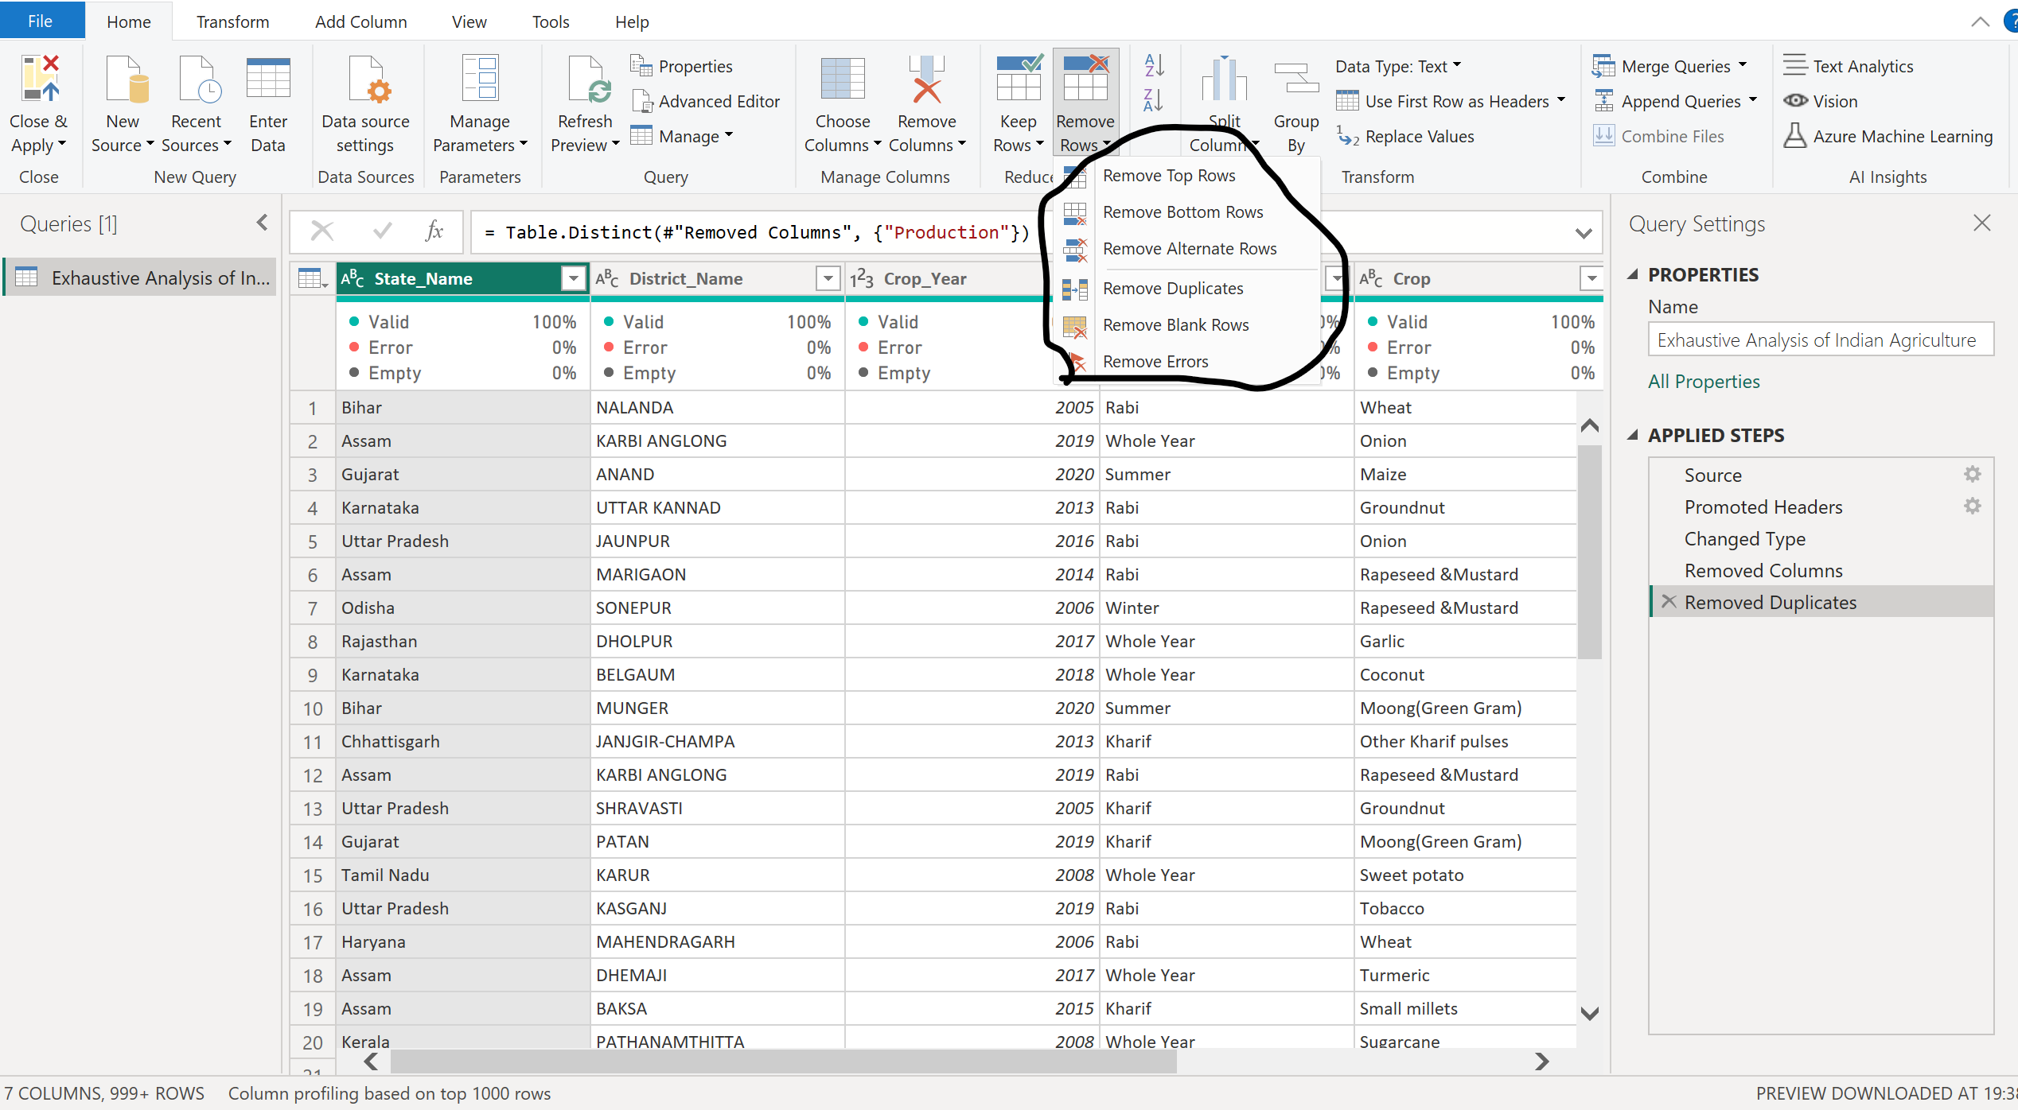

Step 6: To save it, use “Close & Apply”

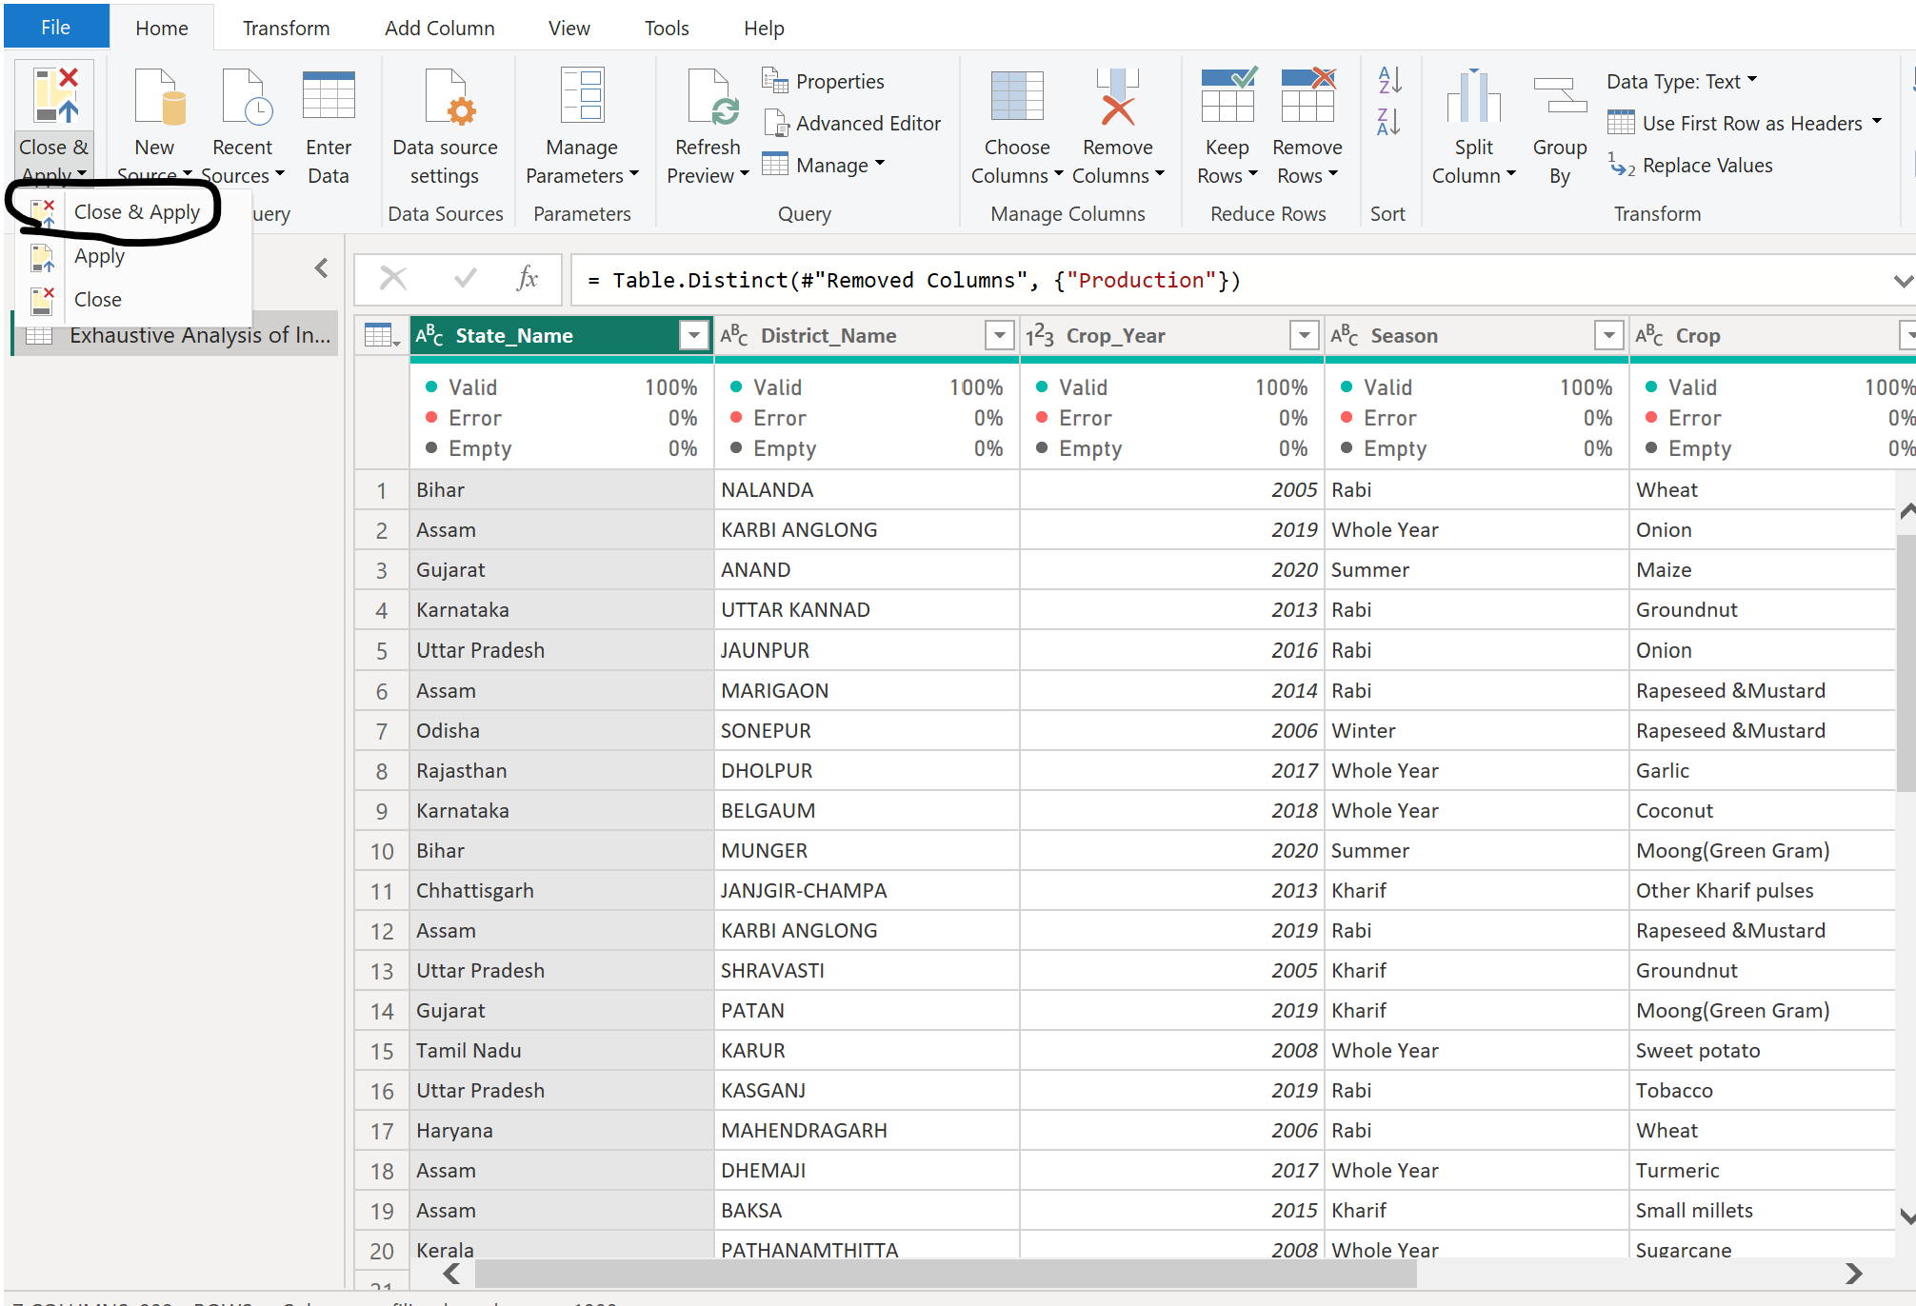

Step 7: Go to table view, we can a clean data without any extra columns or duplicate rows

