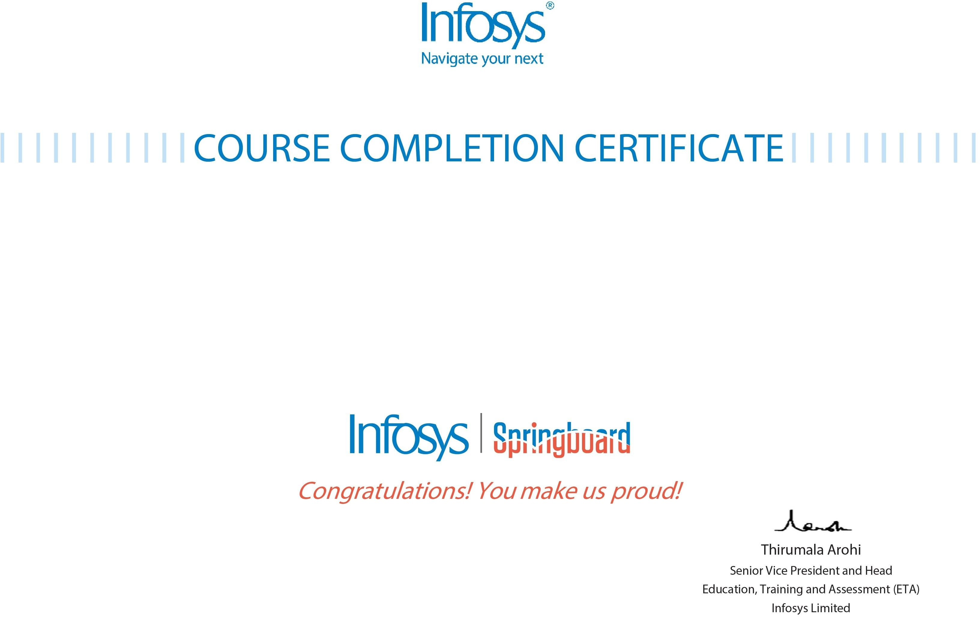

# The certifcate is awarded to

Shravani Potharaju

# for successfully completing the course

Implementing DevOps with AWS

# on December 27, 2023

Issued on: Saturday, December 30, 2023

To verify, scan the QR code at [https://verify.onwingspan.com](https://verify.onwingspan.com/)