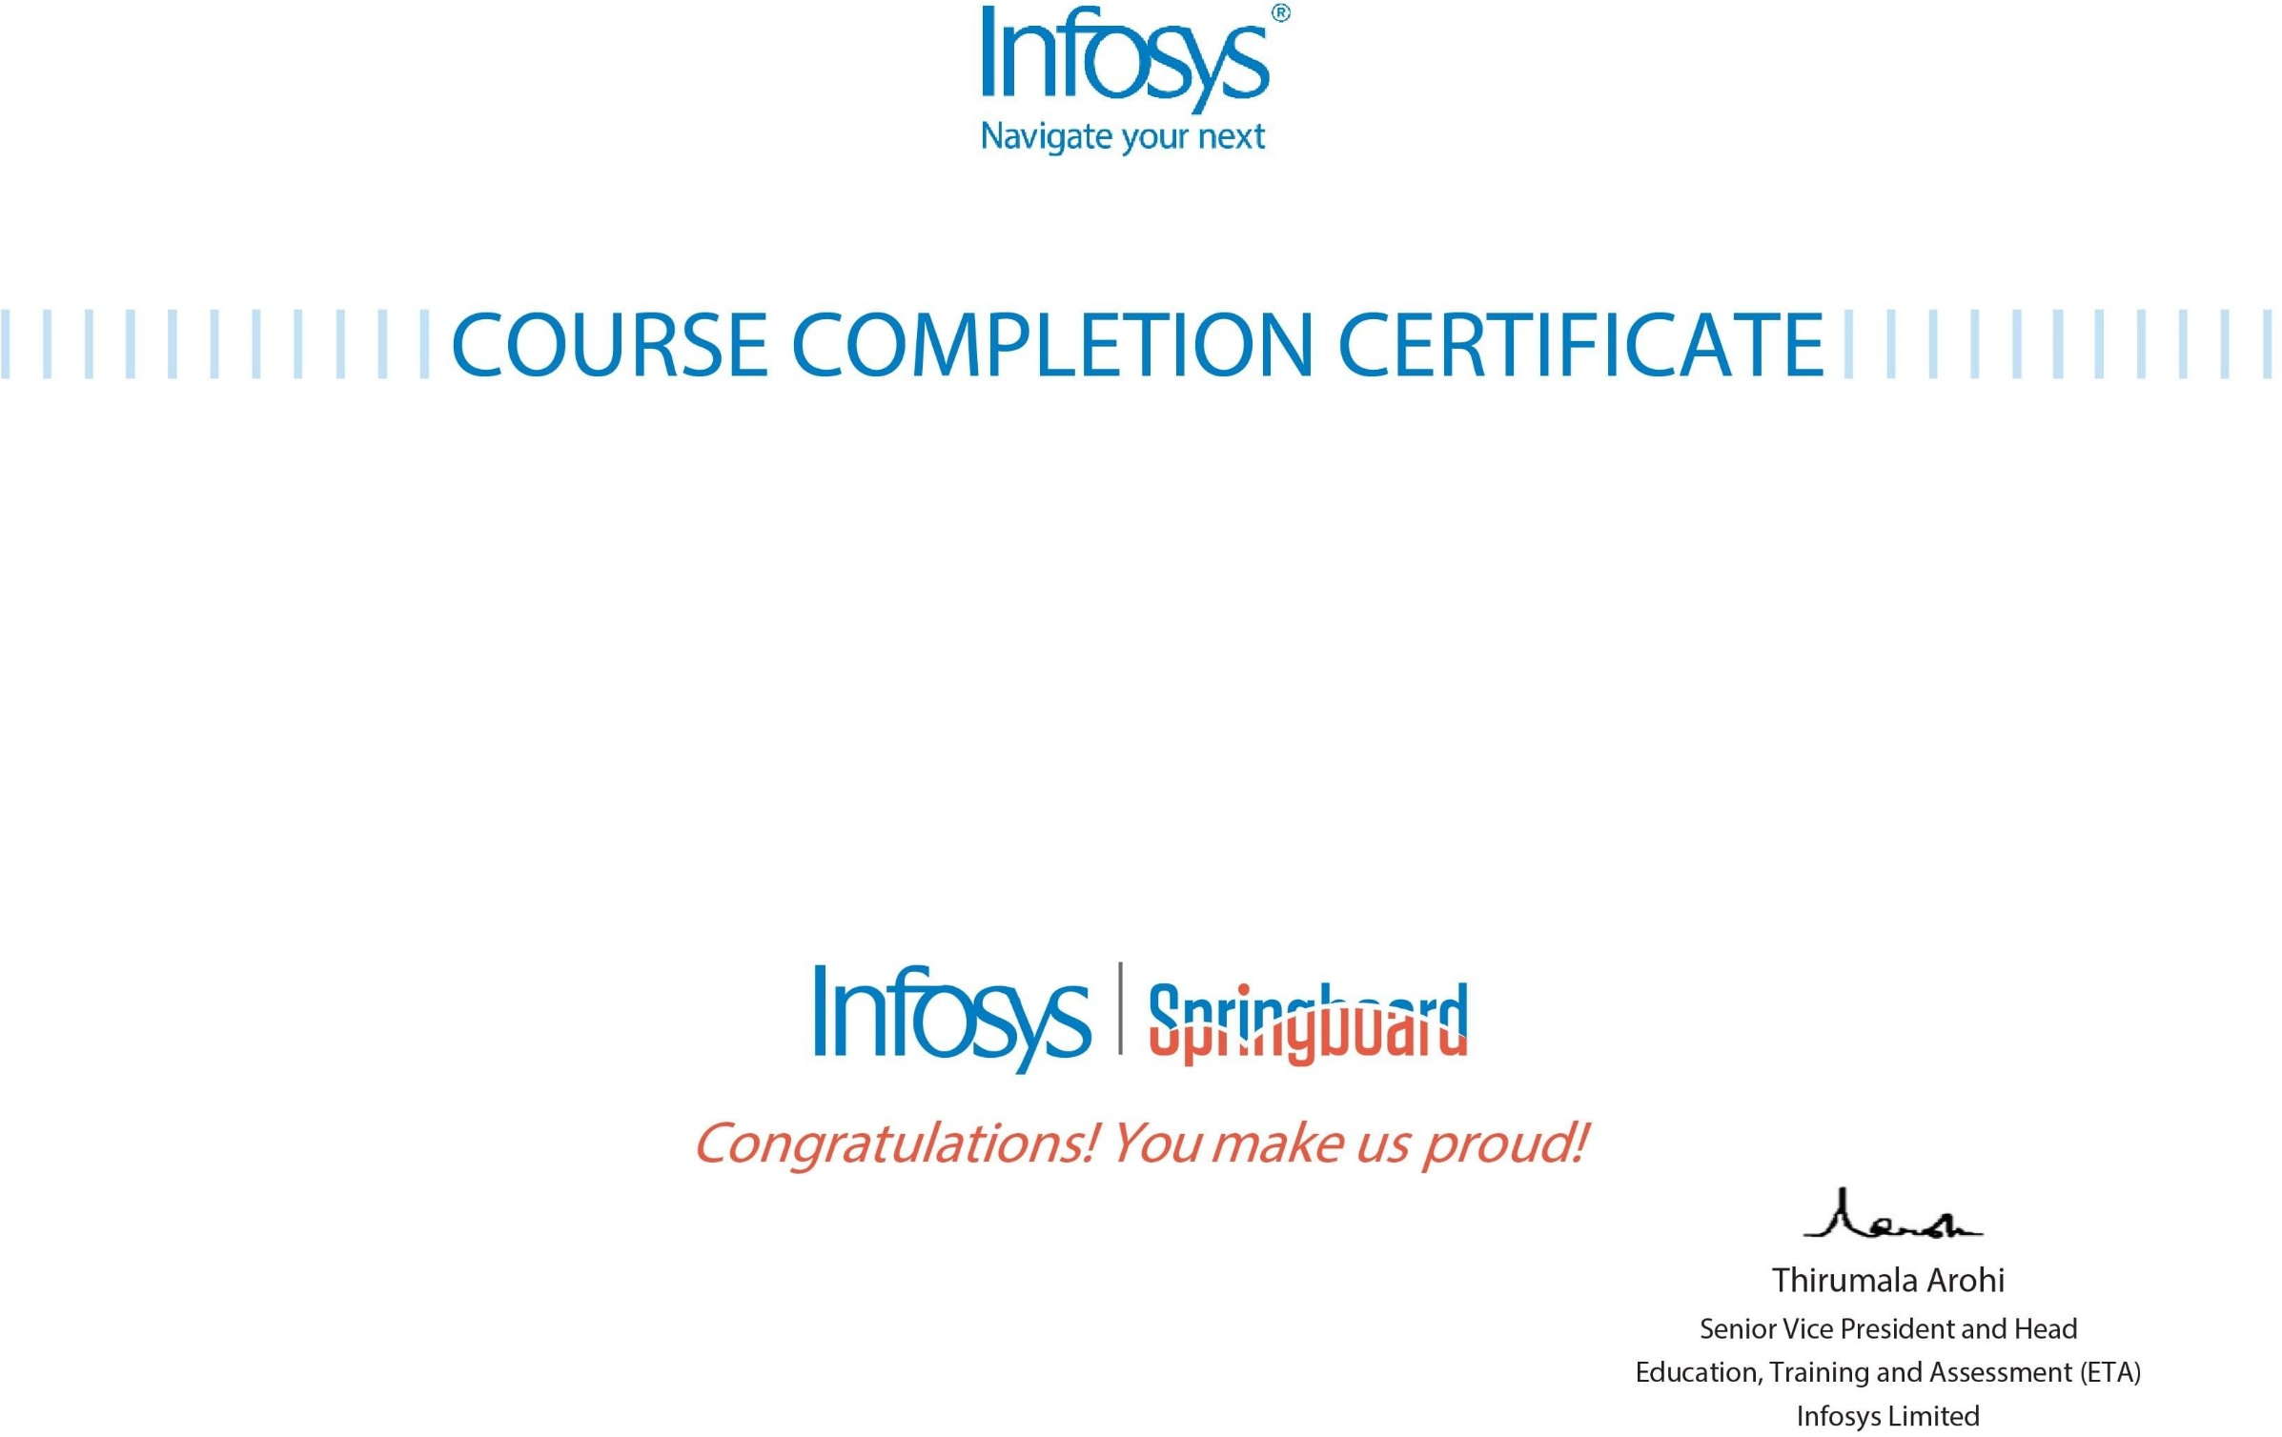

# The certificate is awarded to

Shravani Potharaju

# for successfully completing the course

Mastering DevOps with Advance Concepts

# on December 23, 2023

Issued on: Wednesday, December 27, 2023

To verify, scan the QR code at [https://verify.onwingspan.com](https://verify.onwingspan.com/)