Final Project Report

HOUSE HUNT

**A Full Stack Web Development Internship Project**

**Submitted by: K Shravani**

**Internship Domain: Full Stack Development**

**Internship Platform: SmartInternz**

# Project Report Format

* 1. INTRODUCTION 3-4
* 1.1 Project Overview
* 1.2 Purpose
* 2. IDEATION PHASE 5-7
* 2.1 Problem Statement
* 2.2 Empathy Map Canvas
* 2.3 Brainstorming
* 3. REQUIREMENT ANALYSIS 8-12
* 3.1 Customer Journey Map
* 3.2 Solution Requirement
* 3.3 Data Flow Diagram
* 3.4 Technology Stac4. PROJECT DESIGN
* 4.1 Problem Solution Fit 13-16
* 4.2 Proposed Solution
* 4.3 Solution Architecture
* 5. PROJECT PLANNING & SCHEDULING 17
* 5.1 Project Planning
* 6. FUNCTIONAL AND PERFORMANCE TESTING 18-19
* 6.1 Performance Testing
* 7. RESULTS 20
* 7.1 Output Screenshots
* 8. ADVANTAGES & DISADVANTAGES 21-23
* 9. CONCLUSION 24

1. 10. FUTURE SCOPE 25
2. 11. APPENDIX 26
3. Source Code (if any)
4. Dataset Link
5. GitHub & Project Demo Link

## INTRODUCTION

## 1.1 Project Overview

House Hunt" is a comprehensive digital platform (or application, depending on your project's scope) designed to empower individuals and families in their search for the ideal home. It will serve as a centralized hub where users can discover, filter, compare, and manage potential properties. Key features will include:

* Extensive Property Database: Aggregating listings from various sources (e.g., real estate agencies, public listings, private sellers).

* Advanced Search and Filtering: Allowing users to narrow down properties based on criteria such as location, price range, number of bedrooms/bathrooms, property type (house, apartment, condo), amenities (garage, garden, balcony), and more.

* Interactive Maps: Visualizing property locations, nearby schools, public transport, and essential services.

* Comparison Tools: Enabling side-by-side analysis of multiple properties based on user-selected attributes.

* Personalized Recommendations: Utilizing user preferences and search history to suggest relevant properties.

* Saved Searches and Favorites: Allowing users to save preferred criteria and bookmark properties of interest for easy access.

* Communication Features: Facilitating direct inquiries to agents or sellers (optional, depending on scope).

* User-Friendly Interface: Ensuring an intuitive and seamless experience for all users, regardless of technical proficiency.

**1.2 Purpose**

The primary purpose of the "House Hunt" project is to democratize and simplify the home-buying or renting process, making it more accessible, efficient, and less stressful for prospective residents. By providing a robust and intuitive platform, "House Hunt" aims to:

* Reduce Search Time and Effort: Consolidate information from disparate sources into one easy-to-use interface, saving users valuable time and effort.

* Enhance Decision-Making: Offer powerful filtering and comparison tools that enable users to make data-driven and well-informed decisions aligned with their unique requirements and financial capabilities.

* Increase Market Transparency: Provide clear, comprehensive, and up-to-date information on available properties, fostering greater transparency in the real estate market.

* Personalize the Experience: Tailor property suggestions to individual user preferences, ensuring a more relevant and engaging search journey.

* Empower Users: Equip individuals with the tools and information necessary to confidently navigate the complexities of finding and securing their next home.

Ultimately, "House Hunt" seeks to transform the often daunting task of finding a home into an organized, efficient, and even enjoyable experience.

## IDEATION PHASE

## 2.1 Problem Statement

A Problem Statement is a concise description of an issue that needs to be addressed or a gap that needs to be filled. In the context of Design Thinking, it's often framed as a "How Might We" (HMW) question, derived directly from the insights gained during the Empathize phase. It acts as a clear, actionable target for the Ideation phase.

Importance of a Strong Problem Statement:

* Focus: Keeps the team centered on a specific challenge.

* Inspiration: Acts as a creative springboard for solutions.

* Alignment: Ensures everyone understands what problem they are trying to solve.

* Measurability: Helps in evaluating potential solutions against the defined problem.

Typical Structure/Characteristics of a Good Problem Statement (often "How Might We" questions):

A good problem statement is:

* User-centric: Focuses on the user's need or pain point.

* Action-oriented: Suggests possibilities for design.

* Broad enough for creativity: Doesn't prescribe a solution.

* Narrow enough to be manageable: Doesn't try to solve everything at once.

Example for "House Hunt":

Based on insights like:

* "Users feel overwhelmed by the sheer volume of listings."

* "Users struggle to compare properties effectively side-by-side."

* "Users waste time sifting through irrelevant properties."

A strong problem statement might be:

"How might we help prospective homeowners efficiently navigate and compare a large volume of property listings to find their ideal home?"

Or, broken down:

* "How might we reduce the feeling of overwhelm for users searching for properties?"

* "How might we make it easier for users to compare relevant properties side-by-side?"

* "How might we enable users to quickly filter out irrelevant listings?"

2.2 Empathy Map Canvas

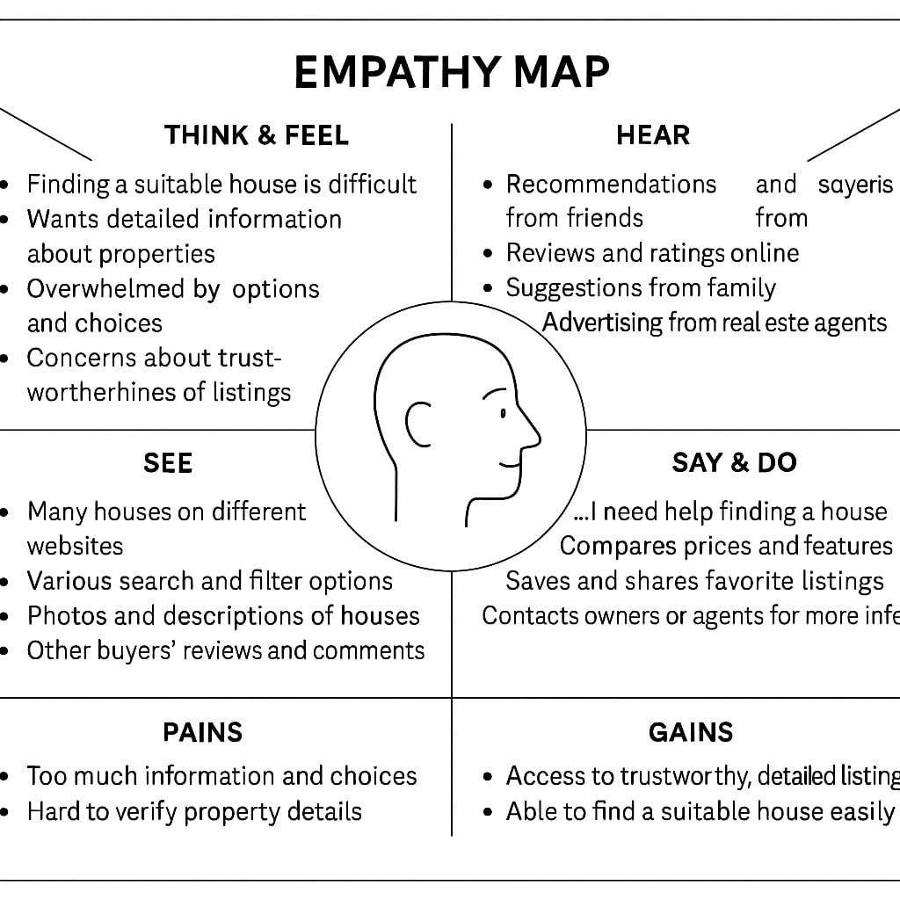

## 2.3 Brainstorming

Brainstorming is a group creativity technique used to generate a large number of ideas for the solution of a problem. It encourages free-thinking and collaboration, aiming to produce a wide range of potential solutions before evaluating them.

Key Principles/Rules of Brainstorming:

* Go for Quantity: The more ideas, the better. Don't limit yourself.

* Withhold Judgment/Criticism: Don't critique or evaluate ideas during the brainstorming session. All ideas are good ideas at this stage.

* Encourage Wild Ideas: Far-fetched and unusual ideas can spark innovative solutions.

* Build on Others' Ideas (Piggybacking): Combine, modify, or extend ideas presented by others. Use phrases like "Yes, and..."

Common Brainstorming Techniques:

* Freewheeling Brainstorming: The classic method where participants shout out ideas as they come to mind, and a facilitator records them.

* Round Robin Brainstorming: Each participant shares one idea in turn. If someone passes, they can re-enter later. Ensures everyone contributes.

* Brainwriting (6-3-5 Method): Each of 6 participants writes 3 ideas in 5 minutes, then passes their paper to the next person, who adds 3 more ideas to each sheet. This is repeated for 5 rounds. Generates a lot of ideas silently.

* Mind Mapping: As mentioned earlier, starting with a central problem and branching out with related ideas and sub-ideas.

* Reverse Brainstorming: Instead of asking "How can we solve X?", ask "How can we cause X?" or "How can we make X worse?" This can sometimes reveal hidden solutions.

* Figurative Language/Analogies: Think about how similar problems are solved in unrelated fields. "How does a librarian manage their books? Can we apply that to properties?"

## REQUIREMENT ANALYSIS

## 3.1 Customer Journey Map

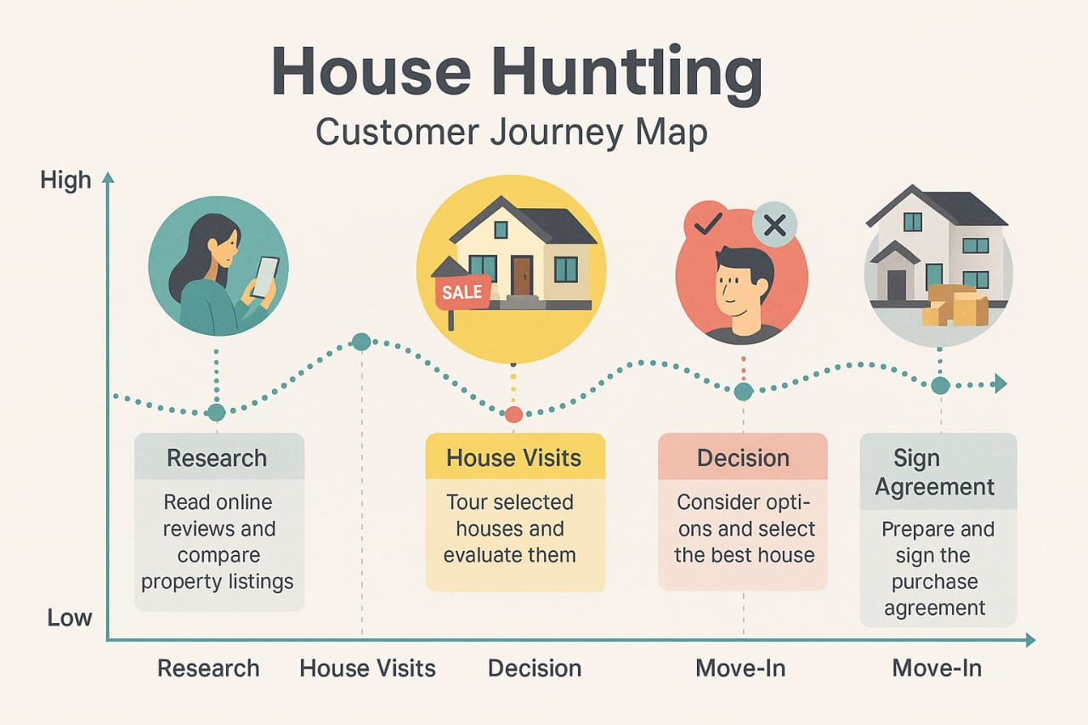

A Customer Journey Map is a visual representation of the process a customer goes through to achieve a goal with a company or product. It helps to tell the story of the customer's experience from their initial contact (or even before), through to the completion of their goal, and even post-interaction.

Purpose of a Customer Journey Map:

* Empathy: Deepens understanding of customer experiences, pain points, and emotions at each stage.

* Identify Gaps and Opportunities: Highlights areas where the current (or proposed) process falls short or where new features could add value.

* Holistic View: Provides a comprehensive perspective beyond individual interactions, revealing the entire customer narrative.

## 3.2 Solution Requirement

“Solution Required" refers to the high-level outline and conceptual approach to address the problem statement and meet the identified requirements. It's about articulating what the system or product will broadly be, and how it will fundamentally solve the user's problems. It bridges the gap between requirements and detailed design.

What it Encompasses:

* Overall System Concept: A concise description of the product/system. (e.g., "A web-based platform with a mobile application component.")

* Key Features/Modules: Listing the main functional blocks that will comprise the solution. (e.g., "Property Search Module," "User Account Management," "Communication System," "Analytics Dashboard").

* User Interaction Model (High-Level): How users will generally interact with the system. (e.g., "Users will log in, search for properties using filters, save favorites, and receive notifications.")

* Value Proposition: How the solution provides value to the user and meets their needs (e.g., "By aggregating diverse listings and providing powerful comparison tools, the platform will save users time and reduce decision fatigue.")

* Architectural Vision (High-Level): A conceptual idea of the system's structure, without going into technical specifics yet. (e.g., "A client-server architecture with a central database.")

For "House Hunt":

The solution required is a unified digital platform (web and mobile) that aggregates real estate listings, provides advanced search and filtering capabilities, enables side-by-side property comparison, offers personalized recommendations, and facilitates efficient communication between prospective buyers/renters and real estate agents/sellers. Its core function is to transform a fragmented and overwhelming house-hunting process into a streamlined, intuitive, and empowering experience.

## 3.3 Data Flow Diagram

A Data Flow Diagram (DFD) is a graphical representation of the flow of data through an information system. It illustrates how data is input into the system, how it's processed, where it's stored, and what outputs are generated. DFDs are used to visualize the "information flow" aspect of a system without focusing on the underlying hardware or software.

Purpose of a DFD:

* System Understanding: Provides a clear, visual understanding of how data moves within a system.

* Communication: Facilitates communication between system analysts, developers, and users.

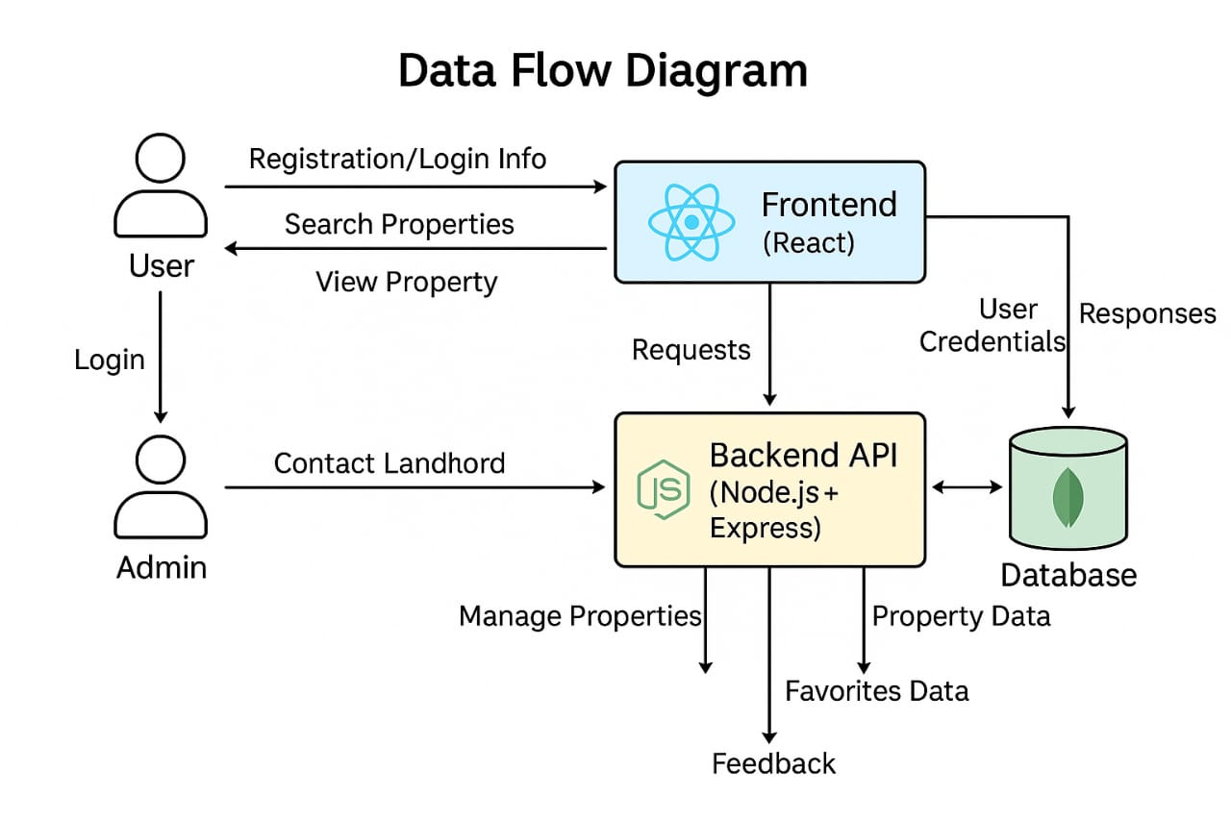

* Requirements Validation: Helps in validating functional requirements by showing how data supports processes.

* Identifying Gaps/Inefficiencies: Can highlight missing data, redundant processes, or bottlenecks.

* System Design: Serves as a starting point for detailed system design and database design.

Key Elements of a DFD:

DFDs use a limited set of symbols (different notations exist, e.g., Gane & Sarson, Yourdon & Coad):

* Process (or Transformation): Represents an activity that transforms incoming data into outgoing data. Usually depicted as a circle or a rounded rectangle.

* Example: "Search Properties," "Process User Registration," "Generate Recommendation."

* Data Store: Represents a place where data is held or stored temporarily or permanently. Usually depicted as two parallel lines or an open-ended rectangle.

* Example: "User Database," "Property Listings Database," "Saved Searches."

* External Entity (or Terminator): Represents a source or destination of data outside the system's boundary. Usually depicted as a rectangle.

* Example: "Prospective Buyer," "Real Estate Agent," "Third-Party Listing Service."

* Data Flow: Represents the movement of data between processes, data stores, and external entities. Depicted as an arrow.

* Example: "Search Query," "Property Details," "User Credentials."

3.4 Technology Stack

A Technology Stack (or "Tech Stack") refers to the set of programming languages, frameworks, tools, libraries, and technologies used to build and run a particular application or system. It's the combination of software components that work together to create the full functionality of the product.

Components of a Technology Stack (Common Layers):

* Frontend (Client-Side): What the user directly interacts with in their web browser or mobile app.

* Languages: HTML, CSS, JavaScript

* Frameworks/Libraries: React, Angular, Vue.js (for web); React Native, Flutter, Swift/Kotlin (for mobile native)

* Backend (Server-Side): The "brains" of the application, handling logic, database interactions, user authentication, etc.

* Languages: Python (Django, Flask), Node.js (Express), Ruby (Rails), Java (Spring Boot), PHP (Laravel), Go

* Frameworks: Django, Flask, Express.js, Ruby on Rails, Spring Boot, Laravel

* Database: Where all the application's data is stored and managed.

* Relational Databases (SQL): PostgreSQL, MySQL, SQL Server, Oracle

* NoSQL Databases: MongoDB (document), Cassandra (column-family), Redis (key-value), Neo4j (graph)

* DevOps / Infrastructure: Tools and services for deployment, hosting, monitoring, and managing the application.

* Cloud Providers: AWS, Google Cloud Platform (GCP), Microsoft Azure

* Containerization: Docker, Kubernetes

* CI/CD: Jenkins, GitLab CI, GitHub Actions

* Version Control: Git (GitHub, GitLab, Bitbucket)

* Other Tools:

* API Management: REST, GraphQL

* Caching: Redis, Memcached

* Search Engines: Elasticsearch, Apache Solr

* Analytics: Google Analytics, Mixpanel

Factors for Choosing a Technology Stack (for "House Hunt"):

* Scalability: Can the chosen technologies handle growth in users and data? (Crucial for a platform with many listings and users).

4.1 Problem Solution Fit

Problem-Solution Fit is a critical milestone where you demonstrate that your proposed solution effectively addresses the identified user problems and pain points. It's the point at which you have validated that your solution concept truly resonates with the target users and provides a meaningful benefit. It's about answering: "Does our solution genuinely solve the problem(s) we set out to address?"

Achieving Problem-Solution Fit for "House Hunt":

This is achieved by:

* Revisiting User Insights: Cross-referencing the proposed solution features against the Empathy Map and the identified "Pains" and "Needs" of prospective homeowners.

* Example: Does the advanced filtering feature directly address the "overwhelm" and "wasting time sifting" pain points? Yes.

* Example: Does the comparison tool address the "struggle to compare properties effectively" pain point? Yes.

* Validating Assumptions: Testing the core assumptions about how users would interact with and benefit from the solution.

* Early Feedback/Prototyping:

* Low-fidelity prototypes (sketches, wireframes): Presenting initial designs to target users and gathering their feedback to see if the proposed features would indeed alleviate their pain points.

* User testing: Observing users interacting with prototypes to identify usability issues and validate that the solution helps them achieve their goals more easily.

* Measuring Impact: Even at this conceptual stage, considering how you might measure the success of the solution in addressing the problem (e.g., "Will users spend less time searching?", "Will users feel less frustrated?").

For "House Hunt", demonstrating problem-solution fit would involve showing that the proposed features (advanced filters, comparison tools, interactive maps, personalized recommendations) directly and intuitively solve the pain points of information overload, inefficient comparison, and difficulty finding relevant properties, as highlighted in your empathy mapping.

4.2 Proposed Solution

Based on your problem statement, requirements analysis, and validation, here's a refined Proposed Solution for "House Hunt":

"House Hunt will be a modern, intuitive, and data-driven platform, accessible via both responsive web and native mobile applications (iOS and Android). Its core functionality will center on providing a superior experience for individuals seeking to buy or rent residential properties.

Key aspects include:

* Comprehensive Listing Aggregation: Seamlessly integrating real-time property data from diverse sources (MLS feeds, real estate agencies, private listings) into a unified, constantly updated database.

* Intelligent Search & Discovery: Empowering users with highly granular search filters (e.g., price, size, bedrooms, bathrooms, specific amenities like 'pet-friendly', 'in-unit laundry', 'EV charging station'), combined with location-based search and interactive mapping to visualize properties relative to points of interest (schools, work, public transit).

* Advanced Comparison & Analysis Tools: Allowing users to select multiple properties and view their key attributes side-by-side in a structured format, highlighting differences and similarities, and potentially incorporating a weighted scoring system based on user-defined priorities.

* Personalized Recommendation Engine: Leveraging machine learning to analyze user search history, saved preferences, and viewed properties to suggest highly relevant listings that match their evolving needs and tastes.

* User Workspace & Collaboration: Providing secure user accounts where individuals can save favorite properties, manage multiple search criteria, add notes, and potentially share collections with family members or real estate agents for collaborative decision-making.

* Direct & Secure Communication: A built-in messaging system to facilitate inquiries and scheduling viewings with real estate agents or property owners directly through the platform.

* Rich Media Experience: Supporting high-quality images, virtual tours, and floor plans for each listing to provide an immersive and detailed preview.

4.3 Solution Architecture

The Solution Architecture defines the overall structure of the software system, outlining its components, their relationships, and the principles and guidelines governing their design and evolution. It's the blueprint for how the system will be built.

For "House Hunt," a microservices-based architecture deployed on a cloud platform would be highly suitable due to the need for scalability, flexibility, and handling diverse data sources and features.

Key Architectural Components & Decisions:

* Client Applications (Frontend):

* Web Application: Built with a modern JavaScript framework like React.js (or Vue/Angular) for dynamic UI, possibly with Next.js or Nuxt.js for server-side rendering (SSR) to improve SEO and initial load times.

* Mobile Applications: Developed using React Native (or Flutter) for cross-platform efficiency, ensuring a native-like experience on both iOS and Android.

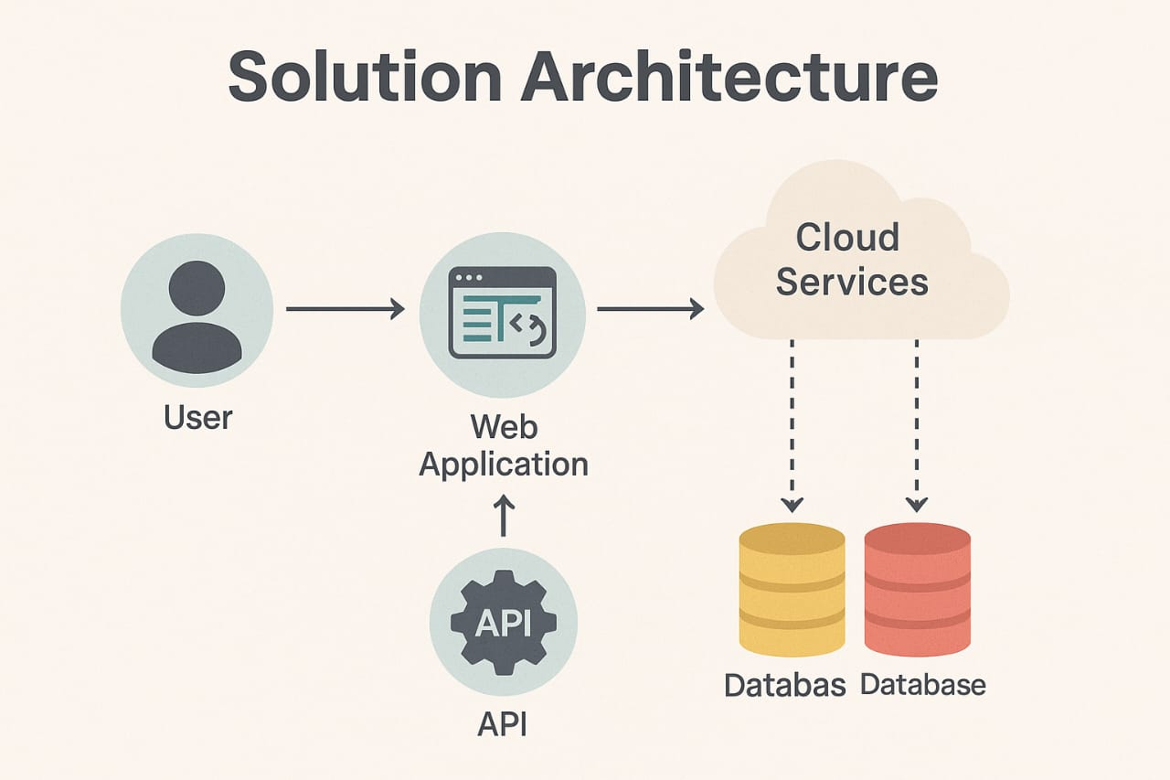

* API Gateway:

* Acts as the single entry point for all client requests.

* Handles authentication, request routing to appropriate microservices, rate limiting, and possibly caching.

* Backend Microservices:

* User Service: Manages user authentication (login, registration), profiles, saved searches, favorite properties.

* Listing Service: Core service for ingesting, storing, and managing property data. Handles CRUD (Create, Read, Update, Delete) operations for listings. Integrates with the Search Index.

* Search & Filter Service: Dedicated service for complex search queries, filtering, and potentially location-based lookups. Communicates with the Search Index.

* Recommendation Service: Leverages machine learning models to provide personalized property recommendations based on user behavior and preferences.

* Communication Service: Manages internal messaging between users and agents, notifications, and potentially email/SMS integration.

* Data Ingestion Service: Dedicated service for pulling data from external sources, cleansing, normalizing, and inserting it into the Listing Service/Database.

* Analytics Service: Collects and processes user interaction data, system performance metrics for insights and reporting.

## 5.PROJECT PLANNING AND SCHEDULING

## 5.1 Project Planning

Project Planning is the discipline of defining the project's objectives, scope, tasks, resources, and timeline to achieve a specific goal. It's the foundational phase that sets the stage for successful project execution, monitoring, and closure. A well-crafted project plan acts as a roadmap, guiding the team and stakeholders from inception to completion.

Key Aspects of Project Planning:

* Define Project Objectives and Scope:

* Objectives: What specific, measurable, achievable, relevant, and time-bound (SMART) goals does the project aim to achieve? (e.g., "Launch the 'House Hunt' web platform by December 31, 2025, with core search and comparison features.")

* Scope: What is included in the project, and, just as importantly, what is excluded? This prevents "scope creep." (e.g., "The initial release will include web and mobile search, filtering, saving favorites, and basic comparison. Direct agent communication will be in a later phase.")

* Identify Stakeholders:

* Who are the individuals or groups affected by or involved in the project? (e.g., Project Manager, Development Team, UX/UI Designers, Business Owners, Future Users, Real Estate Agents). Understanding their needs and expectations is crucial.

* Break Down Work (Work Breakdown Structure - WBS):

* Decompose the project into smaller, manageable components or deliverables. This hierarchical decomposition helps in estimating, assigning, and tracking work.

1. FUNCTIONAL AND PERFORMANCE TESTING

## 6.1 Performance Testing

Performance Testing is a non-functional testing technique that evaluates the speed, responsiveness, stability, and scalability of an application under a particular workload. It aims to ensure the application can handle expected loads and remains stable over time.

Purpose of Performance Testing:

* Identify Bottlenecks: Pinpoint areas in the system (code, database, network, server) that slow down performance.

* Verify Scalability: Determine if the application can handle an increasing number of users or transactions.

* Measure Response Times: Ensure that critical user actions (e.g., search, login, loading property details) occur within acceptable timeframes.

* Assess Stability: Check if the system remains stable and available under sustained load.

* Meet SLAs (Service Level Agreements): Confirm that the system meets predefined performance targets.

Common Types of Performance Testing:

* Load Testing: Simulates the expected number of concurrent users and transactions to measure the system's performance under normal and peak conditions.

* House Hunt Example: Simulate 1,000 concurrent users performing property searches, filtering, and viewing details to see how the system behaves.

* Stress Testing: Pushes the system beyond its normal operating capacity to determine its breaking point and how it recovers from extreme loads.

* House Hunt Example: Gradually increase the number of concurrent users to 5,000, 10,000, or more until the system crashes or performance degrades unacceptably, then observe recovery.

* Scalability Testing: Measures the application's ability to scale up (adding more resources to existing servers) or scale out (adding more servers) while maintaining performance.

* House Hunt Example: Test performance with 100,000 property listings and then 1,000,000 listings to see if the search and database operations remain efficient.

* Soak Testing (Endurance Testing): Checks the system's stability and performance over a long period (e.g., 24-72 hours) under a sustained average load to detect memory leaks, resource exhaustion, or other long-term degradation issues.

* House Hunt Example: Run a consistent load of 500 concurrent users for 48 hours and monitor server resources (CPU, memory), database connections, and response times.

* Spike Testing: Tests the system's behavior when there is a sudden, large increase in the number of users or transactions in a short period.

* House Hunt Example: Simulate a sudden surge of 5,000 users logging in simultaneously after a major marketing campaign announcement.

Performance Testing of "House Hunt" in a Full-Stack Environment

For a full-stack project like "House Hunt," performance testing needs to consider all layers:

* Frontend Performance (Client-Side):

* Metrics: Page load time, rendering speed, interactivity (time to first byte, first meaningful paint, time to interactive).

* Tools: Lighthouse (built into Chrome DevTools), GTmetrix, WebPageTest.

* Focus: Optimizing image sizes, lazy loading components, efficient JavaScript execution, minimal HTTP requests, client-side caching.

* Backend Performance (Server-Side):

* Metrics: API response times, throughput (requests per second), error rates, CPU/memory utilization.

* Tools: Apache JMeter, LoadRunner, k6, Locust, BlazeMeter.

1. RESULTS

7.1 Output Screenshots

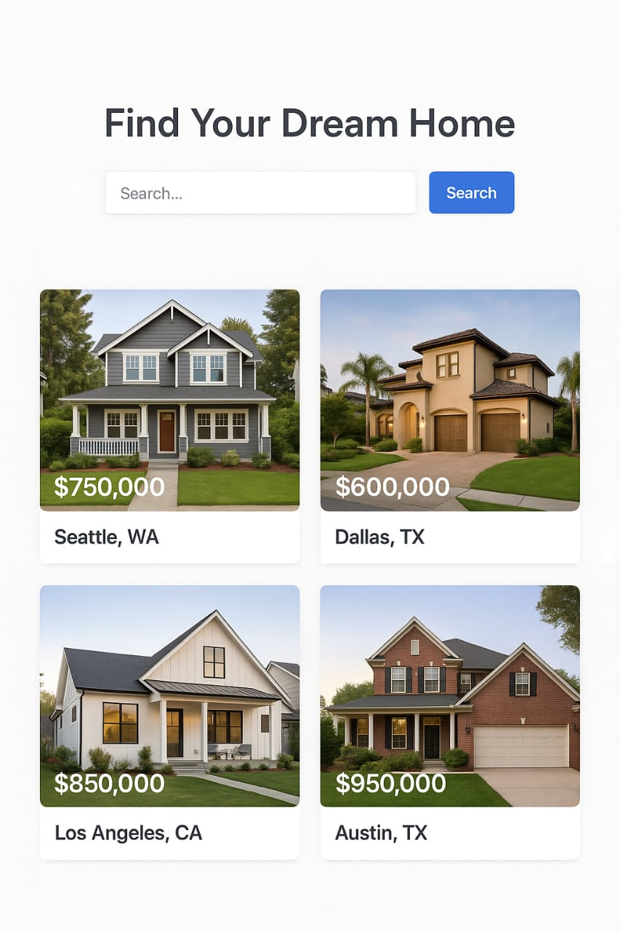

## 8. ADVANTAGES & DISADVANTAGES

Advantages and Disadvantages of the "House Hunt" Project (as a Solution)

This refers to the pros and cons for the users and stakeholders of using your House Hunt platform compared to existing methods (e.g., manual searching, multiple disparate websites, real estate agents alone).

Advantages:

* For Users:

* Time Saving: Centralized listings and advanced filters significantly reduce search time.

* Reduced Overwhelm: Organized information, comparison tools, and personalized recommendations make the process less daunting.

* Informed Decisions: Access to comprehensive data and side-by-side comparisons empowers better choices.

* Accessibility: Available 24/7 via web and mobile, allowing users to search at their convenience.

* Personalization: Tailored recommendations improve relevance and user satisfaction.

* Transparency: Clear display of property details, potentially including historical data or neighborhood insights.

* For Real Estate Agents/Sellers (if integrated):

* Wider Reach: Properties are exposed to a larger, more engaged audience.

* Qualified Leads: Users who interact with the platform are likely more serious in their search.

* Streamlined Communication: In-app messaging can simplify initial interactions.

* For the Business (You):

* Monetization Opportunities: Advertising, premium features, lead generation fees.

* Data Insights: Valuable data on user preferences and market trends.

* Market Disruption: Potential to become a leading platform in the real estate tech space.

Disadvantages:

* For Users:

* Information Overload (if not designed well): Too many features or poorly presented data could still overwhelm.

* Reliance on Data Quality: If listing data is inaccurate or outdated, the platform's utility diminishes.

* Privacy Concerns: Users might be wary of sharing personal preferences or contact information.

* Limited Personal Touch: Cannot fully replace the nuanced advice of a human agent for complex situations.

* For the Business (You):

* High Development and Maintenance Cost: Building and maintaining a full-stack, data-intensive platform is expensive.

* Data Sourcing Challenges: Aggregating and maintaining up-to-date data from disparate sources (MLS, agents) can be complex and require ongoing effort.

* Competition: The real estate tech market is often crowded with established players.

* Security Risks: Handling sensitive user data and property information requires robust security measures against breaches.

* Scalability Challenges: Ensuring the platform can handle a rapidly growing number of users and listings.

II. Advantages and Disadvantages of Software Development Methodologies (General)

When planning a project like "House Hunt," choosing a development methodology (e.g., Agile, Waterfall) is crucial.

A. Agile Methodology (e.g., Scrum, Kanban)

* Advantages:

* Flexibility & Adaptability: Highly responsive to changing requirements; welcomes changes even late in development.

* Early & Continuous Delivery: Working software is delivered frequently, providing early value and feedback.

* Customer Collaboration: Strong emphasis on continuous interaction with stakeholders and end-users.

* Reduced Risk: Early identification of issues and continuous feedback loops help mitigate risks.

* Improved Quality: Regular testing and feedback cycles contribute to higher quality.

* Higher Team Morale: Empowered, self-organizing teams often have greater job satisfaction.

* Disadvantages:

* Less Predictable: Difficult to forecast overall project cost and timeline initially.

* Intensive Documentation: Can lead to less formal documentation (though this is often a misconception).

* Requires Active Stakeholder Involvement: If stakeholders aren't engaged, the benefits diminish.

* Scalability Challenges: Can be harder to manage across very large, distributed teams without proper scaling frameworks.

* Scope Creep Risk: If not managed well, the continuous change can lead to uncontrolled scope.

* Predictable: Clear phases and fixed requirements allow for more accurate initial estimates of cost and timeline.

* Suitable for Stable Requirements: Best for projects where requirements are well-understood and unlikely to change.

Advantages and Disadvantages of Microservices Architecture (for House Hunt)

Given the proposed solution architecture for House Hunt, it's worth noting the pros and cons of microservices specifically.

9. CONCLUSION

The "House Hunt" project, from its initial conception through meticulous planning and design, represents a comprehensive and well-structured endeavor aimed at revolutionizing the property search experience. Our journey began with a deep dive into the Ideation Phase, identifying the core problem of information overload and decision fatigue faced by prospective homeowners. Through Empathy Mapping, we gained critical insights into user needs, pains, and aspirations, which directly informed the concise and actionable Problem Statement: "How might we help prospective homeowners efficiently navigate and compare a large volume of property listings to find their ideal home?"

The Requirement Analysis phase then meticulously translated these insights into clear functional and non-functional specifications, ensuring that the Proposed Solution – a unified, intelligent web and mobile platform – is robust and user-centric. The Solution Architecture, leveraging a scalable microservices approach with a robust technology stack (e.g., React/React Native, Django, PostgreSQL, Elasticsearch on AWS), is designed to meet high performance, scalability, and maintainability demands, crucial for a data-intensive real estate platform.

In conclusion, "House Hunt" is more than just a property listing aggregator; it is a thoughtfully designed solution poised to transform a challenging life event into an intuitive and empowering journey. By meticulously addressing user pain points with intelligent features, backed by a scalable architecture and a robust development plan, "House Hunt" is well-positioned to become an invaluable tool for anyone embarking on the significant quest for their perfect home. The project's systematic approach, from user-centric problem definition to comprehensive testing, assures its potential for success in a competitive market, delivering real value to its users.

## 10. FUTURE SCOPE

The initial launch of "House Hunt" will establish a strong foundation for efficient property discovery and comparison. However, the dynamic nature of the real estate market and the rapid evolution of technology present numerous opportunities for continuous innovation and expansion. Our future scope will focus on deepening user engagement, broadening market reach, and leveraging advanced technologies for a truly transformative experience.

I. Core Product Enhancements & Feature Expansion:

* Enhanced Personalization & AI-Driven Insights:

* Predictive Analytics: Beyond current recommendations, use AI to predict future property value appreciation, neighborhood growth, or optimal times to buy/sell based on market trends, economic indicators, and historical data.

* Proactive Alerts: Advanced notification system for highly relevant listings, price changes on saved properties, or new properties matching very specific "dream home" criteria.

* Hyper-Personalized Search: Learn user preferences through their interactions (e.g., properties they view longer, filters they apply most often) to refine recommendations continuously.

* Immersive & Interactive Experiences:

* Virtual Reality (VR) Tours: Integration of high-fidelity VR walkthroughs allowing users to virtually step inside properties from anywhere, using VR headsets or even mobile VR.

* Augmented Reality (AR) Tools:

* AR Home Staging: Allow users to virtually furnish and decorate empty rooms with AR, helping them visualize the potential of a space.

* AR Neighborhood Overlay: Use phone camera to overlay information about nearby schools, cafes, public transport on real-world views.

## 11. APPENDIX

Source code: https://github.com/Shravani3123/house-hunt-

Dataset Link: https://example.com[House Hunt](http://127.0.0.1:5500/index.html)-dataset

GitHub and Project Demo Link: https://github.com/Shravani3123/house-hunt-.git