** Shravani Shrikrishna Joshi** 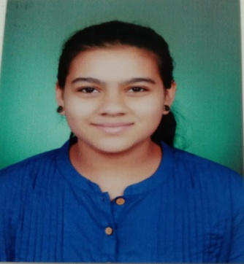

[Shravani Joshi](https://www.linkedin.com/in/shravani-joshi-0023a3269/)

[shravani53](https://leetcode.com/shravani53/)

**Student,Walchand College Of Engineering ,Sangli.**

Sangli – 416416 Maharashtra, India

+91 9763597683 [shravanijoshi262005@gmail.com](mailto:shravanijoshi262005@gmail.com)

**Education**

**Program Institution %/CGPA Year**

TY CSE WCE, Sangli 8.8 2022-2026

HSC (Science) G. A. , Sangli 90.33 2021-2022

SSC L.G.R.PKPS 98 2019-2020

SSC

L.G.R. PKPS, Sangli 98.00 2019-2020

**Projects**

[**My Portfolio – A static Web Page**](https://github.com/Shravani32/My_PortFolio.git)

Showcasing myself in web *- HTML & CSS ,React*

* Programming Languages: C, C++,Java(Novice),Python
* HTML, CSS, JavaScript , React (Novice)
* DSA – [ Linked-List, Stack, Queue, Binary Tree, Searching & Sorting ](Novice)
* Computer Networks ,Operating System,

**Technical Skills**

**Club Experience**

* **ACSES – Departmental Club Of CSEs** 
  + Club Service Director
  + Assistant developer
  + Member

**Coding Platforms**

* Leetcode