WEEK 2 CYBERSECURITY PROJECT REPORT
Footprinting Assessment with theHarvester
and Network Scanning with Zenmap
Practical Documentation • Kali Linux • VirtualBox

Project Area | Cybersecurity — Reconnaissance & Network Scanning
Tools Used | theHarvester and Zenmap (Nmap GUI)
Observed Targets | networkwalks.com; localhost (127.0.0.1)
Environment | Kali Linux running in Oracle VirtualBox

1. Executive Summary
This report documents a Week 2 cybersecurity practical exercise focused on two reconnaissance activities: open-source footprinting with theHarvester and network/service scanning with Zenmap. The work was performed in a Kali Linux virtual-machine environment. theHarvester was used to collect publicly discoverable information associated with the authorized assessment domain, while Zenmap was used to examine the local host at 127.0.0.1. The captured evidence shows hostname discovery during footprinting and a localhost scan in which the host was reachable but no open ports were reported among the 1,000 scanned ports.

2. Objectives
- Understand the role of reconnaissance in a cybersecurity assessment.
- Use theHarvester to collect publicly available domain-related information.
- Observe discovered hostnames/subdomains and understand what they can reveal about an organization's external footprint.
- Use Zenmap to perform a controlled network scan against the local machine.
- Interpret host status, port state, topology, and host-detail information.
- Document limitations and maintain an ethical, authorized testing scope.

3. Tools and Environment
Tool | Purpose | Observed Use
theHarvester 4.10.1 | OSINT footprinting | Searches public sources for domains, hosts, emails, people and related information.
Zenmap / Nmap | Network and service discovery | Scans a target and presents host, port, topology and host-detail information.
Kali Linux | Security testing environment | Used as the operating environment for both practical activities.
Oracle VirtualBox | Virtualization | Hosted the Kali Linux virtual machine.

4. Practical Activity A — theHarvester Footprinting
TheHarvester was run against the domain networkwalks.com using multiple data-source options. The screenshots show searches involving CRT.sh and Baidu, followed by a broader search that produced a list of hostnames/subdomains. The initial source-specific searches reported no IPs, emails, people or hosts for those individual sources, while the broader run displayed multiple hostnames associated with the target domain.

4.1 Key Observations
- CRT.sh source: the captured output reports no IPs, emails, people or hosts from that source.
- Baidu source: the captured output likewise reports no IPs, emails, people or hosts from that source.
- Broader collection: the output contains multiple hostnames/subdomains, including examples such as autodiscover, cpanel, mail, ftp, webdisk and webmail.
- Some hostname entries in the captured output are associated with the IPv4 address 192.232.216.135.
- The tool saved XML and JSON report files during the broader run, providing machine-readable evidence for later documentation.

4.2 Important Limitation
The broader theHarvester screenshot also shows several data-source/API-key errors, including missing API keys for multiple providers. Therefore, the absence of information from those sources must not be interpreted as proof that the target has no such information. The results represent what was obtainable from the configured and accessible sources during this practical.

5. Practical Activity B — Zenmap Network Scanning
Zenmap was configured with the target 127.0.0.1 (localhost) and the profile 'Intense scan'. The visible command was an Nmap scan equivalent to 'nmap -T4 -A -v 127.0.0.1'. The captured host details show the localhost host as up, with 1,000 ports scanned, 0 open ports, 0 filtered ports, and 1,000 closed ports.

5.1 Scan Interpretation
Observation | Meaning
Target | 127.0.0.1 — the local host inside the Kali environment.
Host state | Up — the target responded to the scan.
Open ports | 0 reported in the captured Host Details view.
Filtered ports | 0 reported.
Closed ports | 1,000 reported.
Scanned ports | 1,000 reported.
IPv4 | 127.0.0.1.
IPv6 / MAC | Not available in the captured Host Details view.

5.2 Topology and Host Details
The Zenmap topology view visually represents the localhost as the scanned host. The Host Details view confirms the host status and address information. The Ports/Hosts view contains the scan columns for port, protocol, state, service and version; no open service entries are visible in the supplied evidence.

6. Evidence Captured
The following six screenshots are the selected evidence set. They avoid unnecessary duplication while covering the main footprinting outputs and the main Zenmap views.
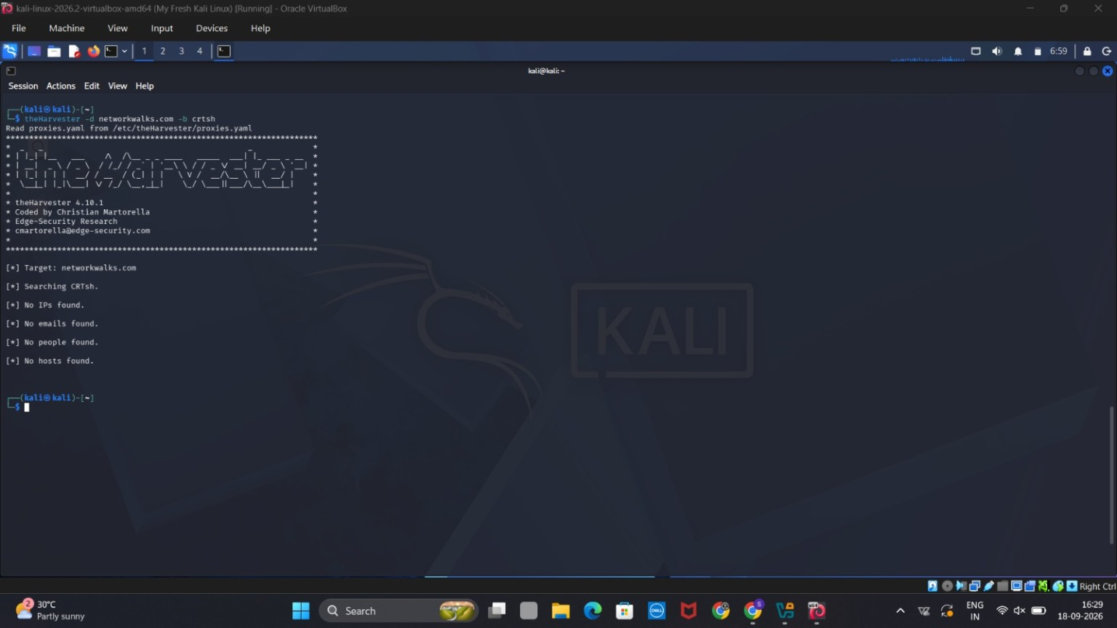
Figure 1 — theHarvester search using the CRT.sh source
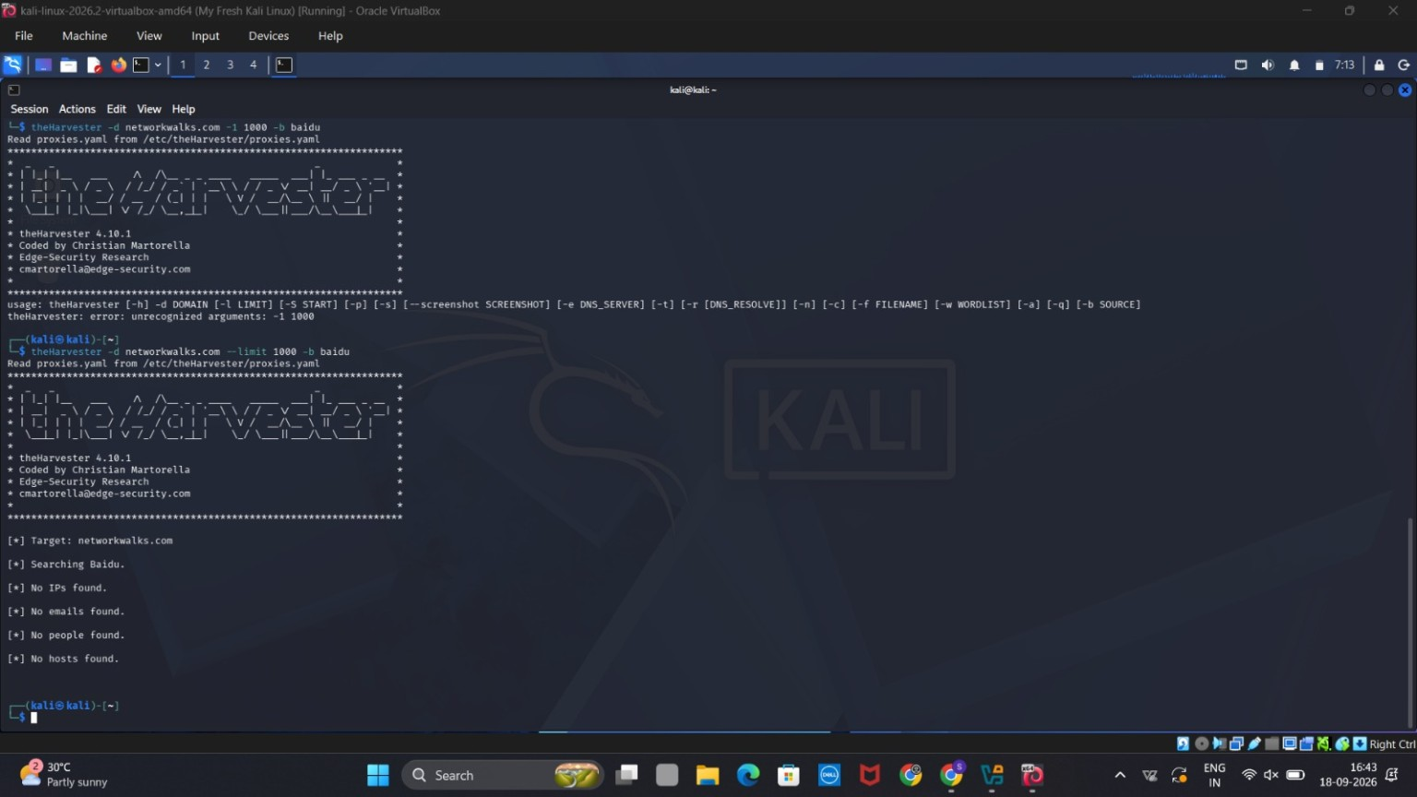
Figure 2 — theHarvester search using the Baidu source
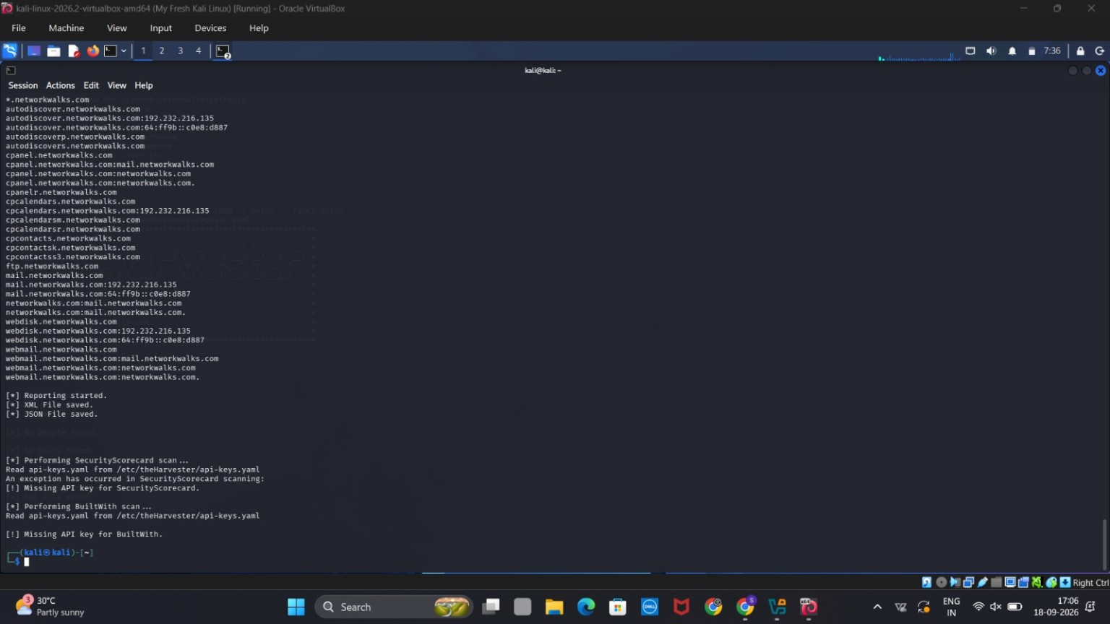
Figure 3 — theHarvester results showing discovered hostnames/subdomains
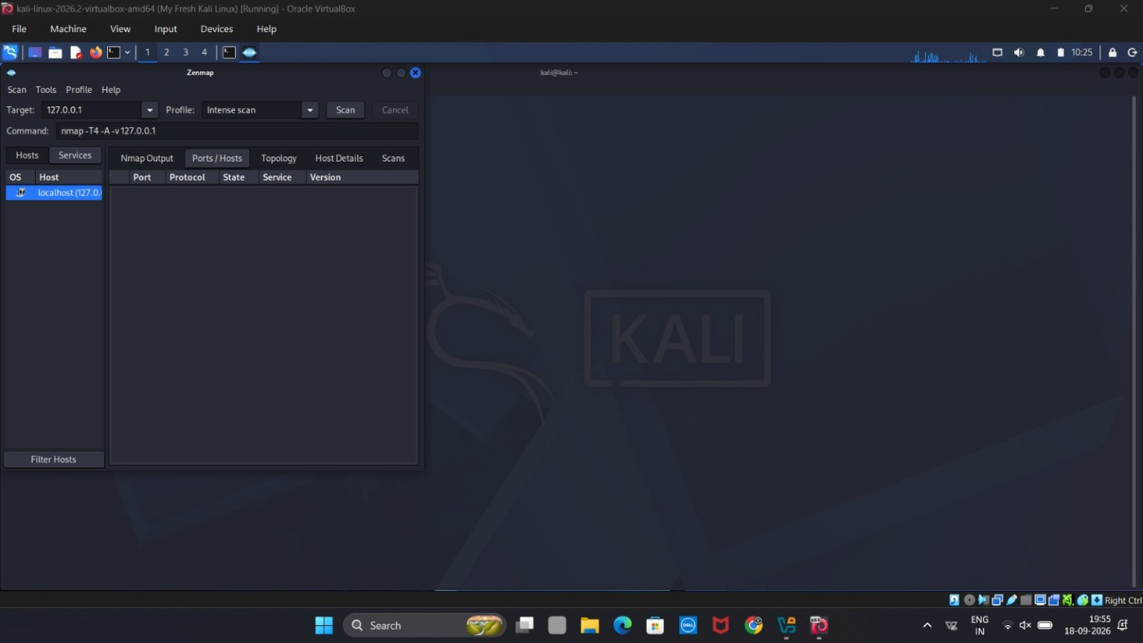
Figure 4 — Zenmap Ports/Hosts view for localhost
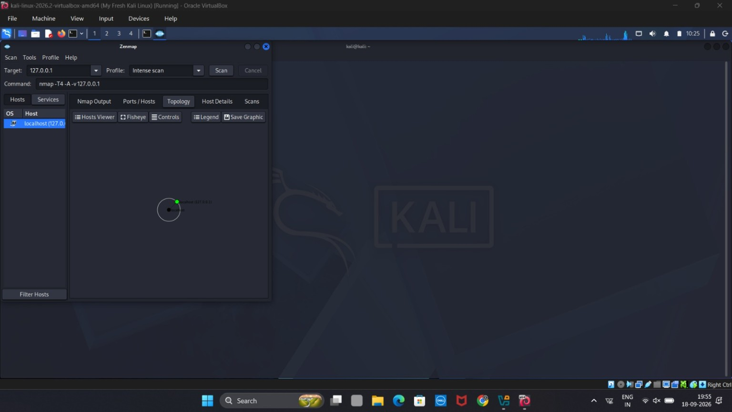
Figure 5 — Zenmap Topology view
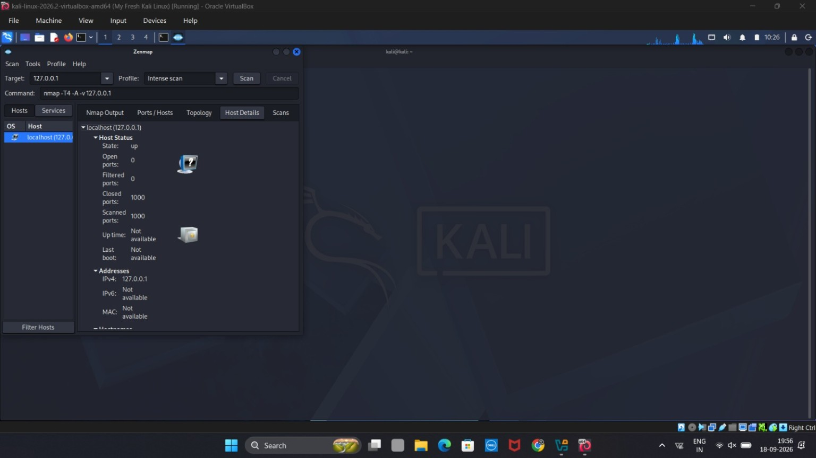
Figure 6 — Zenmap Host Details view

7. Findings
- The footprinting phase demonstrated that different public sources can return different levels of information.
- The broader theHarvester collection exposed a set of publicly discoverable hostnames/subdomains for the target domain.
- The results also demonstrated the practical importance of API configuration when using OSINT aggregation tools.
- The Zenmap scan confirmed that the localhost target was reachable.
- No open ports were reported in the captured 1,000-port localhost scan, so no exposed service was identified by this particular scan.

8. Security Significance
Footprinting helps an assessor understand an organization's externally visible attack surface before deeper testing. Hostnames such as mail, webmail, cpanel or other service-related names can indicate externally exposed functions and therefore deserve appropriate defensive review. Network scanning complements this by identifying reachable hosts and services within an authorized scope. In a real security assessment, these findings would be validated and correlated with asset inventories, DNS records, firewall rules and service configurations.

9. Conclusion
The Week 2 practical successfully demonstrated two foundational cybersecurity reconnaissance techniques. theHarvester was used for passive/public-source footprinting of networkwalks.com and produced hostname information despite several source/API limitations. Zenmap was used for a controlled localhost scan and showed the host as up with all 1,000 scanned ports reported closed in the captured results. The exercise provided practical experience in collecting evidence, interpreting scan results, recognizing tool limitations, and documenting findings professionally.

10. Ethical and Scope Statement
All reconnaissance and scanning documented in this report should be performed only against systems and domains for which the tester has explicit authorization. The Zenmap activity shown here targeted localhost (127.0.0.1), and the footprinting exercise was documented as a controlled practical exercise. Publicly available information should be handled responsibly and not used to access, disrupt or compromise systems without permission.

11. Suggested Repository Structure
- README.md — project overview, objectives, tools, methodology, findings and conclusion.
- screenshots/ — the six selected evidence screenshots.
- reports/ — the final detailed report.
- results/ — exported theHarvester XML/JSON reports, if they are part of the permitted submission.

End of Report

