Description of data:
PassengerId | Pclass | Age | SibSp | Parch | Fare
count | 418.000000 | 418.000000 | 332.000000 | 418.000000 | 418.000000 | 417.000000
mean | 1100.500000 | 2.265550 | 30.272590 | 0.447368 | 0.392344 | 35.627188
std | 120.810458 | 0.841838 | 14.181209 | 0.896760 | 0.981429 | 55.907576
min | 892.000000 | 1.000000 | 0.170000 | 0.000000 | 0.000000 | 0.000000
25% | 996.250000 | 1.000000 | 21.000000 | 0.000000 | 0.000000 | 7.895800
50% | 1100.500000 | 3.000000 | 27.000000 | 0.000000 | 0.000000 | 14.454200
75% | 1204.750000 | 3.000000 | 39.000000 | 1.000000 | 0.000000 | 31.500000
max | 1309.000000 | 3.000000 | 76.000000 | 8.000000 | 9.000000 | 512.329200
Conclusion:
- It gives summary statistics for numerical data .
- Summary statistics : It gives mean, standard deviation, minimum observation, first quantile, second quantile, third quantile and maximum observation
Correlation matrix:
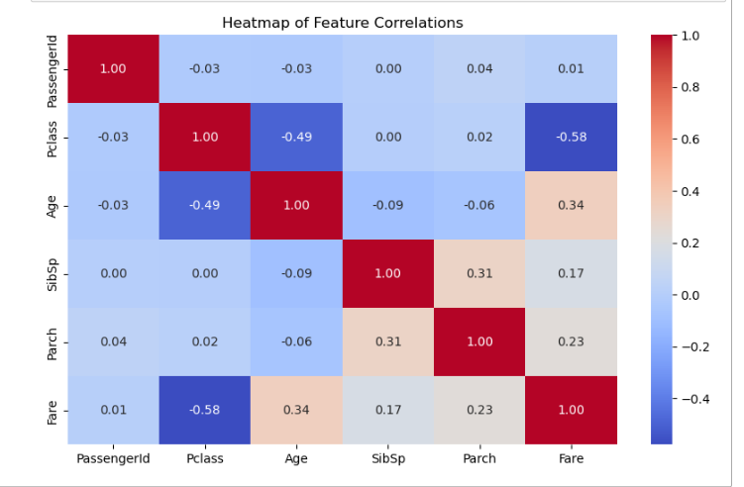
Conclusion:
- SibSp and Parch have a moderate positive correlation (close to 0.4), which makes sense—families traveling together often have both siblings/spouses and parents/children aboard.
- Fare has a positive correlation with Parch and SibSp, suggesting that passengers with more family members on board may have paid higher fares (perhaps due to better accommodations).
- Age has a weak correlation with most other variables, meaning it is relatively independent in this dataset.
- Most features show low or near-zero correlations, indicating they may contribute independently to any predictive model or further analysis.
- Histogram¶
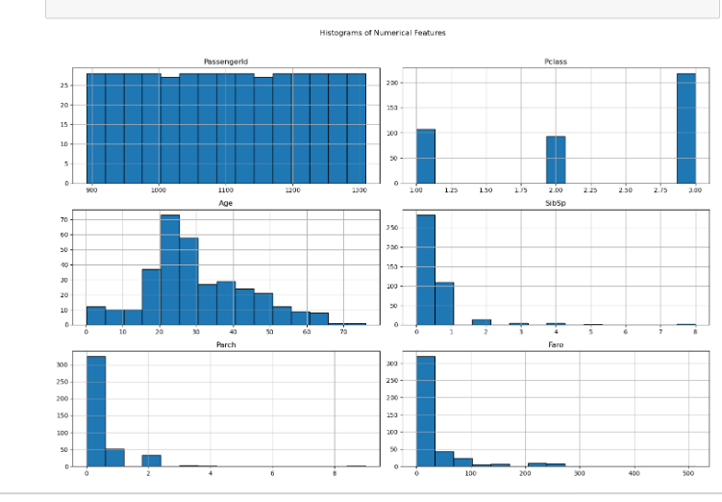
Conclusion:
- Age have positively skewd distribution with peak age between 20-30
- fare has heavily right-skewed. few passengers paid significantly high fare.
- Most passengers had 0 or 1 sibling/ spouse with them showing high concentration at 0.

Boxplot

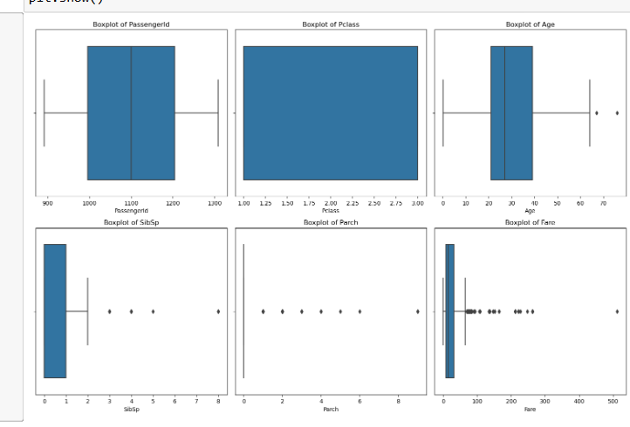
Conclusion:
- PassengerID does not show any outlier. It has approximately normal distribution.
- Age contain outlier having positively skewed distibution. Similarly for fare.
- Sibsp and parch contain more outliers.

