HEALTHCARE DATA ANALYSIS

Overview
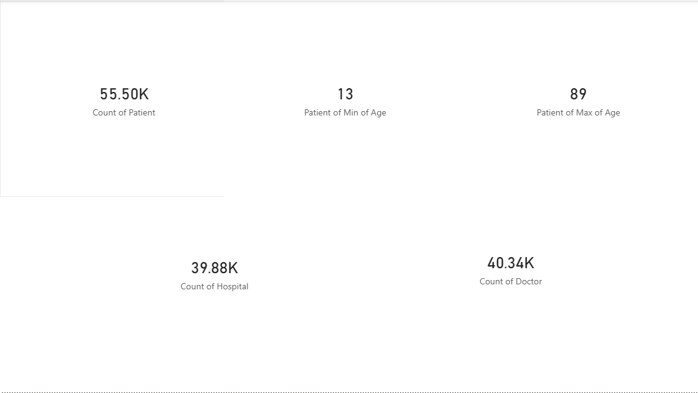
This section presents high-level metrics including total number of patients, minimum and maximum patient age, number of hospitals, and doctors, providing a quick overview of the healthcare dataset scale.

Patient Distribution by Age

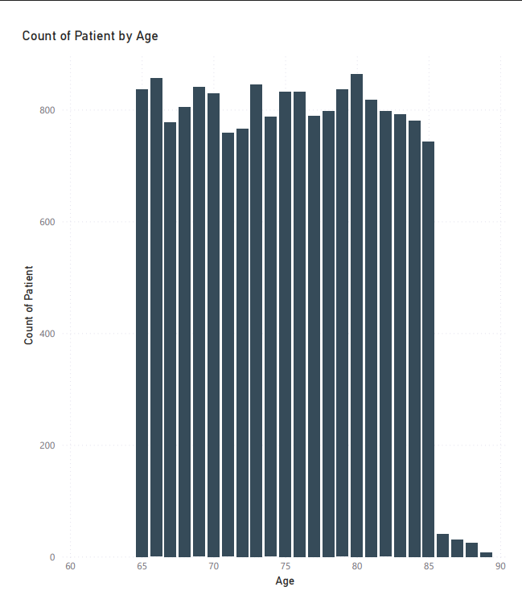
This chart shows the distribution of patients across different ages, highlighting higher healthcare utilization among older age groups.

Patient Distribution by Gender

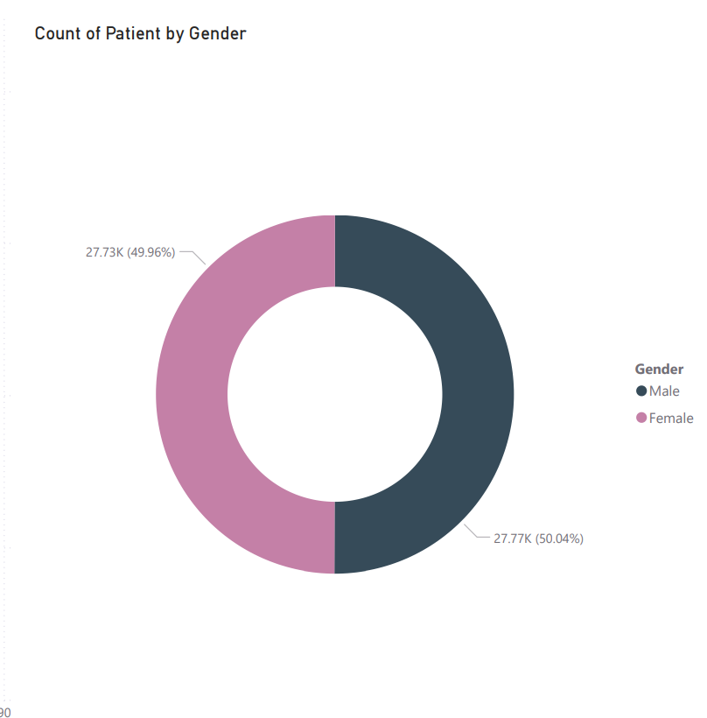

The donut chart represents gender-wise patient distribution, indicating an almost equal proportion of male and female patients.

Patient Count by Medical Condition
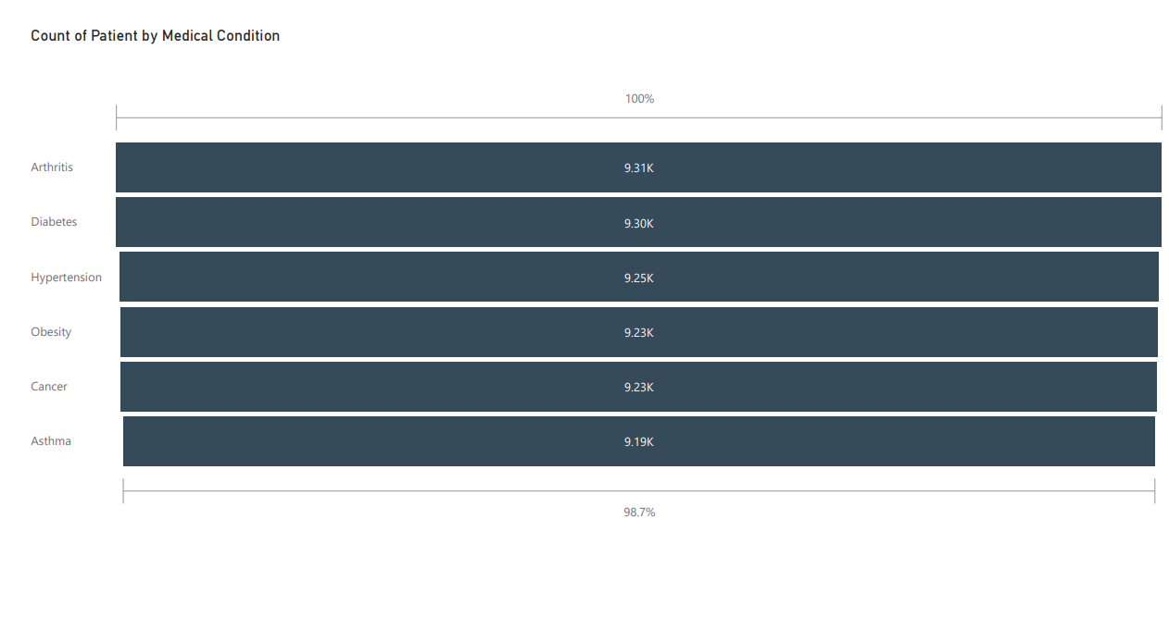
This bar chart displays the number of patients for each medical condition, identifying common chronic diseases such as diabetes, hypertension, and arthritis.

Average Billing Amount by Medical Condition
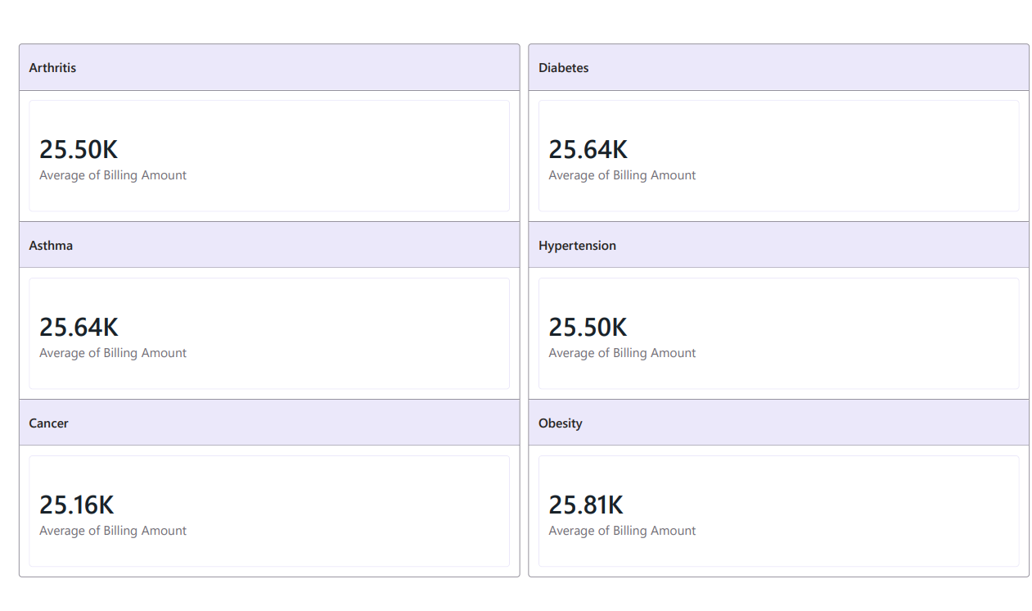
This visualization compares the average treatment cost across different diseases, helping identify cost-intensive medical conditions.

Disease-wise Average Billing Cards
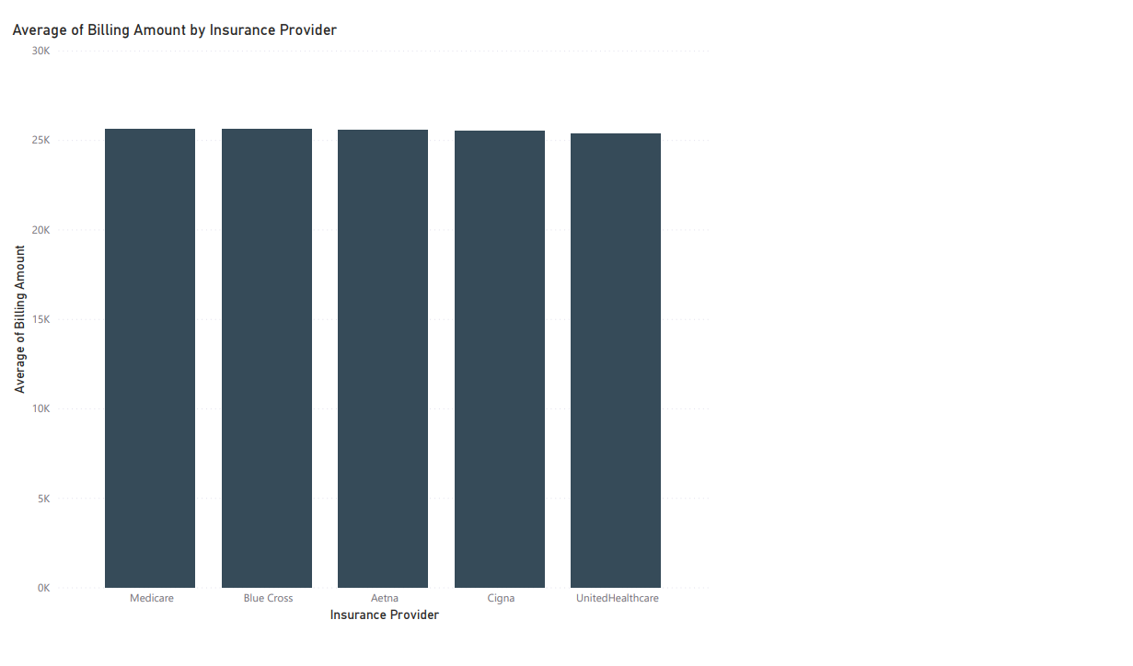

Individual cards highlight the average billing amount for each disease, enabling quick comparison of treatment costs across medical conditions.

