**12. Connect to database using PostgreSQL and get the details of participants in test 1 and age > 50.**

**Python Output:**

**Query:**

import psycopg2conn = psycopg2.connect(  
    dbname="subject_info",  
    user="postgres",  
    password="pgdb",  
    host="localhost",  
    port="5432"  
)cur = conn.cursor()cur.execute("""  
select * from subject_info  
where  
Age > 50  
and  
rtrim(ID_test) like '%\\_1' escape '\\';  
""")column_names = [desc[0] for desc in cur.description]  
results = cur.fetchall()print("Details of Participants in Test 1 and Age > 50:\n")  
print("  ".join(column_names))for row in results:  
  print("\t".join(str(item) for item in row))cur.close()  
conn.close()

**Output:**

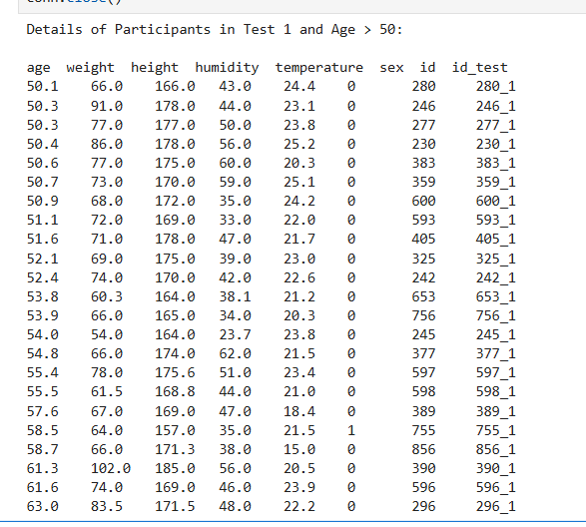

**Sql Output:**

**Query:**

select * from subject_info

where

"Age" > 50

and

rtrim("ID_test") like '%\\_1' escape '\\;

**Output:**

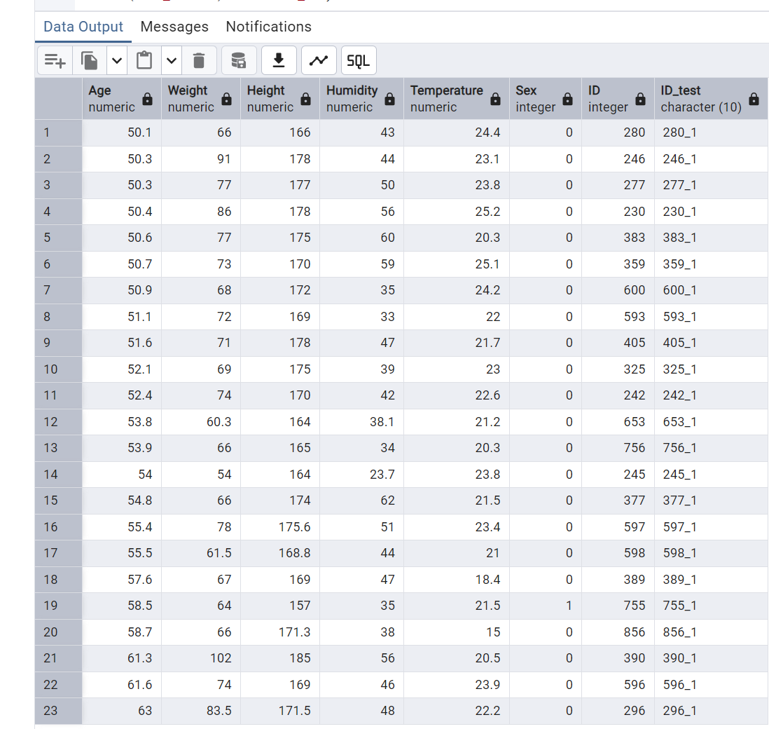

**Question: 33.Connect to database using PostgreSQL and increase the temperature 2 degrees for participant with maximum humidity and display the result.**

**Python Output:**

**Query:**

import psycopg2conn = psycopg2.connect(  
    dbname="subject_info",  
    user="postgres",  
    password="pgdb",  
    host="localhost",  
    port="5432"  
)cur = conn.cursor()cur.execute("""  
    SELECT ID, Humidity, Temperature  
    FROM subject_info  
    WHERE Temperature IS NOT NULL  
    ORDER BY Humidity DESC  
    LIMIT 1;  
""")result = cur.fetchone()if result:  
    id_with_max_humidity = result[0]  
    max_humidity = result[1]  
    current_temperature = result[2]    print("Details of participant with maximum humidity:\n")  
    print(f"Participant ID: {id_with_max_humidity}, Max Humidity: {max_humidity}, Current Temperature: {current_temperature}")    simulated_temperature = current_temperature + 2    print(f"Temperature increased to {simulated_temperature}° for Participant ID: {id_with_max_humidity}")    cur.execute("""  
        SELECT ID, Age, Weight, Height, Humidity, Temperature, Sex, ID_test  
        FROM subject_info  
        WHERE ID = %s;  
    """, (id_with_max_humidity,))    original_result = cur.fetchone()  
    if original_result:        result = list(original_result)  
        result[5] = simulated_temperature

    print("Updated participant info:")  
        print(tuple(result))cur.close()  
conn.close()

**Output:**

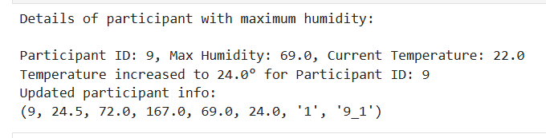

**SQL Output:**

**Query:**

Select id, id_test,humidity, temperature

Temperature + 2 as “increased_temperature+2”

From subject_info

Where humidity=(select max(humidity) from subject_info)

**Output:**

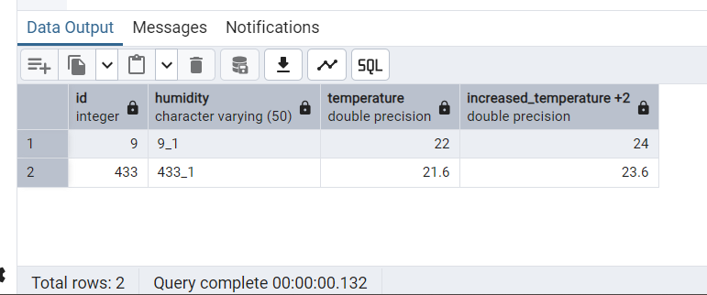

**Question 27: (*for some reason this chart is not shown after the merge)**

