Final. Year. B. Tech (ECE)
Natural Language Processing LCA : 2

Name : Shravani Prashant Deshpande
Final Year ECE Core
PRN : 1032222493
Date : 15/3/2026

- Problem Statement :

Problem no. 36 : Analyze word frequency distribution across BBC vs Reuters.

- Datasets Used:
Two datasets are used in this project:

BBC News Dataset:
The BBC dataset consists of news articles collected from the BBC news platform. Each record contains several attributes including:
- Title
- Publication date
- Description
- Link to the article
For this analysis, the title and description fields are used as the primary textual content.
The dataset contains approximately 42,115 news articles, covering various topics such as politics, international news, business, and social issues.
Link: https://www.kaggle.com/datasets/gpreda/bbc-news

Reuters Dataset:
The Reuters dataset contains a collection of news articles stored as individual text files organized into folders such as training and test.
Reuters is widely known for publishing financial, economic, and business-related news.
The dataset contains thousands of articles covering topics such as:
- Financial markets
- Business news
- Global trade
- Economic policies
Link: https://www.kaggle.com/datasets/nltkdata/reuters

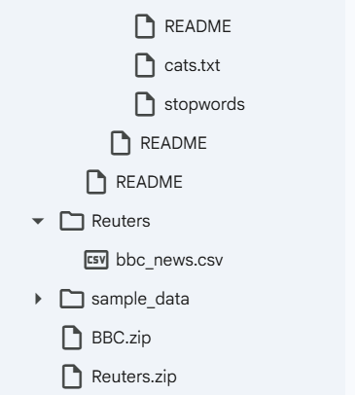
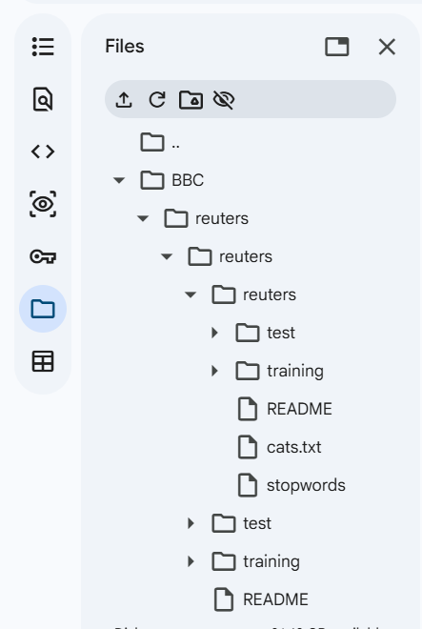

- Problem Statement Description:

The objective of this project is to analyze and compare the word frequency distribution between the BBC News dataset and the Reuters dataset using Natural Language Processing techniques.
The tasks involved in this analysis include:
- Loading the datasets
- Performing text preprocessing
- Tokenizing the text
- Removing stopwords and punctuation
- Applying lemmatization
- Computing word frequency distribution
- Visualizing the results using graphs
The goal is to identify the most frequent words in both datasets and analyze the differences in their vocabulary patterns.

- Methodology:

The following steps were followed to perform the analysis.

Data Extraction:
Both datasets were initially uploaded in ZIP format and extracted using Python’s zipfile library. This allowed access to the dataset files for further processing.

Text Preprocessing:
Text preprocessing is an important step in NLP to clean and normalize the data before analysis. The following preprocessing techniques were applied:

Tokenization:
Tokenization is the process of splitting text into individual words or tokens.

Stopword Removal:
Stopwords are commonly used words such as the, is, and, of which do not add meaningful information. These words were removed using the NLTK stopword list.

Punctuation Removal:
Punctuation symbols were removed to ensure that only meaningful words remain.

Lemmatization:
Lemmatization converts words to their base or root form.

Example:
- running → run
- companies → company
This helps in treating different forms of a word as the same word.

Word Frequency Calculation:
After preprocessing, all tokens were collected and the frequency of each word was calculated using the Counter() function from the collections library.
The top 20 most frequent words were extracted from each dataset.

Data Visualization:
Bar graphs were generated using Matplotlib to visualize the most frequently occurring words in both datasets. These visualizations help compare vocabulary patterns between BBC and Reuters news articles.

- Results:

The preprocessing and analysis steps produced the following results :

BBC Dataset Results:
The most frequently occurring words in the BBC dataset were extracted after preprocessing the text data.

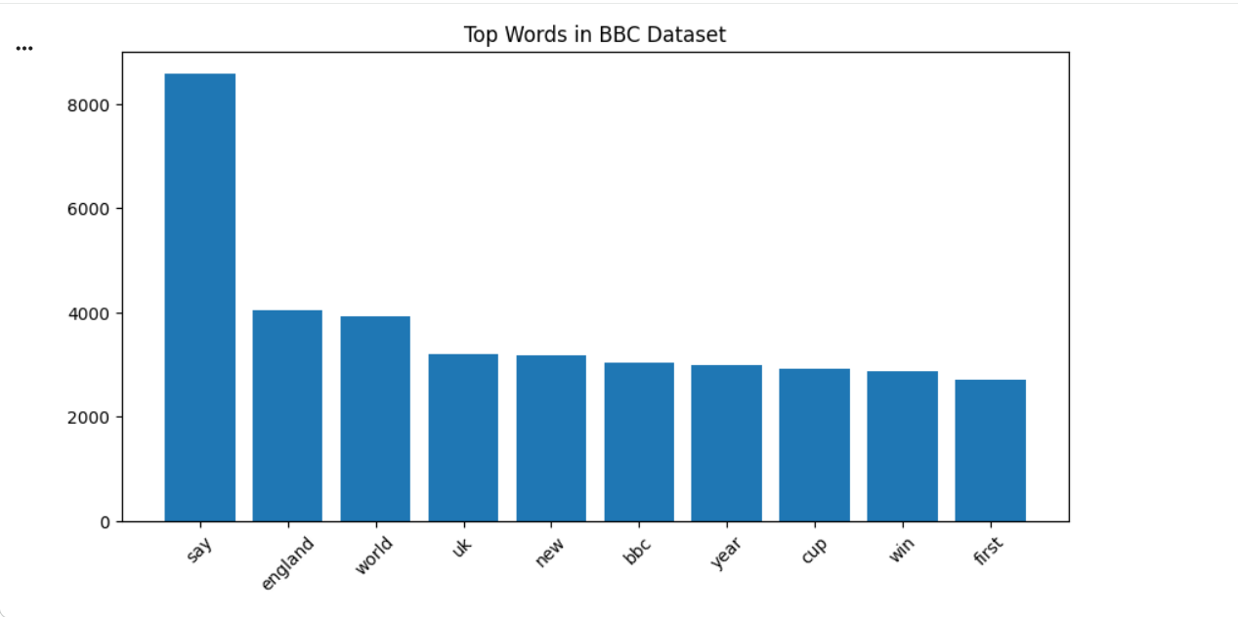These words indicate that BBC articles frequently discuss global events, political developments, and public affairs.

Reuters Dataset Results:

The most frequent words from the Reuters dataset were also extracted and analyzed.
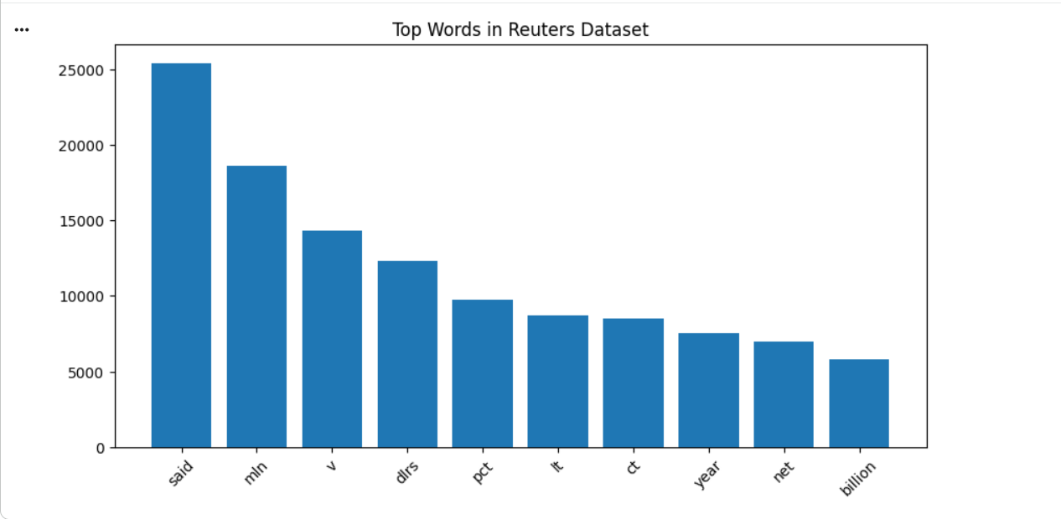

The vocabulary used in Reuters articles shows a strong emphasis on financial and economic topics.

Comparative Visualization:

A combined graph was generated to compare the most frequent words in both datasets.
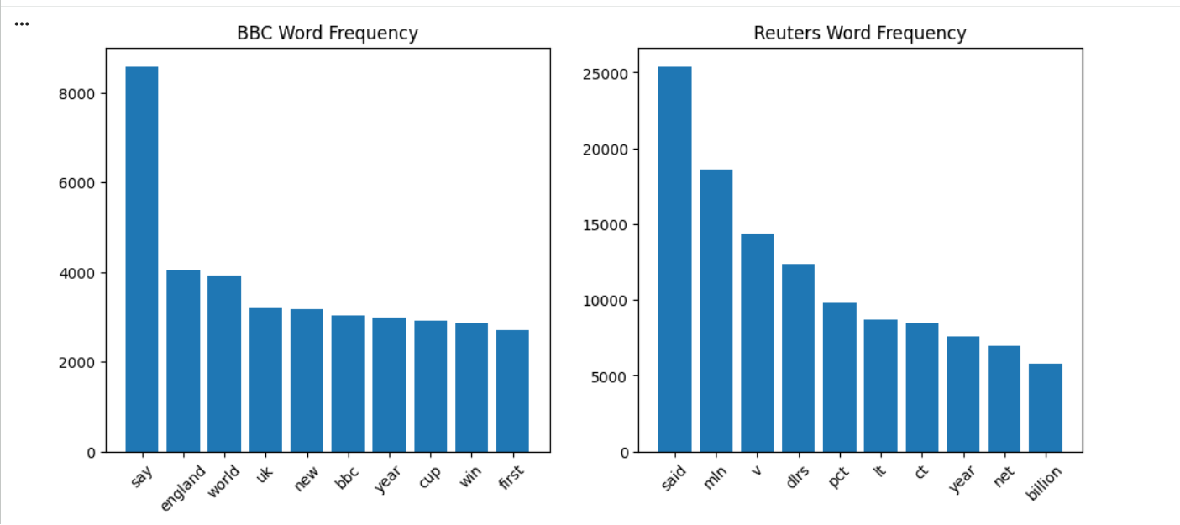
This comparison clearly highlights the differences in vocabulary usage between the two news sources.

- Analysis:

The word frequency analysis reveals noticeable differences in the language patterns of BBC and Reuters news articles.

BBC News:
BBC articles tend to focus on broader global issues such as:
- Politics
- International conflicts
- Social developments
- Public policy
As a result, commonly appearing words include terms related to people, governments, countries, and global events.

Reuters News:
Reuters articles emphasize financial and economic reporting. Frequently appearing terms include words related to:
- Markets
- Companies
- Trade
- Oil and commodities
This indicates that Reuters is more specialized in business and financial journalism.

- Conclusion:
In this project, I analyzed and compared the word frequency distribution of two news datasets: the BBC News dataset and the Reuters dataset using Natural Language Processing techniques.
To perform the analysis, I first cleaned the text data by applying several preprocessing steps such as tokenization, stopword removal, punctuation removal, and lemmatization. These steps helped remove unnecessary words and standardize the text so that meaningful words could be analyzed more effectively. After preprocessing, I calculated the frequency of each word and visualized the most common words using bar graphs.
From the results, I observed that the BBC dataset contains a wider variety of words related to global events, politics, and social issues, which reflects its focus on general news coverage. On the other hand, the Reuters dataset contains more specialized terms related to finance, markets, companies, and trade, indicating its strong focus on business and economic reporting.
Overall, this analysis shows how word frequency distribution can reveal the main themes and focus of different news sources. Even with simple NLP techniques, it is possible to gain useful insights into large text datasets and understand differences in the type of information they provide.

- Tools and technologies used:
Python
NLTK (Natural Language Toolkit)
Pandas
Matplotlib
Google Colab
- References:

BBC News Dataset:
The dataset contains approximately 42,115 news articles, covering various topics such as politics, international news, business, and social issues.
Link: https://www.kaggle.com/datasets/gpreda/bbc-news

Reuters Dataset:
The Reuters dataset contains a collection of news articles stored as individual text files organized into folders such as training and test.
Link: https://www.kaggle.com/datasets/nltkdata/reuters

