Rock-Paper-Scissors Project — Complete Setup Guide
Asked Claude to give me the files I need to send you in order to make your project working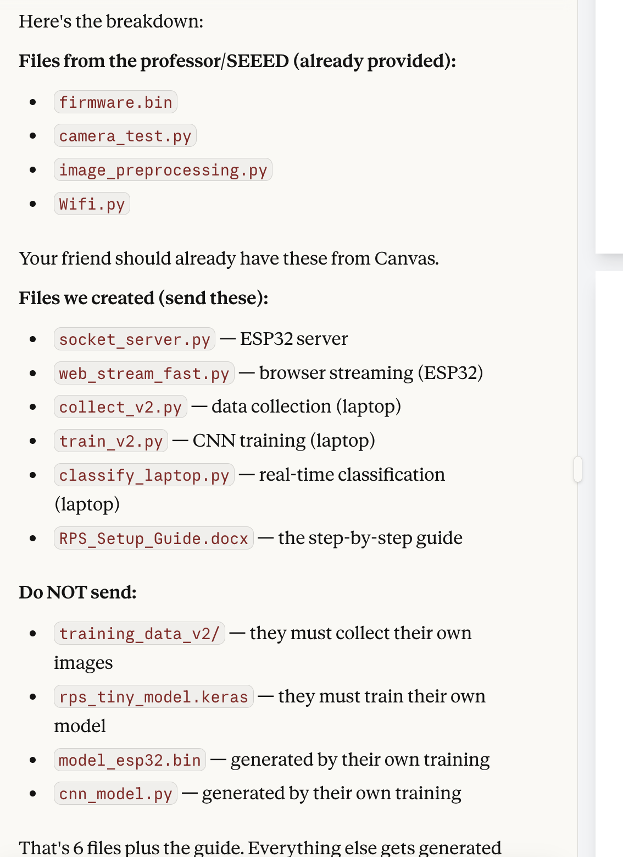

These are the steps you need to follow.
All Files Overview

Files that go on the ESP32 (via Thonny)
File | Purpose
firmware.bin | MicroPython firmware — flash this onto the ESP32 first
camera_test.py | Tests the camera is working (provided by SEEED)
image_preprocessing.py | Image resizing/processing utilities (provided by SEEED)
Wifi.py | WiFi connection helper (provided by Sharil Tumin)
socket_server.py | Runs on ESP32 — captures images and sends them over WiFi to laptop
web_stream_fast.py | Runs on ESP32 — streams camera to a web browser (optional)
model_esp32.bin | CNN model weights for on-device classification (optional)
cnn_model.py | CNN inference engine for ESP32 (optional — for on-device classification)
classify.py | On-device classification script (optional — laptop classification is better)

Files that stay on your Laptop (Mac)
File | Purpose
collect_v2.py | Collects training images from ESP32 camera — saves as numpy arrays
train_v2.py | Trains the CNN model using collected data
classify_laptop.py | Real-time classification — receives images from ESP32 and predicts
socket_client.py | Simple client to capture/view images from ESP32 (used early on)
collect_data.py | Earlier version of data collection (replaced by collect_v2.py)
fix_model.py | Fixes model export for ESP32 (run once after training)
rps_tiny_model.keras | Saved trained model (generated by train_v2.py)
training_data_v2/ | Folder containing all training images (generated by collect_v2.py)

Step-by-Step Setup

PHASE 1: Flash the Firmware
1. Download firmware.bin from Canvas.
2. Connect the ESP32 to your computer with a USB-C cable.
3. Open Thonny IDE.
4. Go to Run → Configure interpreter → Install or update MicroPython.
5. Click the hamburger menu (≡) and select the local file option.
6. Set MicroPython family to "ESP32-S3".
7. Set variant to "<local file>" and browse to firmware.bin.
8. Set Install speed to 38400.
9. Make sure the correct Target port is selected (e.g. /dev/cu.usbmodem101 on Mac).
10. Put ESP32 in bootloader mode: Hold BOOT button, briefly press RESET, release BOOT.
11. Click Install. Wait a few minutes.
12. Unplug the ESP32 USB cable and replug it.
13. In Thonny, click the port at the bottom-right to reconnect.
14. Type help() in the REPL to verify the firmware is working.

PHASE 2: Upload Helper Scripts to ESP32
1. In Thonny, go to View → Files to see the file browser.
2. In the top pane (your computer), navigate to your project folder.
3. Right-click each of these files and select "Upload to /":
• camera_test.py
• image_preprocessing.py
• Wifi.py
• socket_server.py
4. Verify they appear in the bottom pane (MicroPython device).

PHASE 3: Test the Camera
1. Open camera_test.py from the bottom pane (ESP32).
2. Click the green Run button.
3. You should see camera settings printed and "Captured Image of size: XXXXX".
4. If this works, your camera is set up correctly.

PHASE 4: Connect WiFi
1. Connect the external antenna to the ESP32 (tiny U.FL connector under the camera module — you may need to lift the camera to access it).
2. Set up a phone hotspot (the ESP32 only supports 2.4 GHz WiFi).
3. In the Thonny REPL, type:
import network
wlan = network.WLAN(network.STA_IF)
wlan.active(True)
wlan.connect("YourHotspotName", "YourPassword")

4. Wait 5-10 seconds, then type: wlan.isconnected() — should return True.
5. Type: wlan.ifconfig() — note the IP address (e.g. 172.20.10.4).
6. IMPORTANT: Your laptop must also be connected to the same hotspot.

PHASE 5: Run the Socket Server on ESP32
1. After WiFi is connected (Phase 4), open socket_server.py from the bottom pane in Thonny.
2. IMPORTANT: Before running, edit socket_server.py — replace the WiFi section:
Change "from Wifi import Sta" and the Sta() code to:
import network
wlan = network.WLAN(network.STA_IF)
ip = wlan.ifconfig()[0]
(Since WiFi is already connected manually)
3. Click the green Run button.
4. It should print "Server listening on X.X.X.X:8080" and "Waiting for client to connect..."
5. The ESP32 is now ready to accept connections from your laptop.

PHASE 6: Install Laptop Dependencies
Open Terminal on your Mac and run:
pip3 install tensorflow numpy

If tensorflow fails, try: pip3 install tensorflow-macos numpy

PHASE 7: Collect Training Data
1. Make sure socket_server.py is running on the ESP32 (Phase 5).
2. Open collect_v2.py in a text editor and update the ESP32_IP to match your ESP32's IP address.
3. In Terminal, navigate to your project folder:
cd "/path/to/your/project/folder"
4. Run: python3 collect_v2.py
5. It will connect to the ESP32 and show a menu.
6. Select r (rock), p (paper), or s (scissors) to choose what gesture to capture.
7. Hold up the gesture in front of the camera.
8. Press ENTER to capture one image, or type a number (e.g. 20) for burst capture.
9. Collect at least 150 images per class (450+ total).
10. Type "done" to go back, then "q" to quit.
TIPS FOR GOOD DATA:
• Keep the same lighting and background throughout.
• Vary hand angle and distance slightly between bursts.
• Make each gesture clearly distinct.
• Collect data in the same conditions you will classify in.

PHASE 8: Train the CNN Model
1. In Terminal, run: python3 train_v2.py
2. This will load your training images, augment them, train the CNN for 50 epochs.
3. It takes a few minutes. At the end it will show test accuracy.
4. It automatically saves:
• rps_tiny_model.keras (the trained model)
• model_esp32.bin (weights for ESP32)
• cnn_model.py (inference code for ESP32)
5. Target: 90%+ test accuracy. If lower, collect more data and retrain.

PHASE 9: Real-Time Classification
1. Make sure socket_server.py is running on the ESP32.
2. Open classify_laptop.py and update ESP32_IP if needed.
3. In Terminal, run: python3 classify_laptop.py
4. It connects to the ESP32 and waits for you to press Enter.
5. Hold up a gesture (rock/paper/scissors) and press Enter.
6. It captures a fresh image, processes it, and prints the prediction with confidence.
7. Type "q" to quit.

PHASE 10: Browser Streaming (Optional)
1. Connect WiFi on the ESP32 manually (Phase 4).
2. Upload web_stream_fast.py to the ESP32 if not already there.
3. Update the WiFi credentials in web_stream_fast.py.
4. Run web_stream_fast.py on the ESP32.
5. Open the printed URL (e.g. http://172.20.10.4) in your browser.
6. You can view the live camera feed, switch between full-size and 32×32 modes.

Troubleshooting
Problem: "Wifi Internal Error"
Solution: Unplug the ESP32, replug it, reconnect in Thonny, and try WiFi connection again. Always connect WiFi manually in the REPL before running any server scripts.
Problem: "Device is busy"
Solution: Click the red Stop button in Thonny, then try again.
Problem: "Operation timed out" on laptop
Solution: Make sure both the ESP32 and your laptop are on the SAME WiFi network (same phone hotspot). Check that the IP address in the laptop script matches what the ESP32 printed.
Problem: Camera error "ESP_ERR_INVALID_STATE"
Solution: Unplug and replug the ESP32. The camera can only be initialized once per boot.
Problem: Images too dark
Solution: Adjust brightness and contrast in collect_v2.py (BRIGHTNESS_BOOST and CONTRAST_FACTOR). Also try better lighting or removing the lens cover.
Problem: Low classification accuracy
Solution: Collect more training data in the same conditions you classify in. The #1 cause of poor accuracy is mismatch between training and testing conditions.
Problem: WiFi scan returns empty list
Solution: The antenna is not connected. Press the tiny U.FL connector firmly until it clicks.

Quick Start (After Initial Setup)
Once everything is set up, here is the quick process to get running each time:
1. Plug in ESP32, open Thonny, reconnect.
2. Connect WiFi in REPL:
import network
wlan = network.WLAN(network.STA_IF)
wlan.active(True)
wlan.connect("YourHotspot", "YourPassword")
# Wait, then: wlan.isconnected() → True
# Note IP: wlan.ifconfig()
3. Run socket_server.py on ESP32 (green Run button).
4. On Mac Terminal:
cd "/path/to/project"
python3 classify_laptop.py
5. Press Enter to classify gestures!

