Name: Shravani Talwar
Roll No: CO3110

Assignment No: 02

Practical Title: Installation and Configuration of virtualization using KVM.

Objectives:
- Understand the concept of virtualization.
- Be able to setup and configure KVM.

Software Requirement:
- Ubuntu 20.04

Theory:
- Virtualization :-
Virtualization is a technology that enables a single physical computer or server to run multiple virtual systems simultaneously. Instead of using separate hardware for each task, virtualization creates virtual environments that share the same physical resources such as CPU, memory, and storage.

Virtualization in Cloud Computing :-
Virtualization in cloud computing refers to the use of virtualization technology to provide cloud services such as virtual servers, storage, and networking using a single physical infrastructure.

Types of Virtualizations:

  - Server Virtualization: Server virtualization divides a single physical server into multiple virtual servers using a hypervisor. Each virtual server runs its own operating system and applications independently.

  - Storage Virtualization: Storage virtualization combines multiple physical storage devices into a single virtual storage system. Users see it as one large storage unit instead of multiple devices.
  - Network Virtualization: Network virtualization creates virtual networks by combining hardware and software resources. Multiple virtual networks can operate on the same physical network.

  - Desktop Virtualization: Desktop virtualization allows users to access their desktop environment from a remote server instead of a local machine.

  - Application Virtualization: Application virtualization allows applications to run without being installed directly on the user's system. The application is executed in a virtual environment.

Kernel-Based Virtual Machine (KVM) :-
KVM (Kernel-Based Virtual Machine) is an open-source virtualization technology integrated into the Linux operating system. It converts the Linux kernel into a hypervisor, allowing multiple virtual machines to run on a single physical machine. Each virtual machine has its own virtual CPU, memory, storage, and network interface, and can run different operating systems such as Linux or Windows independently. KVM uses hardware virtualization support like Intel VT-x and AMD-V to achieve high performance.

Steps to create KVM:
  - Install KVM and Virtual Machine Manager:
Open the terminal and install the required virtualization packages such as QEMU-KVM, libvirt daemon, libvirt clients, and virt-manager using the package manager.
These packages provide the hypervisor, virtualization services, and graphical management tool required to create and manage virtual machines.

Commands :-
- Check Virtualization Support:-
egrep -c '(vmx|svm)' /proc/cpuinfo
- Update Package List
sudo apt update

- Install KVM & Required Packages
sudo apt install -y qemu-kvm libvirt-daemon-system libvirt-clients virt-manager
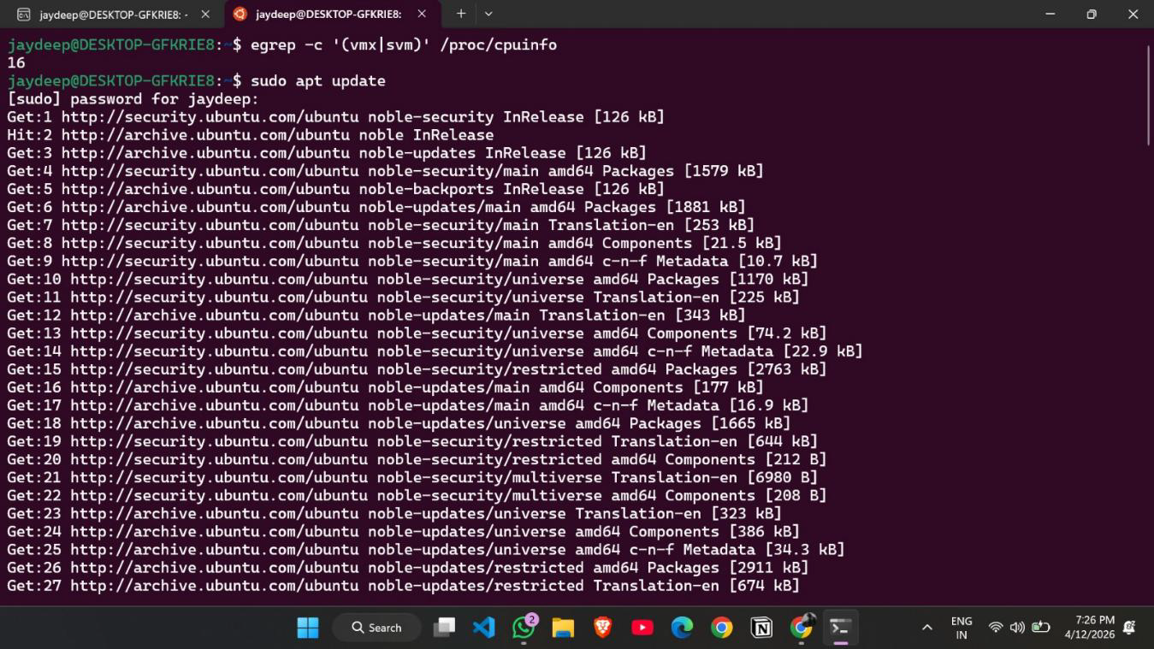

Add User to the libvirt Group:
Add the current user to the libvirt group so that the user has permission to manage virtual machines without needing root privileges.
After adding the user to the group, the changes allow access to virtualization services through virt-manager.

Commands :-
1) Start libvirt Service
sudo systemctl start libvirtd
2) Enable libvirt Service (Auto-start)
sudo systemctl enable libvirtd
3) Verify Installation (List VMs)
sudo virsh list --all
4) Add User to libvirt Group
sudo usermod -aG libvirt $USER

5) Launch Virtual Machine Manager
virt-manager
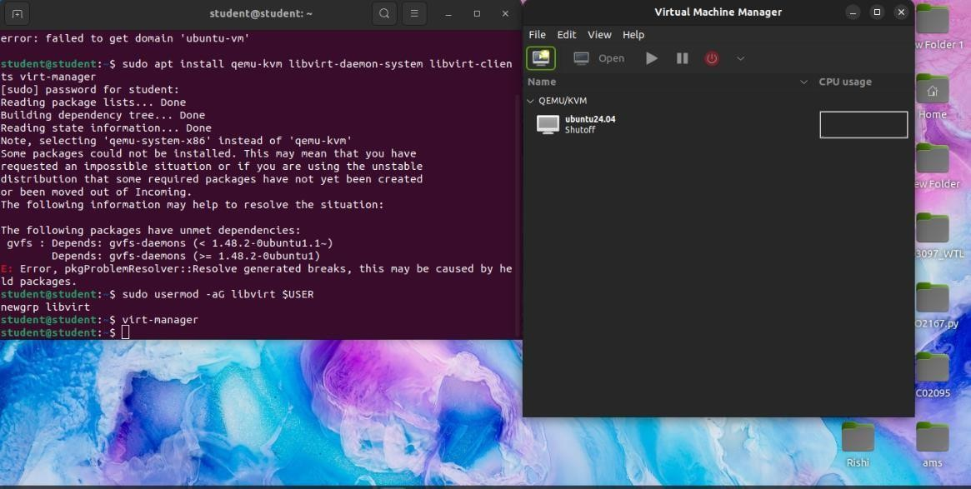

Launch the Virtual Machine Manager:
Start the Virtual Machine Manager (virt-manager) application.
This graphical interface connects to the QEMU/KVM hypervisor and allows users to create, configure, start, stop, and monitor virtual machines.

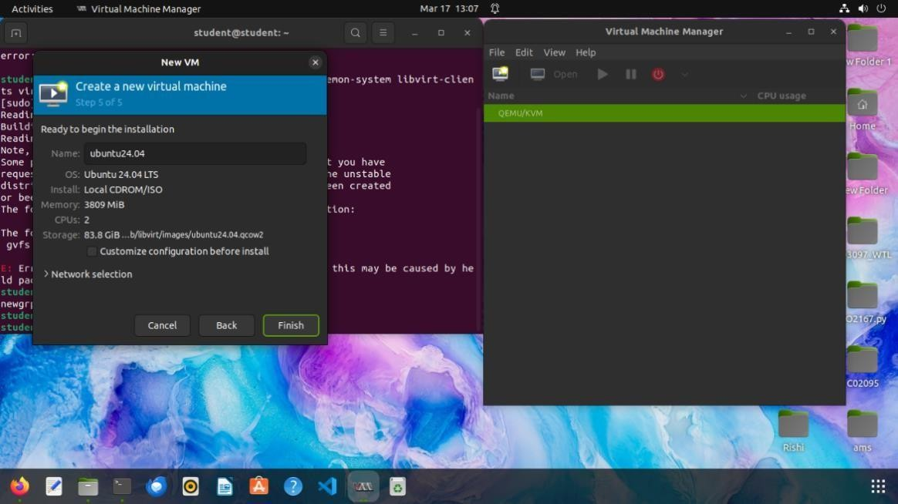

Select Installation Media:
In the Create a New Virtual Machine wizard, choose the installation method by selecting a local ISO installation media.
Browse and select the Ubuntu installation ISO file.
The system automatically detects the operating system type from the installation media.
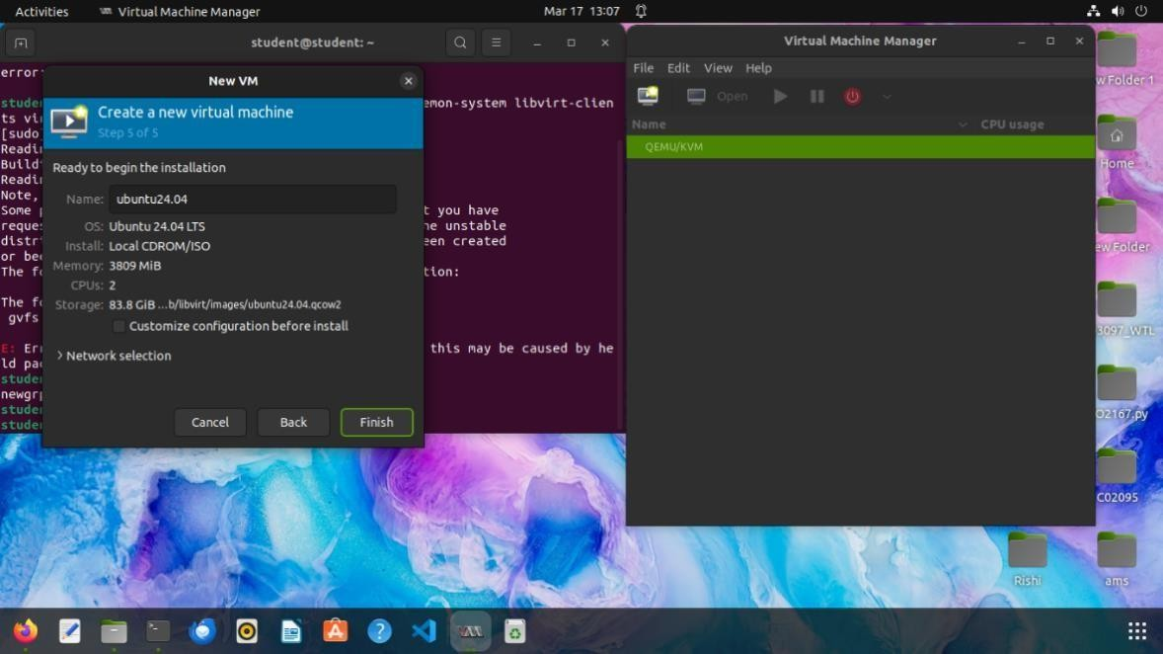

Review Virtual Machine Configuration:
After configuring the virtual machine resources, a summary window displays the configuration details such as:
    - Virtual machine name
    - Operating system type
    - Allocated memory
    - Number of CPUs
    - Storage location and disk size
This step confirms the configuration before starting the installation.

Start the Virtual Machine:
Click Finish to create and start the virtual machine.
The virtual machine appears in Virtual Machine Manager with the status Running, and a console window opens where the operating system installation begins.
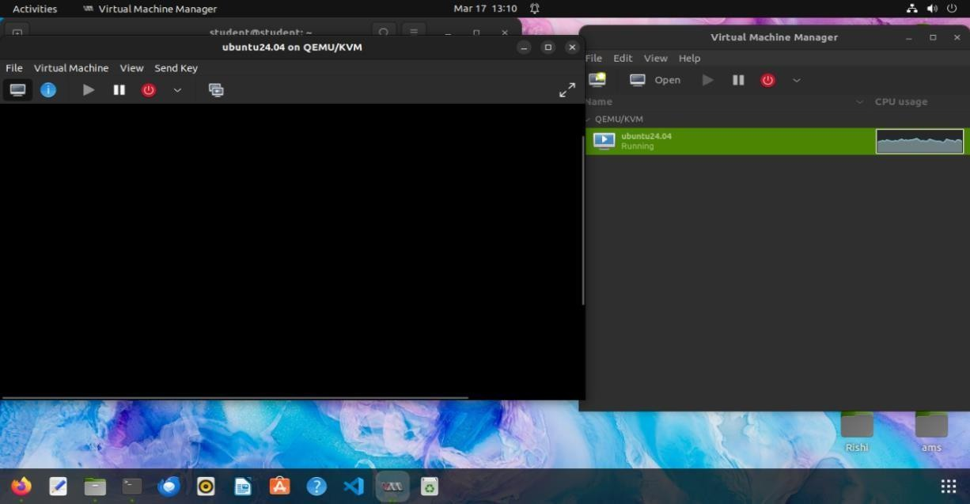

Install the Operating System and Complete Setup:
After starting the virtual machine, the console window displays the operating system installation screen (e.g., Ubuntu installer).
Follow the on-screen instructions to complete the installation process, such as selecting language, time zone, keyboard layout, and creating user credentials. Once the installation is finished, restart the virtual machine and log in to the system.
The virtual machine is now ready to use for further operations and applications.
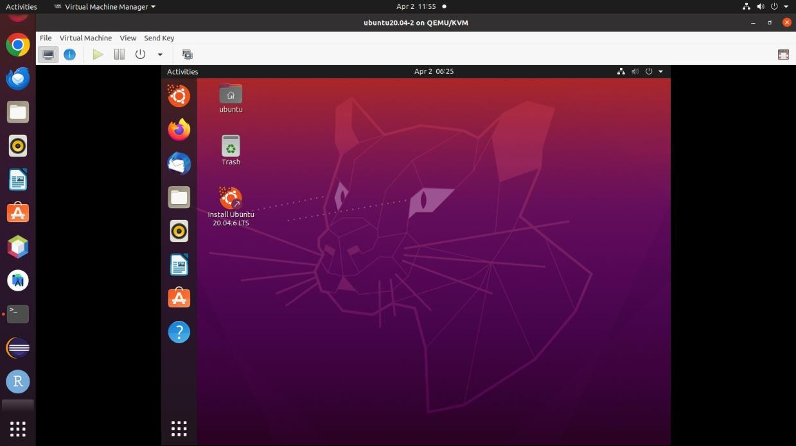
Conclusion: Understood the concept of Virtualization and successfully created a KVM.

