SMS Transaction Parser — Architecture
Sep 29, 2026 · @Shravani

Overview
The project fine-tunes a small open model (0.5B–1.5B parameters) with LoRA to turn Indian bank and UPI transaction SMS into structured JSON, then compares it against regex and a large API model on accuracy, speed, cost and privacy.
Problem. Every Indian bank writes transaction SMS in its own format: different abbreviations (A/c, Acct, INR, Rs.), date styles and field order. Regex breaks on new formats, and sending financial SMS to a cloud API is a privacy risk.
Core question the project answers: for a narrow, high-volume extraction task, is a fine-tuned small model good enough to replace a prompted large model, and at what volume does it become cheaper?
Success criteria
- Fine-tuned small model reaches at least 95% field-level accuracy on a held-out set of real SMS
- At least 99% of outputs are valid JSON matching the schema
- Runs locally on a laptop CPU with no data leaving the device
- A results table and break-even point published in the README

Scope and output schema
The model reads one SMS and returns one JSON object with the fields below; every field not present in the SMS is null.
Field | Type | Example | Rule
is_transaction | boolean | true | false for OTP, promo, failed or pending payment
type | "debit" / "credit" | debit | Refunds and cashback count as credit
amount | number | 450.00 | Rupees, no commas or symbol
account_last4 | string | 1234 | Last 4 digits only, never full number
merchant | string | Swiggy | Normalised brand name, not raw VPA
vpa | string | swiggy@icici | UPI ID if present
mode | enum | UPI | UPI, IMPS, NEFT, CARD, ATM, NETBANKING, OTHER
date | string | 2026-09-28 | Always YYYY-MM-DD
ref_no | string | 426512345678 | UPI or transaction reference
balance | number | 12340.50 | Available balance after transaction
bank | string | HDFC | Short bank or wallet name
Example
Input: Rs.450.00 debited from A/c XX1234 on 28-09-26 to VPA swiggy@icici. UPI Ref 426512345678. Avl Bal Rs.12,340.50 -HDFC Bank
{"is_transaction": true, "type": "debit", "amount": 450.00, "account_last4": "1234", "merchant": "Swiggy", "vpa": "swiggy@icici", "mode": "UPI", "date": "2026-09-28", "ref_no": "426512345678", "balance": 12340.50, "bank": "HDFC"}
Out of scope for v1: spending categories (food, travel), multi-SMS threads, languages other than English, and credit card statements. These are stretch goals.

System architecture
The system has four layers: data feeds the models, one harness scores every model on the same real test set, and the winning adapter is exported for local use.
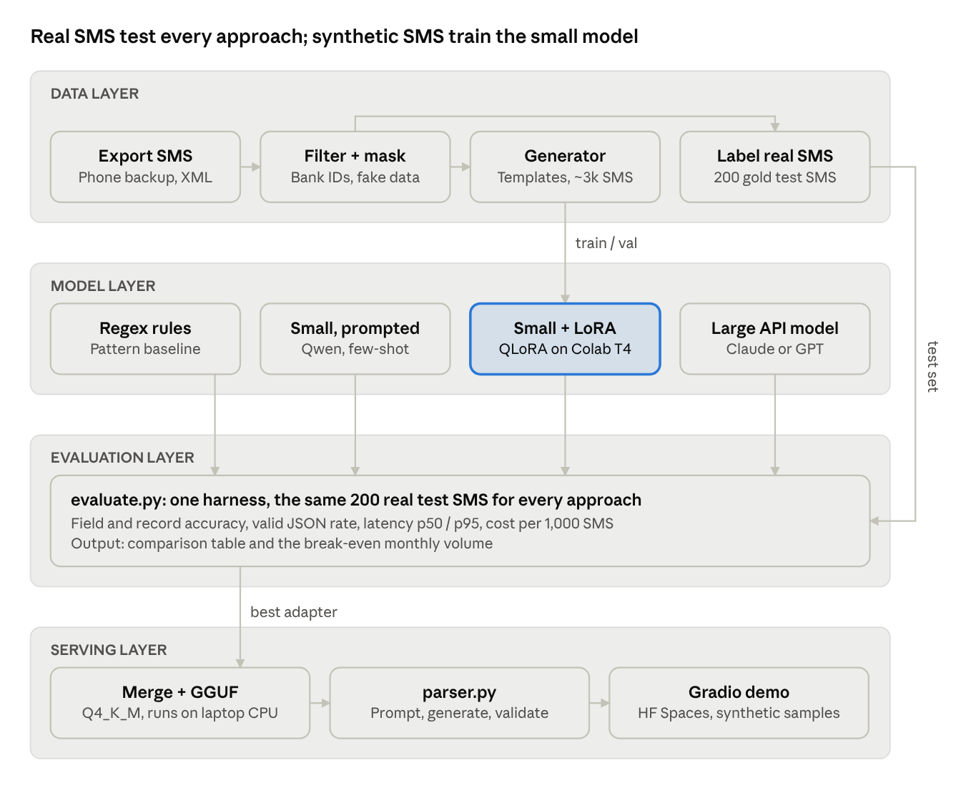
system architecture · 4 layers, 13 components
Synthetic SMS train only the LoRA model; the 200 real SMS bypass training and go straight to evaluation, so test scores stay honest.
Layer | Component | Input | Output
Data | Export + filter + mask | Phone SMS backup (XML) | Masked bank SMS (JSONL)
Data | Generator | Templates per bank | Synthetic train and val JSONL
Data | Labelling | Masked real SMS | 200-record gold test set
Model | 4 predictors | One SMS | One JSON object
Evaluation | evaluate.py | Predictor + test set | Metrics CSV, error CSV, charts
Serving | Export + parser + demo | Best LoRA adapter | GGUF model, Gradio app

Data layer
Real SMS are used only for testing; training relies mostly on synthetic SMS generated from templates, so labels come free and no real financial data is trained on or published.
Pipeline
- Export – SMS Backup & Restore (Android) exports inbox to XML. Collect from own phone plus willing friends and family.
- Filter – keep messages from bank and wallet sender IDs (e.g. HDFCBK, SBIINB, ICICIB, AXISBK, KOTAKB, PAYTMB). Keep some OTP and promo SMS as negative examples.
- Mask – a script replaces account numbers, names, phone numbers and reference numbers with fake values. Raw exports never leave data/raw/, which is git-ignored.
- Label – hand-label about 200 masked real SMS into JSONL using the schema. This is the gold test set.
- Template – write one or more templates per bank format observed in real data.
- Generate – fill templates with random amounts, dates in varied formats, merchants, VPAs and balances; add noise (extra spaces, casing, missing fields).
- Split – synthetic data into train and validation; real labelled data stays test-only.
Target dataset sizes
Split | Source | Size | Used for
train | Synthetic + ~100 real | 2,000–3,000 | Fine-tuning
validation | Synthetic | 300 | Choosing checkpoints
test | Real, hand-labelled | 200 | Final comparison only
File format: JSONL, one record per line: {"sms": "...", "label": {...}}. Each record also stores bank and template_id so errors can be analysed by format.

Model layer
Five approaches share one prompt format and one evaluation harness, so the only thing that changes between them is the model and how it was adapted.
# | Approach | Model | What it tests
1 | Regex rules | None | Cheapest, most brittle baseline
2 | Small, zero/few-shot | Qwen 0.5B or 1.5B Instruct | What prompting alone gets a small model
3 | Small, LoRA fine-tuned | Same base as #2 | The payoff from fine-tuning
4 | Large, few-shot | Claude or GPT via API | Strong baseline with no training
5 | Second small model (optional) | Llama 3.2 1B or Gemma 1B | Whether results hold across model families
Fine-tuning setup (starting values, tune later)
- Method: QLoRA – base model loaded in 4-bit, LoRA adapters trained on top
- Library: Unsloth (wraps Hugging Face Transformers, PEFT and TRL)
- LoRA rank 16, alpha 16, dropout 0, targets: all attention and MLP projections
- Learning rate 2e-4, 2–3 epochs, batch size 8 (via gradient accumulation), max sequence length 512
- Loss computed on the JSON answer only, not the prompt
- Hardware: free Colab or Kaggle T4 GPU
Prompt format: the model's own chat template. System message = task + schema; user message = the SMS; assistant message = the JSON. The same format is used at training and inference time.
Output safety: every prediction is parsed with json.loads and checked against a Pydantic model of the schema. Invalid output counts as wrong.

Evaluation layer
One script, evaluate.py, takes any predictor (a function from SMS to JSON) and scores it on the 200-message real test set, so every approach is measured identically.
Metric | How it is computed | Why it matters
Field accuracy | Exact match per field after normalising (numbers as floats, strings lower-cased) | Shows which fields are hard
Record accuracy | All fields correct in one SMS | What a real app would experience
Transaction detection F1 | Precision and recall on is_transaction | Avoids counting OTPs as spends
Valid JSON rate | Share of outputs that parse and pass the schema | Reliability
Latency p50 / p95 | Wall-clock time per SMS, same hardware for local models | Speed
Cost per 1,000 SMS | API price, or GPU/CPU hours × rate; training cost shown separately | Economics
Break-even: monthly volume at which one-time training cost plus local hosting equals the API bill. Reported as one number in the README.
Error analysis: every run writes a CSV of wrong predictions with bank and template_id, so failures can be grouped by bank and field.
Experiment tracking: each run logs model, dataset version, hyperparameters and scores to Weights & Biases (or a local results/ CSV).

Serving and demo layer
The fine-tuned model ships in two forms: a LoRA adapter on Hugging Face Hub, and a quantised GGUF file that runs on a laptop CPU with no internet.
- Merge and export – merge LoRA into the base model, then convert to GGUF (Q4_K_M) with llama.cpp tools; Unsloth can do both steps.
- Local inference – llama-cpp-python or Ollama loads the GGUF. A thin parser.py wraps prompt building, generation (temperature 0) and schema validation.
- Demo app – Gradio with two tabs: paste one SMS and see JSON; upload an SMS export and see a transaction table plus total debits and credits.
- Hosting – Hugging Face Spaces (free CPU tier) for the public demo, using synthetic sample SMS only.
- Fallback – if the model returns invalid JSON, retry once, then return the regex result flagged as low confidence.

Repository structure and tech stack
One GitHub repo holds all code; data folders with real SMS are git-ignored and only synthetic samples are committed.
sms-txn-parser/
├── README.md
├── LICENSE
├── .gitignore # ignores data/raw, data/real, .env, models/
├── .env.example # API key names, no values
├── requirements.txt
├── configs/
│ └── train_qwen_1.5b.yaml
├── data/
│ ├── raw/ # git-ignored: phone exports
│ ├── real/ # git-ignored: masked + labelled test set
│ ├── synthetic/ # committed: generated train/val JSONL
│ └── samples/ # committed: 20 synthetic demo SMS
├── src/
│ ├── schema.py # Pydantic model of the output
│ ├── collect/ # xml_to_jsonl.py, filter_senders.py, mask.py
│ ├── generate/ # templates/, generator.py
│ ├── baselines/ # regex_parser.py, api_parser.py, prompt_small.py
│ ├── train/ # finetune.py, prompt_format.py
│ ├── evaluate/ # evaluate.py, metrics.py, cost.py
│ └── serve/ # parser.py, export_gguf.py
├── notebooks/ # 01_explore, 02_finetune_colab, 03_results
├── app/
│ └── app.py # Gradio demo
├── results/ # metrics CSVs and charts
└── tests/ # unit tests for schema, masking, metrics
Layer | Tools
Language | Python 3.11
Data | pandas, Faker (en_IN), lxml, Pydantic
Training | Unsloth, Hugging Face Transformers, PEFT, TRL, bitsandbytes
Compute | Google Colab or Kaggle (T4 GPU)
Baseline API | Anthropic or OpenAI Python SDK
Tracking | Weights & Biases (free) or CSV
Serving | llama.cpp / llama-cpp-python or Ollama
Demo | Gradio on Hugging Face Spaces
Quality | pytest, ruff, pre-commit

Privacy, security and risks
Real SMS are personal financial data, so they are masked before use, never committed, and sent to an external API only after masking.
Privacy rules
- Get consent before using anyone else's SMS; mask before sharing files with yourself across devices.
- data/raw/ and data/real/ are in .gitignore from the first commit; a pre-commit hook blocks files matching those paths.
- API keys live in .env, never in code or notebooks.
- The large-model baseline sees only the masked test set.
Risk | Impact | Mitigation
Too few real SMS formats | Model fails on unseen banks | Ask more contacts; search public forums for format examples to template
Synthetic data too clean | Great validation score, poor test score | Add noise; include ~100 real SMS in training; watch the val–test gap
Regex beats the model | Weak story | Report it honestly; focus on unseen-format and robustness results
Colab session limits | Lost training runs | Save checkpoints to Google Drive; keep runs under 1 hour
Merchant names inconsistent | Low merchant accuracy | Keep a merchant alias map; score merchant separately
Real data leak to GitHub | Privacy breach | gitignore + pre-commit hook + review git status before every push

