SMS Transaction Parser — Implementation Plan
Sep 29, 2026 · @Shravani
The project runs about 7 weeks part-time: one setup step, then seven phases, each ending with something committed to GitHub.

Roadmap
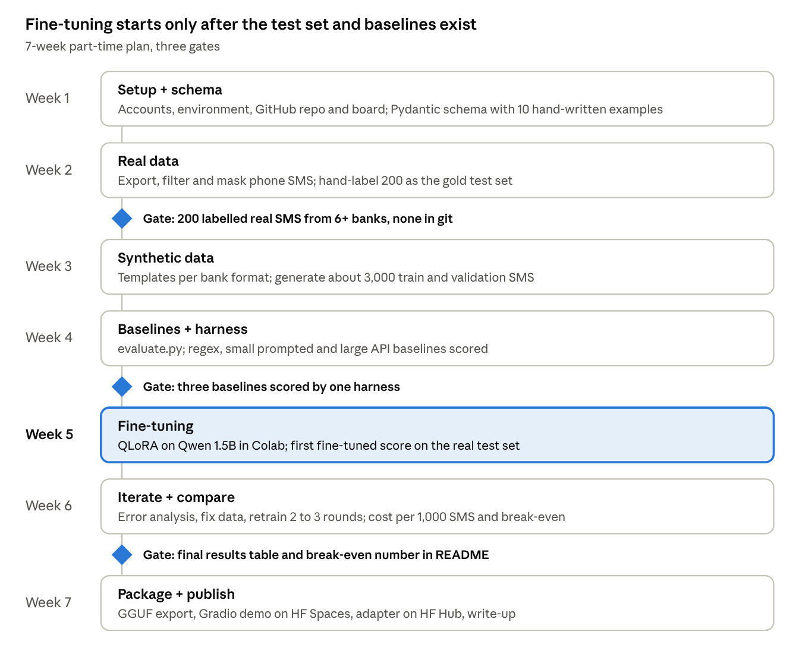
roadmap · 7 weeks, 3 gates
Each gate must pass before the next phase starts; the test set and baselines come first so the fine-tuned score has something honest to beat.

Step 0a — Accounts and tools
Create these accounts and install these tools before writing any project code; all are free except a few rupees of API usage.
Accounts
- ☐ GitHub account, with two-factor authentication turned on
- ☐ Hugging Face account, plus an access token with write permission (Settings → Access Tokens)
- ☐ Google account for Colab; also sign up at Kaggle as a backup GPU source
- ☐ Weights & Biases account (optional, for experiment tracking)
- ☐ Anthropic or OpenAI API account with a small credit balance and a spending limit set
Software on your laptop
- ☐ Git
- ☐ Python 3.11 (python.org, or via Anaconda/Miniconda)
- ☐ VS Code, with the Python, Jupyter and GitLens extensions
- ☐ SMS Backup & Restore app on your Android phone
Skills to brush up (learn as needed)
- ☐ Python: functions, dicts, JSON, reading files, virtual environments
- ☐ Git basics: clone, add, commit, push, pull, branch, merge
- ☐ Jupyter / Colab notebooks

Step 0b — Local environment
Set Git's identity once, then give the project its own virtual environment so its packages never clash with other projects.
- Tell Git who you are (once per laptop):
git config --global user.name "Your Name"
git config --global user.email "you@example.com"
git config --global init.defaultBranch main
- Connect your laptop to GitHub with an SSH key (so you don't type a password on every push):
ssh-keygen -t ed25519 -C "you@example.com"
cat ~/.ssh/id_ed25519.pub # copy this output
Paste the copied key in GitHub → Settings → SSH and GPG keys → New SSH key. Test it with ssh -T git@github.com.
- Check versions: python --version should show 3.11.x and git --version should print a version.
The virtual environment itself is created inside the repo in Step 0c. Heavy training libraries (Unsloth, bitsandbytes) are installed only in Colab, not on your laptop.

Step 0c — GitHub repo setup
The repo's first commit must already contain the .gitignore that blocks real SMS data; everything else can be added later.
- Create the repo on GitHub. New repository → name sms-txn-parser → Public → tick "Add a README" → .gitignore template: Python → License: MIT → Create.
- Clone it and create the environment:
git clone git@github.com:<your-username>/sms-txn-parser.git
cd sms-txn-parser
python -m venv .venv
source .venv/bin/activate # Windows: .venv\Scripts\activate
pip install --upgrade pip
- Create the folder structure (matches the architecture doc):
mkdir -p configs data/{raw,real,synthetic,samples} src/{collect,generate,baselines,train,evaluate,serve} notebooks app results tests
touch src/__init__.py data/synthetic/.gitkeep data/samples/.gitkeep results/.gitkeep
- Add project rules to .gitignore (append to the Python template):
# Private data — never commit
data/raw/
data/real/
*.xml
# Secrets
.env
# Models and large files
models/
*.gguf
*.safetensors
outputs/
wandb/
- Add .env.example with key names only (ANTHROPIC_API_KEY=, HF_TOKEN=, WANDB_API_KEY=). Copy it to .env and fill real values there.
- Add requirements.txt for laptop work: pandas, faker, lxml, pydantic, python-dotenv, anthropic, gradio, pytest, ruff, pre-commit. Then run pip install -r requirements.txt.
- Add a pre-commit safety net — .pre-commit-config.yaml:
repos:
- repo: https://github.com/astral-sh/ruff-pre-commit
rev: v0.6.9
hooks:
- id: ruff
- id: ruff-format
- repo: local
hooks:
- id: block-private-data
name: Block real SMS data
entry: Real SMS data must not be committed
language: fail
files: ^data/(raw|real)/
Then run pre-commit install. Check the latest ruff-pre-commit version on its GitHub page before pinning.
- Write a first README with: one-line description, status ("work in progress"), planned results table (empty), and how to set up.
- First commit and push:
git status # confirm no data/raw or data/real files appear
git add .
git commit -m "chore: project skeleton, gitignore and pre-commit"
git push origin main
- Repo settings (optional but good practice): add a description and topics (llm, lora, fine-tuning, nlp, fintech, india); under Settings → Branches, protect main so changes arrive through pull requests.

Step 0d — Project tracking on GitHub
Track every task as a GitHub issue on one board; it keeps you organised and shows recruiters how you work.
- Milestones (Issues → Milestones): create one per phase — P1 Schema, P2 Real data, P3 Synthetic data, P4 Baselines, P5 Fine-tuning, P6 Comparison, P7 Package.
- Labels: data, model, eval, demo, docs, bug.
- Issues: turn each checklist item in Phase tasks (below) into an issue, with its milestone and label.
- Board (Projects → New project → Board): columns Todo, In progress, Done. Add all issues.
- Link work to issues: mention the issue in commits or pull requests (Closes #12) so it closes automatically when merged.
- Weekly log: keep docs/LOG.md in the repo with a few lines per week — what you tried, what broke, what you learned. It becomes your blog post later.

Phase tasks
Each phase ends with a concrete deliverable in the repo; do not start the next phase until its done-check passes.

Week 1 — Setup + P1 Schema
- ☐ Finish Steps 0a–0d
- ☐ Write src/schema.py: a Pydantic model with all 11 fields and their rules
- ☐ Write 10 example SMS with correct JSON by hand in data/samples/
- ☐ Unit test: all 10 examples validate against the schema
Done when: pytest passes and the schema is documented in the README.

Week 2 — P2 Real data
- ☐ Export SMS from your phone; ask 3–5 people for theirs, with consent
- ☐ src/collect/xml_to_jsonl.py: convert XML export to JSONL
- ☐ src/collect/filter_senders.py: keep bank and wallet senders, plus some OTP/promo negatives
- ☐ src/collect/mask.py: replace account numbers, names, phones, reference numbers with fakes
- ☐ Hand-label 200 masked SMS into data/real/test.jsonl
- ☐ Write down every bank format you saw (bank, example, quirks)
Done when: 200 labelled test records exist, covering at least 6 banks, and git status shows none of them.

Week 3 — P3 Synthetic data
- ☐ One or more templates per bank format in src/generate/templates/
- ☐ generator.py: random amounts, dates in mixed formats, merchants, VPAs, balances, noise
- ☐ Include credits, refunds, ATM, card, failed and non-transaction SMS
- ☐ Generate about 3,000 records; split into train and validation
- ☐ Spot-check 50 random records by eye
Done when: train and val JSONL are committed and every record passes the schema.

Week 4 — P4 Baselines + evaluation harness
- ☐ evaluate.py + metrics.py: field accuracy, record accuracy, valid JSON rate, latency, cost
- ☐ regex_parser.py baseline
- ☐ prompt_small.py: small model few-shot in Colab
- ☐ api_parser.py: large model few-shot on the masked test set
- ☐ Save results to results/baselines.csv
Done when: three rows of the comparison table are filled with real numbers.

Week 5 — P5 Fine-tuning
- ☐ Colab notebook 02_finetune_colab.ipynb adapted from an Unsloth example
- ☐ Format data with the model's chat template; train on the answer only
- ☐ First run: Qwen 1.5B, LoRA rank 16, 2 epochs; save adapter to Google Drive
- ☐ Evaluate on the real test set
Done when: the fine-tuned row is in the results table, even if the score is low.

Week 6 — P6 Iterate + compare
- ☐ Error analysis: group wrong predictions by bank and field
- ☐ Fix the data (new templates, more noise), retrain, re-evaluate — 2 to 3 rounds
- ☐ Optional: try Qwen 0.5B or Llama 3.2 1B for the size comparison
- ☐ Compute cost per 1,000 SMS and the break-even volume
- ☐ Make charts: accuracy by approach, accuracy by field
Done when: the final comparison table and break-even number are in the README.

Week 7 — P7 Package + publish
- ☐ Merge adapter, export GGUF, test it on laptop CPU
- ☐ app/app.py Gradio demo; deploy to Hugging Face Spaces with synthetic samples
- ☐ Push the adapter to Hugging Face Hub with a model card
- ☐ Final README: problem, architecture diagram, results, how to run, what you learned
- ☐ Write a blog post or LinkedIn write-up from docs/LOG.md
Done when: a stranger can open the repo, understand the result in 30 seconds and run the demo.

Working conventions
Small, frequent commits on short-lived branches, one change per experiment, and a data check before every push.
Area | Convention | Example
Branches | <type>/<short-name>, merged to main by pull request | feat/sms-masking, exp/qwen-rank32
Commits | Conventional commits: feat, fix, data, exp, docs, chore | feat: add HDFC and SBI templates
Experiments | Change one thing per run; name runs <model>-<data-version>-<change> | qwen1.5b-v2-lr1e-4
Dataset versions | Bump a version tag when training data changes; record it in results | synthetic-v3
Results | Every run appends one row to results/runs.csv | model, data, params, scores, date
Secrets | Only in .env locally and Colab Secrets in notebooks | never pasted in cells
Data safety | Run git status before every push; real SMS stay in git-ignored folders | —
Notebooks | Clear outputs before committing if they show real SMS | —

Definition of done
The project is finished when all of these are true:
- ☐ Public GitHub repo with README, architecture diagram and results table
- ☐ Comparison of 4 approaches on the same 200 real test SMS
- ☐ Break-even volume stated as one number with its assumptions
- ☐ LoRA adapter on Hugging Face Hub with a model card
- ☐ Working demo link on Hugging Face Spaces
- ☐ GGUF model runs offline on a laptop CPU
- ☐ No real SMS, account numbers or API keys anywhere in git history
- ☐ Write-up published (blog or LinkedIn)

