Beyond Demographics: Engagement, Product Depth, and Relationship Strength as Drivers of Retail Banking Customer Retention
Shravani Shivajirao Ghorpade.
Dept. of Data Science
D.Y.Patil College of Engineering and Technology
Kolhapur,Maharashtra,India
shravaniig16@gmail.com
Abstract— This paper quantifies the relationship between customer engagement, product ownership depth, and account churn in a retail banking context, reframing retention analysis around customer behavior and relationship strength rather than demographics alone. Using a customer-level dataset of 10,000 accounts, activity status is found to be the strongest observed correlate of retention: active members are retained at 86.2% versus 53.2% for inactive members, an Engagement Retention Ratio of 1.62x. Product depth shows a non-monotonic relationship with churn, with two-product customers churning least (19.6%) while customers holding three or more products churn substantially more (56.7%-57.3%). A segment of 556 "at-risk premium" customers -- disengaged but holding high balances and above-median income -- is identified, whose churn rate of 58.3% confirms that balance alone does not predict loyalty. A five-metric KPI framework and a logistic-regression risk model are proposed for ongoing retention monitoring and intervention targeting.
Index Terms— customer churn, retention analytics, customer engagement, relationship strength, retail banking, logistic regression, cross-sell strategy

I. Introduction
Banks increasingly recognize that customer behavior and engagement, not just demographics, determine long-term retention. A customer may appear financially strong, holding a high balance or income, and still churn due to low engagement, limited product adoption, or a weak overall relationship with the institution. Understanding how customers use banking products and services is essential to designing cross-sell strategies, loyalty programs, and engagement-driven retention initiatives. This work evaluates retention through the lens of customer behavior and relationship strength rather than static demographic attributes.
Despite widespread collection of engagement and product-usage data, banks often lack quantitative insight into which behaviors drive retention, clarity on whether product depth reduces churn, and evidence on whether high balances alone ensure loyalty. As a result, retention strategies are frequently generic and misaligned with actual customer behavior. This paper addresses that gap directly using a customer-level analytical pipeline and an accompanying interactive dashboard.
A. Objectives
The primary objectives are to (i) evaluate the relationship between engagement and churn, (ii) measure the retention impact of product count and product mix, and (iii) identify disengaged yet high-value customers before they leave. Secondary objectives are to support engagement-driven retention strategies, improve product bundling decisions, and reduce silent churn among premium customers.
II. Related Concepts
Logistic regression remains a standard, interpretable baseline for binary churn prediction in applied settings [1], and is used here for exactly that reason: its coefficients are directly interpretable as directional churn drivers, which matters more for a decision-support tool than marginal gains in predictive accuracy from a black-box model [2]. Implementation uses the standard scikit-learn machine learning library [3]. The broader framing of relationship depth and cross-sell strategy as retention levers is consistent with established customer relationship management practice [4].
III. Dataset and Methodology
A. Dataset
The analysis uses a customer-level dataset of 10,000 records spanning three geographies (France, Germany, Spain) with thirteen fields: customer and surname identifiers, credit score, geography, gender, age, tenure, account balance, number of products held, credit card ownership, activity status, estimated salary, and a binary churn indicator (Exited).
This version of the analysis runs on a synthetic dataset constructed to match the schema and general behavioral patterns described in the project brief (activity-driven churn, a non-monotonic product-depth effect, and geography-driven variation). Figures reported here illustrate the analytical method and should be re-validated against verified production data before informing operational or supervisory decisions.
B. Data Ingestion and Validation
Prior to analysis, binary fields (HasCrCard, IsActiveMember, Exited) are checked for non-0/1 values and coerced, duplicate CustomerId rows are removed, and missing numeric fields are median-imputed. Churn labeling is confirmed to be binary and consistent across the record set before any downstream metric is computed.
C. Engagement Classification
Each customer is assigned to exactly one of four mutually exclusive engagement profiles, evaluated in priority order: (1) Inactive High-Balance -- inactive with balance in the top quartile, the primary silent-churn flag; (2) Inactive Disengaged -- inactive, balance below that threshold; (3) Active Low-Product -- active with exactly one product; (4) Active Engaged -- active with two or more products.
D. Relationship Strength Index
A composite 0-100 score blends four weighted components: activity status (40%), product depth capped at two products (30%), tenure capped at ten years (20%), and credit card ownership (10%). Customers are grouped into Low / Medium / High / Very High tiers using fixed 25-point bands, operationalizing the "sticky customer" concept used throughout this analysis.
E. Risk Model
A logistic regression classifier is trained on standardized numeric features and one-hot encoded categorical features (Geography, Gender), with balanced class weighting to correct for the ~71:29 retain:churn split. The model supports a what-if simulator that estimates churn probability for a hypothetical customer profile and compares the effect of individual retention interventions.
TABLE I
Key Performance Indicator Definitions
KPI | Value | Definition
Engagement Retention Ratio | 1.62x | Active ÷ inactive retention
Product Depth Index | +11.8 pp | Best tier − single-product retention
High-Bal. Disengagement | 46.2% | Top-quartile balance, inactive
Card Stickiness Score | +3.9 pp | Cardholder − non-cardholder retention
Relationship Strength | 61.1/100 | Composite activity/product/tenure/card
IV. Results
A. Engagement vs. Churn
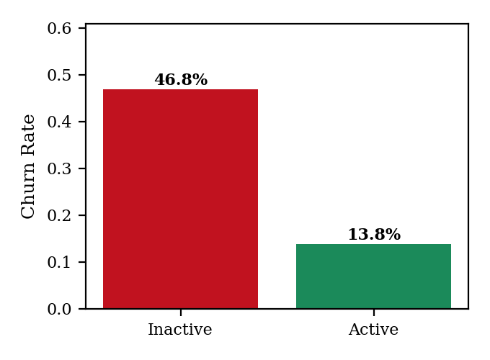
Fig. 1. Churn rate by activity status.
Activity status is the strongest single driver observed. Inactive members churn at 46.8% versus 13.8% for active members, an Engagement Retention Ratio of 1.62x.
B. Product Utilization
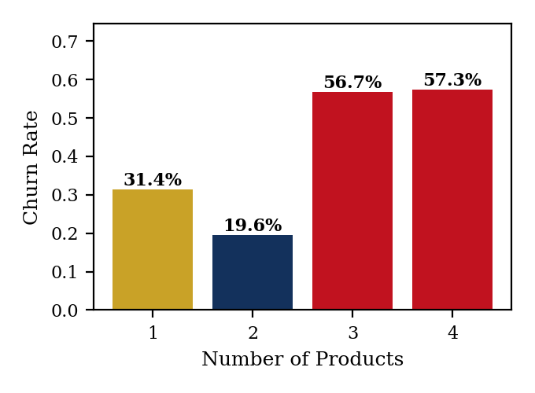
Fig. 2. Churn rate by number of products held.
Product depth does not reduce churn monotonically. Two-product customers show the lowest churn (19.6%), below single-product customers (31.4%). Customers holding three (56.7%) or four (57.3%) products churn far more than either group, consistent with distress-driven bundling (e.g., loan consolidation) rather than deeper loyalty. A simple single- versus multi-product split (31.4% vs. 26.5%) masks this inflection.
C. Geographic Variation
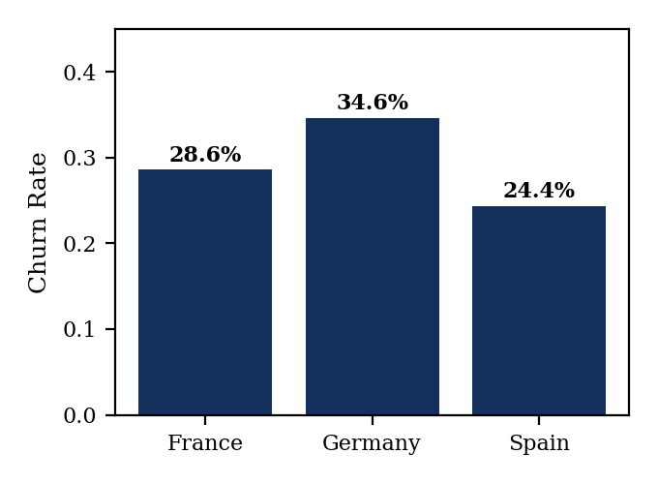
Fig. 3. Churn rate by geography.
Germany shows elevated churn (34.6%) relative to France (28.6%) and Spain (24.4%), likely proxying market-specific competitive or product-mix effects not captured in this dataset.
D. Engagement Profiles
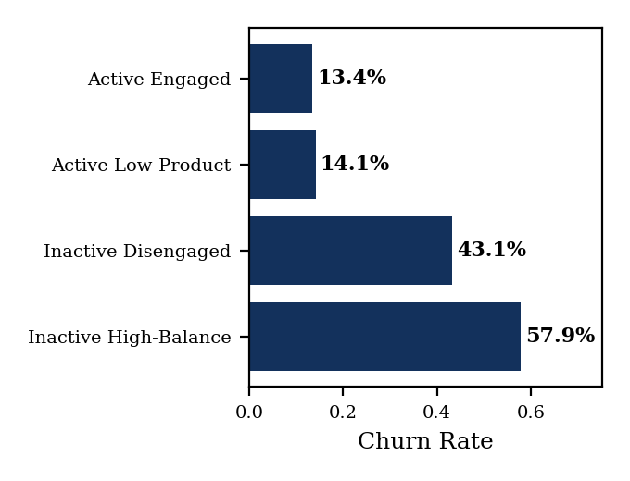
Fig. 4. Churn rate by engagement profile.
The four engagement profiles separate churn risk cleanly. Active Engaged (13.4%) and Active Low-Product (14.1%) customers churn at similarly low rates, confirming activity -- not product count -- drives most of the separation. Inactive High-Balance customers churn highest of all, at 57.9%.
E. Financial Commitment vs. Engagement
High balance alone does not protect against churn: 46.2% of top-quartile-balance customers are currently inactive. A related salary-balance mismatch segment (high income, low balance at this institution) comprises 9.3% of the base and churns at 27.1%, above baseline. An at-risk premium filter (inactive, top-quartile balance, above-median salary) isolates 556 customers (5.6% of the base); 58.3% of this watchlist has already churned, confirming the filter's advance-detection value.
F. Retention Strength Assessment
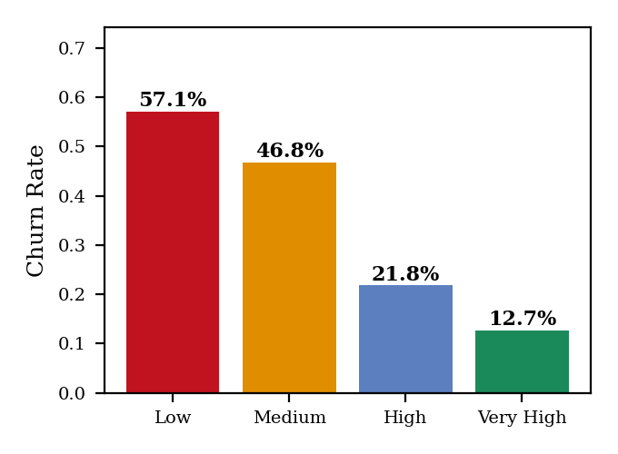
Fig. 5. Churn rate by Relationship Strength Index tier.
Churn falls in a stable, monotonic gradient as Relationship Strength rises, from 57.1% (Low) to 12.7% (Very High), validating the composite index as a genuine ordinal risk scale suitable for a single scorecard metric.
V. Discussion
Engagement, not tenure or balance, is the dominant retention lever observed in this data. Product depth exhibits a sweet spot rather than a linear benefit: two products correlates with the strongest retention, while additional products beyond that correlate with higher churn, likely reflecting distress bundling rather than loyalty. Balance is not a loyalty signal on its own -- high-balance inactive customers are the highest-churn segment identified. Silent churn is detectable in advance: the at-risk premium filter flags most eventual premium-customer losses before they occur. The Relationship Strength Index behaves as a genuine ordinal risk scale, supporting its use as a standing scorecard metric.
VI. Recommendations
Three recommendation areas follow directly from the results. First, engagement-driven retention: treat activation, not only acquisition, as a first-class lever, and instrument an early-warning trigger on the Active-to-Inactive transition rather than waiting for a churn signal. Second, product bundling: target a two-product relationship as the cross-sell objective rather than maximizing product count, and distinguish cross-sell-driven multi-product holders from distress-driven ones in bundling campaigns. Third, silent churn among premium customers: operate a recurring at-risk premium report using the High-Balance Disengagement Rate and watchlist filter, reviewed by relationship managers on a fixed cadence, and treat the salary-balance mismatch segment as a share-of-wallet opportunity as well as a churn risk.
VII. Limitations
This analysis uses synthetic data matching the schema described in the project brief; findings should be re-validated against production data before informing business or supervisory decisions. The dataset provides product count but not product type, so true product-mix analysis, as distinct from product depth, is not possible with the fields available. Relationship Strength Index weights (40/30/20/10) are set judgmentally rather than statistically fit. Churn is treated as a static label; no time-to-churn or survival analysis is performed, so intervention timing is not yet optimized.
VIII. Conclusion
This work reframes customer churn from a behavioral and relationship-strength perspective rather than a demographic one. Engagement emerges as the clearest quantitative driver of retention, product depth shows a sweet-spot rather than linear relationship, and high-balance customers prove just as capable of silent, undetected churn as any other segment. The KPI set, engagement-profile framework, and risk model developed here give an institution a concrete, monitorable basis for engagement-driven retention strategy, more disciplined bundling decisions, and early detection of premium-customer attrition, pending validation against real production data.
REFERENCES
[1] D. W. Hosmer, S. Lemeshow, and R. X. Sturdivant, Applied Logistic Regression, 3rd ed. Hoboken, NJ, USA: Wiley, 2013.
[2] G. James, D. Witten, T. Hastie, and R. Tibshirani, An Introduction to Statistical Learning, New York, NY, USA: Springer, 2013.
[3] F. Pedregosa et al., "Scikit-learn: Machine learning in Python," Journal of Machine Learning Research, vol. 12, pp. 2825–2830, 2011.
[4] P. Kotler and K. L. Keller, Marketing Management, 15th ed. Boston, MA, USA: Pearson, 2016.

