📘 Book Suggestion App - README

This is my final project for the Python certification course. I created a simple book suggestion app using Python. It uses the Google Books API to get real book data, filters the results based on user input, and gives a random book recommendation.

# ✅ What This App Does

- Takes your favorite genre as input  
- Lets you filter books by rating and publication year  
- Gets real book data from the internet (Google Books)  
- Shows one random book based on your filters

# 🧪 How to Run the App

## 1. Install Python Libraries

Make sure you have Python installed. Then, open your terminal or command prompt and install the libraries:

pip install requests pandas

## 2. Save the Code

Copy the code from book_suggestion_app.py and save it in your project folder.

## 3. Run the App

In the terminal, go to your project folder and run:

python book_suggestion_app.py

## 4. Follow the Prompts

- Type in a genre like fiction, romance, or science.  
- You can enter a minimum rating (like 4) or skip it.  
- You can also enter a year like 2020 or skip that too.  
Then the app will show you one book suggestion!

# 💡 Example Output

📖 Welcome to the Book Suggestion App!  
Enter your favorite genre (e.g. fiction, history, science): fiction  
Enter minimum rating (1 to 5, or leave blank): 4  
Enter a publication year to filter (or leave blank): 2020  
  
📚 Book Suggestion:  
Title: The Midnight Library  
Authors: Matt Haig  
Year: 2020  
Rating: 4.3  
Genre: fiction

# 📸 Screenshots

Please see the screenshots folder for:

**Input:**

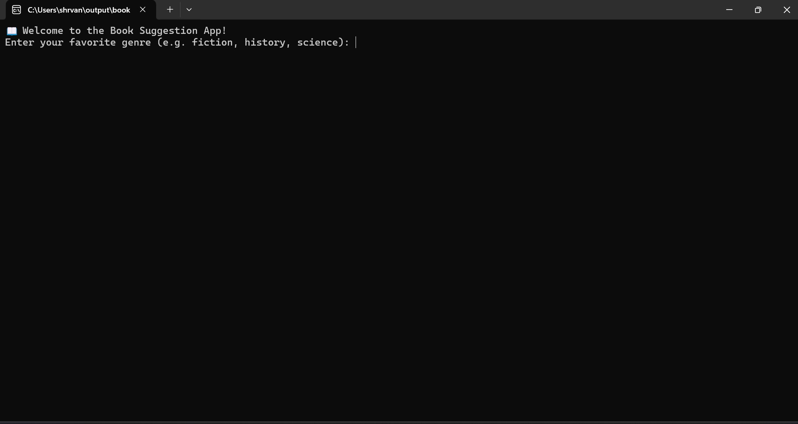

**Output:**

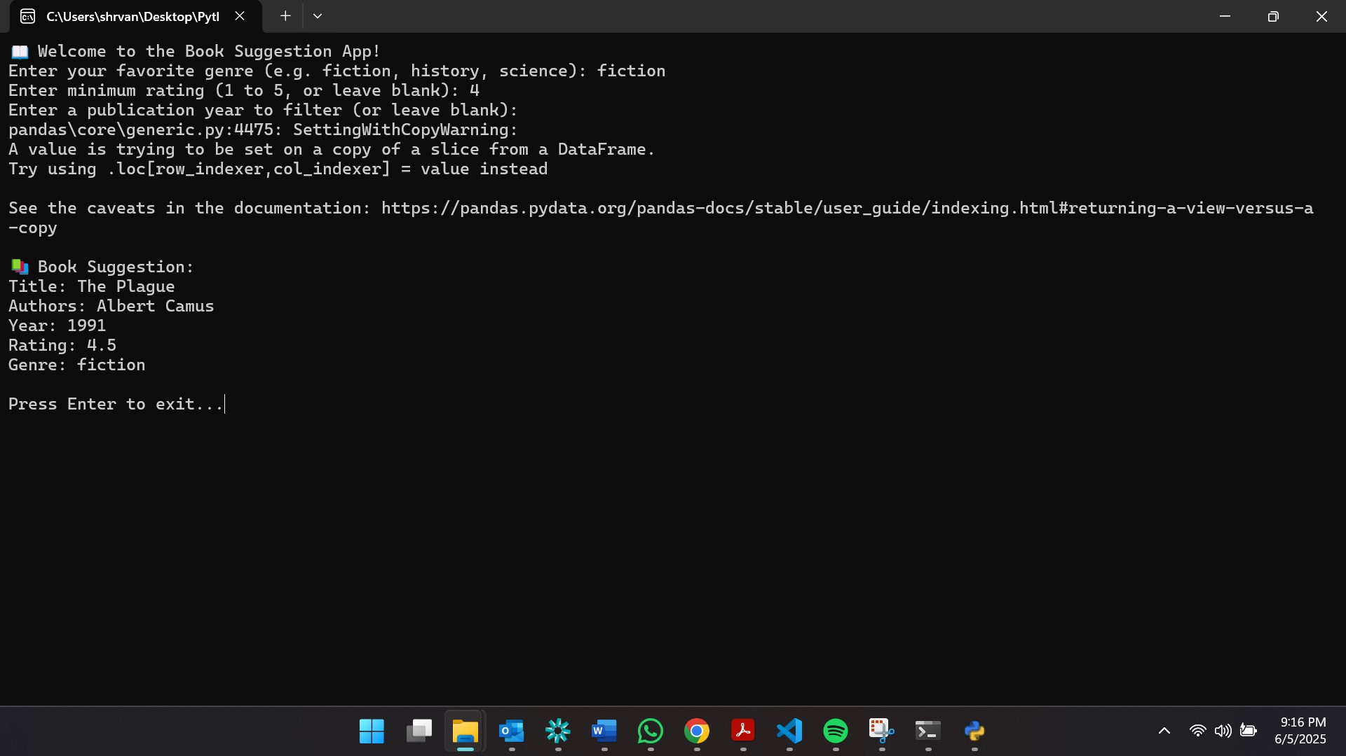

**Output in VS code:**

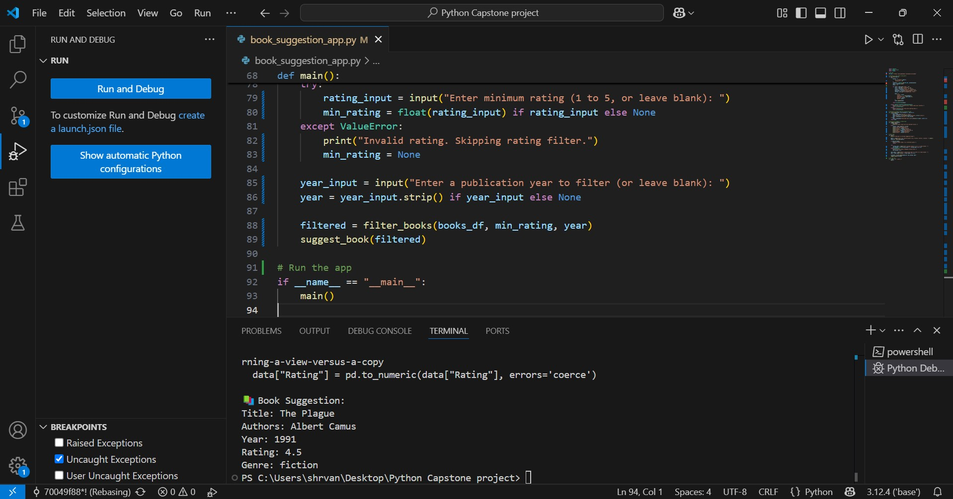

# 🛠 Technologies Used

- Python 3  
- requests  
- pandas  
- Google Books API

# 🔗 Repository Structure

Python-Project-Submission/  
│  
├── book_suggestion_app.py  
├── README.md  
└── screenshots/  
 ├── genre_input.png  
 └── final_output.png

# ✨ Final Thoughts

I enjoyed building this project and learned a lot about using APIs, pandas, and handling errors in Python. Thank you for reviewing my submission!