Task 1 - Set up a database using Docker:

Step1:-

Created a Docker container for a SQL Server database.

Created table with appropriate schemas in the database.

Inserted sample data into the tables using SQL statements.

Task 2 - Data migration to AWS:

Wrote a Python script using pandas and NumPy to connect to the SQL Server database and retrieve the data from the tables.

Created an AWS S3 bucket and uploaded the transformed data as CSV or Parquet files to the S3 bucket.

Task 3 - Automate data crawler using AWS Glue:

Create an AWS Glue crawler that automatically detects the data in the S3 bucket and creates a Glue table.

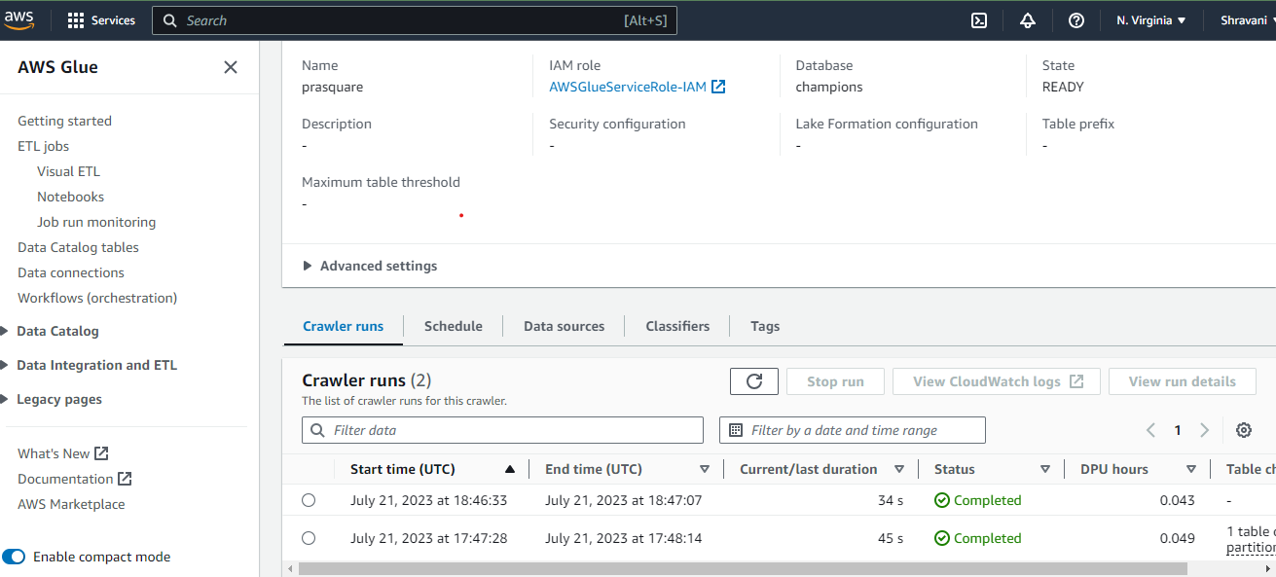

Configured the Glue crawler to run hourly to capture any new data in the S3 bucket and update the Glue table accordingly.

