

**Department of Electronics & Communication Engineering**

*(Accredited by NBA)*

**Project Title: Visual Cryptography for Biometrics Privacy**

**Team Members: Suprabha, M B Sachin, Shravan Kumar, Sooraj Shetty**

**Guide: Mr. Ganesh V N**

* The proposed method is divided into 2 categories, namely Image Encryption and Image Decryption.
* Encryption: Every image consists of 3 shares, RGB, hence each image is divided into 3 shares. Then, Sieving, Division, Shuffling, Combining is done.
* Decryption: The 2 randomly generated images are chosen to obtain the decrypted image i.e., the original image.
* Face Matching: It matches the original image with the decrypted image and checks for the similarity.

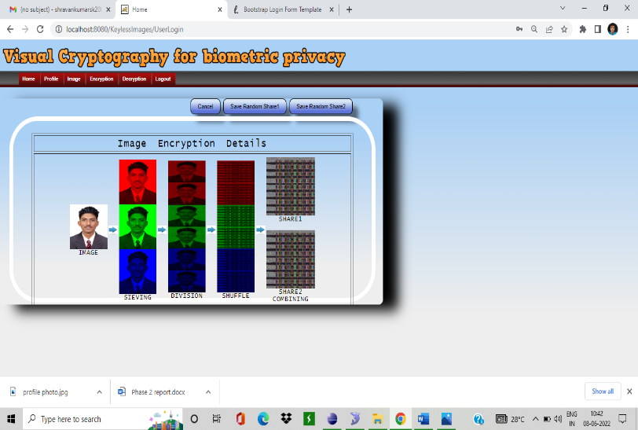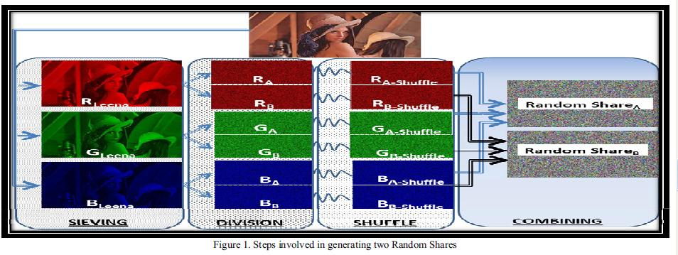

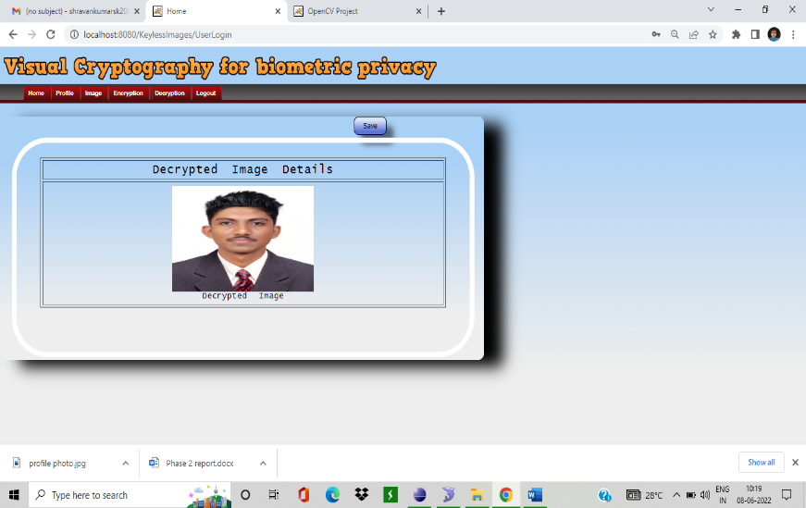

Fig. 1: Steps involved in generating 2 random shares Fig. 2: Image Encryption Fig. 3: Decrypted Image