CURRENT PIPELINE • ARRIVE CASE • COMPARISON WORKSHEET

MP4 to Animated GLB
Pipeline Comparison Guide
A code-verified description of our conversion process, why ARRIVE’s hands enter the body, where FFmpeg fits, and how to compare another pipeline fairly.
Key conclusion FFmpeg is useful as a controlled input-normalization step. It is not the cause of—or a complete solution for—the 3D hand/body intersection.

Prepared for | Pipeline owner and comparison partner
Repository | D:\video2glb
Case studied | Arrive.mp4 → Arrive.glb
Document date | 25 August 2026

Share this document together with the exact input video, avatar, commands, version manifest, reports, and GLB. Without identical inputs, the comparison is not conclusive.

Contents
Contents 2
How to use this guide 3
1 Executive summary 4
2 Implemented architecture 5
2.1 Runtime and core inputs 5
2.2 Command-line entry points 6
2.3 Configuration: active versus declarative 6
3 Detailed 17-stage conversion process 7
3.1 Output package 8
4 Video ingestion and landmark tracking 8
4.1 Inspection and decoding 8
4.2 MediaPipe outputs 9
4.3 Raw pose archive and missing data 9
4.4 Tracking QC 10
5 Motion solving, retargeting, and GLB export 10
5.1 Coordinate and body model 10
5.2 Palms and fingers 10
5.3 Global wrist/elbow targets 11
5.4 Blender bake and export 11
6 Validation and its present limits 12
6.1 Status aggregation 12
6.2 Known validator and failure-handling issues 13
7 ARRIVE case study: measured diagnosis 13
7.1 Direct motion and avatar measurements 14
7.2 Root cause ranking 14
7.3 How to read the existing QC metrics 15
8 FFmpeg: where it fits and how it affects output 15
8.1 Conservative normalization for the ARRIVE experiment 16
8.2 Record the source and normalized identity 16
9 Side-by-side pipeline worksheet 17
10 Fair A/B comparison protocol 18
10.1 Four-run matrix 18
10.2 Lock these variables 19
10.3 Test clip set 19
10.4 Save this evidence for every run 19
11 Metrics and acceptance gates 20
11.1 Comparison scorecard 21
12 Recommended target pipeline and implementation priorities 21
12.1 Target end-to-end process 21
12.2 Prioritized work for this repository 22
12.3 Adoption recommendation 23
A Code and artifact reference map 23
A.1 Current repository requirements 24
A.2 Glossary 24

The table of contents is a Word field and was updated during final rendering.

How to use this guide
- Sections 1–6 describe what the current repository actually executes, including inputs, intermediate artifacts, Blender work, and validation.
- Section 7 analyzes the ARRIVE failure using measured artifacts. It separates the exported GLB defect from a separate debug-preview timing defect.
- Section 8 explains FFmpeg’s real role and gives a conservative normalization command for a controlled test.
- Sections 9–11 are the worksheet, A/B protocol, and acceptance gates for comparison with a friend’s pipeline.
- Section 12 proposes a better target pipeline and implementation priorities.
Scope note. The friend’s implementation has not been inspected. Every friend-side field is intentionally marked “To be supplied” until the exact command, code, models, avatar, and outputs are available.

1 Executive summary
The current project does not use external FFmpeg to convert MP4 motion into GLB. It decodes the source with OpenCV, tracks body and hand landmarks with MediaPipe, turns those landmarks into avatar-space motion, applies that motion to an FBX rig in Blender, bakes the animation, and exports an animated GLB. ffprobe is optional metadata support, while Blender’s internal FFmpeg encoder is used only for the diagnostic preview video.
Decision. Do not replace the entire current pipeline only because another pipeline contains FFmpeg. First add or test FFmpeg as a controlled front-end normalization step, then compare the four A/B combinations in Section 10. The 3D solver still needs reach, depth, and collision fixes.

Question | Verified answer
What produces the GLB? | Python motion solver + Blender retarget, bake, and glTF export.
What does FFmpeg do now? | No external preprocessing. Optional ffprobe metadata; Blender internally encodes the debug avatar MP4.
Why do hands enter the body? | Wrist/elbow targets are built from raw 2D points, put on one fixed depth plane, allowed beyond arm reach, and never checked against the torso mesh.
Is the ARRIVE GLB structurally broken? | No. It contains 8 meshes, 1 armature, and 1 animation with the correct 36.44 s action duration. The defect is motion/constraint quality.
Is the side-by-side preview synchronized? | No. The avatar preview is 876 frames rather than 912 because GLB import occurs at Blender’s default 24 FPS before rendering is set to 25 FPS.
Can FFmpeg alone fix penetration? | No. It can stabilize FPS, timestamps, rotation, codec, and pixel format, but it cannot infer 3D contact or add rig constraints.
What should be compared? | Identical source bytes, avatar, clip range, timebase, model versions, postprocessing, viewer, metrics, and signer review.

Quick terminology: FFmpeg is the multimedia toolkit; ffprobe is its metadata inspector; IK bends a rig toward targets; and GLB is the final binary glTF package. A fuller glossary appears in Appendix A.2.

2 Implemented architecture
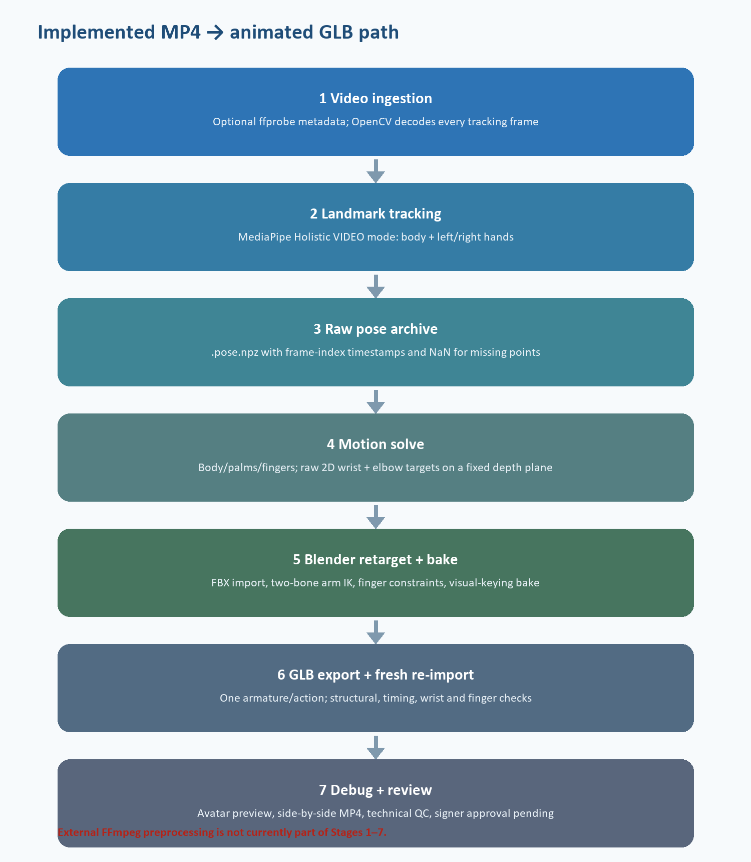
Figure 1. Current code path. External FFmpeg transcoding is not an implemented stage.

2.1 Runtime and core inputs
Component | Observed/required | Function
Python | 3.12.4 observed | Orchestrates tracking, motion solving, reports, and Blender subprocesses.
Blender | 4.5.11 LTS configured | Imports FBX, constructs constraints, bakes animation, exports/re-imports GLB, renders preview.
MediaPipe | >= 0.10.20 | Holistic Landmarker in VIDEO mode.
OpenCV | >= 4.8 | Actual source-video decoding and debug/comparison MP4 writing.
NumPy | >= 1.26 | Pose and motion arrays, interpolation, filtering, metrics.
PyYAML | >= 6.0 | Settings and QC thresholds.
External FFmpeg | Not on PATH in audited run | Not required by current tracking path; optional ffprobe metadata only.

Input | Current location/argument | Purpose
Source video | --video | MP4 signer footage.
Avatar | assets/character.fbx | Skinned mesh and rig used for all three milestone exports and final GLB.
Tracker model | models/holistic_landmarker.task | MediaPipe pose and hand landmark model.
Settings | config/settings.yaml | Paths, confidence values, smoothing, debug behavior.
QC thresholds | config/qc_thresholds.yaml | Body/hand availability, gap, and swap thresholds.
Avatar profile | config/avatar_profile.json | Rest bone heads/tails, lengths, matrices, and mesh inventory.
Bone map | config/avatar_bone_map.json | 43 canonical body/hand bones mapped to avatar names.

2.2 Command-line entry points
python convert.py --video ".\video\Arrive.mp4"
python convert.py --video ".\input\Example.mp4" --avatar ".\assets\character.fbx" --save-debug
python convert.py --input-dir ".\input" --batch
python convert.py --revalidate-failed --input-dir ".\input"
- Output paths are derived from the input stem; there is no --output argument.
- Batch mode processes top-level *.mp4 files only, not nested directories.
- --save-debug forces debug output; there is no --no-debug switch. Debug output is enabled in the current settings.
- Revalidation reuses saved pose and motion files; it does not rerun tracking.
- Relative paths are resolved against the project directory.

2.3 Configuration: active versus declarative
Setting group | Implementation state | Effect
Avatar path; Blender executable | Active | Used to locate the FBX and Blender.
MediaPipe model and confidence values | Active | Passed into the Holistic Landmarker.
processing.smoothing | Active for final solve | Stages 6 and 8 explicitly disable smoothing.
output.debug | Active | Controls overlay, preview, and comparison artifacts.
output.uppercase_directory | Active | Controls output folder naming.
processing.preserve_source_fps | Declarative only | No code branch uses this setting.
processing.mirror_input | Declarative only | Input is not mirrored and handedness is not remapped.
processing.auto_trim | Declarative only | No automatic trimming occurs.
tracking.body / hands / face | Declarative only | Tracker options do not switch these branches; face animation is absent.
output.save_pose / save_motion | Declarative only | Pose and motion are saved regardless.

3 Detailed 17-stage conversion process
The following is the executed order in convert.py. A stage printed as PASS only means its function returned without raising; it does not guarantee that the returned QC object itself is PASS.
# | Stage | Input | Output | Important behavior
1 | Inspect video | MP4 | VideoInfo in memory | ffprobe when available; otherwise OpenCV metadata.
2 | Extract holistic landmarks | MP4 + MediaPipe model | PoseSequence; optional overlay | OpenCV decodes; MediaPipe VIDEO mode processes each frame.
3 | Save raw pose | PoseSequence | {gloss}.pose.npz | Preserves raw landmark arrays, indices, and synthetic timestamps.
4 | Validate tracking | PoseSequence + QC YAML | Tracking QC result | Availability, no-hand gaps, and suspected swaps only.
5 | Calibrate avatar | FBX | Avatar profile + bone map | Runs only when cached files are absent/unloadable.
6 | Solve body milestone | Raw pose NPZ | *_body_only.motion.npz | Torso/arms; palms/fingers requested off; smoothing off.
7 | Export body milestone | FBX + body motion | *_body_only.glb | Blender path still enables IK and finger tracking flags.
8 | Solve palm milestone | Raw pose NPZ | *_palms.motion.npz | Palms on, fingers off, smoothing off.
9 | Export palm milestone | FBX + palm motion | *_palms.glb | Diagnostic milestone; finger-direction constraints can still be applied.
10 | Solve final motion | Raw pose NPZ | {gloss}.motion.npz | Body, palms, fingers, interpolation, configured smoothing, continuity checks.
11 | Bake and export final GLB | FBX + final motion | {gloss}.glb + IK report | Two-bone IK, finger constraints, visual-keying bake, GLB export.
12 | Fresh re-import validation | GLB + motion + profile | GLB validation JSON | Structure, duration, wrist/finger metrics; no mesh collision test.
13 | Render avatar preview | GLB | Debug avatar MP4 | Debug only; 512×512 Eevee render via Blender’s internal FFmpeg encoder.
14 | Build side-by-side | Source + avatar MP4s | Comparison MP4 + timing result | Pairs frames until either video ends; checks FPS/frame count only.
15 | Write review reports | QC results | Comparison/review JSONs | Technical comparison, match result, signer-review template.
16 | Write metadata and QC | All results | Metadata + consolidated QC | Worst technical state and production status are recorded.
17 | Record research status | Final GLB | Comparison-status JSON | Legacy/research tracking status.

3.1 Output package
Group | Artifact | Meaning
Primary | Arrive.glb | Animated binary glTF deliverable.
Tracking | Arrive.pose.npz | Raw pose and hand landmarks, frame metadata, presence flags.
Motion | Arrive.motion.npz | Bone rotations, four IK targets, finger directions, masks, influences.
Milestones | Arrive_body_only.*; Arrive_palms.* | Diagnostic motion/GLB variants; not perfectly isolated.
Calibration | avatar_profile.json; avatar_bone_map.json | Rig geometry and 43-bone mapping.
Validation | *.qc.json; *.glb_validation.json; *.ik_calibration.json | Tracking, import, duration, wrist/finger and pole reports.
Review | *.source_avatar_validation.json; *.match_validation.json; *.signer_review.json | Preview timing and pending human approval.
Debug video | debug/*_pose_overlay.mp4; *_avatar_preview.mp4; *_source_avatar_comparison.mp4 | Visual diagnostics, not source-of-truth animation timing.

4 Video ingestion and landmark tracking

4.1 Inspection and decoding
- The inspector searches PATH for ffprobe. When present, it reads codec, size, average/nominal frame rate, frame count, duration, and rotation metadata.
- If ffprobe is absent or fails, OpenCV supplies metadata. The audited ARRIVE run used this fallback.
- All frames supplied to MediaPipe are decoded through cv2.VideoCapture.read(), even when ffprobe is installed.
- Tracking timestamps are synthesized from frame_index / reported_fps. Real packet presentation timestamps are not consumed, so variable-frame-rate sources can drift.
- No implemented preprocessing applies rotation, mirroring, crop, trim, stabilization, denoise, deinterlace, scale, codec normalization, or constant-frame-rate conversion.
- Audio is ignored. The pose overlay is encoded by OpenCV using mp4v at reported source resolution and FPS.
Comparison implication. If a friend normalizes to constant frame rate before tracking while this pipeline reads a variable-frame-rate file directly, different frame/timestamp sequences may reach the tracker. That is a valid FFmpeg effect—but it must be isolated from all later algorithm differences.

4.2 MediaPipe outputs
Array | Per-frame shape | Current use
Pose image | 33 × (x, y, z, visibility) | Normalized image coordinates; primary source for body and global arm mapping.
Pose world | 33 × (x, y, z, visibility) | Converted but currently not used by the final global IK-target builder.
Left hand image | 21 × (x, y, z) | Palm orientation and finger curls.
Left hand world | 21 × (x, y, z) | Local finger geometry/directions, not global hand placement.
Right hand image | 21 × (x, y, z) | Palm orientation and finger curls.
Right hand world | 21 × (x, y, z) | Local finger geometry/directions, not global hand placement.
Presence | Body, left-hand, right-hand booleans | Tracking availability and gaps.

4.3 Raw pose archive and missing data
For ARRIVE, the major raw arrays are pose_image (912, 33, 4), pose_world (912, 33, 4), and four hand arrays of shape (912, 21, 3). Missing detections are NaN. The file also stores FPS, dimensions, frame_count, frame_indices, timestamps_ms, quality JSON, and coordinate notes.
- Body gaps up to about 0.25 s and hand gaps up to about 0.20 s are linearly interpolated only when the gap is internal.
- Long gaps and leading/trailing gaps remain missing.
- The final solve can apply One Euro smoothing to pose and hand arrays with separate parameters.
- Critical exception: the final wrist/elbow IK-target function receives raw pose_image, not the interpolated or smoothed pose_points. Visible arms therefore bypass final arm smoothing when Blender IK is enabled.

4.4 Tracking QC
Metric | FAIL rule | REVIEW rule
Body availability | FAIL below 0.50 | REVIEW below 0.80
Either-hand availability | No fail gate | REVIEW below 0.20
Longest interval with neither hand | No fail gate | REVIEW above 1.50 s
Possible left/right swaps | No fail gate | REVIEW at 1 or more

Limit. Tracking QC does not detect body penetration, unreachable targets, arm stretch, pole flips, or semantic ISL correctness. A single conversion can continue even when tracking QC returns REVIEW.

5 Motion solving, retargeting, and GLB export

5.1 Coordinate and body model
Item | Implementation | Consequence
MediaPipe world → canonical | [x, −y, −z] | Converted world_points are not used for global wrist placement.
Image → canonical | [x − 0.5, 0.5 − y, −z] | Image-space body directions and arm target mapping.
Quaternions | Internal WXYZ; glTF XYZW | Converted during export/validation.
Root | All-zero translation | Avatar does not move through the scene.
Torso | Limited Chest Z twist | Hips/spine chain/neck/head/legs remain essentially at rest.
Shoulders/clavicles | Not solved | Two-bone arm IK cannot recruit clavicle motion for cross-body reach.

5.2 Palms and fingers
- Palm orientation uses wrist, index-MCP, middle-MCP, and pinky-MCP image landmarks. The result is blended at 45% and capped at 35°; it is not a full measured palm quaternion/twist.
- Finger curls come from image-landmark joint angles, are scaled by 0.72, constrained by joint-specific caps, and limited to 35° change per frame.
- Hand-world landmarks form a local palm basis for 30 finger-segment directions. Direction changes are capped at 24° per frame, with an approximately 0.18 s hold/fade/reacquisition policy.
- Blender applies Damped Track constraints to all 30 segments, builds moving targets in each animated palm’s local frame, then bakes the evaluated result.

5.3 Global wrist/elbow targets
Property | Current behavior
Target order | LeftWrist, LeftElbow, RightWrist, RightElbow
Source | Raw 2D pose_image landmarks; smoothed pose array is bypassed.
X mapping | Centered on source shoulders; scale recalculated from shoulder width every frame.
Y mapping | Centered on source shoulders; separate scale recalculated from torso height every frame.
Z mapping | Every wrist and elbow receives exactly rest_depth + 16.0.
Missing landmarks | Previous target is held; initial fallback is the shoulder center.
Reach | No arm-length or safety clamp.
Collision/contact | No torso proxy, mesh distance, capsule test, surface clearance, or contact state.
Joint limits | No feasibility layer before Blender’s IK solve.

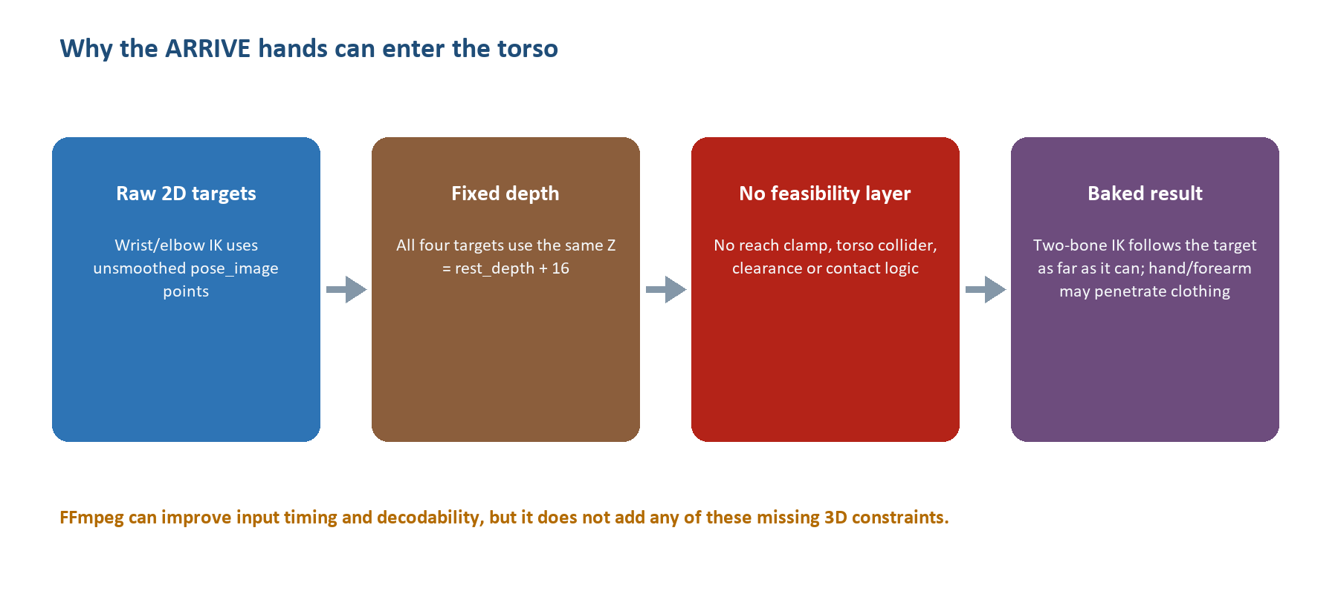
Figure 2. The failure is created in the 2D-to-3D target and constraint layers, not by MP4 encoding alone.

5.4 Blender bake and export
- The FBX is imported; the scene is set to rounded source FPS; one action spans frames 1 through N.
- Four empties drive two-bone forearm IK constraints. Each elbow target is also a pole object; one fixed pole angle per arm is chosen from 33 candidates over at most 72 sample frames.
- Direct upper-arm and forearm quaternion keys from the Python solver are skipped whenever IK targets exist, so the raw-target exception dominates visible arm motion.
- Finger Damped Track constraints and non-IK bone quaternions are evaluated per frame. Visual keying bakes the result and clears constraints/targets.
- GLB export selects the armature and every mesh, includes the action, forces sampling over the frame range, and excludes cameras/lights.
Milestone warning. All three export calls unconditionally enable IK and finger tracking, and the solver writes finger-direction arrays even for body-only/palms modes. Those diagnostic GLBs are not clean ablation tests.

6 Validation and its present limits
Gate | What it checks | Interpretation/limit
Structure | GLB is non-empty; mesh, armature, one action, expected bones | Good structural gate.
Quaternion sanity | Finite values and norm error ≤ 1e−3 | Good numeric gate.
Duration | Fresh-import duration within max(1 source frame, 0.05 s) | GLB timing itself passes ARRIVE.
Hand visibility | Five samples; checks X separation of hand heads from chest | Cannot detect depth penetration or mesh intersection.
Wrist endpoint | Normalized target-to-wrist error | Current implementation samples imported action by frame index, causing a timebase confound at 24/25 FPS.
Finger continuity | Maximum and p99 local turn | Same sampling/timebase issue can inflate reported jumps.
Finger target direction | Mean and p95 angular error | Same sampling/timebase issue can inflate error.
Source/avatar comparison | FPS and frame-count equality | Does not compare trajectories, fingers, collision, appearance, or meaning.
ISL correctness | isl_verified always false | Qualified signer review is intentionally required.

6.1 Status aggregation
The worst of tracking QC, GLB validation, and source/avatar timing becomes technical_qc. However, quality FAIL reasons from wrist/finger metrics are generally demoted to top-level REVIEW unless they match structural-failure markers. Therefore ARRIVE is reported as REVIEW even though several submetrics say FAIL. Technical success never certifies sign-language correctness; production status remains PENDING_SIGNER_REVIEW.

6.2 Known validator and failure-handling issues
- The validator’s imported-action sampling and the preview renderer both mix a GLB imported at Blender’s default 24 FPS with source-frame indices from 25 FPS. Metrics and preview motion can be misaligned in time.
- A validator control-flow anomaly can replace metric records with false “No armature” records when finger continuity passes; this needs a code fix before the report is treated as production evidence.
- The validator process exits nonzero on FAIL. Because the caller uses subprocess.run(check=True), the later code intended to move failed GLBs may be bypassed.
- One source/avatar report message is hard-coded to Passenger.glb_validation.json even when another gloss is processed.

7 ARRIVE case study: measured diagnosis
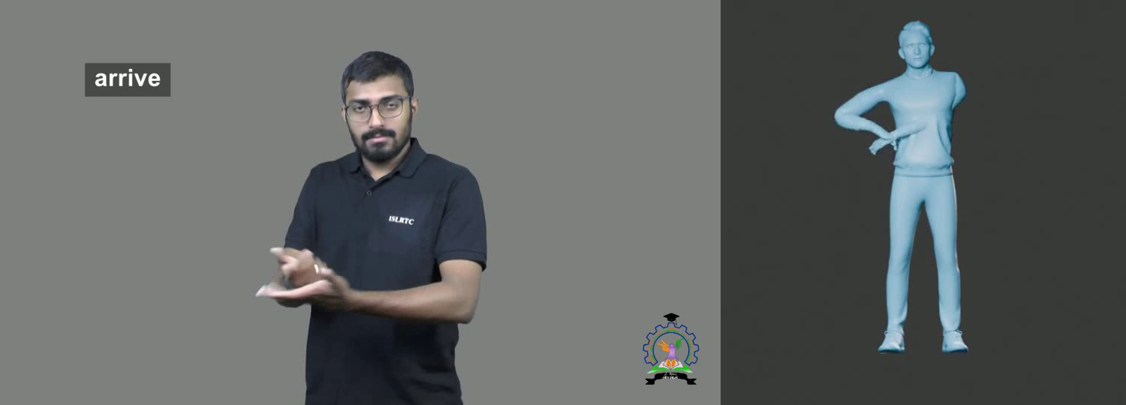
Figure 3. Source/avatar comparison near 2 s. The avatar’s cross-body hand/forearm is visibly buried in or occluded by the torso/clothing.
Area | Measured result | Meaning
Source | H.264, 1920×1080, 25 FPS, 912 frames | Expected frame-interval duration: 36.44 s; container duration about 36.48 s.
Tracking | Body 100%; left hand 94.30%; right hand 86.95% | Longest no-hand sequence: 43 frames / 1.72 s; suspected swaps: 0.
Final GLB | 58,608,708 bytes; 8 meshes; 1 armature; 1 action | Fresh-import duration: 36.4400008 s; structure and duration are correct.
Production state | Technical REVIEW; ISL verification pending | Human signer approval remains required.
Debug preview | 876 frames / 35.00 s | 36 frames / 1.44 s shorter than the source; preview plays 4.17% fast.

7.1 Direct motion and avatar measurements
Measurement | ARRIVE value | Interpretation
IK depth | All 912 × 4 target Z values are 13.085551 | The entire wrist/elbow system is constrained to one depth plane.
Garment depth support | Sweater rest geometry reaches Z +15.6726; target plane is 2.587 profile units behind that front extreme | Supports the visible intersection diagnosis; exact deformed local surface varies by frame.
Left arm reach | 48.7378 profile units | 107/912 targets exceed full reach; 116 exceed a 97% safety radius.
Right arm reach | 48.7226 profile units | 28/912 targets exceed full reach; 34 exceed a 97% safety radius.
Worst left target | 64.8514 at source frame 146 (~5.80 s) | 16.11 units or about 33.1% beyond arm reach.
Worst right target | 52.2909 at frame 902 (~36.04 s) | 3.57 units or about 7.3% beyond arm reach.
Target scaling | X min/median/max 207.59/226.81/261.25; Y 91.11/95.94/103.90 | Anisotropic, frame-varying scale can make targets pump and distort proportions.
Pole calibration | Mean elbow error: left 0.09747; right 0.11666 Blender units | With armature scale 0.01, approximately 9.7 cm and 11.7 cm world-space error.

7.2 Root cause ranking
Rank | Cause | Role | Evidence/consequence
1 | No torso collision or clearance model | Primary | Nothing prevents the target, hand, or forearm from entering the body/clothing.
2 | Fixed wrist/elbow depth | Primary | Source depth is discarded; the target plane is behind the sweater’s front rest extent.
3 | Unreachable wrist targets | Primary | A substantial left-arm subset lies outside the rig’s reachable sphere.
4 | Raw IK targets bypass smoothing | Contributing | Visible arms follow noisy/raw landmarks even though final smoothing is enabled.
5 | Per-frame independent X/Y scale | Contributing | Target position can change from body-proportion noise and becomes anisotropic.
6 | No clavicle/shoulder participation | Contributing | Cross-body motion must be produced by a two-bone chain alone.
7 | Fixed pole-angle compromise | Contributing | One pole angle cannot fit all arm configurations; elbow error remains large.
8 | Preview timebase defect | Diagnostic only | Makes visual comparison progressively misaligned but does not shorten the GLB action itself.
9 | Input encoding | Possible upstream influence | Can affect detection quality, but does not explain the fixed-depth and no-collision behavior.

7.3 How to read the existing QC metrics
The stored ARRIVE GLB report lists a wrist mean normalized error of 0.17094, p95 0.41348, and max 0.74084, plus large finger errors. Those values are real outputs of the current validator, but they are not clean estimates of retargeting accuracy because imported 24-FPS action frames are sampled using 25-FPS source frame indices. A separate correct-time audit found much smaller typical errors when targets were reachable. Treat the stored values as a warning that the validator/timebase must be fixed, not as proof that every frame is tens of centimeters wrong.
Diagnosis. The visible penetration is genuine even though some QC numbers are timing-inflated. The strongest direct evidence is the constant target depth, garment depth relationship, unreachable-target counts, missing collision layer, and the source/avatar frames.

8 FFmpeg: where it fits and how it affects output
FFmpeg is a video/audio processing toolkit. It can decode and re-encode the source before tracking, but it does not infer skeleton landmarks, solve IK, rig an avatar, prevent collision, or create a semantically correct animated GLB by itself. A friend who says “my pipeline uses FFmpeg” is describing only one part unless another model/service performs motion capture and retargeting.
FFmpeg operation | What changes | Likely pipeline effect
Inspect streams | ffprobe reports codec, FPS fields, duration, rotation, pixel format | Improves reproducibility and catches suspicious sources.
Constant frame rate | Resamples VFR/irregular timestamps to a declared CFR | Can stabilize frame_index/fps tracking; may duplicate/drop frames.
Apply rotation | Bakes display rotation into pixels | Can correct tracker orientation; must be applied identically in both pipelines.
Pixel format | Example: yuv420p | Improves decoder compatibility; usually neutral if quality is retained.
Codec/container | Example: H.264 in MP4 | Reduces backend variability; lossy re-encoding can remove small finger detail.
Scale/crop | Changes resolution or composition | Can help a tiny signer but also alter landmark accuracy; avoid in the first fair test.
Denoise/sharpen | Changes image statistics | May help or hurt tracking; test as a separate variable.
Mirror | Horizontally flips frames | Changes handedness and sign meaning unless landmarks/labels are remapped consistently.
Remove audio | -an | No effect on this tracker; reduces test-file variability/size.
GLB compression | Not an MP4 operation | Use glTF/mesh/texture tools such as Draco/Meshopt/KTX2 after animation quality is correct.

8.1 Conservative normalization for the ARRIVE experiment
For a controlled ARRIVE test only, normalize to its observed 25 FPS while preserving resolution and avoiding geometric or cosmetic filters:
ffmpeg -hide_banner -i ".\video\Arrive.mp4" `
-map 0:v:0 -an `
-vf "fps=25,setsar=1" `
-c:v libx264 -preset medium -crf 16 `
-pix_fmt yuv420p -movflags +faststart `
".\input\Arrive_CFR25.mp4"
Do not generalize 25 FPS. For a 29.97, 30, 50, or 60 FPS source, choose and document the intended timebase. Forcing every video to 25 FPS can discard or duplicate motion samples and change fast hand movement.

8.2 Record the source and normalized identity
Get-FileHash ".\video\Arrive.mp4" -Algorithm SHA256
Get-FileHash ".\input\Arrive_CFR25.mp4" -Algorithm SHA256
ffprobe -v error -select_streams v:0 `
-show_entries stream=codec_name,width,height,pix_fmt,avg_frame_rate,r_frame_rate,nb_frames:stream_tags=rotate:format=duration `
-of json ".\input\Arrive_CFR25.mp4"
ffmpeg -i ".\input\Arrive_CFR25.mp4" -map 0:v:0 -f framemd5 ".\input\Arrive_CFR25.framemd5"
- Keep the exact FFmpeg version/build and complete command, not only the output file.
- Keep both the original and normalized file; never overwrite the source.
- Do not crop, resize, mirror, denoise, sharpen, or change clip boundaries in the first normalization-only test.
- Use one decode-to-RGB definition for both pipelines if pixel-exact parity is required; decoder color/range conversions can otherwise differ slightly.

9 Side-by-side pipeline worksheet
Fill the final two columns with the friend. “Unknown” is preferable to an assumption. Attach the exact evidence path, command, config key, report field, or code location for every material difference.
# | Comparison item | Our current pipeline | Friend’s pipeline | Evidence / conclusion
1 | Source identity | SHA-256 + frame hash to be recorded | To be supplied
2 | Software environment | Python 3.12.4; Blender 4.5.11; package minimums in requirements.txt | To be supplied
3 | Video inspection | Optional ffprobe; otherwise OpenCV metadata | To be supplied
4 | Pre-normalization | None in repository | Exact FFmpeg command/version required
5 | Rotation handling | Metadata may be read by ffprobe; not explicitly baked | To be supplied
6 | FPS/timebase | Reported FPS; synthetic frame_index/fps timestamps | To be supplied
7 | Decoder | OpenCV VideoCapture | To be supplied
8 | Frame selection | Every decoded frame until EOF | To be supplied
9 | Color conversion | OpenCV BGR → RGB before MediaPipe | To be supplied
10 | Tracker/model | MediaPipe Holistic Landmarker task | To be supplied
11 | Tracker mode | VIDEO; timestamp per frame | To be supplied
12 | Landmarks | 33 pose; 21 per hand; image and world arrays | To be supplied
13 | Confidence gates | Four configured values, currently 0.5 | To be supplied
14 | Missing values | NaN; short internal interpolation; long/edge gaps remain | To be supplied
15 | Smoothing | One Euro for final pose/hands; IK arms bypass it | To be supplied
16 | Outlier rejection | Step caps for fingers; no robust global wrist outlier gate | To be supplied
17 | Left/right handling | MediaPipe streams kept separate; QC swap heuristic | To be supplied
18 | Body coordinate frame | Image-centered canonical; limited chest twist | To be supplied
19 | Scale | Independent X/Y scale recomputed each frame | To be supplied
20 | Global hand depth | Fixed rest_depth + 16 for wrists and elbows | To be supplied
21 | Root/torso | Root zero; legs/head/static; limited Chest twist | To be supplied
22 | Avatar calibration | Cached FBX profile + automatic 43-bone map | To be supplied
23 | Avatar fingerprint | Not recorded; stale cache possible after FBX change | To be supplied
24 | Arm solver | Blender two-bone IK; wrist target + elbow pole | To be supplied
25 | Clavicle | Not animated for reach | To be supplied
26 | Pole handling | One fixed angle per arm, brute-force calibrated | To be supplied
27 | Reach constraint | None | To be supplied
28 | Joint limits | No pre-IK arm feasibility layer | To be supplied
29 | Torso collision | None | To be supplied
30 | Contact state | None | To be supplied
31 | Palm orientation | Image landmarks; 45% strength; 35° cap | To be supplied
32 | Finger solve | Image curls + local hand-world directions; 30 segments | To be supplied
33 | Bake | Visual keying every frame; constraints cleared | To be supplied
34 | GLB export | Blender glTF; armature + all meshes; one action; forced sampling | To be supplied
35 | Compression | No explicit Draco/Meshopt/KTX2 stage | To be supplied
36 | Fresh re-import | Yes, Blender process | To be supplied
37 | Collision validation | No | To be supplied
38 | Timing validation | Duration; preview FPS/frame-count check; known 24/25 bug | To be supplied
39 | Human review | Qualified signer required; currently pending | To be supplied
40 | Failure handling | Batch isolation; validator FAIL move path has exception issue | To be supplied
41 | Runtime/hardware | Record CPU/GPU/RAM and stage timings | To be supplied
42 | Manual work | None intended in direct pipeline | To be supplied

10 Fair A/B comparison protocol

10.1 Four-run matrix
Run | Downstream pipeline | Video input | Question answered
A0 | Our current pipeline | Original source | Baseline current result
A1 | Our current pipeline | Shared normalized source | Measures normalization effect on our downstream pipeline
B0 | Friend’s pipeline | Original source | Friend baseline
B1 | Friend’s pipeline | Shared normalized source | Measures normalization effect on friend downstream pipeline

Interpretation. A0 vs A1 and B0 vs B1 isolate input normalization. A0 vs B0 and A1 vs B1 compare the downstream systems. If only A1 is compared with B0, FFmpeg and solver differences are mixed together.

10.2 Lock these variables
- Exact original and normalized video bytes; record SHA-256 and frame hash.
- Same clip start/end time, orientation, resolution, view, and sign performance.
- Same avatar FBX and verified bone map. If avatars differ, report motion accuracy separately from mesh/rig behavior.
- Same target FPS/timebase and timestamp-based evaluation—not integer frame index after import.
- Same output coordinate system, unit scale, root reference, GLB viewer, camera, and rendering conditions.
- Exact model/version/config/command manifests and hardware. Run each case three times if either tracker is nondeterministic.
- Same blinded signer reviewers and review form; remove pipeline labels from preview videos.

10.3 Test clip set
Clip | What it isolates | Expected behavior
Arms away from torso | Basic tracking and retarget baseline | Hands remain outside torso; wrist path is smooth.
Cross-body sign | ARRIVE failure mode | No penetration; clavicle/arm pose remains natural.
Intentional torso contact | Contact-state discrimination | Hand reaches and stays on surface without passing through.
Hands crossing each other | Left/right identity | No swap or discontinuous jump.
Fast wrist/finger motion | Temporal sampling/filtering | No lag, oversmoothing, or frame-index drift.
Short occlusion | Gap handling | Smooth hold/interpolation and controlled reacquisition.
Long occlusion / exit frame | Failure behavior | No indefinite stale hand or implausible snap.
Full arm extension | Reach constraint | Target capped below full reach; no stretch/IK singularity.
Detailed finger sign | Hand model | Finger order, bends, directions, and timing preserve meaning.

10.4 Save this evidence for every run
Evidence group | Required artifacts
Input | Source/normalized MP4, SHA-256, ffprobe JSON, framemd5, exact FFmpeg command and version
Environment | Python/Blender/tracker/model/package versions; OS; CPU/GPU/RAM
Tracking | Raw landmarks, presence/confidence, timestamps, overlay, interpolation/smoothing masks
Motion | Clean landmarks, coordinate transform, target positions, reach ratio, collision/contact report, bone rotations
Export | Avatar hash, bone map, motion file, GLB, export settings, runtime logs
Validation | Fresh-import structure/timing, timestamp-aligned wrist/finger metrics, penetration report, preview
Review | Blinded signer form, reviewer count, comments, PASS/REVIEW/FAIL decision

11 Metrics and acceptance gates
Use identical definitions on both pipelines. Thresholds below are recommended engineering gates for comparison; the existing repository implements only a subset.
Metric | Suggested gate | Current state | Notes
Input identity | Exact SHA-256 for each declared test input | Required | Both use the intended bytes.
FPS | Absolute difference ≤ 0.01 | Implemented in preview comparison | Also compare actual timestamps.
Frame count | Difference ≤ 1 | Implemented in preview comparison | Must be measured on correctly synchronized renders.
Duration | Difference ≤ one frame | Implemented for GLB | Use seconds, not assumed frame indices.
Body availability | ≥ 95% for controlled signer clips | Proposed stricter comparison gate | Report active interval separately.
Hand availability | ≥ 95% during hand-active intervals | Proposed | Per side and both-hands coverage.
Missing active-hand gap | No gap > 5 frames at 25 FPS | Proposed | Adjust in seconds for other FPS.
Left/right swaps | 0 | Existing review heuristic | Add stronger temporal identity checks.
Reach safety | Every wrist target ≤ 97–98% of arm reach | Missing | Allow reserve for solver stability.
Non-contact penetration | 0 frames | Missing | Hand/forearm must stay outside torso proxy/mesh.
Surface clearance | Suggested ≥ 5 mm when not in contact | Missing | Calibrate by avatar scale and skin thickness.
Contact penetration | ≤ small avatar-specific tolerance | Missing | Allow controlled surface contact, never through-body motion.
Pole/arm continuity | No elbow flip, stretch, or singular snap | Partially observed only | Measure angular/position discontinuity.
Wrist target error | Mean ≤ 0.08; p95 ≤ 0.15 of arm length for PASS | Existing thresholds | Evaluate at matching timestamps.
Finger continuity | Max ≤ 30°; p99 ≤ 26° for PASS | Existing thresholds | Evaluate at matching timestamps.
Finger direction | Mean ≤ 15°; p95 ≤ 30° for PASS | Existing thresholds | Evaluate at matching timestamps.
Semantic sign | Qualified signer PASS | Required but manual | Technical metrics cannot replace this.
Performance | Runtime, peak RAM/VRAM, output size | Record, no universal gate | Compare only after quality gates pass.

11.1 Comparison scorecard
Dimension | A0 | A1 | B0 | B1
Input/timebase correctness
Tracking coverage
Wrist trajectory
Arm feasibility
Torso clearance
Palm orientation
Finger motion
GLB structure/timing
Visual synchronization
Signer approval
Runtime
Output size

12 Recommended target pipeline and implementation priorities

12.1 Target end-to-end process
- Inspect every input with ffprobe and save a machine-readable manifest.
- Normalize only when required: apply rotation, choose a documented CFR/timebase, preserve composition, use a high-quality compatible pixel format/codec.
- Decode with timestamp awareness and retain frame PTS; do not rebuild time only from frame index when input can be VFR.
- Track pose and hands, retaining confidence, handedness, image/world landmarks, and missing-value masks.
- Reject implausible outliers; interpolate only short internal gaps; preserve uncertainty.
- Filter pose/hand trajectories in a stable body-centered coordinate frame.
- Derive a temporally stable global wrist depth from body/hand depth cues or a monocular 3D model—not one fixed plane.
- Estimate one stable clip/avatar scale, or regularize scale slowly; avoid independent frame-wise X/Y scaling.
- Transform wrist/elbow targets into a torso-local animated frame.
- Project targets into a reachable workspace with a 97–98% safety limit and joint-limit awareness.
- Animate clavicle/shoulder contribution for cross-body and high-reach poses.
- Resolve elbow pole orientation continuously rather than with one clip-wide compromise.
- Apply torso/upper-arm/forearm/hand collision proxies and distinguish intentional contact from non-contact clearance.
- Solve palm twist and finger pose in the hand’s local basis with confidence-aware blending.
- Retarget to a fingerprinted avatar profile and bake at the declared timebase.
- Export one animated GLB with a known unit/coordinate convention and optional post-quality compression.
- Fresh-import the GLB at the correct timebase and evaluate at timestamps, not mismatched frame indices.
- Render a synchronized comparison whose frame count and motion duration match the source.
- Generate penetration, reach, tracking, wrist, finger, timing, and reproducibility reports.
- Require a qualified signer’s semantic approval before production use.

12.2 Prioritized work for this repository
Priority | Change | Implementation direction | Expected benefit
P0 | Fix timebase handling | Set scene FPS before GLB import/render; remap or sample imported action by seconds in validation. | Trustworthy preview and metrics.
P0 | Use processed arm landmarks | Build IK targets from interpolated/smoothed pose_points with confidence/outlier gating. | Reduces raw jitter and makes smoothing real.
P0 | Add reach projection | Clamp wrist targets to 97–98% of rest arm length before Blender IK. | Prevents impossible targets and singular stretch.
P0 | Add torso clearance/contact | Start with torso ellipsoid/capsules and hand/forearm radii; later add mesh-aware distance/raycasting. | Directly prevents the reported defect.
P0 | Replace fixed depth | Fuse pose/hand Z cues with temporal regularization and torso-relative calibration. | Allows front-of-body and contact motion.
P1 | Stabilize coordinate mapping | Use one clip-level uniform scale and torso-local transform; remove per-frame anisotropic X/Y scale. | Reduces target pumping and distortion.
P1 | Add clavicle and pole continuity | Recruit shoulders and optimize pole motion over time with joint limits. | Improves cross-body reach and elbow shape.
P1 | Repair validator logic | Fix control-flow anomaly, failed-output move, and hard-coded report name; add collision metrics. | Makes automated status reliable.
P1 | Make milestones true ablations | Disable IK/fingers as named for body-only and palm-only exports. | Makes diagnosis and regression testing meaningful.
P2 | Add conditional FFmpeg front end | Manifest + optional normalization, never blind re-encode; keep originals and hashes. | Improves input robustness and reproducibility.
P2 | Add avatar fingerprint | Hash FBX and invalidate cached profile/map when it changes. | Prevents stale calibration.
P2 | Add semantic review workflow | Versioned signer form and blinded preview package. | Separates technical and linguistic approval.

12.3 Adoption recommendation
Recommended decision. Use the friend’s FFmpeg preprocessing command only as an experimental, shared normalization front end after reviewing its exact filters and version. Do not replace the downstream solver merely because FFmpeg is present. Select the better downstream pipeline from A0/A1/B0/B1 evidence and signer review.

- If A1 improves over A0 and B1 improves over B0, adopt the shared normalizer as a documented optional/required stage.
- If A1 ≈ A0 but B1 improves over B0, the friend’s decoder/tracker may depend more strongly on normalization; that does not prove his complete GLB process is better.
- If B0/B1 avoid penetration while A0/A1 do not, inspect his depth, reach, collision, clavicle, and IK layers—not FFmpeg alone.
- If a pipeline looks better but fails signer review, it is not a production win for the stated aim.

A Code and artifact reference map
Area | Code/artifact | Use
Orchestration | convert.py:68–209 | 17-stage conversion and report flow.
CLI | convert.py:238–252 | Arguments and modes.
Video inspection | src/video/inspector.py:30–121 | ffprobe/OpenCV metadata and fallback.
Tracking/decode | src/tracking/holistic_tracker.py:47–152, 260–274 | MediaPipe VIDEO mode, OpenCV decode, arrays and timestamps.
Pose schema | src/tracking/pose_schema.py:39–92 | NPZ fields and coordinate notes.
Tracking QC | src/tracking/tracking_qc.py:32–120 | Availability, gaps, swap heuristic.
Coordinate conversion | src/motion/coordinate_system.py:6–37 | Axis and quaternion conventions.
Gap interpolation | src/motion/interpolation.py:6–23 | Short internal linear fill.
Smoothing | src/motion/smoothing.py:7–45 | One Euro filter.
Motion solver | src/motion/skeleton_solver.py:51–552 | Body/palm/finger solve and IK-target construction.
Avatar calibration | src/blender/blender_calibrate_avatar.py:59–142 | Rig profile and automatic mapping.
Blender apply/bake | src/blender/blender_apply_motion.py:26–364 | IK, pole calibration, finger constraints, bake.
GLB export | src/blender/blender_utils.py:24–67 | Scene checks and export options.
Fresh-import validation | src/blender/blender_validate_glb.py:35–479 | Structure, timing, wrist/finger, hand visibility.
Avatar render | src/blender/blender_render_animation.py:11–39 | Preview and internal FFmpeg encoder.
Side-by-side | src/qc/source_avatar_comparison.py:8–72 | Comparison MP4 and timing check.
ARRIVE metadata/QC | output/ARRIVE/Arrive.metadata.json; Arrive.qc.json | Source facts and tracking result.
ARRIVE validation | output/ARRIVE/Arrive.glb_validation.json; Arrive.ik_calibration.json | GLB and pole metrics.
ARRIVE motion | output/ARRIVE/Arrive.motion.npz | 912-frame solved targets/rotations/finger arrays.
Visual evidence | output/ARRIVE/debug/Arrive_source_avatar_comparison.mp4 | User-reported source/avatar comparison.

A.1 Current repository requirements
mediapipe>=0.10.20
numpy>=1.26
opencv-python>=4.8
PyYAML>=6.0

A.2 Glossary
Term | Meaning in this project
FFmpeg | The multimedia toolkit. “fmprg” and “ffmpege” in earlier messages refer to FFmpeg.
ffprobe | FFmpeg’s metadata-inspection program; it reports stream/container facts but does not create 3D motion.
GLB | A binary glTF package containing mesh, rig/skin, materials, and animation.
IK | Inverse kinematics: Blender bends an arm so the wrist reaches a target while an elbow pole guides the bend direction.
Landmark | A detected 2D/3D point such as shoulder, elbow, wrist, or finger joint.
Retargeting | Mapping motion from detected landmarks/canonical bones onto the chosen avatar rig.
Bake | Converting evaluated constraints into ordinary animation keyframes for export.

End of guide.

