-----------------------------------------------------------------------------------------------------------------
Neural Network Assignment 1
Shravanthi Arvind Patil and Sreenivasa Hikkal Venugopala
6th Oct 2019
---------------------------------------------------------------------------------------------------------------------

Question 2 : Read chapter 1 from Haykin’s book; summarize or sketch your insights in a mind-map or an outline or a summary.

Solution: MindMap image below, a separate .png file is also attached.

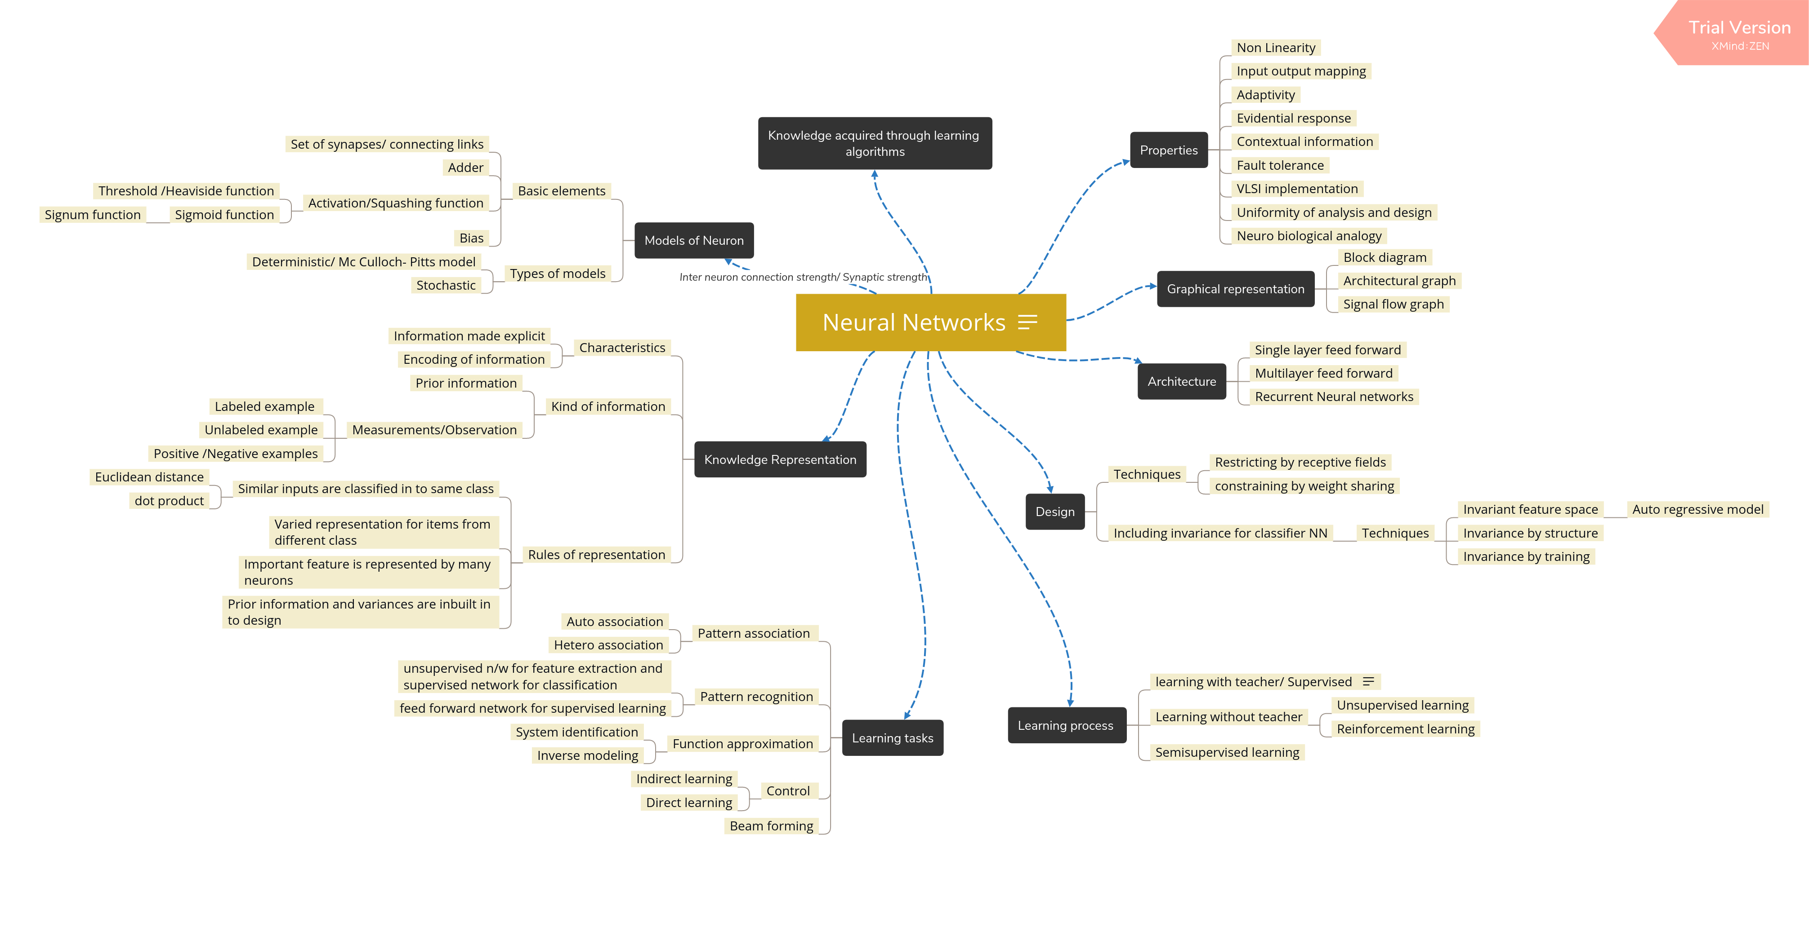
Question 3: Upload 3 questions on the reading material in a separate txt file in the given format:

Solution: Have attached the questions and answers in the expected format in the txt file named : NN_assignment1_Question3

Below is the content:
Q1. Why does the neural model include an externally applied bias?
A:
* The bias, denoted as b_k, where K is the neuron, has the effect of increasing or lowering the net input of the activation function, depending whether it is positive or negative respectively.
* The use of bias, has the effect of applying an affline transformation to the output u_k of the linear combiner in the model.

Q2. What are the two concepts, the measure of similarity is based on? How are they related?
A:
* The two concepts are: Euclidean distance and the dot product between the input vectors.
* When the individual elements of the input vectors are closer, the Euclidean distance is smaller and therefore the input vectors have greater similarity and also the inner product/dot product is larger between the two elements of the input vector.

Q3. What is probability of detection and probability of false alarm? How are they related to one another.
A:
* The probability of detection is defined as probability that a system decides that a target is present when it is.
* The probability of false alarm is defined as probability that a system decides that a target is present when it is not.
* As per the Neymon-Pearson criteria, the probability of detection is maximized, subject to the constraint that the probability of false alarm does not exceed a prescribed value.

Question4 : From Haykin’s book, Chapter 1 problems – “Models of a neuron”, solve any 2 out of 11 (1.1 to 1.11); use the sympy package to solve them.

Solution:
Q1.1 solution and Q1.2 solution are attached in a jupyter notebook named - NN_assignment1_ShravanthiPatil_SreenivasaHikkal
Alternative questions solved below:
Q1.9 solution:
Given bias,b_k = 0 , Net input signal, u_k = w_k1 *x_1 + w_k2 *x_2 + w_k3 *x_3 + w_k4 *x_4
net I/p = 10(0.8) + (-20)(0.2) + 4(-1.0) + (-2)(-0.9) = 8+4 -4+1.8 = 9.8

a. Neuron is linear : y_k = activation function ( u_k +b_k)
given, b_k = 0 , hence output signal of the neuron y_k = u_k = 9.8

b. neuron is represented by a McCulloch-Pitts model
In a McCulloch-pitts model, output is either 1 or 0 depending on the output signal being positive or negative respectively.
Hence y_k= 1.

Q1.10 solution:
If the neuron is based on logistic function,
output, y_k = 1/(1+ exp(-v) = 1/(1+ exp(-9.8)) = 0.999

Question5: From Haykin’s book, Chapter 1 problems – “Network architectures”, solve any 2 out of 7 (1.12 to 1.19), including 1.13.

Q1.12 solution:
A fully connected Feed forward network with 10 source nodes, two hidden layers and a single output neuron.
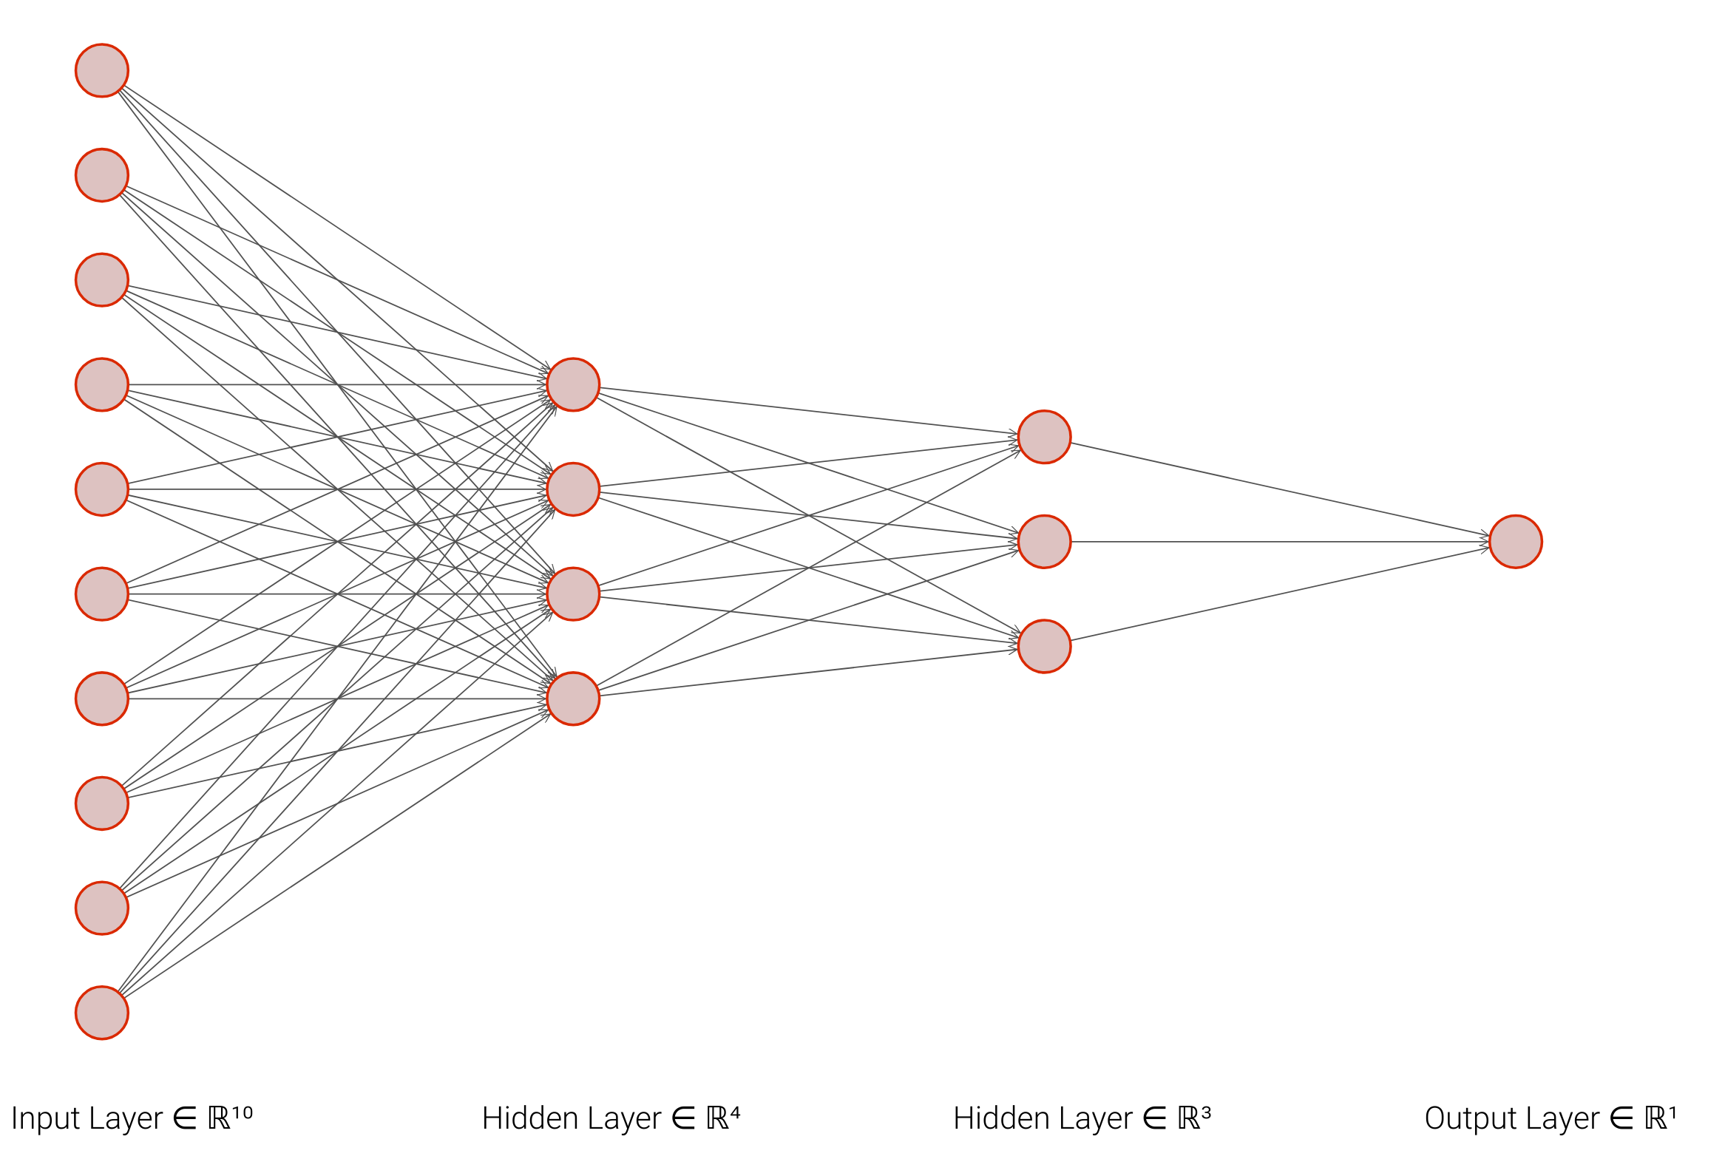

Q1.16 solution:
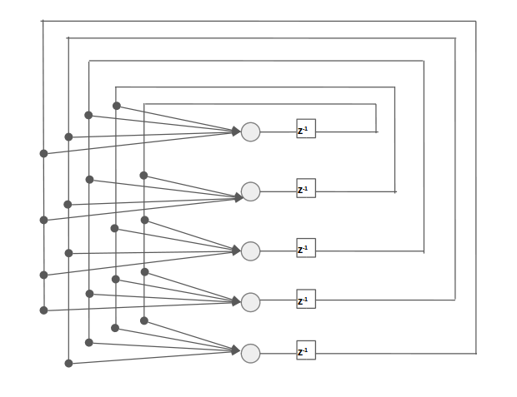
A fully recurrent network with 5 neurons but with no self feedback.

Q1.13a solution:
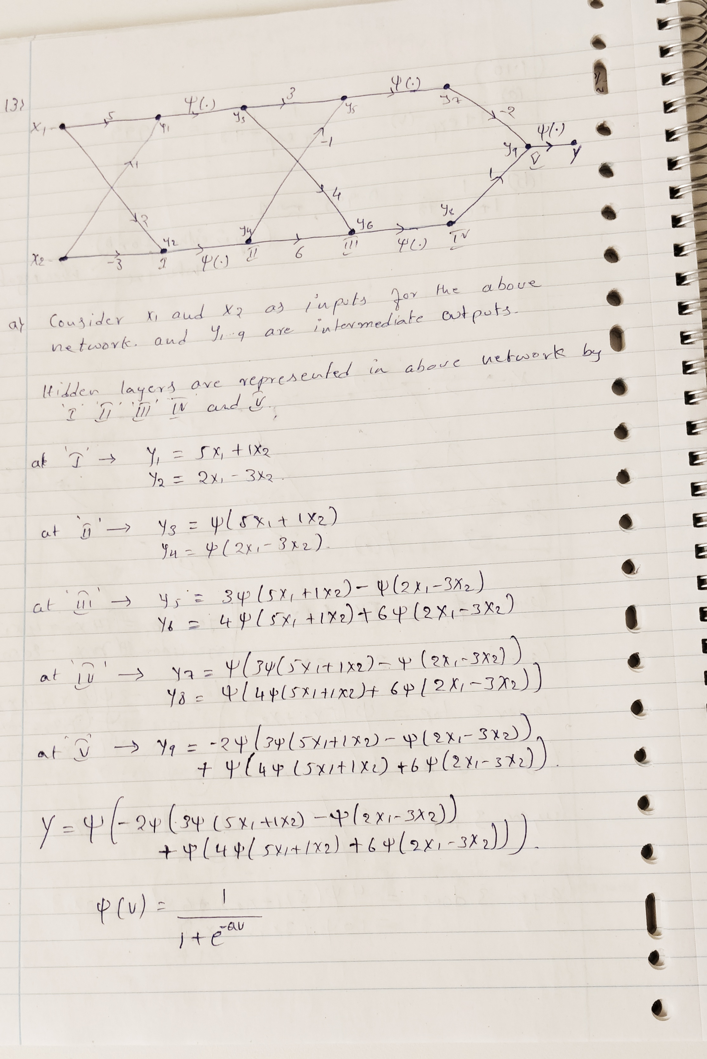

Q1.13b solution:
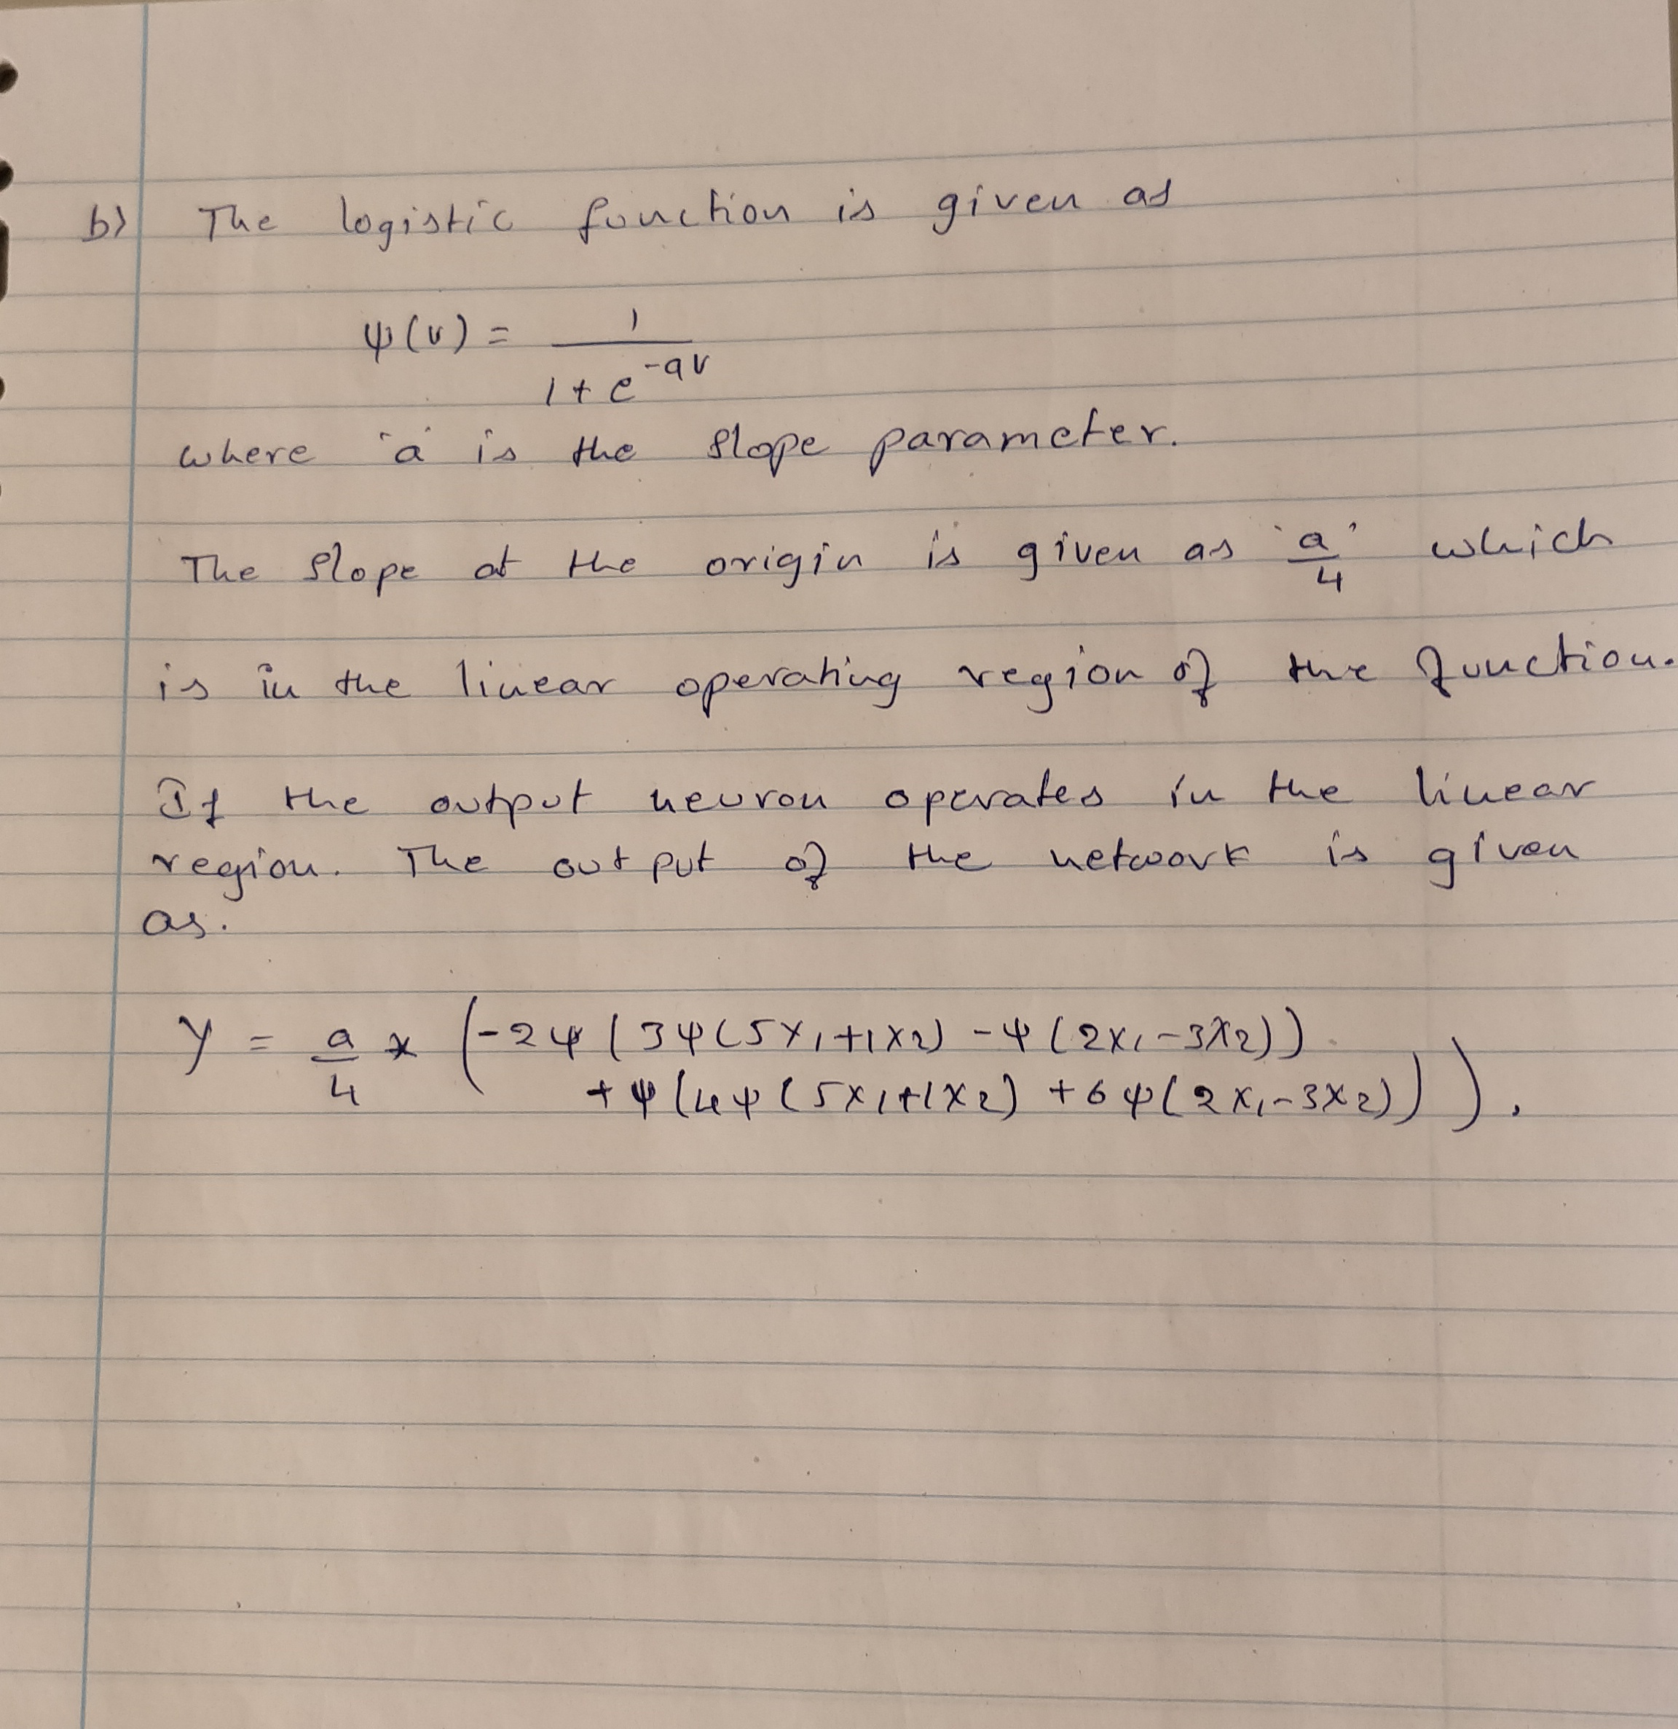

Question6: Solve 1.20 or 1.21 in section “Knowledge representation” . Hint: To solve the exersice use z-transform and the definition of time invariance filter filter(delay(y))=delay(filter(y))
Q1.20Solution:
Please note: Below is the screen shot of the equations in latex form written by us in the jupyter notebook .
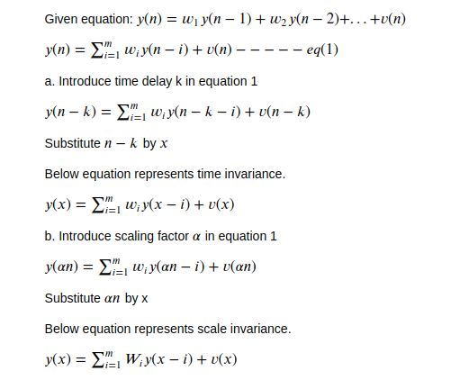

Use of the invariances in neural network:
1. Scale invariance are used in convolutional neural networks by implementing a technique involving progressive sequential resizing of all images while training the Convnet. It should be however noted that not all features are scale invariant and hence involves pooling concept, which gives CNN the resilience to translation.
2. Time invariance : The units in the time delay NN within each layer, receive input from a contextual window of output from the layer below. Each unit of a time varying signal has connections to the output from units below and also with time delayed outputs from the same units. This way, the units’ temporal pattern/trajectory are modeled. Higher layers receive inputs from wider context windows than lower layers and thereby model coarser levels of abstraction.

