STEP 1:
Line to be executed 60.
“main“method is currently executing.new stack frame is pushed into the empty call stack. Each frame contains the essential data needed for the method to run like local variables, parameters return address.
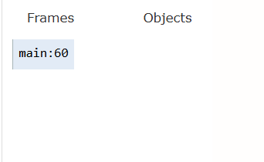

STEP 2:
Line executed 60.
Line to be executed 32.
The “Electronics” constructor is invoked in the lne 60 when object is created. The electronics instance is stored in the heap stack memory and the <init> incall stack. The program control moves from “main” method to electronics.
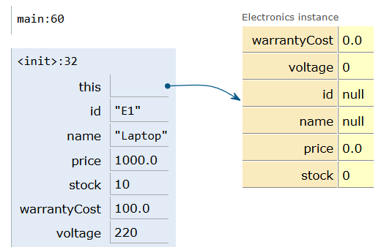

STEP 3:
Line executed 32.
Line to be executed 6.
The constructor of the parent class “Product” is invoked due to the Super keyword. Parent constructor has initialised the inherited fields. The fields are not initialised inside heap object. But hold vaues in the active stack. “This” variable in the stack points to the Electronics instance.
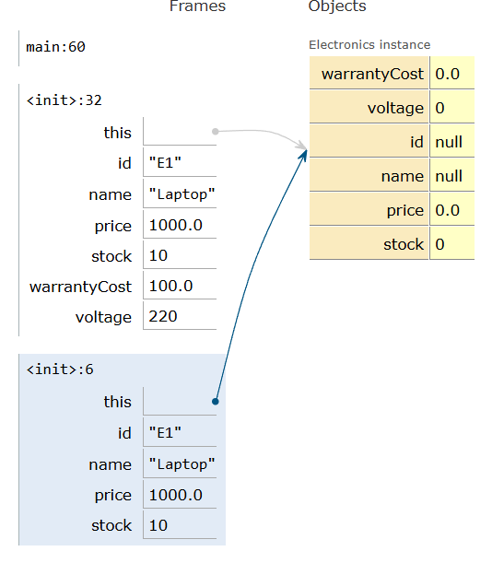

STEP 4:
Line executed 6.
Line to be executed 7.
The program control is on assignment statements inside the parent class constructor but not executed. The local variables are still uninitialised in the heap.

STEP 5:
Line to be executed 7.
Assignment statement is executed, ”id” field inside the heap object is updated to ‘E1’.

STEP 6:
Line to be executed 7.
Assignment statement is executed, “name” field inside the heap object is updated to ‘Laptop’.

STEP 7:
Line to be executed 7.
Assignment statement is executed, “price” field inside the heap object is updated to ‘1000.0’.

STEP 8:
Line executed 7.
Line to be executed 8.
Assignment statement is executed, “stock” field inside the heap object is updated to ‘10’.
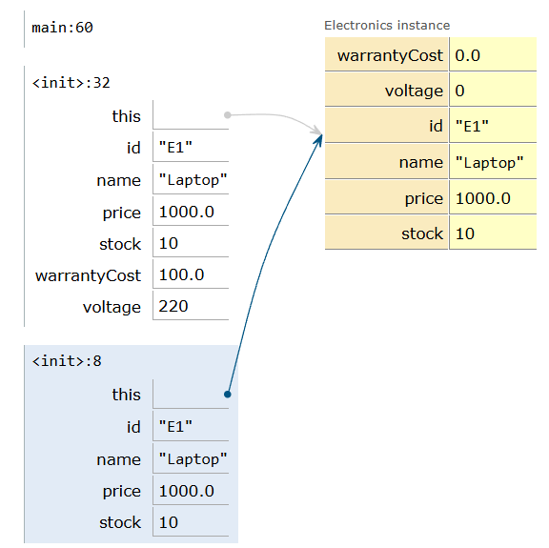

STEP 9:
Line executed 8.
Line to be executed 33.
Parent constructor “Product” is successfully executed. Program control comes back to electronics constructor.The fields of parent class is updated in the heap memory. The local fields of electronics constructor is still uninitialised with default values.
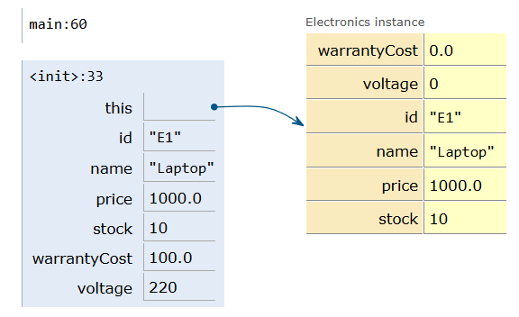

STEP 10:
Line executed 33.
Line to be executed 34.
Heap object has been successfully updated. The “warrantycost” field is updated from its default valule to 100.

STEP 11:
Line executed 34.
Line to be executed 35.
The “voltage” field in the heap is updated from its default valule to 220.
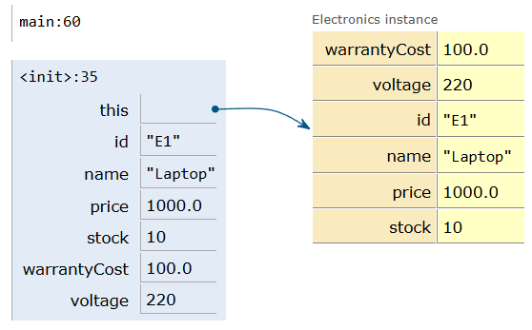

STEP 12:
Line executed 35.
Line to be executed 61.
Initilization of the electronics object is completed and updated in the heap, program has returned to main method. The active stack has popped the frame and returned to the main frame.
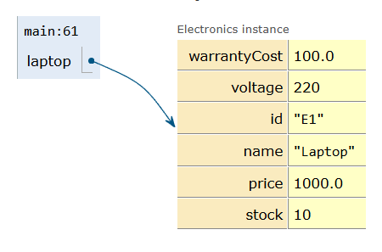

STEP 13:
Line executed 61.
Line to be executed 47.
Consstructor of clothing is invoked. Clothing instance is created in the heap alongside electronics instance.. It will invoke parent class “Product” constructor to intialise the inherited fields. The <init> is in call stack.
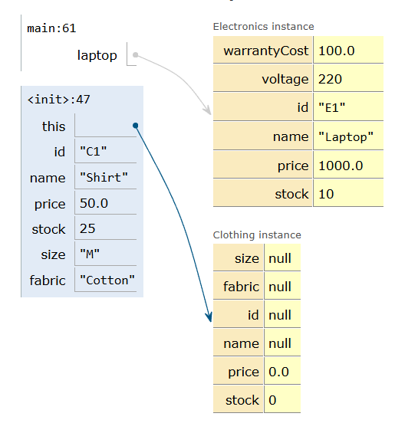

STEP 14:
Line executed 47.
Line to be executed 6.
Re-entered the parent class constructor to intialise the inherited fields for the second object instance.
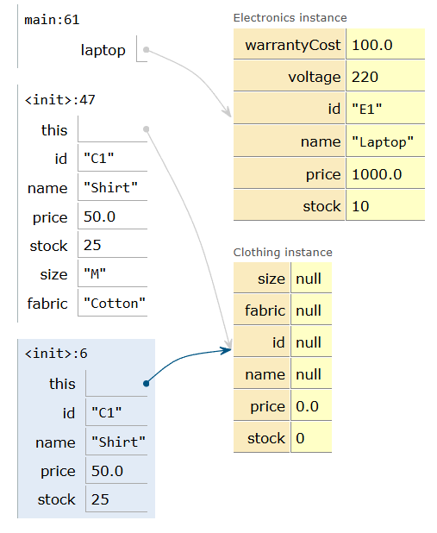

STEP 15:
Line executed 6.
Line to be executed 7.
Program control is on the assignment statements in the parent constructor.

STEP 16:
Line to be executed 7.
Assignment statement is executed, “id” field inside the heap object is updated to ‘C1’

STEP 17:
Line to be executed 7.
Assignment statement is executed “name” field inside the heap object is updated to ‘Shirt’

STEP 18:
Line to be executed 7.
Assignment statement is executed “price” field inside the heap object is updated to ‘50.0’

STEP 19:
Line executed 7.
Line to be executed 8.
Assignment statement is executed, “stock” field inside the heap object is updated to ‘25’.

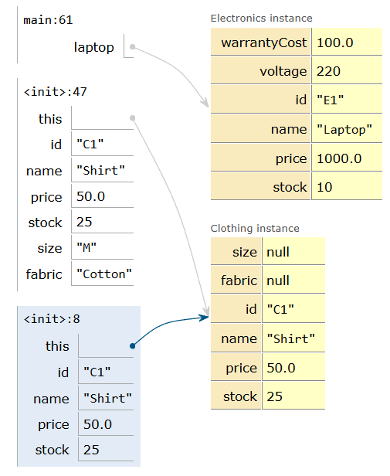

STEP 20:
Line executed 8.
Line to be executed 48.
Parent constructor is successfully executed. Program control comes back to Clothing constructor.The fields of parent class is updated in the heap memory. The local fiels of clothing constructor is still unitialissed with default values.

STEP 21:
Line executed 48.
Line to be executed 49.
The “size” field has been updated in the heap from its default valule to ‘M’.

STEP 22:
Line executed 49.
Line to be executed 50.
The “fabric” field has been updated in the heap from its default valule to ‘cotton’.
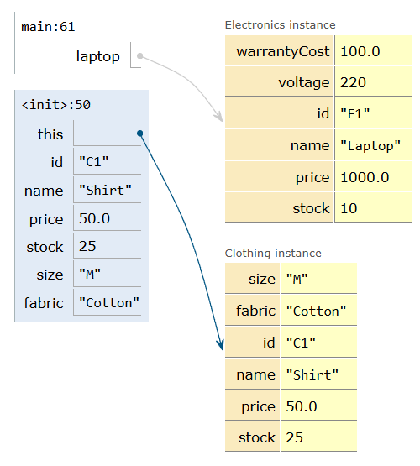

STEP 23:
Line executed 50.
Line to be executed 63.
Both objects are now fully intialised on the heap, program has returned to main method.
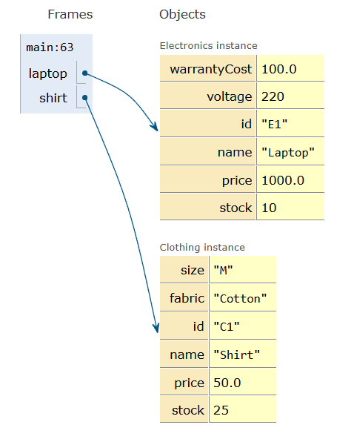

STEP 24:
Line executed 63.
Line to be executed 38.
“printDetails()” method of electronics class was invoked in the line 63. new stack frame is pushed into the call stack. “This” variable inside the call stack points to the electronics instance.
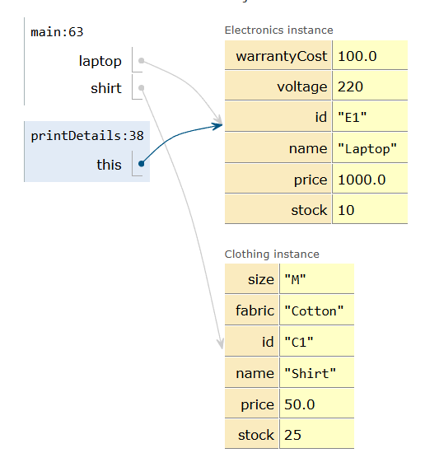

STEP 25:
Line executed 38.
Line to be executed 11.
Super keyword in line 38 has invoked the inherited method “printBaseInfo()”. Program control has entered the parent class. New stack is pushed into the active call stack. ‘This” variable in the stack in pointing to the electronics instance.
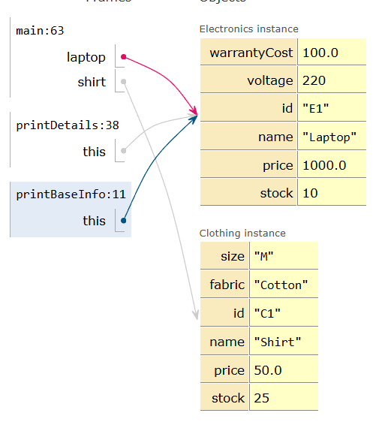

STEP 26:
Line executed 11.
Line to be executed 12.
Printing the output : “ID: E1, Name: Laptop, Price: $1000.0, Stock: 10”.
Outpput is retrieved from the heap stack. Program control is in the closing braces of the parant class. Active stack is prepared to pop off the call stack and return back to subclass “printDetails()” metod frame.

STEP 27:
Line executed 12.
Line to be executed 39.
Call stack has popped the parent class method.Control is returned back to the subclass method
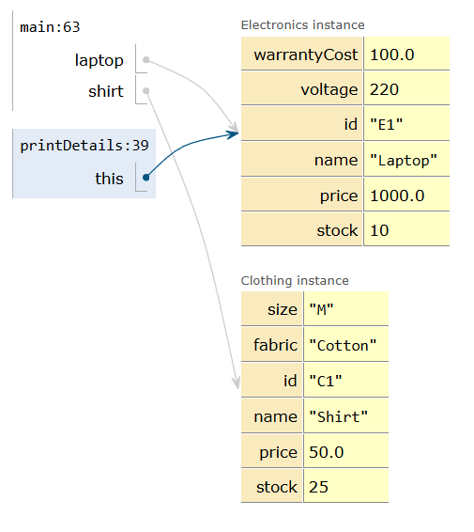

STEP 28:
Line executed 39.
Line to be executed 40.
Printing thre output retrived from the heap stack. “ID: E1, Name: Laptop, Price: $1000.0, Stock: 10
Warranty: $100.0, Voltage: 220V”. Program control is in the closing braces of the subclass method “printDetails()”. Active stack is prepared to pop off the call stack and return back to main method frame.

STEP 29:
Line executed 40.
Line to be executed 64.
Call stack has popped the subclass method “printDetails()”. Control is returned back to the main method frame.
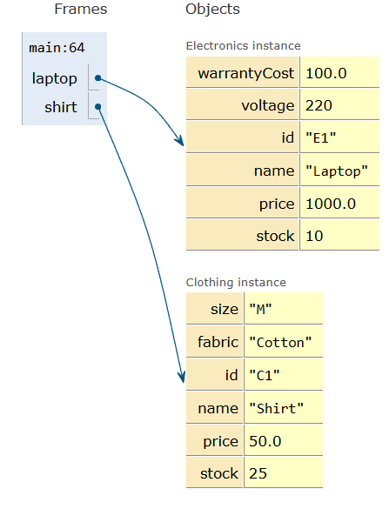

STEP 30:
Line executed 64.
Line to be executed 53.
“pritndetails()” of clothing class was invoked in the line 64. New stack frame is pushed into the call stack. ”this” variable inside the active stack points to the clothing instance.
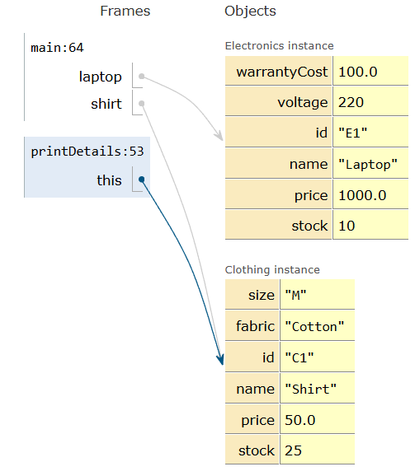

STEP 31:
Line executed 53.
Line to be executed 11.
Super keyword in line 53 has invoked the inherited method “printBaseInfo()”. Program control has entered the parent class. New stack is pushed into the call stack. “this” variable in the active stack in pointing to the clothing instance.
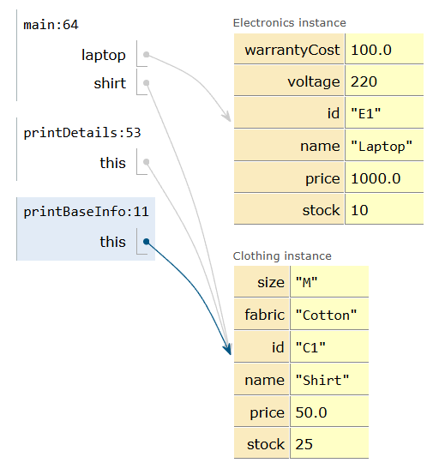

STEP 32:
Line executed 11.
Line to be executed 12.
Printing the output : “ID: C1, Name: Shirt, Price: $50.0, Stock: 25”.
Output is retrieved from the heap stack. Program control is in the closing braces of the parant class. Active stack is prepared to pop off the call stack and return back to subclass “printdetails()” metod frame.

STEP 33:
Line executed 12.
Line to be executed 54.
Call stack has popped the parent class method “printBaseInfo()” . Control id returned back to the subclass method “printDetails()”.
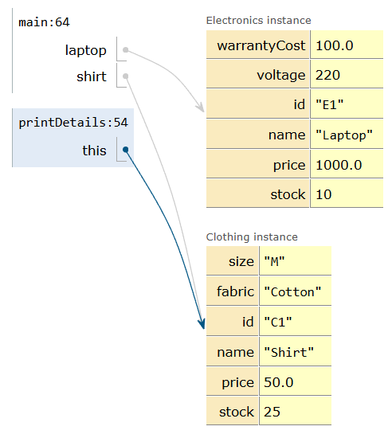

STEP 34:
Line executed 54.
Line to be executed 55.
Printing the output retrieved from the heap stack. “ID: C1, Name: Shirt, Price: $50.0, Stock: 25
Size: M, Fabric: Cotton
Program control is in the closing braces of the subclass method “printDetails()”. Active stack is prepared to pop off the call stack and return back to main metod frame.

STEP 35:
Line executed 55.
Line to be executed 66.
Call stack has popped the subclass method “printDetails()”. Control is returned back to the main method frame.
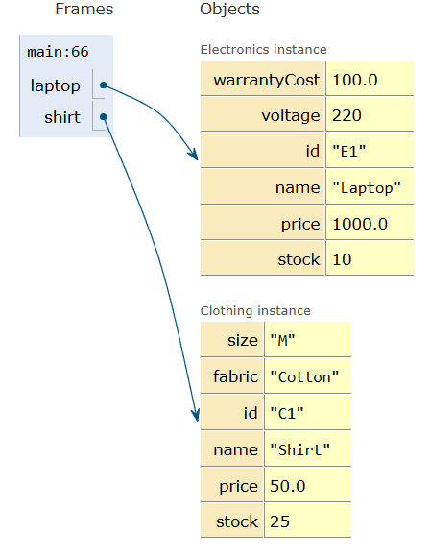

STEP 36:
Line executed 66.
Line to be executed 16.
“applyDiscount()” method of the parent class is invoked.The method is called with only one argument. “this” keyword is pointing to the electronic instance.
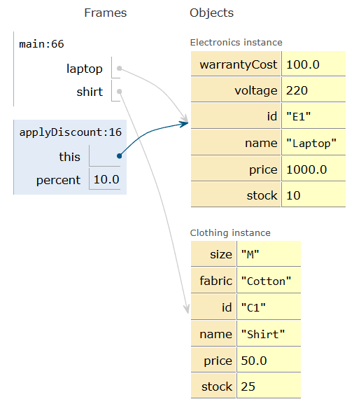

STEP 37:
Line executed 16.
Line to be executed 17.
“this” updates the price value in the heap from ’1000’ allocated to ‘900’.
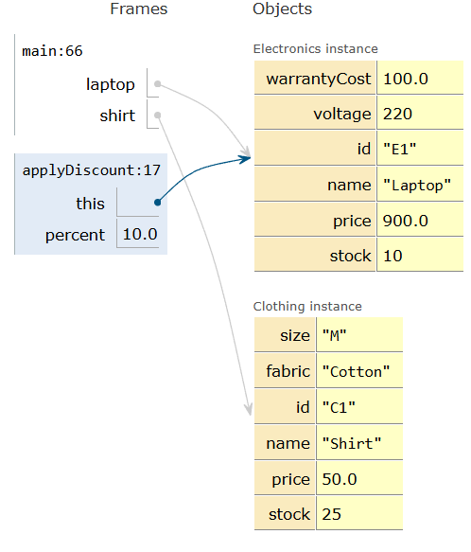

STEP 38:
Line executed 17.
Line to be executed 18.
Printing the output
“Laptop price after 10.0% off: $900.0 “ retrieved from the heap stack. Active Stack is preparing to pop “applyDiscount()” method.

STEP 39:
Line executed 18.
Line to be executed 67.
The active stack pops the parentclass method “applyDiscount()” and the program control returns to the main method frame.
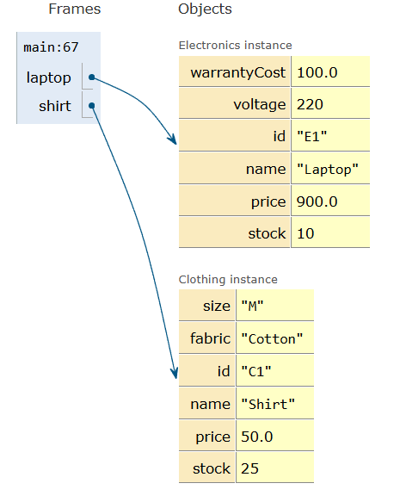

STEP 40:
Line executed 67.
Line to be executed 22.
The “applyDiscount()” method is invoked in the line 67. The method is called with two arguments. A new frame is pushed into the active stack. “this” variable in the stack is pointing to the clothing instance.
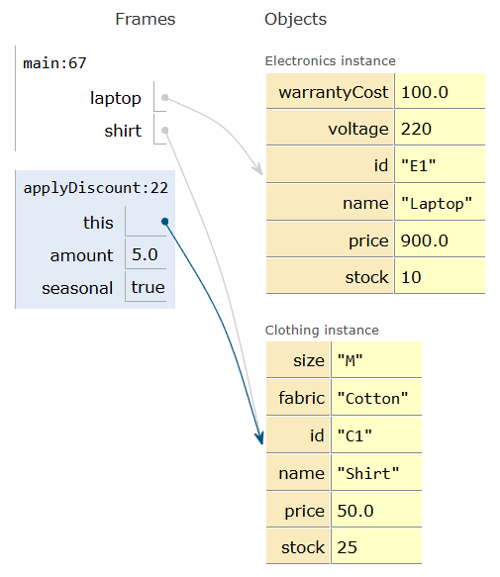

STEP 41:
Line executed 22.
Line to be executed 23.
”this updates the value of price in the heap memory.

STEP 42:
Line executed 23.
Line to be executed 24.
The updated value is retrived from the heap and printed as the ouput.
“[Seasonal] Shirt price after $5.0 off: $45.0”
The active stack prepares to pop the parent class method “applyDiscount()”.

Executing line 68. The active stack pops the “applyDiscount()” method frame and the contolreturns to the main frame.
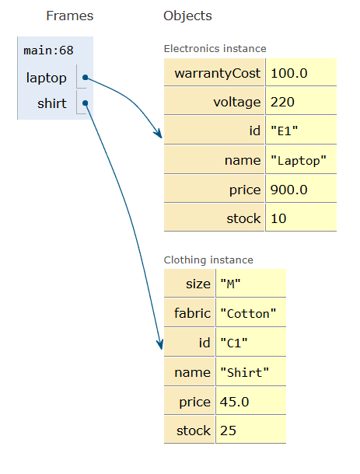

CODE:
class Product {
private String id, name;
private double price;
private int stock;

public Product(String id, String name, double price, int stock) {
this.id = id; this.name = name; this.price = price; this.stock = stock;
}

public void printBaseInfo() {
System.out.println("ID: " + id + ", Name: " + name + ", Price: $" + price + ", Stock: " + stock);
}

// Overload 1: Percentage discount
public void applyDiscount(double percent) {
price -= price * (percent / 100.0);
System.out.println(name + " price after " + percent + "% off: $" + price);
}

// Overload 2: Flat amount discount with seasonal flag
public void applyDiscount(double amount, boolean seasonal) {
price -= amount;
System.out.println((seasonal ? "[Seasonal] " : "") + name + " price after $" + amount + " off: $" + price);
}
}

class Electronics extends Product {
private double warrantyCost;
private int voltage;

public Electronics(String id, String name, double price, int stock, double warrantyCost, int voltage) {
super(id, name, price, stock); // Constructor chaining
this.warrantyCost = warrantyCost;
this.voltage = voltage;
}

public void printDetails() {
super.printBaseInfo(); // Parent method invocation using super
System.out.println("Warranty: $" + warrantyCost + ", Voltage: " + voltage + "V\n");
}
}

class Clothing extends Product {
private String size, fabric;

public Clothing(String id, String name, double price, int stock, String size, String fabric) {
super(id, name, price, stock); // Constructor chaining
this.size = size;
this.fabric = fabric;
}

public void printDetails() {
super.printBaseInfo(); // Parent method invocation using super
System.out.println("Size: " + size + ", Fabric: " + fabric + "\n");
}
}

public class Main {
public static void main(String[] args) {
Electronics laptop = new Electronics("E1", "Laptop", 1000.0, 10, 100.0, 220);
Clothing shirt = new Clothing("C1", "Shirt", 50.0, 25, "M", "Cotton");

laptop.printDetails();
shirt.printDetails();

laptop.applyDiscount(10.0);
shirt.applyDiscount(5.0, true);
}
}

