**Software Requirements Specification**

**On**

**Order Management System**

Submitted by

K.Shivani

Mahveesh Fatima

M.Vyshnavi

P.Nikhila

k.Shravya

**1.Introduction:**

Seamlessly manage your desktop orders from placement to delivery, ensuring exceptional customer satisfaction and timely fulfillment.

Effortlessly track real-time inventory levels to prevent stockouts and overstock situations, optimizing your business operations.

Streamline your workflows with automated processes, reducing manual tasks and minimizing errors for smoother operations.

Deliver outstanding service with swift order processing, accurate tracking, and personalized support tailored to your customers' needs.

Gain valuable insights with comprehensive analytics, enabling you to identify sales trends, seize opportunities, and make data-driven decisions.

Integrate seamlessly with various sales channels, including online platforms and physical stores, for centralized order management.

Access your order management system from anywhere with a mobile-friendly interface, providing flexibility and convenience for on-the-go management.

Scale your operations seamlessly to meet growing demands, adapting your system to evolving business requirements.

Customize the application to fit your specific needs, easily adding or modifying features as needed for optimal functionality.

**2.Functional Requirements**

The Order Management System should be able to register, log in, and log out users, including administrators.

The Order Management System should provide a dashboard for users and administrators to view order statuses, statistics, and other relevant information.

The Order Management System should allow users to create, update, and cancel orders as needed.

The Order Management System should provide a categorized and searchable catalog of products or services.

The Order Management System should display detailed information about products or services, including descriptions, images, and prices.

The Order Management System should allow users to add, remove, and update items in their orders.

The Order Management System must initiate a secure and user-friendly checkout process.

The Order Management System should support multiple payment options such as credit card, bank transfer, and PayPal.

The Order Management System should allow users to view their order history and track the status of their orders in real-time.

The Order Management System should implement a search functionality for orders and filtering options based on various criteria such as date, status, and customer name.

The Order Management System should provide administrative features for managing products, inventory, customers, and orders.

**3.Non-Functional Requirements**

**Performance:**

- The order management system should respond promptly to user actions, ensuring quick access to order details and efficient processing.

- The system must handle spikes in user activity during peak times without experiencing significant slowdowns or performance degradation.

**Error handling:**

- The system should maintain high availability, allowing users to access and manage orders without interruption.

- It must be resilient to failures, ensuring that any errors or issues do not lead to system-wide downtime.

**Security Requirements:**

- Employ encryption protocols to safeguard sensitive user data, particularly during transactions and when storing payment information.

- Implement robust authentication and authorization mechanisms to protect user accounts and prevent unauthorized access to critical functionalities.

**Usability Requirements:**

- Ensure that the user interface is intuitive and easy to navigate, facilitating seamless order management and completion of transactions.

- The system's database should be scalable to accommodate a growing number of orders, customers, and transactions effectively.

**Maintainability:**

- The order management system should be compatible with various web browsers, maintaining consistent functionality across different platforms.

- Regularly back up the database and user data to prevent data loss and ensure continuity of operations in case of unforeseen circumstances.

**Software Requirements:**

React

Firebase

API’s

**Hardware Requirements:**

* Intel Pentium 4 and above Windows 7
* Memory 8 GB
* Edge/Chrome browser
* Visual Studio Code
* Firebase

**ADMIN:**

**1. Manage Product Catalog:**

- Actors: Admin

- Precondition: Admin is authenticated and has access to the product management interface.

- Description: The admin can add, edit, or remove products from the catalog. This includes adding new products with details, editing existing product information, and removing products from the catalog.

**2. Manage Customer Accounts:**

- Actors: Admin

- Precondition: Admin is authenticated and has access to the customer management interface.

- Description: The admin can view and manage customer accounts. This includes viewing a list of registered customers, viewing and modifying customer details, and disabling or deleting customer accounts if necessary.

**3. Monitor Orders:**

- Actors: Admin

- Precondition: Admin is authenticated and has access to the order monitoring interface.

- Description: The admin can view and manage customer orders. This involves actions such as viewing a list of recent orders, tracking the status of orders (processing, shipped, delivered), and updating order status to manage order fulfillment.

**4. Handle Customer Support:**

- Actors: Admin

- Precondition: Admin is authenticated and has access to the customer support interface.

- Description: The admin can respond to customer inquiries and issues. This includes actions such as viewing and responding to customer support messages and resolving customer complaints and issues.

**CUSTOMER:**

**1. Login/Register:**

- Actors: Customer

- Precondition: The customer is not logged in or doesn’t have an account on the website.

- Description: The customer needs to log in to access personalized features and complete transactions.

**2. Search Products:**

- Actors: Customer

- Precondition: Customer is authenticated or browsing anonymously.

- Description: Customers can browse the product catalog. This involves actions such as navigating through product categories and using search and filtering options to find desired products.

**3. Add to Cart:**

- Actors: Customer

- Precondition: Customer is authenticated and has selected a product to add to the cart.

- Description: Customers can add products to their shopping cart. This involves actions such as clicking on a product to view details and adding the product to the shopping cart.

**4. Manage Shopping Cart:**

- Actors: Customer

- Precondition: Customer is authenticated and has items in the shopping cart.

- Description: Customers can view and edit the contents of their shopping cart. This involves actions such as viewing items in the cart and updating quantities or removing items.

**5. Proceed to Checkout:**

- Actors: Customer

- Precondition: Customer has items in the shopping cart.

- Description: Customers initiate the checkout process to complete their purchase. This involves actions such as clicking on the "Checkout" button and providing shipping and payment information.

**6. Payment:**

- Actors: Customer

- Precondition: The customer is logged in and has items in the shopping cart.

- Description: The customer, after logging in, proceeds to make a payment for the items in the shopping cart.

**5.Sequence Diagram**

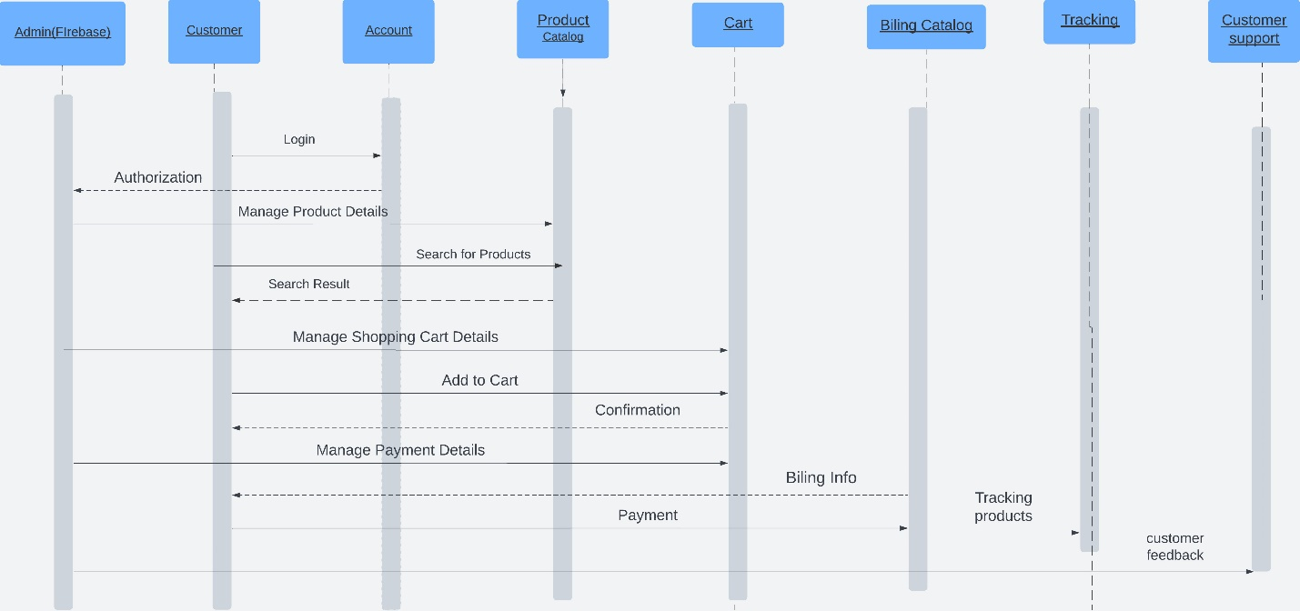

**6.Use Case Diagram**

