A Project report on

**SUSTAIN A PLATE Using React And PlayFrameWork**

Submitted in partial fulfillment of the requirement for the award of the degree of

Bachelor of Technology in Information Technology

By:

K.Shivani-20251A12A5

D.HimaSri-

Under the Guidance of

Dr I.Ravi Prakash Reddy Dean, Placements & Corporate Relations

Project Batch Number**-20B10**



**Department Of Information Technology**

**G. Narayanamma Institute of Technology and Science**

**(for Women)**

Approved by AICTE, New Delhi & Affiliated to JNTUH, Hyderabad

Accredited by NBA & NAAC Shaikpet, Hyderabad – 500104, TS.

# July 2024 to April 2024

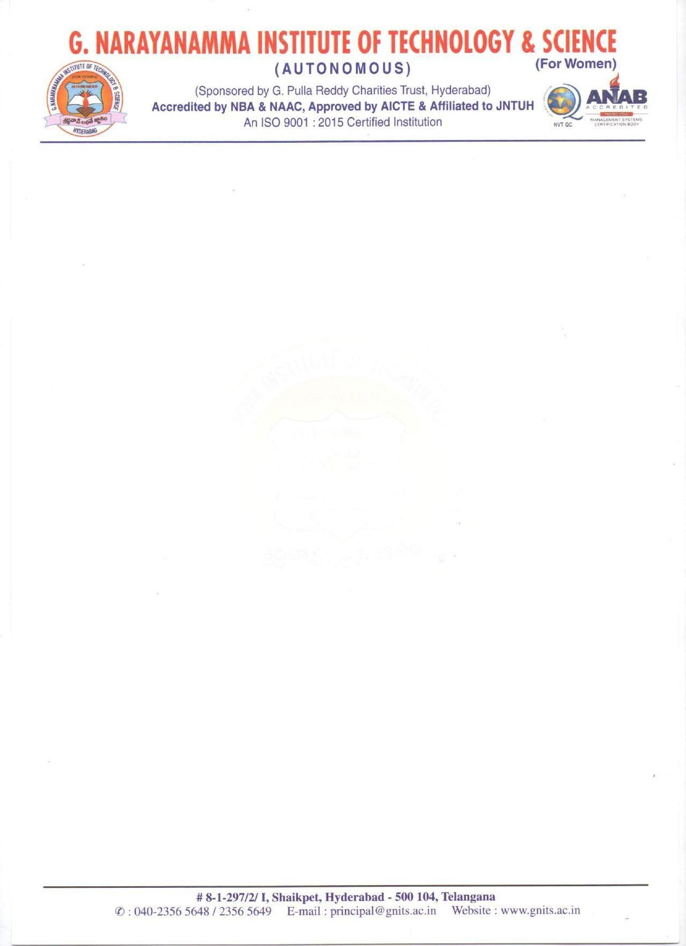

# CERTIFICATE

This is to certify that the Project Report entitled **Classification of Multilingual poetry text into emotion states using Deep Learning** is bonafide workdone

By:

**Name of the candidate Registration Number**

**1**  K.Shivani 20251A12A5

2 D.HimaSri

Under the guidance of Dr I.Ravi Prakash Reddy Dean, Placements & Corporate Relations during **July 2024 to April 2024**, in partial fulfillment for the award of degree in B.Tech in Information Technology, from G. Narayanamma Institute of Technology and Science.

Dr I.Ravi Prakash Reddy Dr.S.Ramacharan

**Internal Guide Head of the Department**

# CERTIFICATE

This is to certify that the project report entitled **SUSTAIN A PLATE Using React**

**And PlayFrameWork** that is being submitted

By:

**Name of the candidate Registration Number**

**1**  K.Shivani 20251A12A5

2 D.HimaSri

in partial fulfillment for the award of B.Tech in Information Technology to the G. Narayanamma Institute of Technology and Science is a record of bonafide work carried out by us at our organization/institution.

Signature of the Head/Director of Organization

# ACKNOWLEDGEMENT

We would like to express our sincere thanks to Dr K. Ramesh Reddy, Principal, G. Narayanamma Institute of Technology and Science for providing the working facilities in the college. Our sincere thanks and gratitude to Dr.S.RamaCharan, Professor and HOD, Department of Information Technology, GNITS for all the timely support and valuable suggestions during the period of our project.

We are extremely thankful and indebted to our Internal guide, Dr I.Ravi Prakash Reddy Dean, Placements & Corporate Relations, Department of Information Technology, GNITS and project coordinators, Dr.L.Smitha, Ch.Sravanthi, Assistant Professors, Department of Information Technology, GNITS for their constant guidance, continuous advice, encouragement and moral support throughout the project.

Finally, we would also like to thank all the faculty and staff of Department of Information Technology who have helped us directly or indirectly, parents and friends for their cooperation in completing the project report work.

# ABSTRACT

**CONTENTS**

**1. INTRODUCTION**

* 1. General / Domain Description…………………………………………….....1
  2. Objective & Scope of the Project………………………………………….....2
  3. Project Definition………….............................................................................3
  4. Organization of Project Report……………………………………………....4

1. LITERATURE SURVEY
   1. Existing Approaches / System……………………………………………….6
   2. Drawbacks in Existing System………………………………………………14
   3. Motivation for Proposed System…………………………………………….16
2. REQUIREMENT SPECIFICATION
   1. Introduction…………………………………………………………………..18
   2. System Environment…………………………………………………………19
   3. Functional Requirement Specification

3.3.1.Use case description………………………………….......................20

3.3.2.List of Functional Requirements……………………22

* 1. Non-Functional Requirements…………………………………………….…24
  2. H/w &S/W requirements……………………………………………….…….27
  3. System Architecture…………………………………………………..……...29

1. DESIGN SPECIFICATION
   1. Overall Use case Diagram……………………………………………………33
   2. ER diagrams with Normalized Databases …………………………………...34
   3. Class Diagrams……………………………………………………………….37
   4. Activity / State chart diagrams……………………………………………….38
   5. Sequence Diagrams…………………………………………………………..40
   6. Collaboration/Deployment Diagrams………………………………………...42

# BIBLIOGRAPHY / REFERENCES………………………………...…43

**LIST OF FIGURES**

**Figure No. Figure Description Page No.**

# 3.6 System Architecture 29

# 4.1 Use case Diagram 33

# 4.2 E-R Diagram 35

# 4.3 Class Diagram 37

# 4.4 Activity Diagram 38

# 4.5 Sequence Diagram 40

# 4.6 Collaboration Diagram 42