import tensorflow as tf

import nibabel as nib

import numpy as np

import os

from sklearn.preprocessing import LabelBinarizer

from tensorflow.keras.utils import to_categorical

from scipy.ndimage import zoom, rotate, shift

from sklearn.utils.class_weight import compute_class_weight

from tensorflow.keras.regularizers import l2

from sklearn.metrics import classification_report, confusion_matrix

import seaborn as sns

import matplotlib.pyplot as plt

import nibabel as nib

import numpy as np

from skimage.transform import resize

import os

# Directories

healthy_directory = "nd/healthy/"

schiz_directory = "nd/schizophrenia/"

he_directory = "resized/healthy/"

sz_directory = "resized/schizophrenia/"

def resize_data(data, new_shape):

# Resize each slice independently

resized_slices = np.zeros((data.shape[0], new_shape[0], new_shape[1]))

for i in range(data.shape[0]):

resized_slices[i, :, :] = resize(data[i, :, :], new_shape, mode='reflect', anti_aliasing=True)

return resized_slices

def process_and_resize_directory(input_directory, output_directory, slice_start, slice_end, new_shape):

if not os.path.exists(output_directory):

os.makedirs(output_directory)

print(f"Listing files in directory: {input_directory}")

files = os.listdir(input_directory)

print(f"Files found: {files}")

files_processed = False # Flag to check if any file was processed

for filename in files:

if filename.endswith('.nii'):

file_path = os.path.join(input_directory, filename)

try:

print(f"Processing file: {file_path}")

# Load the NIfTI file

img = nib.load(file_path)

data = img.get_fdata() # Get the image data as a NumPy array

print(f"Original data shape: {data.shape}")

# Extract middle slices

middle_slices = data[slice_start:slice_end, :, :]

# Resize each slice

resized_slices = resize_data(middle_slices, new_shape)

# Save the resized data

new_file_path = os.path.join(output_directory, f"resized_{filename}")

new_img = nib.Nifti1Image(resized_slices, img.affine)

nib.save(new_img, new_file_path)

print(f"Resized and saved {filename} to {new_file_path}")

files_processed = True

except Exception as e:

print(f"Error processing {filename}: {e}")

if not files_processed:

print(f"No files processed in directory: {input_directory}")

# Define the range of slices you want to extract

slice_start = 86

slice_end = 106 # Note that end is exclusive

# Define the new shape

new_shape = (128, 128)

# Process and resize both directories

process_and_resize_directory(healthy_directory, he_directory, slice_start, slice_end, new_shape)

process_and_resize_directory(schiz_directory, sz_directory, slice_start, slice_end, new_shape)

import albumentations as A

import nibabel as nib

import numpy as np

import os

from sklearn.utils import shuffle

from albumentations.pytorch import ToTensorV2

# Directories

he_directory = "resized/healthy/"

sz_directory = "resized/schizophrenia/"

# Augmentation pipeline

def get_augmentation_pipeline():

return A.Compose([

A.RandomRotate90(p=0.5),

A.HorizontalFlip(p=0.5),

A.VerticalFlip(p=0.5),

A.RandomBrightnessContrast(brightness_limit=0.2, contrast_limit=0.2, p=0.5),

A.RandomGamma(gamma_limit=(80, 120), p=0.5),

A.Resize(height=128, width=128), # Resize to a common shape if needed

ToTensorV2() # Convert to PyTorch tensors if using PyTorch

])

def load_images_and_labels(directory, label, augmentation=None):

files = [f for f in os.listdir(directory) if f.endswith('.nii')]

images = []

for file in files:

file_path = os.path.join(directory, file)

img = nib.load(file_path)

data = img.get_fdata()

# Apply augmentation if provided

if augmentation:

for i in range(data.shape[0]): # Apply augmentation to each slice

augmented = augmentation(image=data[i])

images.append(augmented['image'])

else:

images.extend(data)

return np.array(images), np.full(len(images), label)

# Define augmentation pipeline

augmentation_pipeline = get_augmentation_pipeline()

# Load and augment data

S_healthy_images, healthy_labels = load_images_and_labels(he_directory, 0, augmentation=augmentation_pipeline)

S_schiz_images, schiz_labels = load_images_and_labels(sz_directory, 1, augmentation=augmentation_pipeline)

# Concatenate the healthy and diseased data into a single array

S_data = np.concatenate((S_healthy_images, S_schiz_images), axis=0)

S_labels = np.concatenate((healthy_labels, schiz_labels), axis=0)

# Shuffle the data and labels together

S_data, S_labels = shuffle(S_data, S_labels, random_state=42)

# Split the data and labels into training and testing sets

split_index = int(len(S_data) * 0.8) # 80% for training

S_train_data = S_data[:split_index]

S_test_data = S_data[split_index:]

S_train_labels = S_labels[:split_index]

S_test_labels = S_labels[split_index:]

print(f"Training data shape: {S_train_data.shape}")

print(f"Testing data shape: {S_test_data.shape}")

print(f"Training labels shape: {S_train_labels.shape}")

print(f"Testing labels shape: {S_test_labels.shape}")

import tensorflow as tf

from tensorflow.keras import layers, models

def create_3d_cnn_model(input_shape):

model = models.Sequential()

model.add(layers.Conv3D(filters=32, kernel_size=(1, 3, 3), activation='relu', input_shape=input_shape))

model.add(layers.MaxPooling3D(pool_size=(1, 2, 2)))

model.add(layers.Conv3D(filters=64, kernel_size=(1, 3, 3), activation='relu'))

model.add(layers.MaxPooling3D(pool_size=(1, 2, 2)))

model.add(layers.Conv3D(filters=128, kernel_size=(1, 3, 3), activation='relu'))

model.add(layers.MaxPooling3D(pool_size=(1, 2, 2)))

model.add(layers.Flatten())

model.add(layers.Dense(512, activation='relu'))

model.add(layers.Dropout(0.5))

model.add(layers.Dense(1, activation='sigmoid')) # Binary classification

model.compile(optimizer='adam', loss='binary_crossentropy', metrics=['accuracy'])

return model

input_shape = (1, 128, 128, 1) # Adjusted for depth of 1

model = create_3d_cnn_model(input_shape)

from sklearn.utils.class_weight import compute_class_weight

# Compute class weights

class_weights = compute_class_weight('balanced', classes=np.unique(S_train_labels), y=S_train_labels)

class_weight_dict = dict(enumerate(class_weights))

# Compile the model (no class_weight here)

model.compile(optimizer='adam', loss='binary_crossentropy', metrics=['accuracy'])

# Train the model with class weights

model.fit(S_train_data, S_train_labels, epochs=50, batch_size=32, class_weight=class_weight_dict)

#Save the model

model.save('resized/223d_cnn_model.h5')

model.save('resized/223d_cnn_model.keras')

# Load the model (example)

loaded_model_h5 = tf.keras.models.load_model('resized/223d_cnn_model.h5')

loaded_model_keras = tf.keras.models.load_model('resized/223d_cnn_model.keras')

from sklearn.metrics import accuracy_score

# Predict the labels for the test data

S_test_predictions = model.predict(S_test_data)

# Convert predictions to binary class labels if not already done

S_test_predictions_binary = (S_test_predictions > 0.5).astype(int) # Assuming binary classification

# Calculate accuracy

accuracy = accuracy_score(S_test_labels, S_test_predictions_binary)

print(f"Test Accuracy: {accuracy:.4f}")

from sklearn.metrics import confusion_matrix

# Assuming you have your true labels (S_test_labels) and predictions (S_test_predictions)

S_test_predictions_binary = (S_test_predictions > 0.5).astype(int) # Convert to binary if needed

# Compute confusion matrix

conf_matrix = confusion_matrix(S_test_labels, S_test_predictions_binary)

print("Confusion Matrix:\n", conf_matrix)

import matplotlib.pyplot as plt

from sklearn.metrics import roc_curve, roc_auc_score

# Compute ROC curve

fpr, tpr, thresholds = roc_curve(S_test_labels, S_test_predictions)

# Compute AUC

roc_auc = roc_auc_score(S_test_labels, S_test_predictions)

# Plot ROC curve

plt.figure()

plt.plot(fpr, tpr, color='darkorange', lw=2, label=f'ROC curve (area = {roc_auc:.2f})')

plt.plot([0, 1], [0, 1], color='navy', lw=2, linestyle='--')

plt.xlim([0.0, 1.0])

plt.ylim([0.0, 1.05])

plt.xlabel('False Positive Rate')

plt.ylabel('True Positive Rate')

plt.title('Receiver Operating Characteristic (ROC)')

plt.legend(loc="lower right")

plt.show()

print(f"AUC: {roc_auc:.4f}")

from sklearn.metrics import accuracy_score

# Calculate accuracy

accuracy = accuracy_score(S_test_labels, S_test_predictions_binary)

print(f"Accuracy: {accuracy:.4f}")

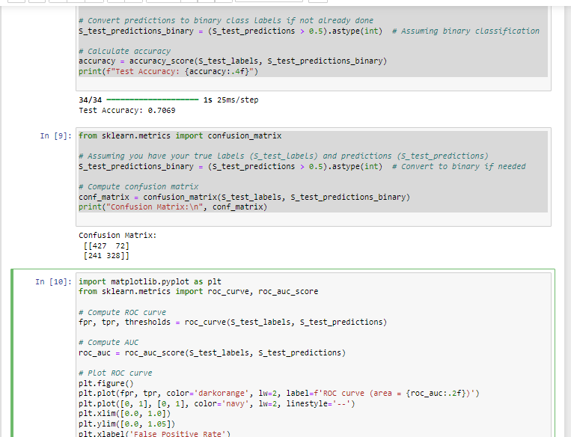

100 epochs

2 COMBINED_DATASET_3D_CNN- 100 epochs

2 COMBINED_DATASET_3D_CNN-5fold cross validation

Average Accuracy: 0.6270

2 COMBINED_DATASET_3D_CNN

complex model

