Project -9

How to automatically trigger the job in Jenkins using pipelines integrating with GitHub Dashboard:

Creating job4:

Status: 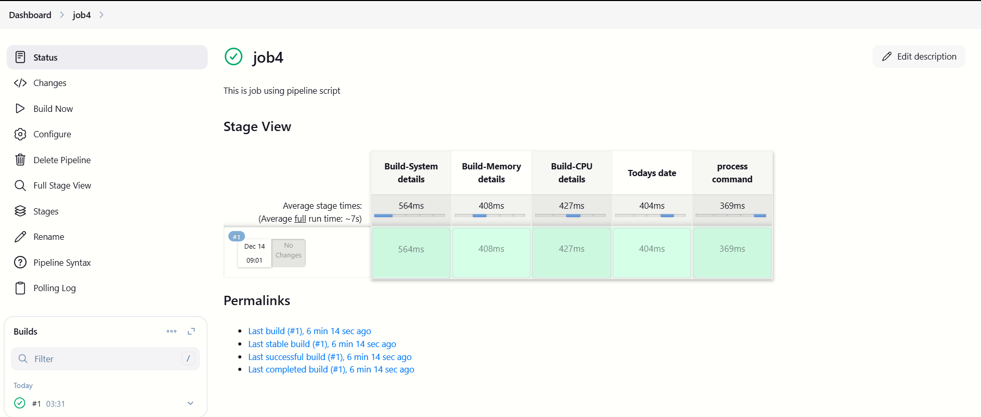

Stage Logs:

Shell Script

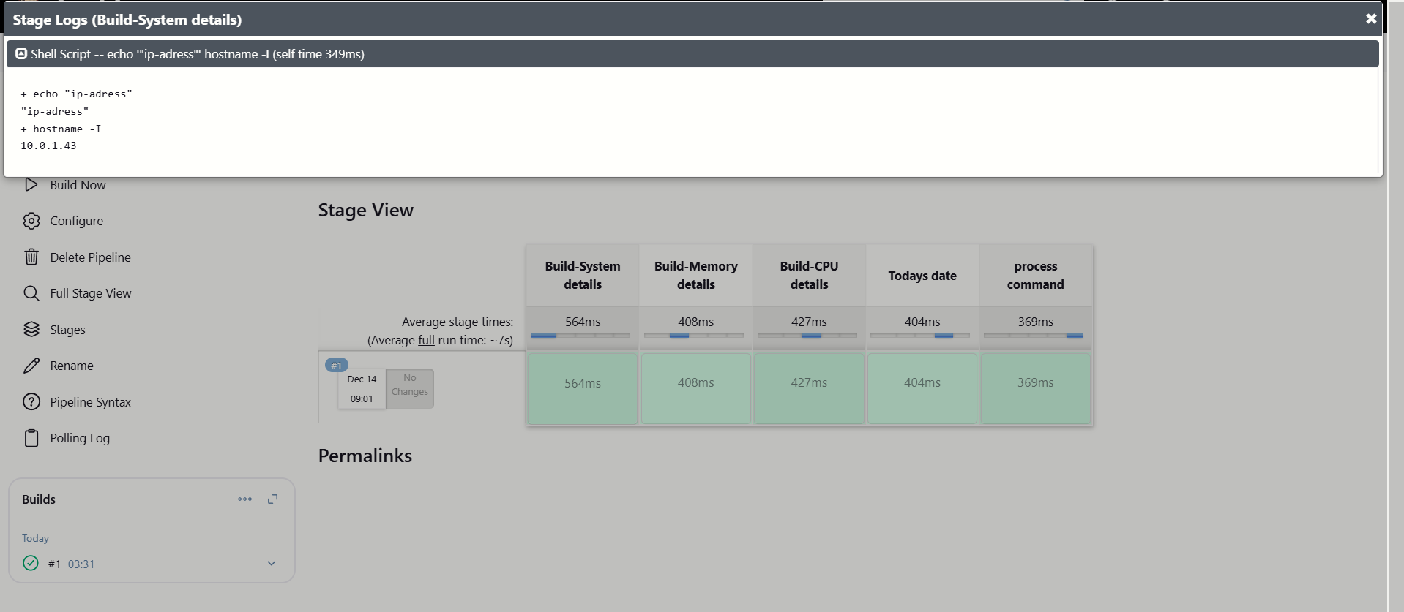

Creating Webhooks:

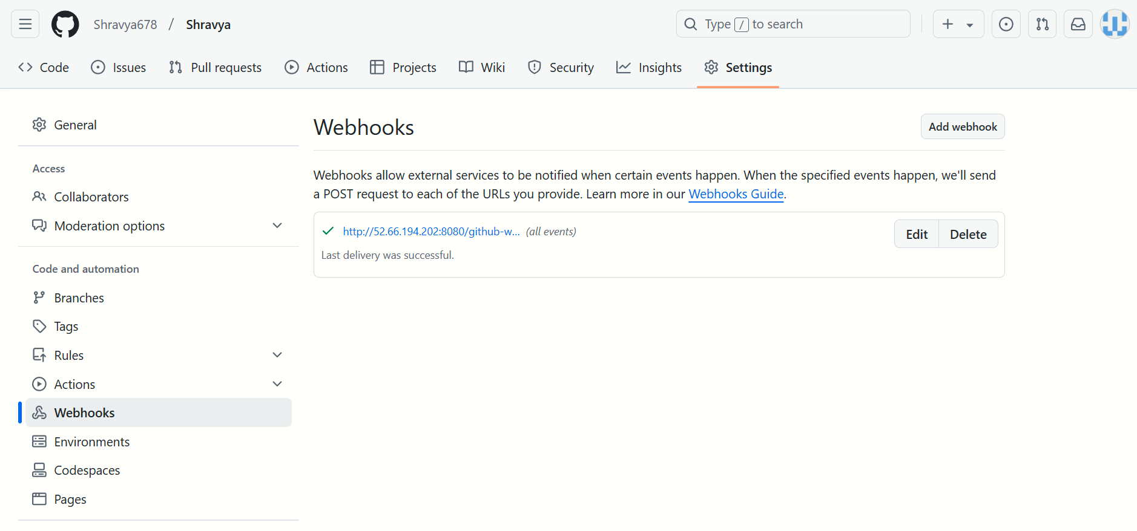

Status:

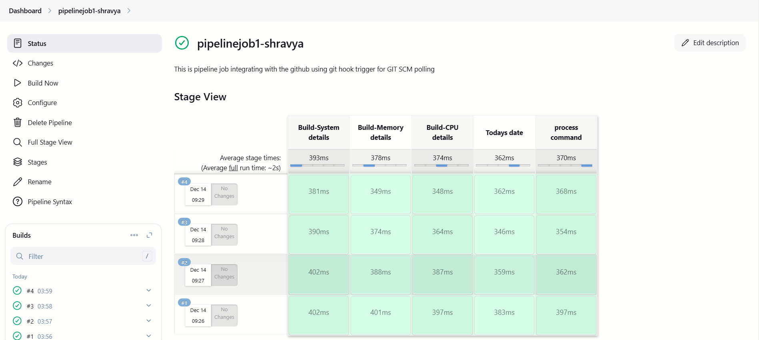

Logs:

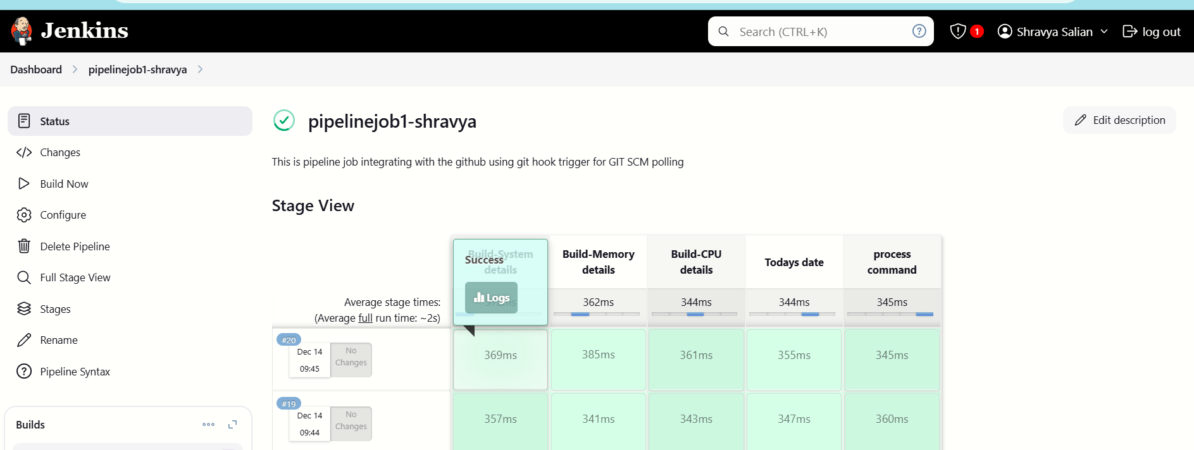

Stage logs:

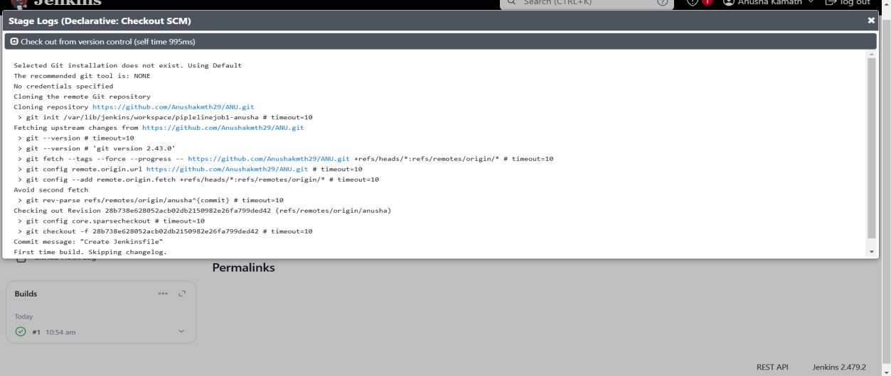

Stage Logs:

(Shell script):

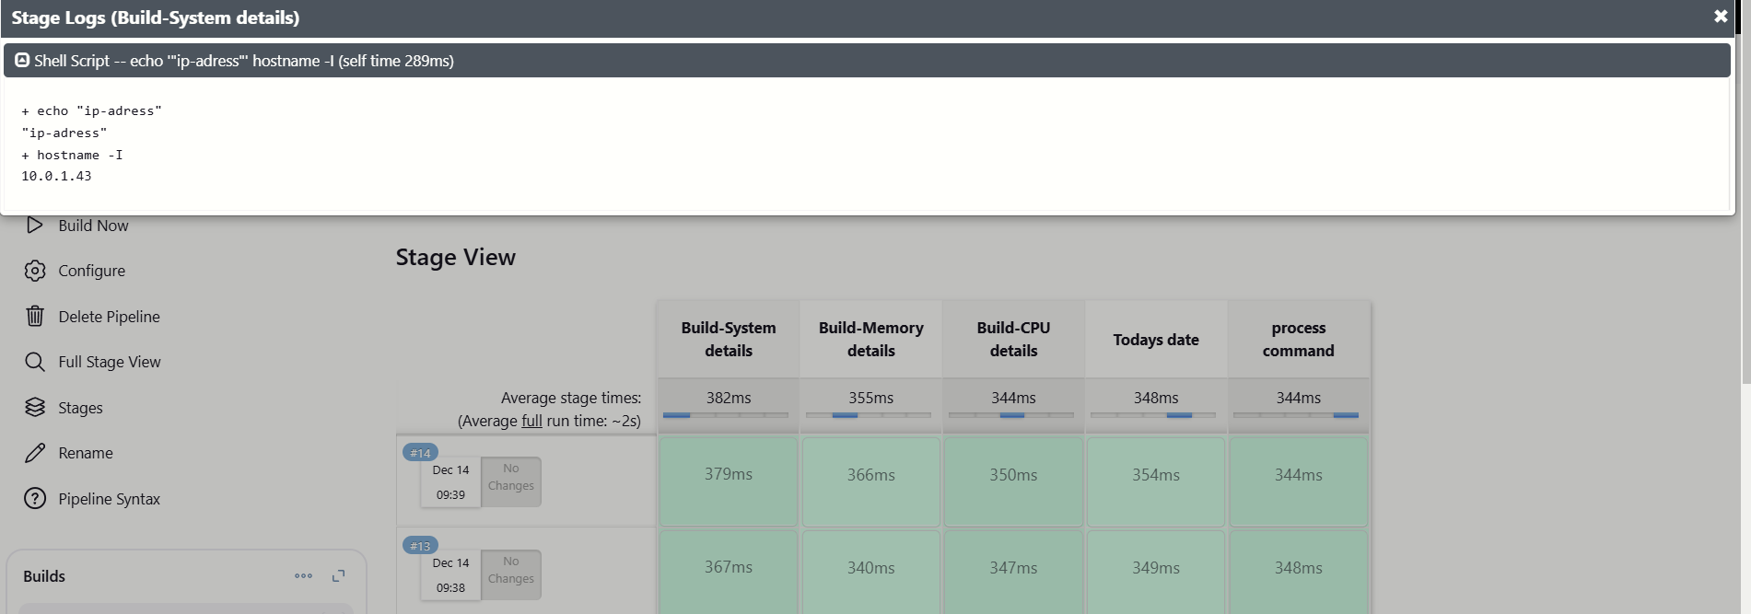

Jenkins Dashboard:

