**DESIGN DOCUMENT**

**CALENDAR**

**VERSION: 1.1**

**By**

**Anandsai ChinthamReddy**

**ShravyaGaddam**

**Sai Gandham**

**Pranitha Madduri**

**CLASS DIAGRAM:**

The Class Diagram mentioned below has various classes such as Calendar, Event, Calendar Database, Day, Month and Week. The classes Day, Month and Week are related by aggregation and rest all other classes are related by generalization. Each of the class contains operations used by it and the attributes used by the respective operations.

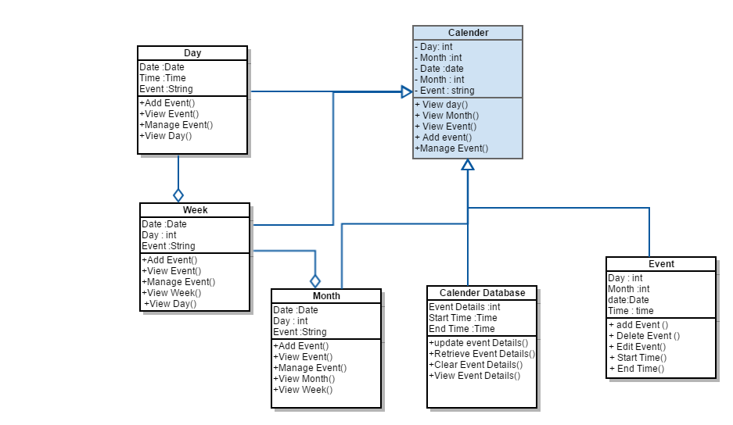

**SEQUENCE DIAGRAM:**

The Objects used in the Sequence Diagram are User, Calendar, Event and Calendar Database. Various operations are performed by interactions between the objects. The following flow events show the interaction between these objects.

