NetFense: Adversarial Defenses against Privacy Attacks on Neural Networks for Graph Data
Many online applications such as E-commerce, online social networks will outsource their data for research purpose and this data will contains information about users and its communities in the form graph where user will be connected to their sharing community as edges. Some malicious users can use this Graph data to identify sensitive information like person salary, gender etc. Malicious users can train this data with Graph Neural Network (GNN) to predict target or sensitive labels.
In propose paper to avoid such leakage of private information author employing NetFense algorithm which will perturbed graph data by adding or removing random edges. Adding or removing edges will make attacker confuse or may predict wrong label upon training with GNN. So by adding NetFense we can provide security graph data but adding random edges will affect security. Author saying by reducing some accuracy we can provide security to user data from malicious attackers. Propose adversarial defence against privacy attack on graph data. Given a graph, in which each node is associated with a feature vector, a targeted label (e.g., topic or category), and a private label (e.g., gender or age), our goal is to perturb the graph structure by adding and removing edges such that the privacy is protected and the data utility is maintained at the same time.
Propose algorithm consists of following modules
- Candidate Selection: this module will perturbed dataset by adding and removing some edges
- Influence with GNN: perturbed data will get trained with GNN to identify margin and accuracy of prediction
- Combinatorial Optimization: will check how accurate is perturbed data after training with GNN
To train and test above algorithm author has utilized CORA and CITESEER dataset which contains information about authors published same IEEE papers. Two authors will connected to one and other using edges if both done same paper. In below screen showing dataset details
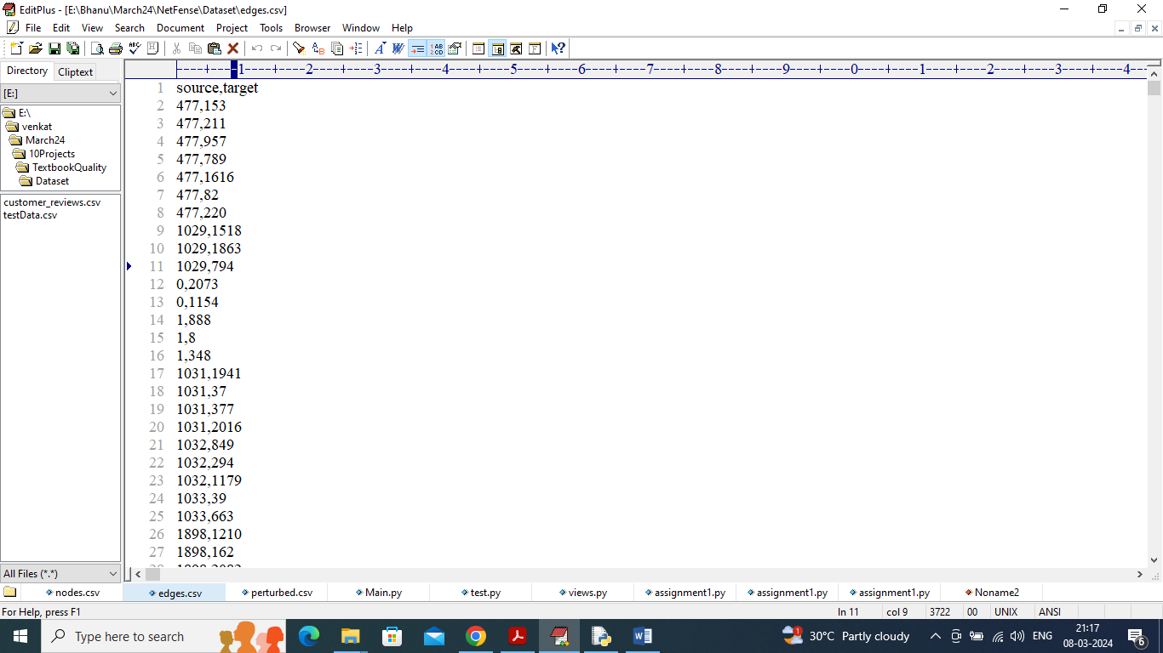
In above dataset screen source author connected to target author based on citation and by using above dataset we will evaluate quality of GNN on prediction. In normal dataset GNN is giving 98% accuracy which means malicious attacker can predict sensitive data correctly up to 98% so after perturbing accuracy may reduce and security of data privacy will be more.
Extension Concept
In propose paper author is providing security to data just by adding and removing some dummy or fake edges but the ID of the authors are clearly visible to attackers so as extension we are encrypting and perturbing above author ID’s so attacker should not understand ID also. After encrypting accuracy may be high or low but privacy will be more.
To implement this project we have designed following modules
- Upload CiteSeer Dataset: using this module will upload CITESEER data to application and then record size of dataset
- Perturbed Dataset: this module will perturbed data by adding and removing edges and after adding and removing edges we can see the change size of dataset
- Trained GNN on Perturbed Data: perturbed data will be input to GNN algorithm to train a model and this model will be applied on test data to calculate accuracy. Wrong predicted percentage will be consider as privacy margin for the dataset. The more records the GNN predicted wrongly the more data security will be achieved
- Extension GNN on Perturbed & Encrypted: perturbed & encrypted data will be input to GNN algorithm to train a model and this model will be applied on test data to calculate accuracy. Wrong predicted percentage will be consider as privacy margin for the dataset. The more records the GNN predicted wrongly the more data security will be achieved
- Comparison Graph: will plot algorithm training loss graph between propose and extension algorithm. The lower the loss the better is the algorithm
SCREEN SHOTS
To run project double click on run.bat file to get below screen
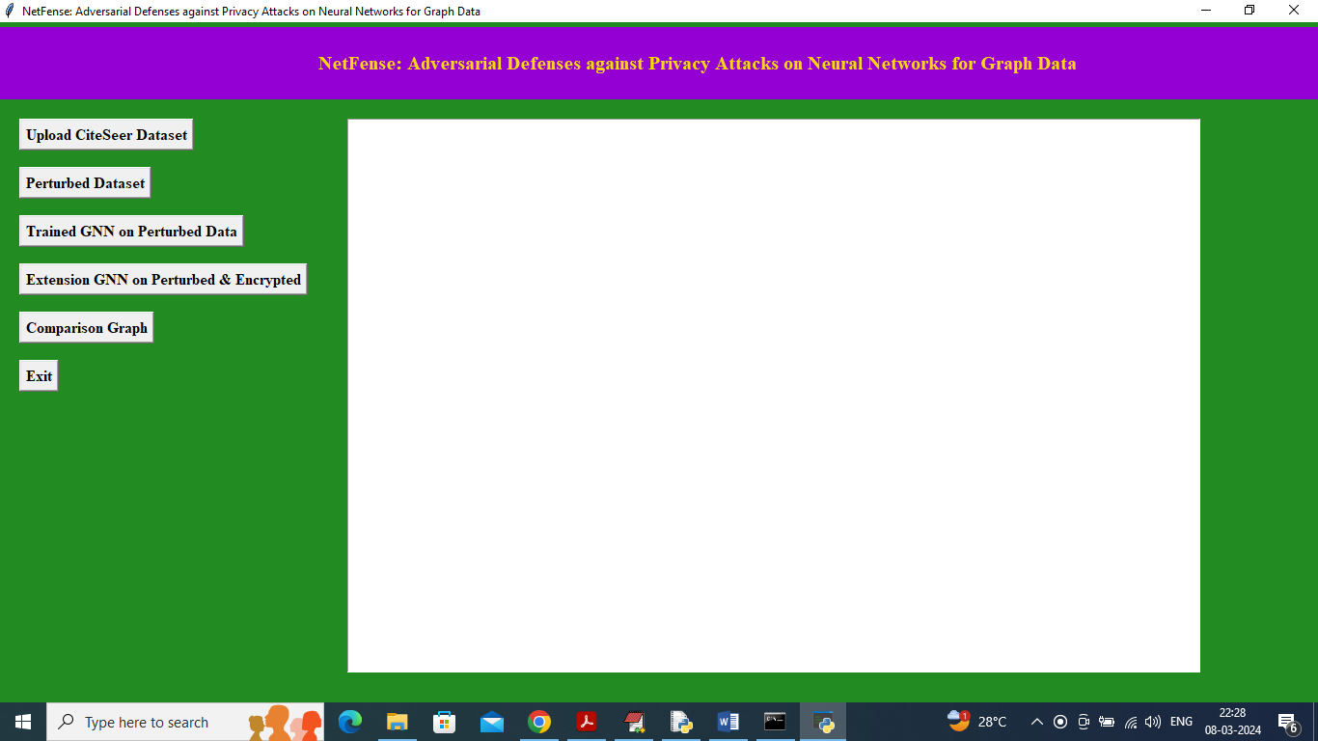
In above screen double click on ‘Upload CiteSeer Dataset’ button to upload dataset and get below page
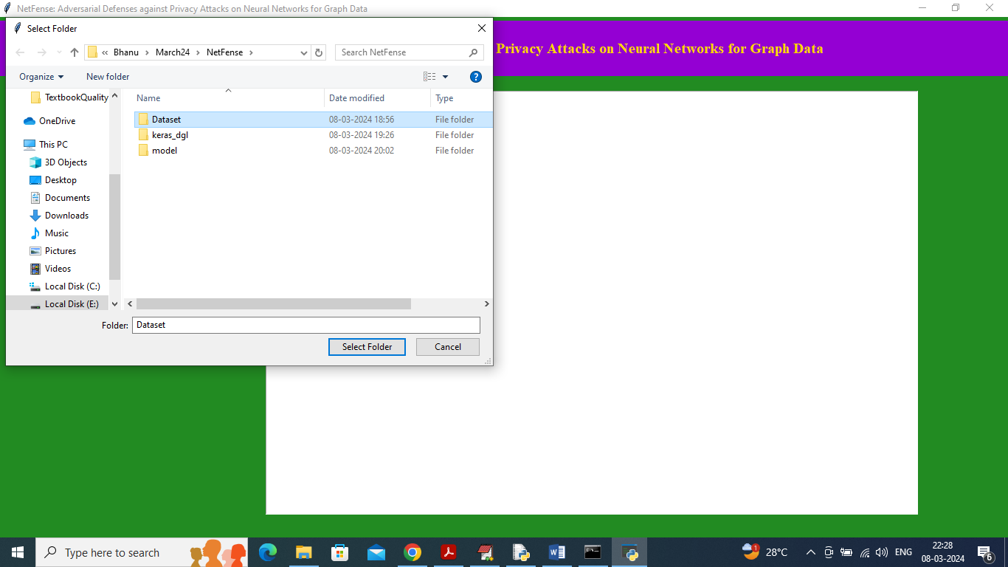
In above screen selecting and uploading dataset folder and then click on ‘Select Folder’ button to load dataset and get below page
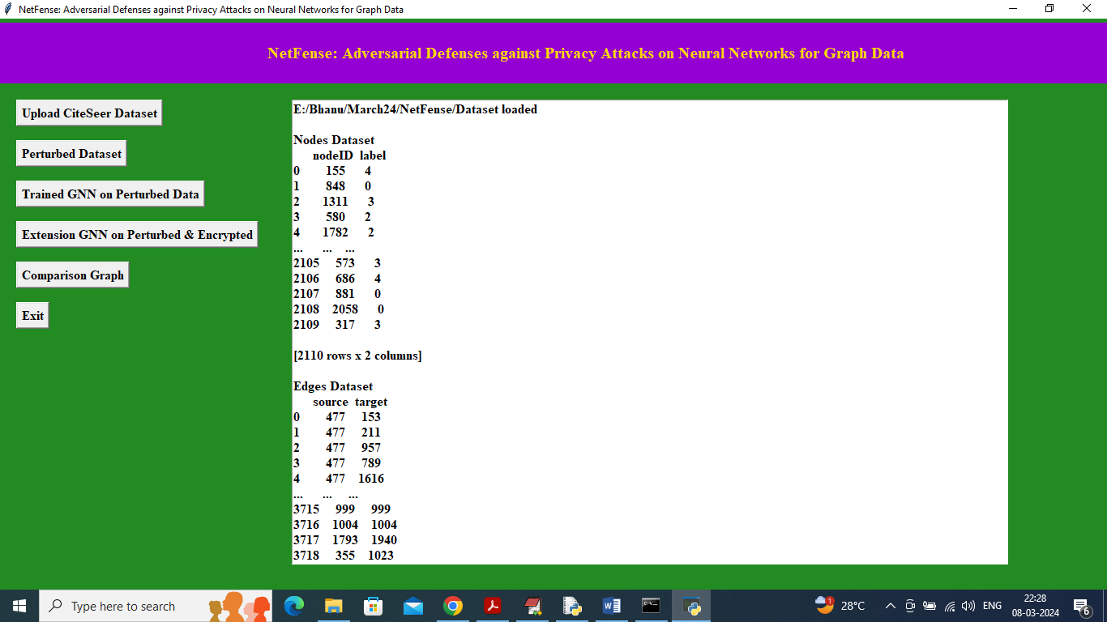
In above screen node and edges data loaded and scroll down to view total edges available in normal dataset
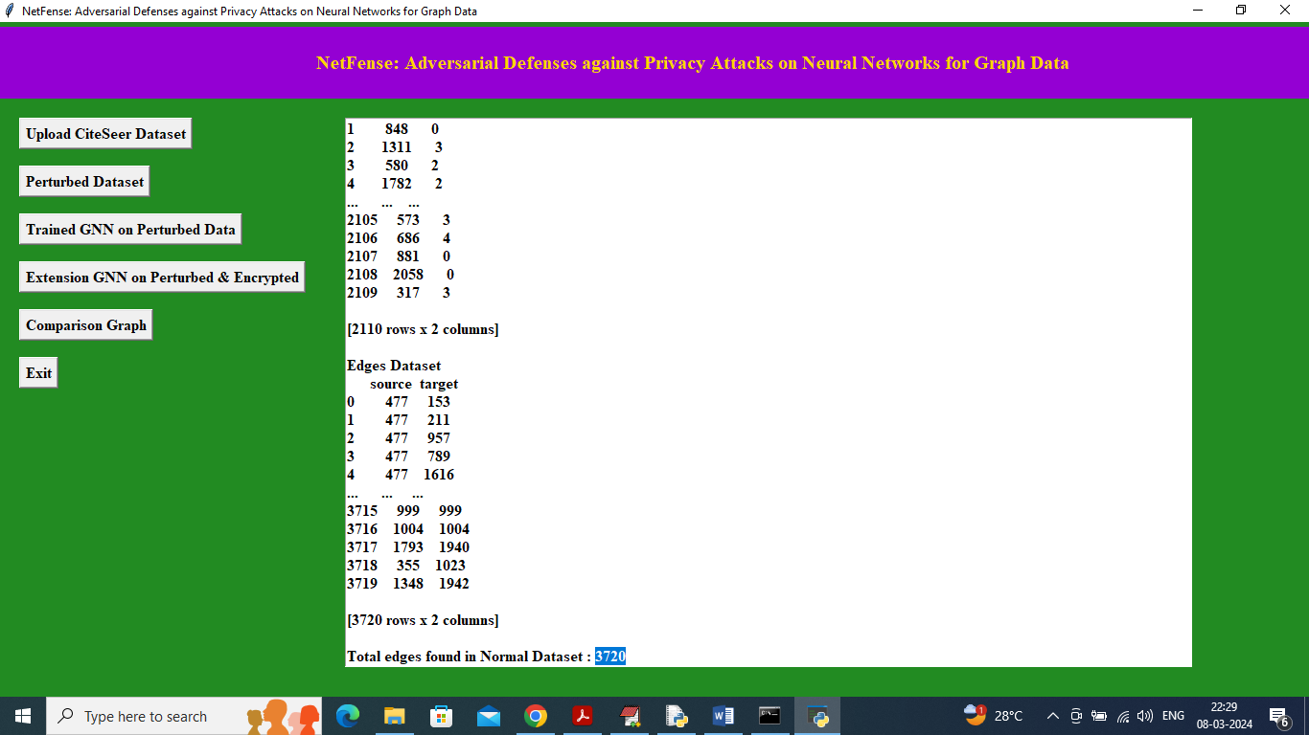
In above screen in last line can see normal dataset contains 2720 records and now click on ‘Perturbed Dataset’ link to add and remove some edges and get below page
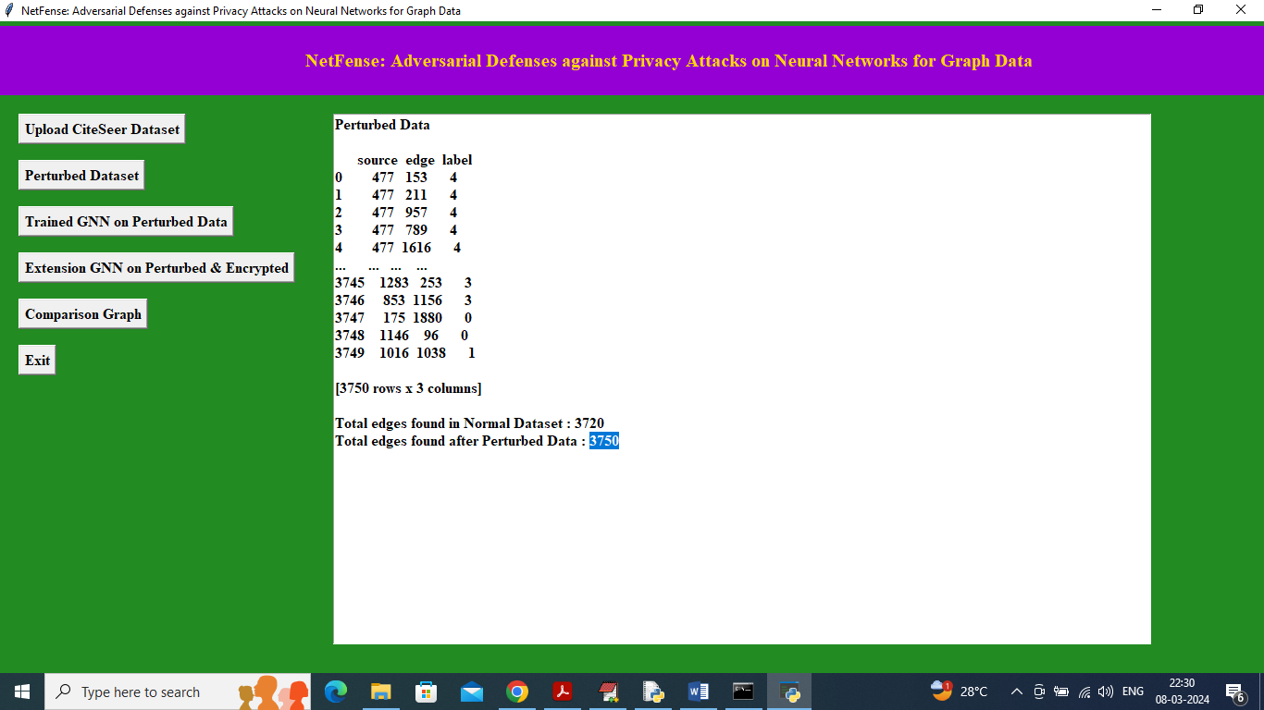
In above screen can see now dataset having source node, connecting edge node name and label and after perturbing edges size increase to 3750 from 3720 and now click on ‘Trained GNN on Perturbed Data’ button to trained GNN algorithm on perturbed data and get below output
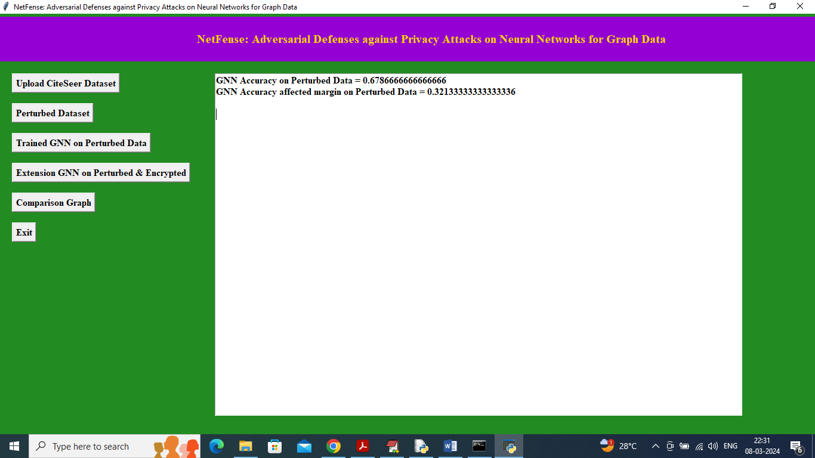
In above screen GNN got 67% accuracy and incorrect prediction margin is 32% so above screen accuracy is reduced but data will be having more privacy as algorithm able to predict 67% records correctly. Now click on ‘Extension GNN on Perturbed & Encrypted’ button to encrypt data and then train with GNN to further reduce accuracy and to increase privacy
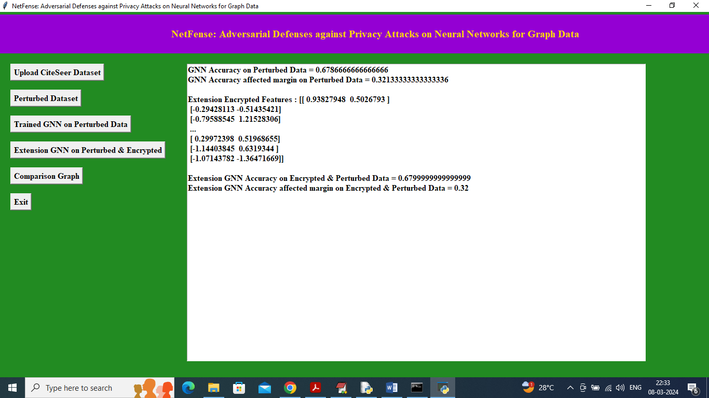
In above screen extension accuracy is increased in points and data is having encrypted points so data will be more secured and in above screen can see some encrypted values. So with extension technique by adding encrypted training we can provide more security or privacy to data. Now click on ‘Comparison Graph’ link to get below graph
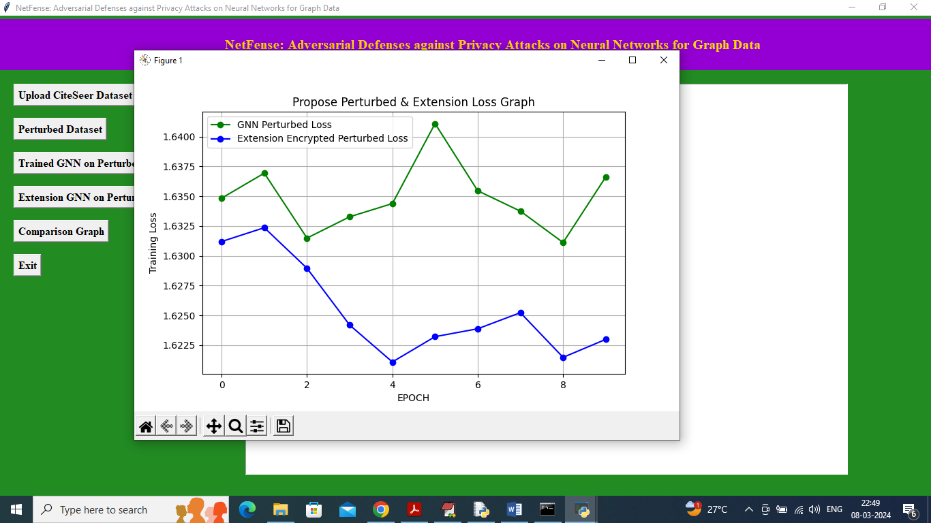
In above graph x-axis represents training epochs and y-axis represents training loss and then green line represents ‘GNN Perturbed Loss’ and blue line represents ‘Extension Encrypted Perturbed Loss’. In both algorithms can see Extension got less loss so it will provide more security or privacy to data.

