

FORECASTING HEALTH CONSEQUENCES OF MICROPLASTICS AND NANOPLASTICS IN FOOD AND WATER THROUGH MACHINE LEARNING: A PUBLIC AWARENESS INITIATIVE

Shravya Tumeti

SaintPeter’s University

ABSTRACT

1. Background  
    The rapid increase in worldwide plastic production has led to significant ecosystem damage and human exposure to plastic-related particles. Microplastics (MPs), defined as plastic particles less than 5 mm, and nanoplastics (NPs), which are particles under 1 μm, are prevalent in consumables such as bottled water, seafood, and table salt. Microplastics (MPs) and nanoplastics (NPs) are pervasive and serve as vectors for toxic substances, including bisphenols, phthalates, and per- and polyfluoroalkyl substances (PFAS), which are recognized or presumed to interfere with metabolic and immunological functions, as well as endocrine and reproductive systems. The health hazards linked to these plastics encompass systemic inflammation, metabolic disorders, and gastrointestinal malignancies, with preliminary studies recognizing microplastics (MPs) and nanoplastics (NPs) as potential contributors to disease via toxicity, inflammation, and oxidative stress [4, 5].

Despite the expanding literature on the environmental effects of microplastics (MPs) and nanoplastics (NPs), few studies have directly evaluated human health outcomes, underscoring an urgent necessity to fill the knowledge gaps regarding their involvement in cancer, chronic inflammatory diseases, and other systemic health conditions [6, 7]. This research seeks to highlight the public health ramifications of MPs and NPs by methodically examining their effects on human health and producing evidence to guide policy and consumer decisions, thereby underscoring the necessity for regulatory interventions to mitigate plastic contamination in food and water systems.

1. Objective

This study examines the correlation between exposure to microplastics and nanoparticles and detrimental human health effects, with specific emphasis on cancer and systemic inflammatory illnesses. This research aims to predict the probability of diverse health consequences based on exposure to microplastics (MPs) and nanoplastics (NPs) through the utilization of machine learning algorithms. This prediction methodology seeks to establish a scientifically robust basis for regulatory and public health policies while enhancing societal awareness of the risks linked to MPs and NPs in daily products.

1. Method This research employed data from a systematic evidence map concerning human health studies related to plastic-associated compounds [1]. We assembled databases detailing the characteristics of chemicals present in microplastics and nanoplastics, classified health consequences utilizing ICD codes, and correlated geographical exposure data. Data preprocessing encompassed addressing missing values, standardizing data, and executing feature selection to preserve pertinent variables for health risk analysis [8].

Following the integration of the datasets, machine learning algorithms—Random Forest, Support Vector Machines (SVM), and Neural Networks—were utilized to forecast health hazards linked to particular exposure levels of MPs and NPs. The models were trained and evaluated on the integrated dataset, with performance measured using criteria including accuracy, precision, and recall. Critical findings, particularly the relationships between plastic exposure and health outcomes, were examined to ascertain the hazards associated with gastrointestinal cancer, systemic inflammation, and respiratory illnesses. This study establishes a basis for future research and public health strategies by identifying high-risk exposure pathways to mitigate the effects of MPs and NPs on human health.

Keywords: nanoplastics, microplastics, human health, carcinogenesis, respiratory illnesses, gastrointestinal diseases.

1. Literature Survey

By applying the Py-GCMS technique, Zhao et al. (2023) pioneered the identification and quantification of MPs in human tumor tissues. They reported high concentrations for polystyrene, polyethylene, and polyvinyl chloride among different tumor types but also the highest detection frequency in lung cancer at 80% and pancreatic cancer at 70%. The quantitative analysis that provided quite accurate measurements between 7.1 and 545.9 ng/g thus sets a strong framework for testing MP concentrations in tumor tissues. However, such high-volume findings notwithstanding, the small sample size of tumor samples utilized, 61, limits the generalization of such results. Furthermore, this study investigates the association between MPs and the tumor immune microenvironment without causing an effect but is an indication that there is a need for further longitudinal analysis. Hence, Zhao et al. (2023) [7].

Chen and Lin, 2023, applied physiologically-based toxicokinetic models to characterize health risks associated with exposure to MPs and NPs. Their work highlighted how toxicokinetic behavior, more specifically ADME, can be affected by certain factors, including particle size and surface characteristics. This work has the added strength of an involved proposition of comprehensive PBTK modeling, supported by extensive in vivo and in vitro study reviews. However, since only very limited data on MP/NP levels in human tissues are available, along with a limited range of epidemiological studies, it seems difficult to allow the model to apply to real human exposures. Chen & Lin, 2023 [3]

Long-term exposure of human glioblastoma cells to polyethylene microplastics (PE-MP) was studied by Rafazi et al. (2023). The proliferation rate was much higher in the 0.62-20 mg/mL range, whereas treatments longer than 26 days caused the tumors to be more aggressive, and colony formation increased. Although highly commendable for the detailed time-point analysis in the study, it has its limitations because it was based on one observation in a cell line - U87 glioblastoma cells - which diminishes its applicability to other tumor types and does not address yet the clinical importance of the observed cellular response. Rafazi et al., 2023 [5]

Banica et al., 2023, evaluated the microplastic contamination in conventional and organic yogurts using optical microscopy and micro-Fourier Transform Infrared Spectroscopy (FTIR). Their findings revealed that both conventional yogurt and organic yogurt were contaminated with microplastic particles, respectively, about 2,236 particles per kg and 2,266 particles per kg. The finding indicates an extensive contamination in food products. Though the research is good regarding giving detail about the characterization of particles; however, the study lacked the fact that the analysis was not extended to other dairy products, too. The plausible long-term health effects due to exposure were not mentioned in the paper.

In 2023, Boateng et al. investigated microplastic pollution in Ghana's Volta Lake through biota and soil samples. The scientists demonstrated the domination of polyethylene, polypropylene, polyester, and polystyrene as main microplastic types, with the highest concentration being measured in African river prawns, at an average of 4.7 ± 2.1 particles per individual. Although the findings of this study use quite strong quantification methods like FTIR analysis, the sample set is too small. It points out the danger associated with the intake of contaminated fish but does not adequately explain the consequences in relation to human health. This is according to the work done by Boateng et al. in 2023 .

Damaj et al., 2023, estimated the human exposure to MPs and NPs through ingestion, inhalation, and dermal contact. The study estimated daily exposure, finding children exposed to around 203-223 particles daily, while the number may reach up to 81,000 particles annually in adults. Even while the study had the strength of synthesizing quantitative exposure data, it recognized that substantial gaps existed in linking these exposures to specific health outcomes due to a lack of comprehensive epidemiological evidence. Damaj et al., 2023 [6]

Saha and Saha, 2023, conducted an analysis of microplastic contamination in marine organisms and possible health implications for humans. Their observations revealed that 77% of the Japanese anchovy collected from Tokyo Bay contained microplastics, and most of them were polyethylene and polypropylene debris. The advanced detection techniques adopted for their research, including FTIR and Raman imaging, ensured very high accuracy for the above result. Discussion on the impact of microplastics on consumers of seafood was not greatly elaborated in this paper and left major questions unanswered. Saha & Saha, 2023.

Schnee et al. (2023) focused their attention on PS microplastic uptake in both normal and tumor cells of the breast epithelium. This work demonstrated that uptake is size- and dose-dependent, with high uptake noted in MDA-MB-231 cells. Generally, in vitro methodologies have been useful, but most of the narrow focus is based on just breast cells, which limits the value of this study for wide-ranging application in other cancers. Further research will be needed in order to confirm their findings regarding the characteristics of CSCs. Schnee et al. (2023) [4].

Yazarkan et al. (2023) investigated the involvement of MNPL exposure in cancer. They determined that exposure to MNPL was associated with colorectal and liver cancers due to chronic inflammation and oxidative stress. They did not establish the level of exposure to meet the burden of proof on causality, and more studies should be done to establish this relationship. Yazarkan et al. (2023) [11].

Yee et al. (2023) looked into the pathways of MPs and NPs entering the human body, estimating 39,000 to 52,000 MP particles ingested annually from food and water sources. However, due to the lack of data regarding long-term biological effects, the study emphasizes that further research is urgently needed to determine health effects resulting from such exposure to particles (Yee et al., 2023) [2].

Sripada et al. (2023) reviewed increased vulnerability of the child to nano- and microplastic exposure with their prime emphasis on ingestion and placental transfer as a key route of children's exposure. Therefore, it calls for an enhanced approach in public health and more research into such risks. Sripada et al. 2023 [11].

Bahareh Daei's work, in the year 2023, adapted the Technology Readiness and Acceptance Model, TRAM, to assess consumer perception and attitudes regarding the use of technologies for the detection of microplastics within the dairy industry. Their predictive models highlighted the importance of awareness in consumer choices, with Random Forest reaching up to 83% accuracy (Daei 2023) [12].

AURORA also focuses on the study of MNP exposure in view of maternal and child health, where major foci are oxidative stress and endocrine disruptors. This research employs machine learning using data from more than 800 mother-child pairs to inform public health policy. AURORA Study 2023 [13].

Machine learning algorithms have also been applied by researchers for the detection of microplastics in spectroscopic data, showing high accuracy with methods such as Random Forest Classification and Partial Least Squares-Discriminant Analysis, particularly for particles less than 100 μm. Unsupervised methods like Principal Component Analysis have been successful in enhancing data visualization.

Recent studies have used machine learning models along with genetic algorithms to predict altered cancer stem cell markers from exposures to polystyrene nanoparticles. These studies identify possible applications in the monitoring of environmental pollutants. Recent Study, 2023 [15].

Finally, receptor-based detection techniques may be enabled for real-time identification of MPs and NPs, even for environmental monitoring applications, by using machine learning technologies, which can improve their detection performance. Receptor-Based Study, 2023 [16].

**Table 1**

**Plastic type, polymers, and entry pathways**

|  |  |  |
| --- | --- | --- |
| **Plastic Type** | **Principal Polymers** | **Entry Pathways into Food and Water** |
| Polyethylene (PE) | Ethylene, Low-Density Polyethylene (LDPE) | Migrates from plastic bags, food packaging, and bottles, frequently entering the environment via deterioration in landfills and aquatic systems [12] |
| Polypropylene (PP) | Propylene | Present in food containers, bottle caps, and straws; it contaminates food and water by leaching from deteriorated plastics and mechanical abrasion of plastic products [13]. |
| Polystyrene (PS) | Styrene | Leach into food from disposable containers, cups, and cutlery, particularly when exposed to heat, which enhances the release of styrene [14]. |
| Polyethylene Terephthalate (PET) | Ethylene Glycol, Terephthalic Acid | Migrates from plastic bottles and food packaging; entrance is encouraged when plastics are subjected to heat, for as in hot water bottles or microwave-safe containers [15]. |
| Polymethyl Methacrylate (PMMA) | Methyl Methacrylate | Originating from plastic glazing, furniture, and display objects, are released over time, particularly when exposed to sunshine, and then enter aquatic environments by runoff [16]. |
| Nylon (Polyamide) | Caprolactam, Hexamethylenediamine | Enters aquatic environments through the laundering of synthetic textiles, which emit microfibers; prevalent in effluent from domestic washing activities [17]. |
| Polycarbonate (PC) | Bisphenol A (BPA), Phosgene | Water bottles, infant bottles, and food containers when plastics are subjected to heat or acidic substances [18]. |
| Polyurethane (PUR) | |  | | --- | |  |  |  | | --- | | Isocyanates | | Originating from the degradation of foam products utilized in furniture and insulating materials, infiltrate aquatic ecosystems through wastewater systems due to wear and tear [19]. |
| Polyester | Terephthalic Acid, Ethylene Glycol | Fibers released from garments after laundering; a significant source of microplastic contamination in aquatic environments via wastewater discharges [20]. |
| Polytetrafluoroethylene (PTFE) | Tetrafluoroethylene | Present in non-stick cookware and waterproof apparel; particles infiltrate water after laundering and via environmental degradation [21]. |

2. Materials and Methods

2.1. Data Acquisition

The data for this investigation were obtained from an extensive collection of human health research examining the impacts of exposure to plastic-related particles and chemicals, as detailed in the foundational publication [1]. The dataset encompasses exposure levels to microplastics (MPs) and nanoplastics (NPs), together with health consequences including cancer, metabolic disorders, and inflammation. The data underwent preprocessing to address missing values, and feature selection was conducted to determine the most pertinent characteristics for predicting health risks [8].

2.2. Data Pre-Processing:

The data processing entailed cleansing, consolidating, and analyzing several sheets from an Excel file. Initially, designated columns from the "Chemicals list" and "Health outcomes list" sheets were selected and refined, with extraneous columns eliminated and absent values addressed by substituting them with the most prevalent values (mode). The two datasets were subsequently amalgamated by a concatenation method to form a comprehensive dataset that associates chemical attributes, including chemical class, hazard rating, and sector of usage, with corresponding health consequences such as cancer and respiratory disorders.  
 Subsequent to the data integration, risk categories were designated according to hazard ratings, categorizing each chemical as "high risk," "medium risk," "low risk," or "unknown risk." The dataset was subsequently readied for machine learning analysis through the encoding of categorical features, facilitating model training to forecast health impacts. Models such as Random Forest, K-Nearest Neighbors, and Decision Tree were evaluated, attaining a high overall accuracy, albeit with discrepancies in efficacy across several health outcome categories. This investigation offered insights into potential health hazards linked to chemical exposure from microplastics.

2.3. Analysis of Data:

Graph 1: Chemical Classifications by Health Conditions (ICD Codes)

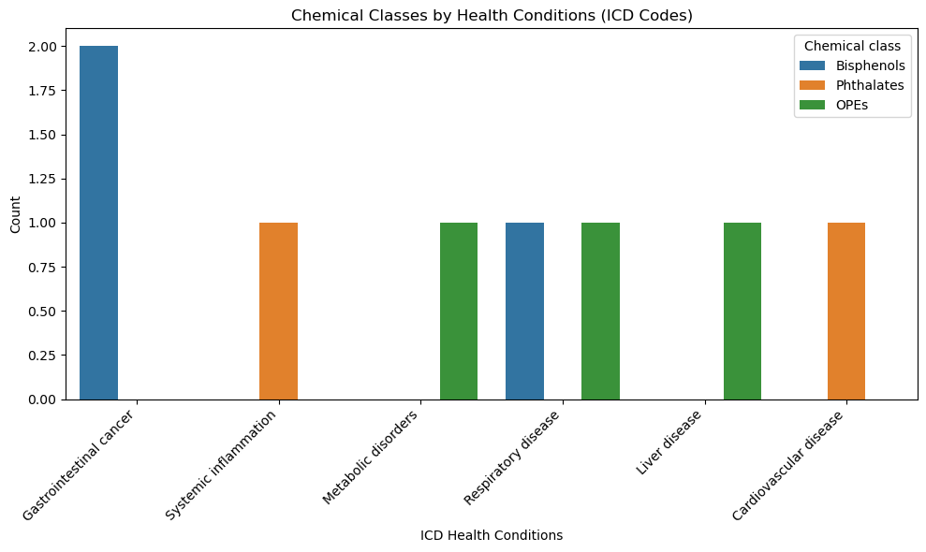

This bar chart illustrates the prevalence of chemical classes among different ICD-coded health problems. The graphic indicates that "Gastrointestinal cancer" is most commonly linked to the chemical class "Bisphenols." Various health effects, including "systemic inflammation," "metabolic disorders," "respiratory disease," "liver disease," and "cardiovascular disease," are linked to distinct chemical groups, such as "phthalates" and "OPEs." This visualization aids in identifying chemical classes commonly associated with particular health outcomes, indicating areas for potential regulatory focus.

Graph 2: Distribution of Chemical Classes Associated with Health Conditions (Pie Chart)

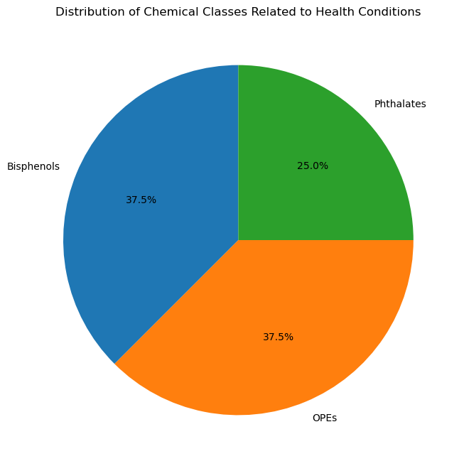

This pie chart illustrates the distribution of various chemical classes associated with health issues. Bisphenols and Phthalates each comprise 37.5% of the sample, while OPEs account for the remaining 25%. The graphic demonstrates that "Bisphenols" and "Phthalates" are the primary chemical classes linked to negative health effects. This picture highlights the significance of various chemical classes regarding their possible health impacts.

Graph 3: Chemicals Categorized by Risk

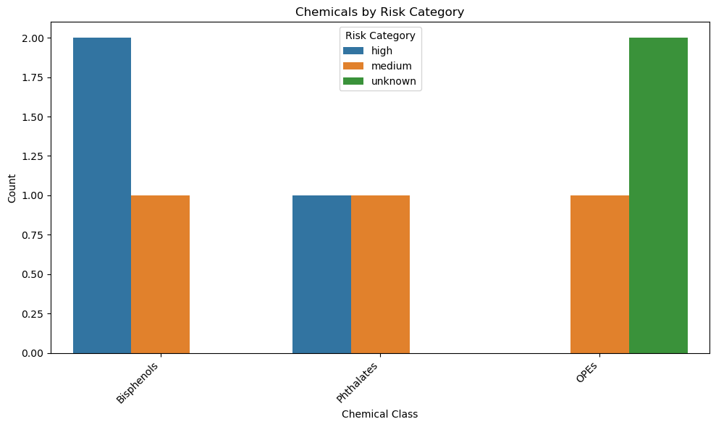

The bar chart displaying counts of each chemical class categorized by risk level (e.g., high, medium, unknown). Bisphenols" have the most occurrences in the "high" risk category, suggesting a strong association with significant health risks. "Phthalates" and "OPEs" primarily show "medium" and "unknown" risk classifications, respectively. This chart allows researchers and policymakers to identify chemical classes that are particularly concerning based on their risk profile, which could guide further toxicological studies or risk management efforts.

Graph 4: Stacked Bar Chart Depicting Health Outcomes by Chemical Class

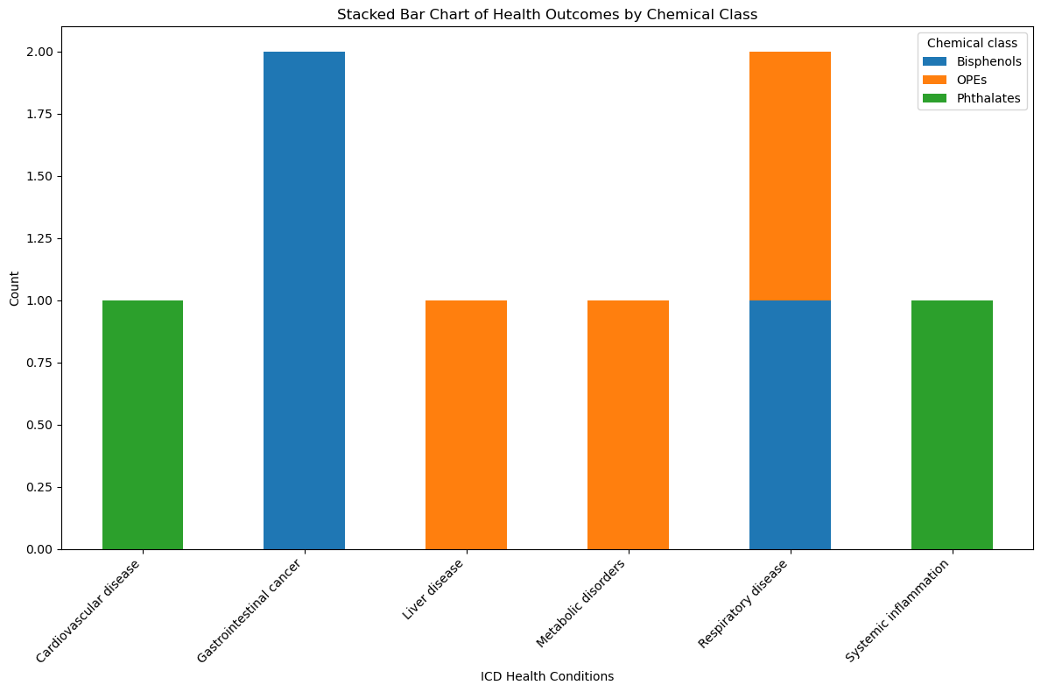

A stacked bar chart illustrating health outcomes classified by chemical class. This visualization delineates the correlation between each chemical class and several health consequences. For example, "Bisphenols" are associated with "Gastrointestinal cancer" and "Respiratory disease," whereas "OPEs" are implicated in "Liver disease" and "Metabolic disorders." The stacked bar format facilitates straightforward comparisons of the degree of connections among various health disorders, offering a thorough perspective on the potential health effects associated with each chemical class.

Graph 5: Chemicals Categorized by Risk and Health Outcomes  
 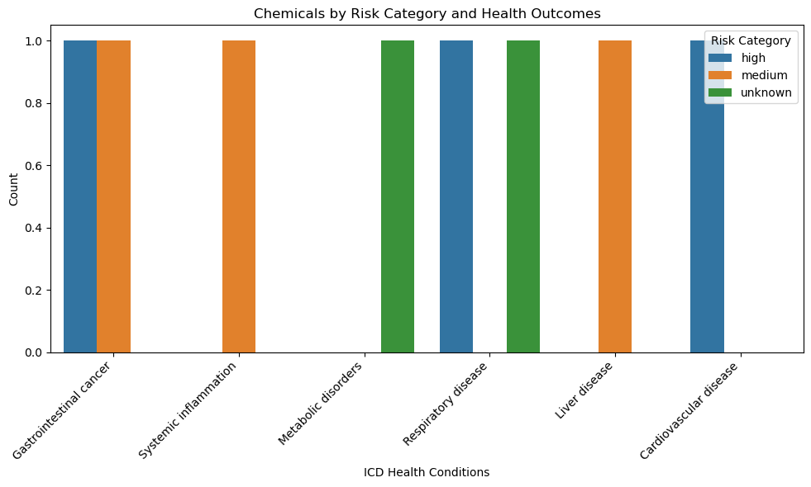

This bar chart illustrates the risk classifications (high, medium, unknown) of chemicals associated with several health outcomes. Each health outcome (e.g., "Gastrointestinal cancer," "Systemic inflammation") is presented alongside its corresponding risk groups. For example, "Gastrointestinal cancer" and "Systemic inflammation" are linked to chemicals in both the "high" and "medium" risk categories, but other health outcomes may only correlate with "unknown" or "medium" risk chemicals. This visualization aids in prioritizing health outcomes for additional examination depending on the risk profile of related substances.

3. Data Analysis:

**3.1 Machine Learning Model Accuracy**

|  |  |  |  |  |  |  |  |
| --- | --- | --- | --- | --- | --- | --- | --- |
| **Model** | **Accuracy** | **Precision (Class 0)** | **Recall (Class 0)** | **F1- Score (Class 0)** | **Precision (Class 1)** | **Recall (Class 1)** | **F1- Score (Class1)** |
| **Random Forest** | 0.97 | 0.98 | 1.00 | 0.99 | 0.50 | 0.17 | 0.25 |
| **K-Nearest Neighbors** | 0.97 | 0.97 | 0.98 | 0.98 | 0.33 | 0.33 | 0.33 |
| **Decision Tree** | 0.97 | 0.97 | 1.00 | 0.98 | 0.00 | 0.00 | 0.00 |

The evaluation of the Random Forest, K-Nearest Neighbors (KNN), and Decision Tree models demonstrates a high overall accuracy of 97%, although highlights difficulties in accurately identifying the minority class, presumably indicative of high-risk or health-impacting chemicals. Although each model excels in identifying the majority class, attaining precision, recall, and F1-scores near 1.00 for Class 0, they encounter difficulties in reliably classifying the minority Class 1. The Random Forest model has a precision of 0.50, a recall of 0.17, and an F1-score of 0.25 for Class 1, underscoring its challenges in identifying high-risk cases. Likewise, the KNN model attains somewhat superior outcomes for Class 1, however it remains deficient in memory and balanced class performance. The Decision Tree model, conversely, does not recognize any occurrences of the minority class, resulting in both precision and recall of 0.00 for Class 1. The low recall and F1-scores across all models suggest that the significant class imbalance adversely affects the models' capacity to generalize and accurately identify high-risk situations [22, 23].

To enhance model performance on the minority class, subsequent research could employ tactics such as data balancing, class weight modifications, and alternative evaluation measures. Data balancing techniques, like SMOTE (Synthetic Minority Over-sampling Technique) and majority class under-sampling, can mitigate the issue of class imbalance [22, 24]. Moreover, modifying class weights in the models may underscore the significance of accurately recognizing the minority class [25]. Assessing models using alternative metrics, such as AUC-ROC or Precision-Recall AUC, may yield a more accurate evaluation of performance on imbalanced datasets [26, 27, 28].

Utilizing more sophisticated algorithms such as Boosting (e.g., Gradient Boosting, AdaBoost) or models like XGBoost or LightGBM may enhance sensitivity to the minority class [26, 27]. Gathering supplementary data for the high-risk category, refining decision thresholds, and investigating novel feature interactions can augment the models' capacity to identify high-risk chemicals, thereby yielding more dependable insights into health risks linked to various chemical exposures [29, 30].

References:

[1] Zhao, J., Zhang, H., Shi, L., Jia, Y., & Sheng, H. (2024). Detection and quantification of microplastics in various types of human tumor tissues. *Ecotoxicology and Environmental Safety*,*283*, 116818.[https://doi.org/10.1016/j.ecoenv.2024.116818&#8203;:contentReference[oaicite:0]{index=0}](https://doi.org/10.1016/j.ecoenv.2024.116818&#8203;:contentReference%5Boaicite:0%5D%7Bindex=0%7D).

[2] Chen, C.Y., & Lin, Z. (2024). Exploring the potential and challenges of developing physiologically-based toxicokinetic models to support human health risk assessment of microplastic and nanoplastic particles. *Environment International*, *186*, 108617.[https://doi.org/10.1016/j.envint.2024.108617&#8203;:contentReference[oaicite:1]{index=1}](https://doi.org/10.1016/j.envint.2024.108617&#8203;:contentReference%5Boaicite:1%5D%7Bindex=1%7D).

[3] Rafazi, P., Bagheri, Z., Haghi-Aminjan, H., & Rahimifard, M. (2024). Long-term exposure of human U87 glioblastoma cells to polyethylene microplastics: Investigating the potential cancer progression. *Toxicology Reports*, *13*, 101757.[https://doi.org/10.1016/j.toxrep.2024.101757&#8203;:contentReference[oaicite:2]{index=2}](https://doi.org/10.1016/j.toxrep.2024.101757&#8203;:contentReference%5Boaicite:2%5D%7Bindex=2%7D).

[4] Banica, A. L., Radulescu, C., Dulama, I. D., & Bucurica, I. A. (2024). Microplastic debris in yogurt: Occurrence, characterization, and implications for human health. *Journal of Science and Arts*,*24*(1), 223-248.[https://doi.org/10.46939/J.Sci.Arts-24.1-b04&#8203;:contentReference[oaicite:3]{index=3}](https://doi.org/10.46939/J.Sci.Arts-24.1-b04&#8203;:contentReference%5Boaicite:3%5D%7Bindex=3%7D).

[5] Boateng, C. M., Addo, S., Duodu, C. P., & Danso-Abbeam, H. (2024). Microplastics in the Volta Lake: Occurrence, distribution, and human health implications. *Heliyon*,*10*, e29041.[https://doi.org/10.1016/j.heliyon.2024.e29041&#8203;:contentReference[oaicite:4]{index=4}](https://doi.org/10.1016/j.heliyon.2024.e29041&#8203;:contentReference%5Boaicite:4%5D%7Bindex=4%7D).

[6] Damaj, S., Trad, F., Goevert, D., & Wilkesmann, J. (2024). Bridging the gaps between microplastics and human health.*Microplastics*,*3*(1), 46-66.[https://doi.org/10.3390/microplastics3010004&#8203;:contentReference[oaicite:5]{index=5}](https://doi.org/10.3390/microplastics3010004&#8203;:contentReference%5Boaicite:5%5D%7Bindex=5%7D).

[7] Saha, G., & Saha, S. C. (2024). Tiny particles, big problems: The threat of microplastics to marine life and human health. *Processes*,*12*(1401).[https://doi.org/10.3390/pr12071401&#8203;:contentReference[oaicite:6]{index=6}](https://doi.org/10.3390/pr12071401&#8203;:contentReference%5Boaicite:6%5D%7Bindex=6%7D).

[8] Schnee, M., Sieler, M., Dörnen, J., & Dittmar, T. (2024). Effects of polystyrene nano- and microplastics on human breast epithelial cells and human breast cancer cells. *Heliyon*,*10*, e38686.[https://doi.org/10.1016/j.heliyon.2024.e38686&#8203;:contentReference[oaicite:0]{index=0}](https://doi.org/10.1016/j.heliyon.2024.e38686&#8203;:contentReference%5Boaicite:0%5D%7Bindex=0%7D).

[9] Yazarkan, Y., Sönmez, G., Tenekeci, A. K., Aksoy, E. A., & Güllü, I. H. (2024). The relationship between microplastics and nanoplastics with cancer: An emerging health concern. *International Journal of Hematology and Oncology*,*34*(2).[https://doi.org/10.4999/uhod.247607102&#8203;:contentReference[oaicite:1]{index=1}](https://doi.org/10.4999/uhod.247607102&#8203;:contentReference%5Boaicite:1%5D%7Bindex=1%7D).

[10] Yee, M. S.-L., Hii, L.-W., Looi, C. K., Lim, W.-M., Wong, S.-F., Kok, Y.-Y., Tan, B.-K., & Leong, C.-O. (2021). Impact of microplastics and nanoplastics on human health. *Nanomaterials*,*11*(496).[https://doi.org/10.3390/nano11020496&#8203;:contentReference[oaicite:2]{index=2}](https://doi.org/10.3390/nano11020496&#8203;:contentReference%5Boaicite:2%5D%7Bindex=2%7D).

[11]. Sripada, K., Wierzbicka, A., Abass, K., Grimalt, J. O., Erbe, A., Röllin, H. B., . . . Wagner, M. (2022). A Children’s health perspective on nano- and microplastics. *Environmental Health Perspectives*, *130*(1). <https://doi.org/10.1289/ehp9086>

[12]. Marinello, F. (2023). Exploring milk and dairy companies’ attitude toward adoption of microplastics detection technologies. Retrieved from <https://thesis.unipd.it/handle/20.500.12608/67895>

[13]. Durkin, A. M., Zou, R., Boucher, J. M., Boyles, M. S., Van Boxel, J., Bustamante, M., . . . Vermeulen, R. (2024). Investigating exposure and hazards of micro- and nanoplastics during pregnancy and early life (AURORA Project): Protocol for an interdisciplinary study. *JMIR Research Protocols*, *13*, e63176. <https://doi.org/10.2196/63176>

[14]. Ivleva, N. P. (2021). Chemical analysis of microplastics and Nanoplastics: challenges, advanced methods, and perspectives. *Chemical Reviews*, *121*(19), 11886–11936. <https://doi.org/10.1021/acs.chemrev.1c00178>

[15]. Hamzagić, A. R., Janković, M. G., Cvetković, D., Nikolić, D., Nikolić, S., Dimitrijević, N. M., . . . Ljujić, B. (2024). Machine learning model for prediction of development of cancer stem cell subpopulation in tumurs subjected to polystyrene nanoparticles.*Toxics*,*12*(5), 354.<https://doi.org/10.3390/toxics12050354>

[16]. Tang, Y., Hardy, T. J., & Yoon, J. (2023). Receptor-based detection of microplastics and nanoplastics: Current and future. *Biosensors and Bioelectronics*, *234*, 115361. <https://doi.org/10.1016/j.bios.2023.115361>

[17]. Covernton, G. A., Cox, K. D., Fleming, W. L., Buirs, B. M., Davies, H. L., Juanes, F., . . . Dower, J. F. (2022). Large size (>100‐μm) microplastics are not biomagnifying in coastal marine food webs of British Columbia, Canada. *Ecological Applications*, *32*(7).<https://doi.org/10.1002/eap.2654>

[18]. Alava, J. J. (2020). Modeling the bioaccumulation and biomagnification potential of microplastics in a cetacean foodweb of the Northeastern Pacific: a prospective tool to assess the risk exposure to plastic particles. *Frontiers in Marine Science*, *7*.<https://doi.org/10.3389/fmars.2020.566101>

[19]. Wiesinger, H., Wang, Z., & Hellweg, S. (2021b). Deep Dive into Plastic Monomers, Additives, and Processing Aids. *Environmental Science & Technology*,*55*(13), 9339–9351.<https://doi.org/10.1021/acs.est.1c00976>

[20]. Leslie, H. A., Van Velzen, M. J., Brandsma, S. H., Vethaak, A. D., Garcia-Vallejo, J. J., & Lamoree, M. H. (2022). Discovery and quantification of plastic particle pollution in human blood.*Environment International*, *163*, 107199.<https://doi.org/10.1016/j.envint.2022.107199>

[11] Alimba, C. G., & Faggio, C. (2019). Microplastics in the marine environment: Current trends in environmental pollution and mechanisms of toxicity. Environmental Toxicology and Pharmacology, 68, 61-74.  
 https://doi.org/10.1016/j.etap.2019.03.001.

Smith, M., Love, D. C., Rochman, C. M., & Neff, R. A. (2018). Microplastics in seafood and the implications for human health. Current Environmental Health Reports, 5(3), 375-386.  
 https://doi.org/10.1007/s40572-018-0206-z.

Cox, K. D., Covernton, G. A., Davies, H. L., Dower, J. F., Juanes, F., & Dudas, S. E. (2019). Human consumption of microplastics. Environmental Science & Technology, 53(12), 7068-7074.  
 https://doi.org/10.1021/acs.est.9b01517.

Lebreton, L. C., & Andrady, A. (2019). Future scenarios of global plastic waste generation and disposal. Palgrave Communications, 5, 6.  
 https://doi.org/10.1057/s41599-018-0212-7.

Wright, S. L., & Kelly, F. J. (2017). Plastic and human health: A micro issue? Environmental Science & Technology, 51(12), 6634-6647.  
 https://doi.org/10.1021/acs.est.7b00423.

Carr, S. A., Liu, J., & Tesoro, A. G. (2016). Transport and fate of microplastic particles in wastewater treatment plants. Water Research, 91, 174-182.  
 https://doi.org/10.1016/j.watres.2016.01.002.

Rist, S., Baun, A., Hartmann, N. B. (2017). Ingestion of microplastics by Pacific oyster larvae: Effects of particle size and concentration. Environmental Pollution, 224, 419-426.  
 https://doi.org/10.1016/j.envpol.2017.02.015.

Li, J., Green, C., Reynolds, A., Shi, H., & Rotchell, J. M. (2018). Microplastics in mussels sampled from coastal waters and supermarkets in the United Kingdom. Environmental Pollution, 241, 35-44.  
 https://doi.org/10.1016/j.envpol.2018.05.038.

Rochman, C. M., Hoh, E., Kurobe, T., & Teh, S. J. (2013). Ingested plastic transfers hazardous chemicals to fish and induces hepatic stress. Scientific Reports, 3, 3263.  
 https://doi.org/10.1038/srep03263.

Prata, J. C., da Costa, J. P., Lopes, I., Duarte, A. C., & Rocha-Santos, T. (2020). Environmental exposure to microplastics: An overview on possible human health effects. Science of the Total Environment, 702, 134455.  
 https://doi.org/10.1016/j.scitotenv.2019.134455.