ASG Airlines
End-to-End Data Engineering Case Study
Project Documentation
Prepared for: Team NeoStats

1. Overview
ASG Airlines collects operational flight data from its booking platform, scheduling system, and airport logs. This document covers the complete delivered solution: the dataset, the repository structure, the pipeline architecture and data flow, the assumptions made, the cleaning/transformation logic, the KPIs produced, and the Power BI dashboard built on top of the cleaned data.
Implementation: a local Python (pandas) pipeline organized as reusable modules (src/), driven by a documented Jupyter notebook (notebooks/airline_data_pipeline.ipynb), feeding a 5-page Power BI dashboard (powerbi/ASG_Airlines_Dashboard.pbix). Azure was the preferred platform in the original brief but is not required; Section 4 maps each stage to its Azure equivalent.

2. Repository Structure
ASG-Airlines-Data-Engineering/
├── README.md Project overview + run instructions
├── requirements.txt Python dependencies
├── data/
│ ├── raw/ Source workbook (as received)
│ └── processed/ cleaned_flights.csv, cleaned_bookings.csv,
│ cleaned_payments.csv, cleaned_passengers.csv
├── notebooks/
│ └── airline_data_pipeline.ipynb Orchestrates src/ end-to-end, with markdown
├── src/
│ ├── ingestion.py Load raw sheets
│ ├── cleaning.py Per-table cleaning rules
│ ├── transformation.py Overnight/duration, anomalies, PII masking, KPIs
│ └── validation.py Pre- and post-clean data quality checks
├── powerbi/
│ └── ASG_Airlines_Dashboard.pbix 5-page interactive dashboard
├── docs/ This document + architecture/flow/model diagrams
└── screenshots/ Preview of each dashboard page
Business logic lives in src/ rather than only inside the notebook, so it is unit-testable and reusable outside a notebook context (e.g. as an Azure Databricks job).

3. Dataset Structure
The source workbook (data/raw/UseCase_-_Airlines.xlsx) contains four sheets, mirroring ASG's operational systems:

3.1 flights (scheduling system)
Field | Description | Data quality notes
flight_id | Flight identifier, e.g. AI155, 6F026 | Some duplicated across rows
airline | Carrier name | 41 blank / 'UNKNOWN' values
source / destination | Departure / arrival airport code | Validated against each other
departure_time / arrival_time | Full timestamps | 1 record had arrival <= departure (broken overnight case)
duration | Pre-computed Excel formula column | Not trusted — dropped; recomputed from timestamps

3.2 bookings (booking platform)
Field | Description | Data quality notes
booking_id, passenger_id, flight_id | Keys | 12 rows missing all key fields
booking_date | Timestamp of booking | —
status | CONFIRMED / CANCELLED / PENDING | 57 blanks + an 'INVALID' value present
passport_number | PII | Hashed — see Section 6.4
seat_number | Seat assignment | —
emergency_contact_name / phone | PII (phone) | Phone masked — see Section 6.4

3.3 payments (booking platform)
Field | Description | Data quality notes
payment_id, booking_id | Keys | —
amount | Payment amount | Some values arrived as non-numeric text
payment_method | CARD / UPI / NETBANKING etc. | —

3.4 passengers (booking platform)
Field | Description | Data quality notes
passenger_id | Key | 39 duplicate rows
first_name / last_name | Name | 10 blank last names
age, gender, date_of_birth | Demographics | Range-checked (0–110)
email, phone, aadhaar_id | PII | Masked / hashed — see Section 6.4

4. Architecture
The pipeline runs in five stages, implemented as the src/ modules shown below, feeding the Power BI dashboard. Azure-equivalent services are noted for teams migrating this to the cloud.
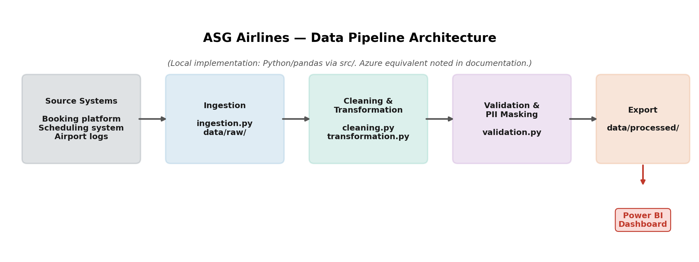
Stage | This implementation (src/) | Azure equivalent
Ingestion | ingestion.py — pandas.read_excel per sheet | ADF copy activity into ADLS / Synapse staging
Validation (pre) | validation.profile_raw() | Data quality rules in ADF / Great Expectations on Databricks
Cleaning | cleaning.py — dedup, standardize, drop orphans | ADF Mapping Data Flow or Databricks notebook (PySpark)
Transformation | transformation.py — overnight repair, anomalies, PII masking, KPIs | Databricks + Key Vault-backed masking, Delta tables
Validation (post) & Export | validation.validate_cleaned_*() + CSV export | Delta/Parquet in ADLS, consumed by Power BI via Synapse

4.1 Detailed Data Flow
The flow below shows the step-by-step logic inside the pipeline, including the overnight-repair decision point:
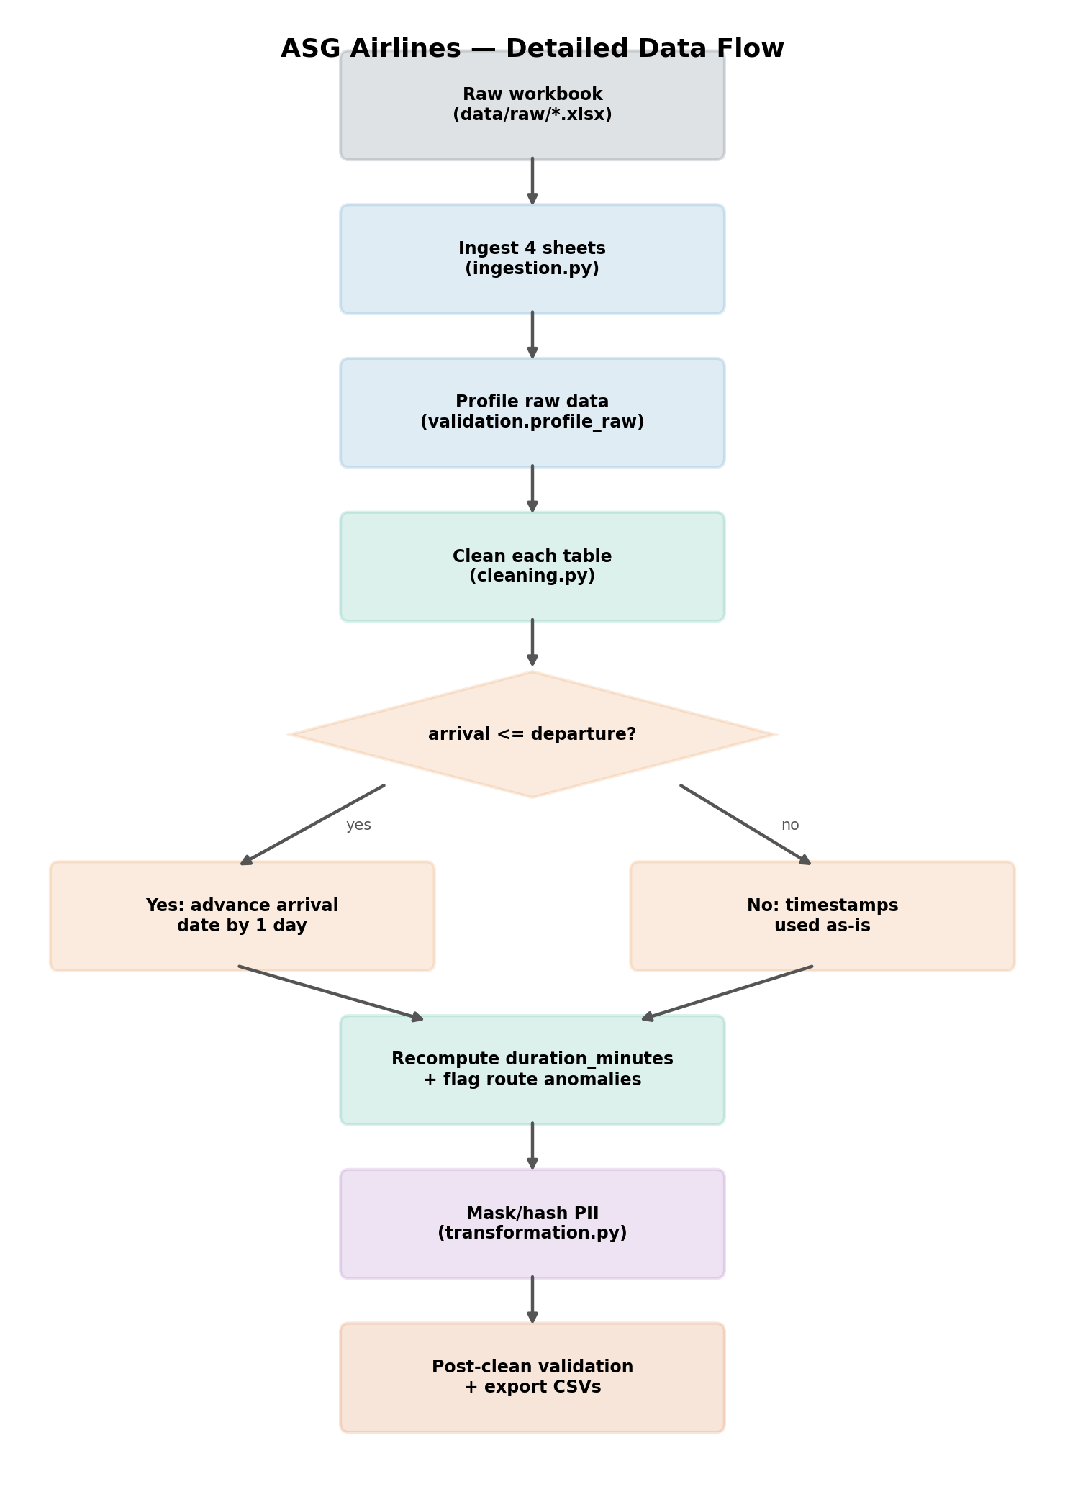

4.2 Data Model
The four cleaned CSVs in data/processed/ relate to each other via shared keys and are loaded into the Power BI dashboard's semantic model as four tables with these relationships.
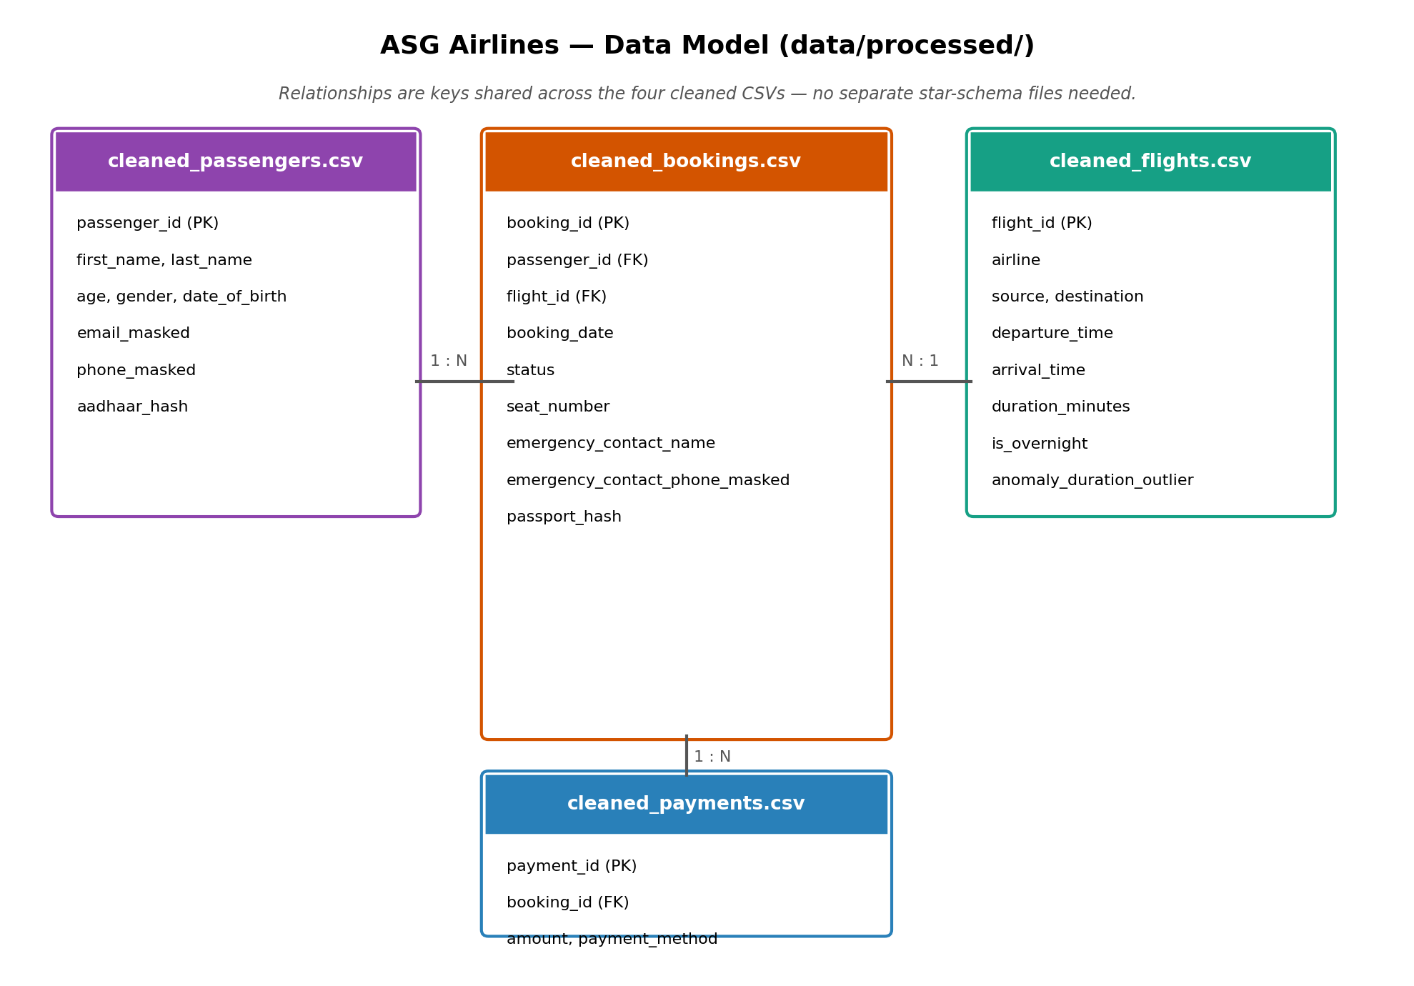

5. Assumptions
- Flight identifiers follow a consistent carrier-code pattern (2–3 alphanumeric characters + 2–4 digits, e.g. AI155, 6F026); records matching this pattern are treated as structurally valid even if duplicated or missing an airline name.
- A flight record with a blank or 'UNKNOWN' airline is still an operationally real flight — it is relabeled 'Unknown' and kept, rather than dropped, so route/traffic counts stay accurate.
- Where arrival_time <= departure_time, the intended meaning is a flight that crosses midnight but was recorded without the date rolling over; the arrival date is advanced by one day rather than discarding the record.
- Bookings referencing a flight_id that does not exist in the cleaned flights table are treated as unrecoverable orphans and excluded (rather than guessed at).
- A booking status outside {CONFIRMED, CANCELLED, PENDING} (blank, 'INVALID', etc.) is relabeled 'UNKNOWN' — the booking itself is kept since payments/passenger links may still be valid.
- Payment amount values that cannot be parsed as a positive number are excluded; a payment cannot be reported against without a usable amount.
- Passenger age is only invalidated (set to null) outside a plausible human range of 0–110.
- Duration and delay/anomaly metrics are computed purely from the departure/arrival timestamps present in the data. No separate 'scheduled time' field exists, so 'delay' is operationalized as a statistical route-level duration outlier (Section 6.3) rather than actual-vs-scheduled variance.

6. Data Cleaning & Transformation Logic
General strategy: prefer repair over deletion where the intended value can be reasonably inferred (overnight timestamps, blank airline names); delete only when a record is structurally unusable (missing keys, orphaned foreign keys, unparseable amounts). Implemented in src/cleaning.py and src/transformation.py.

6.1 Per-Table Cleaning (src/cleaning.py)
- flights: trim/uppercase flight_id; drop exact duplicate rows, then drop residual duplicate flight_id rows keeping the first occurrence; standardize airline (blank/UNKNOWN → 'Unknown'); uppercase source/destination; drop source == destination rows; parse timestamps and drop unparseable rows; drop the untrusted source 'duration' column.
- passengers: de-duplicate on passenger_id; title-case names; lower-case email; upper-case gender; null out ages outside 0–110.
- bookings: drop rows missing booking_id/passenger_id/flight_id; drop bookings whose flight_id doesn't exist in cleaned flights (orphaned FK); standardize status to CONFIRMED/CANCELLED/PENDING, else 'UNKNOWN'.
- payments: coerce amount to numeric; drop rows where it can't be parsed or is <= 0.

6.2 Duration Calculation & Overnight Handling (src/transformation.py)
Duration is always recomputed as arrival_time − departure_time from the repaired timestamps:
duration_minutes = (arrival_time - departure_time).total_seconds() / 60
Two distinct concepts are handled:
- Data-quality repair: if arrival_time <= departure_time, the arrival date is assumed to have not rolled over correctly and is advanced by one day before duration is calculated — a narrow correction for a broken record.
- Operational flag (is_overnight): set whenever departure and arrival fall on different calendar dates, regardless of whether a repair was needed. Kept as a genuine flight attribute for reporting, not treated as an error.

6.3 Delay / Anomaly Detection
No separate 'scheduled' timestamp exists, so actual-vs-scheduled delay can't be computed directly. As a practical substitute, statistical outliers are flagged at the route level: for each source→destination pair with at least 3 flights, any flight whose duration deviates more than 2 standard deviations from that route's own mean duration is flagged as anomaly_duration_outlier. Against the delivered dataset this flags 1 flight out of 1,004.

6.4 PII Masking Logic
Field | Technique | Rationale
email | Partial mask: first char + asterisks + @domain | Keeps enough for support/debug matching without exposing the full address
phone (passenger + emergency contact) | Partial mask: all but last 4 digits replaced with * | Common masking pattern used in support tooling
aadhaar_id | One-way SHA-256 hash, truncated to 16 hex chars | Government ID with no reporting use — irreversible hash removes exposure, remains usable as a join/dedup key
passport_number | One-way SHA-256 hash, truncated to 16 hex chars | Same rationale as Aadhaar ID
The raw PII columns (email, phone, aadhaar_id, passport_number, emergency_contact_phone) are dropped from every table the pipeline outputs — only the masked/hashed columns reach data/processed/ and, from there, the Power BI dashboard. This is checked automatically by validation.validate_cleaned_passengers().

7. Business KPIs Delivered
KPI | Definition | Delivered value
Average Flight Duration | Mean of duration_minutes across all cleaned flights | 164.8 minutes
Route-wise Traffic | Flight count grouped by (source, destination) | Top route: BOM → CCU (90 flights)
Delays / Anomalies | Route-level duration outliers (>2σ) + overnight flight count | 1 outlier flight; 122 overnight flights
Distribution of Flights by Airline | Flight count grouped by airline | IndiGo 249, SpiceJet 236, Air India 233, Vistara 218, Unknown 68
Booking Status Distribution (additional) | Booking count by status | Confirmed 320, Cancelled 314, Pending 291, Unknown 75
All five are computed in transformation.compute_kpis() and previewed in the notebook, and are visualized interactively (filterable by airline/route/status) across the Power BI dashboard described in Section 10.

8. Privacy & Access Control
The dataset contains passenger PII (contact details, government ID numbers). Recommended controls for a production deployment:
- Keep data/raw/ (with real emails/phones/Aadhaar/passport numbers) restricted to the data engineering team only.
- Only the masked/hashed columns in data/processed/ are exposed to Power BI and business users — confirmed by the pipeline's validation step.
- Role-based access control (RBAC): a small 'Data Engineering' group with access to data/raw/ for reprocessing; a broader 'Business/Analytics' group with read-only access to data/processed/ and the dashboard only.
- On Azure: raw data in an ADLS container restricted via Azure AD security groups + ACLs; masking applied in the Databricks/ADF transformation layer; Power BI connecting only to curated, masked Synapse/Delta tables; row-level security (RLS) in Power BI if airline- or region-specific access restrictions are needed.
- Audit logging on data/raw/ access, and treating any hashing salt/key material as a secret so hashes can't be trivially reversed via a rainbow-table attack on a small ID space (e.g. Aadhaar/passport formats).

9. Running the Pipeline

9.1 Setup
pip install -r requirements.txt

9.2 Regenerate the cleaned data
The four files in data/processed/ are already generated and committed. To reproduce them from data/raw/UseCase_-_Airlines.xlsx:
jupyter nbconvert --to notebook --execute notebooks/airline_data_pipeline.ipynb
This re-runs ingestion → validation → cleaning → transformation → validation → export, printing what each stage dropped or repaired so the cleaning is auditable.

10. Power BI Dashboard
powerbi/ASG_Airlines_Dashboard.pbix is a 5-page interactive report built directly on the four cleaned CSVs, with Airline / Origin / Destination / Booking Status slicers on every analytical page.

10.1 Pages & Visuals
Page | Visuals
Executive Overview | KPI cards (Total Bookings, Total Flights, Avg Duration, Total Revenue); Flights by Source Airport; Flight Duration Distribution; Flights by Airline; Airline/Origin/Destination slicers
Duration Analysis | Min/Avg/Max Duration + Total Flights cards; Flights by Duration Category; Average Duration by Airline; Average Duration by Route; Overnight vs Same-Day donut; Flight Anomalies chart
Route Performance | Total Flights/Bookings + Average Duration + Top Route cards; Flights by Route; Bookings by Route; Average Duration by Route; Origin/Destination/Airline slicers
Airline Trends | Total Bookings/Flights + Airlines Count + Avg Duration cards; Flights by Airline; Average Duration by Airline; Booking Status Distribution donut
Delay & Anomaly Insights | Total Flights + Anomalous Flights + Overnight cards; Average Duration by Route; Overnight vs Same-Day donut; Anomalies by Route; Anomalous vs Normal donut
Two calculated columns support readable axis labels across pages:
- Route — concatenates source and destination (e.g. "BOM → CCU") so route charts don't need two-column grouping.
- Duration Category — buckets duration_minutes into 1-hour bands for the distribution chart.
One explicit DAX measure, Top Route, drives the "Top Route" card on Route Performance. All other visuals use Power BI's implicit aggregations (Count, Distinct Count, Sum, Average, Min, Max) directly on the underlying columns.

10.2 Dashboard Previews
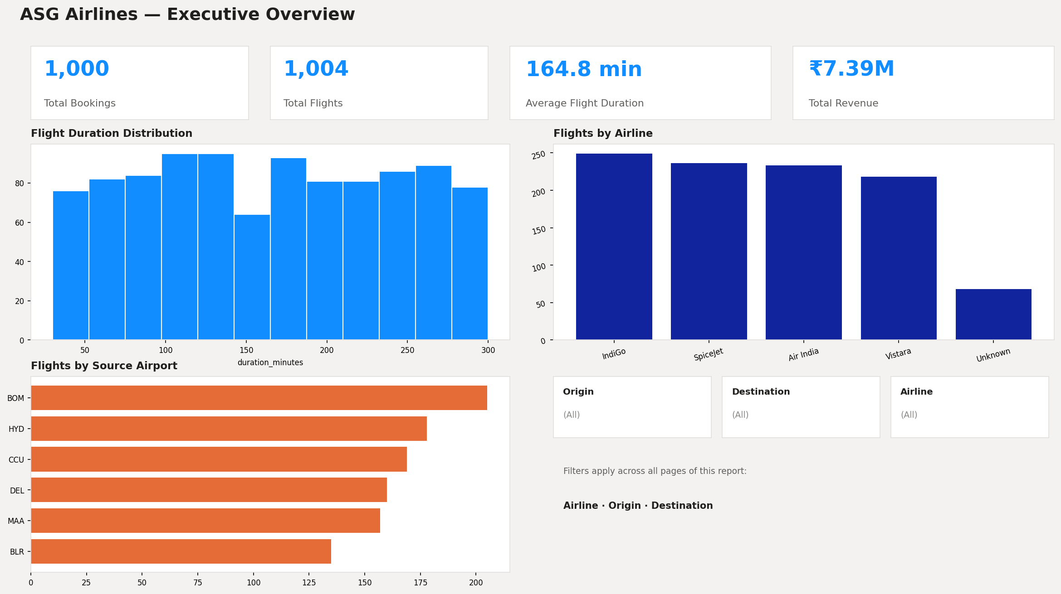
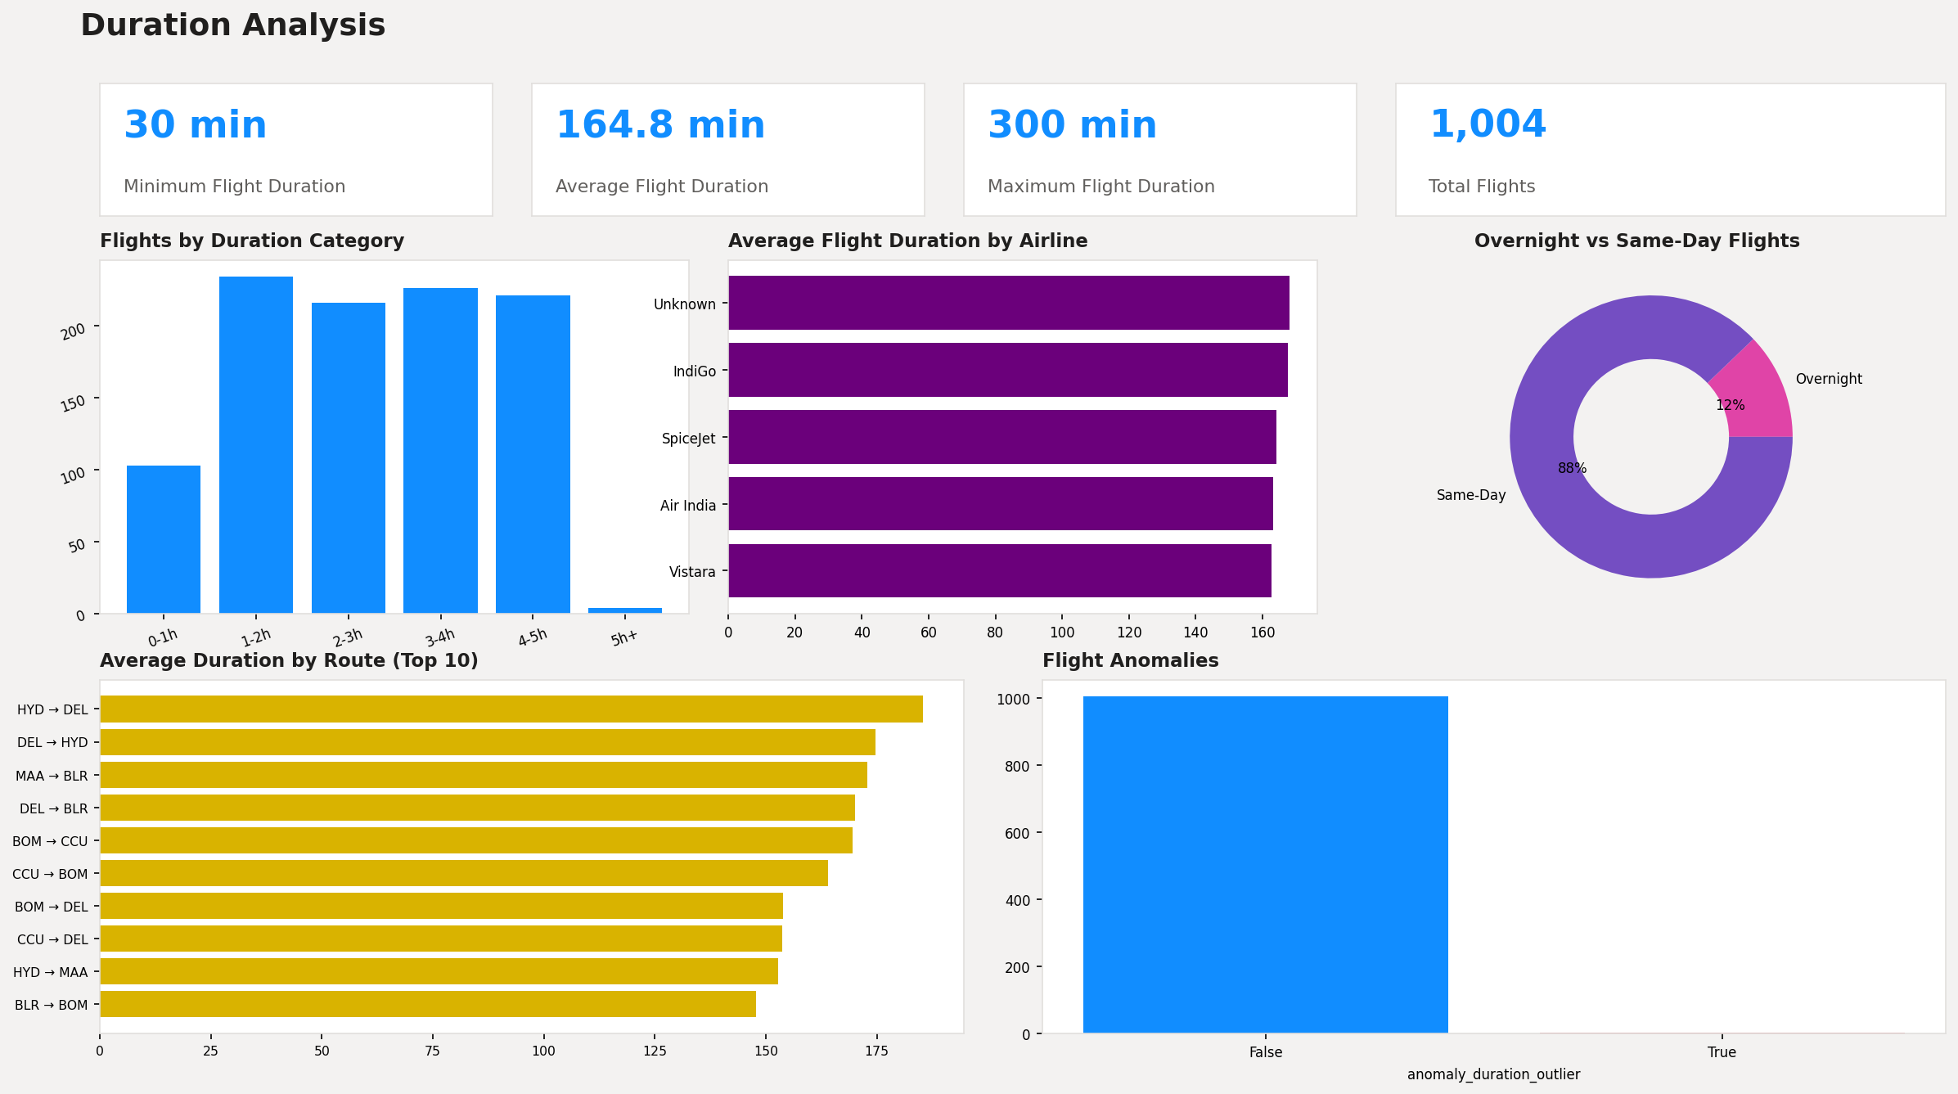

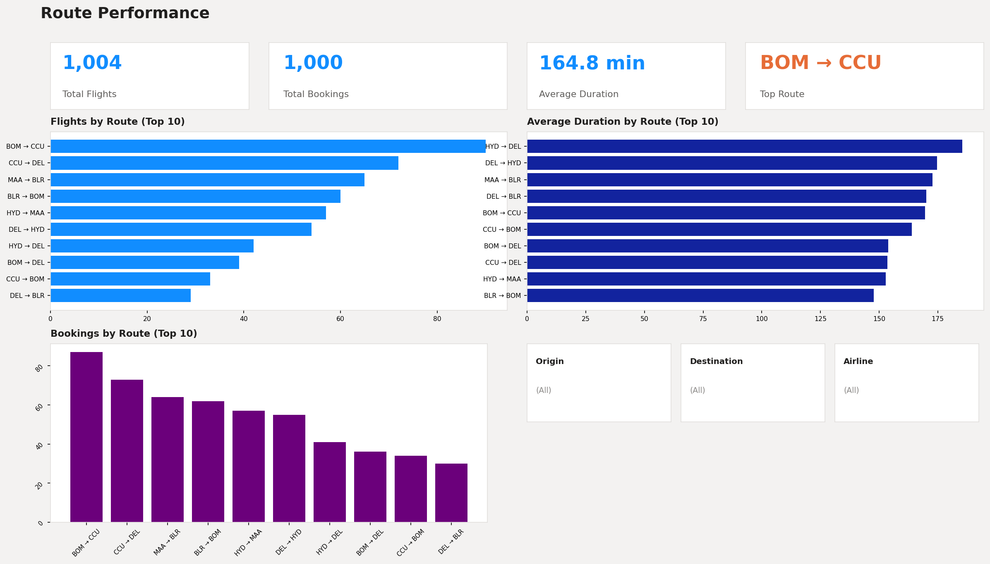
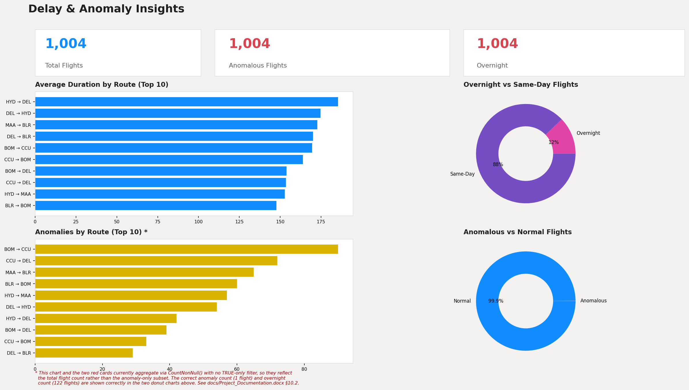

10.3 Implementation Note — Delay & Anomaly Insights Cards
The Anomalous Flights and Overnight cards, and the Anomalies by Route chart, currently aggregate with CountNonNull() and no TRUE-only filter. Since anomaly_duration_outlier and is_overnight are never null, this returns the total flight count (1,004) on all three visuals rather than the TRUE-only subset.
The correct subset counts are computed correctly elsewhere on the same page: the Anomalous vs Normal Flights donut and the Overnight vs Same-Day Flights donut both use the boolean column as a category/legend field, which correctly splits the data — they show 1 anomalous flight (0.1%) and 122 overnight flights (12%) respectively. Those two donuts are the authoritative figures for this dataset.
For reference, the equivalent DAX measures that would make the three affected visuals consistent with the donuts:
Anomalous Flights = CALCULATE(COUNTROWS(cleaned_flights), cleaned_flights[anomaly_duration_outlier] = TRUE())
Overnight Flights = CALCULATE(COUNTROWS(cleaned_flights), cleaned_flights[is_overnight] = TRUE())

