Error Intelligence — local user guide
This guide shows how an engineer uses the running product from an empty workspace to a visible incident. The screenshots come from the real browser connected to the project's isolated, synthetic local staging database. They contain no real customer errors or plaintext keys. The normal local development URLs are used in the steps below.

1. Confirm the frontend is connected
From the repository root in VS Code PowerShell, run the project database and backend in one terminal:
powershell.exe -NoProfile -ExecutionPolicy Bypass -File scripts\Local-Database.ps1 -Action Start
powershell.exe -NoProfile -ExecutionPolicy Bypass -File scripts\Run-Backend.ps1
In a second terminal:
cd front-end
npm run dev
Open https://127.0.0.1:5173. The banner should say Services connected. The frontend proxies /api and /actuator calls to the Java backend at http://127.0.0.1:8080; the backend stores application data in the project's isolated PostgreSQL database. Verify the same path yourself:
Invoke-RestMethod http://127.0.0.1:5173/actuator/health/readiness
Invoke-RestMethod http://127.0.0.1:5173/api/v1/system
The first response should have status equal to UP. A connected UI can still look empty until a user creates a project and sends an event. No Docker Desktop container or company project is involved in this local path.

2. Create your workspace account
On the overview page, open Create account. Enter your name, an organization name, email address, and a password of at least 12 characters. Select Create workspace. You are signed in as the owner of the new organization. On later visits, use Sign in.
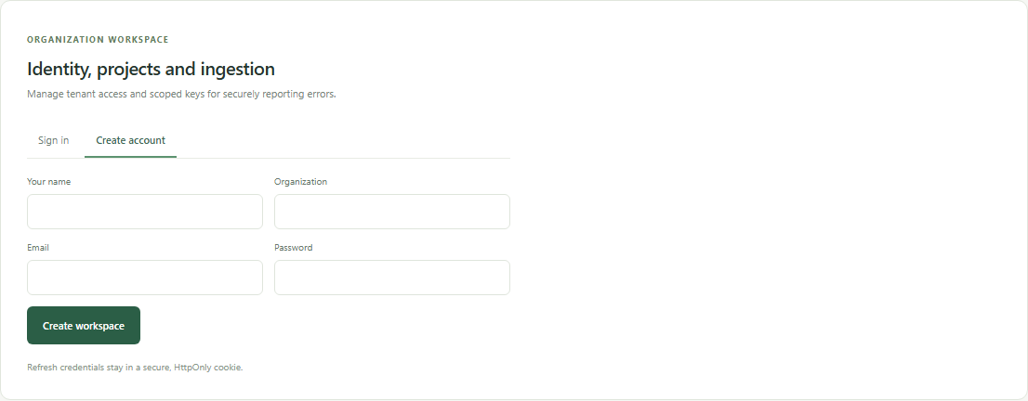
Create account form in the connected app
What happens behind the UI: the React form calls the Java authentication API. The backend creates the account and organization in PostgreSQL and returns a session. This is a product account, separate from your OpenAI Platform account.

3. Create a project
In Projects, enter a project name, such as My Java API, and a lowercase URL slug, such as my-java-api. Select Add project. The project scopes its events, incidents, analytics, and ingestion keys. If you already see a project, you can use it.
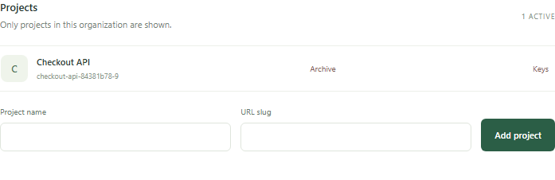
Projects panel and Add project form

4. Create an ingestion key for that project
In the project row, select Keys. Enter a label such as Local demo sender, then select Create key. Copy the new ei_... value immediately: it is displayed only once. Keep it server-side or in your local secret manager. If you lose it, revoke that key and create another. The screenshot shows only the safe prefix of an existing key.
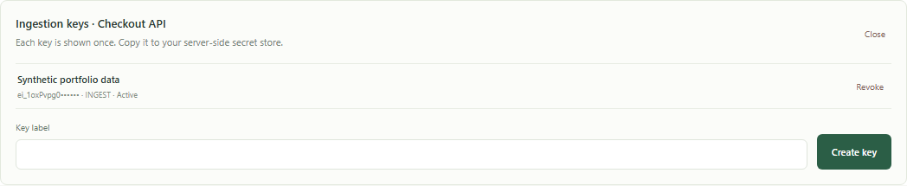
Ingestion key panel with Create key form
Use this project ingestion key for the next step. It is not the OpenAI API key. An OpenAI key is relevant only if you later enable paid AI diagnosis or semantic retrieval. Basic account, project, ingestion, incident, and analytics flows work without paid AI.

5. Send a first test error to the backend
An application sends error events to POST /ingest/v1/events; the UI does not invent them automatically. With the backend still running, paste the following into a new PowerShell terminal from anywhere. When prompted, paste the project ingestion key you just copied. PowerShell will not display it as you type. The command uses invented test data and never prints the key.
$secureKey = Read-Host 'Paste project ingestion key (ei_...)' -AsSecureString
$key = [System.Net.NetworkCredential]::new('', $secureKey).Password
$event = @{
eventId = [guid]::NewGuid().ToString()
occurredAt = [DateTimeOffset]::UtcNow.ToString('o')
environment = 'local-demo'
exceptionType = 'java.lang.IllegalStateException'
message = 'Synthetic checkout failure for local demo'
stackTrace = 'at example.CheckoutService.submit(CheckoutService.java:42)'
} | ConvertTo-Json
try {
Invoke-RestMethod -Method Post -Uri 'http://127.0.0.1:8080/ingest/v1/events' `
-Headers @{ 'X-API-Key' = $key } -ContentType 'application/json' -Body $event
} finally {
$key = $null
$secureKey = $null
}
A successful request returns an event receipt with HTTP 202 Accepted. The backend authenticates the project key, sanitizes and saves the event, then groups it into an incident. Run the command again to add another occurrence; each run generates a new event UUID. Do not send passwords, tokens, personal data, or real production stack traces while learning the workflow.

6. Investigate and resolve the incident
Return to the browser and refresh the page. Open Incidents from the left navigation, select your project, and set the status filter to All statuses if needed. Select the new incident to view recent event evidence. A developer or owner can change status, assign a member, add a comment, and enter a resolution summary and root cause before selecting Verify and resolve. Repeated events with the same fingerprint are grouped together.
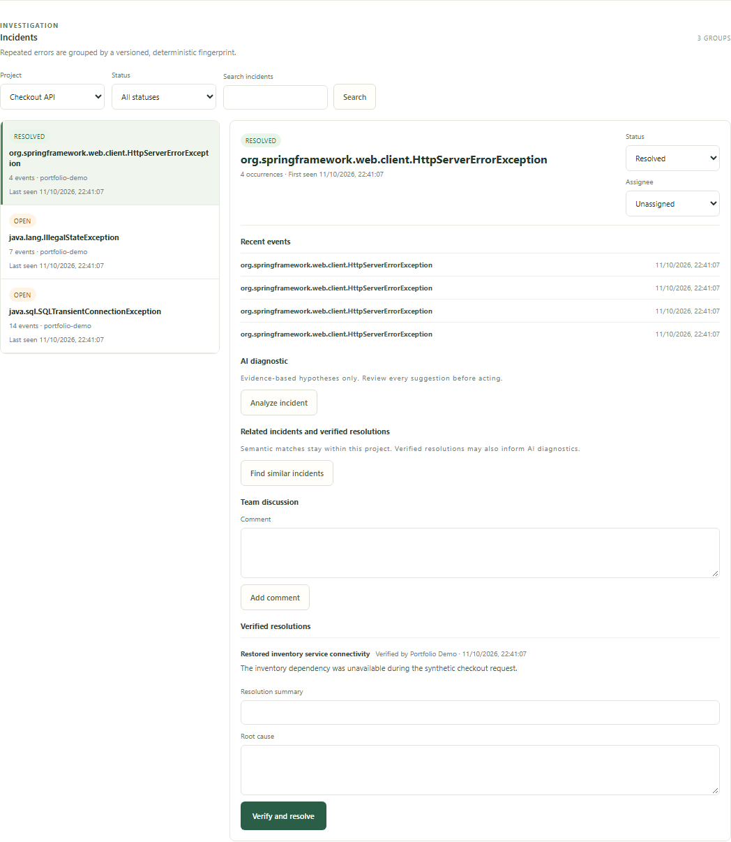
Incident list, evidence and resolution form using synthetic events
The Analyze incident and Find similar incidents buttons belong to the optional AI workflow. In the free local demo, background AI workers are disabled, so these buttons do not demonstrate a completed AI diagnosis. The incident investigation and manual resolution flow is still usable.

7. Review analytics
Open Analytics, choose the same project and a time period. You will see event totals, incident counts, open incidents, resolution rate, daily volume, and frequent incidents. The screenshot below uses 25 synthetic events already ingested in local staging; your new workspace starts with smaller numbers.
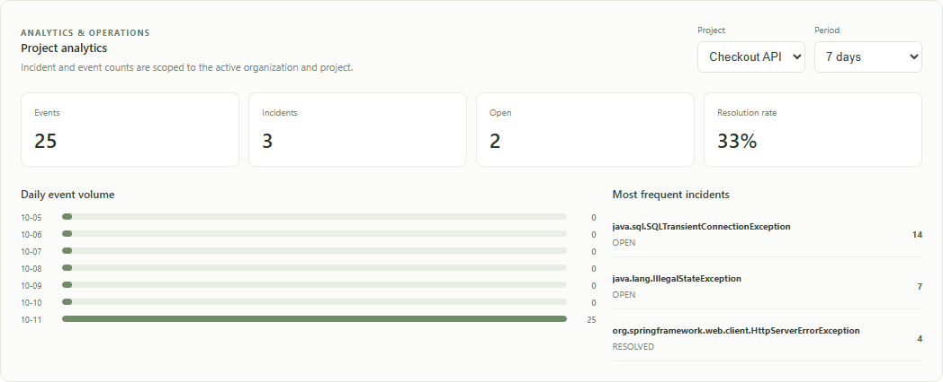
Analytics populated by synthetic backend events

What is still needed for everyday use
The backend and UI are connected, but a separate application must actually send its errors. The PowerShell command above proves the full path; for ongoing use, add a small server-side sender to your Java app or another service that posts sanitized failures with its project ingestion key. The current UI does not capture errors automatically from VS Code or from your browser.
The free local profile does not run paid AI workers, so completed AI diagnoses are not part of this demo. Public hosting and the independent production staging gate are also still open. You can use registration, projects, ingestion, incident investigation, manual verified resolutions, and analytics locally now.

If something does not appear
Symptom | Check
Connection unavailable | Check that the Java backend is still running. Run Invoke-RestMethod http://127.0.0.1:8080/actuator/health/readiness; then check the Vite terminal and http://127.0.0.1:5173.
No projects | Sign in, then create one with Add project. Projects are scoped to the active organization.
No incidents | Create a project ingestion key, send the test event above, refresh, choose that project, and use All statuses. Merely creating a project does not create an incident.
401 or 403 while ingesting | Use the ei_... project ingestion key, not the OpenAI key or your login password. Check that the key is active and belongs to the intended project.
No AI result | The no-cost local profile keeps AI workers disabled. Manual investigation and analytics remain available.
Further details: API overview, portfolio demo and repository README.

