

SUMMER INTERNSHIP & TRAINING COURSE
June – July 2019
Task Report
-----------------------------------------------------------------------------------------------------------------------------------------------------
Title of the Task – Handwritten digit detection using neural network
Group No: 21
----------------------------------------------------------------------------------------------------------------------------------------
Group Members
No. | Name | GR. No. | Div-Roll no. | Domain
1) | Shray Tyagi | 11810615 | E57 | ML
2) | Prashant Kumar | 11810969 | E46 | ML
3)
4)
5)
6)
7)
8)

----------------------------------------------------------------------------------------------------------------------------------------
The Project made by the students in the list above is assessed by us.

Prof. H. M. Khare Prof. Dr. G. N. Kotwal
(Guide & Examiner) (Guide & Examiner)

TRF Summer internship and training course 2018 Task Report

INDEX

Group No.: 21
Project Title: Digit Detection Using Neural Network

Member 1 Member 2
Name: Shray Tyagi Name: Prashant Kumar
Div. & Roll no.: E 57 Div. & Roll no.: E 46
GR No.: 11810615 GR No.: 11810969
E-mail ID: shray.tyagi18@vit.edu E-mail ID: Prashant.yadav18@vit.edu

1. INTRODUCTION
Our objective was to recognize handwritten digits using neural network.
A neural network is a network or circuit of neurons, or in a modern sense, an artificial network, composed of artificial neurons or nodes. Thus, a neural network is either a biological neural network, made up of real biological neurons, or an artificial neural network, for solving artificial intelligence (AI) problems. The connections of the biological neuron are modelled as weights. A positive weight reflects an excitatory connection, while negative values mean inhibitory connections. All inputs are modified by a weight and summed. This activity is referred as a linear combination. Finally, an activation function controls the amplitude of the output.
- Digit detection for digits ranging from 0-9 in.
- Digits are in the form of an image.
- Functional Requirements: Divide the sample image to boxes or layers
Handle any size of image
Divide the image further through width & height
Recognize only digits from 0-9 from the image
- Developed as python Ways to approach this:
- Dividing the character in rectangular boxes
- Detection through layering method (going deep in resolution at each layer)
- Back propagation (going from highest resolution to lowest)

- Enumerate the steps that are needed to detect handwritten digits
- Create a database of handwritten digits(in our project we have used the mnist dataset which is imported externally in pycharm.
- Installing the packages that are used in our project (i.e keras, tensorflow, numpy, cv2)
- We've created two dataframes, train and test to store the training and testing data respectively. The training and testing datasets are taken from mnist.
- Then resizing the image that is taken for training from the mnist dataset.
- Our model consists of 2 Pairs of Conv2D-MaxPool layers and 2 Dense layers. Dropout is also used to fight overfitting.
- Since this is a multiclass classification problem, we use loss as categorial_crossentropy.
- The model is then compiled and training of the model is performed, following which validation is done.
- The model is then saved.
- Another code “predict” is written in which we pass the handwritten digits. It loads the model and traverse through our model and predict the output.
- The output is predicted in the form of an array. The index number of value 1 gives the number predicted in the range of of 0-9.
- In predict we have used numpy, overflow and cv2 libraries.
- The system/software used for our project is Pycharm 2019, Python 3.7.2. All the libraries used in our project are installed from the pycharm.

2. WORKING METHODOLOGY
Algorithms that can be used for digit detection:

Linear SVC

- In a Support Vector Machine (SVM) model, the dataset is represented as points in space. The space is separated in clusters by several hyperplanes. Each hyperplane tries to maximize the margin between two classes (i.e. the distance to the closest points is maximized).
- Scikit-learn provided multiple Support Vector Machine classifier implementations. SVC supports multiple kernel functions (used to split with non-linearly) but the training time complexity is quadradic with the number of samples. Multiclass classification is done with a one-vs-one scheme. On the other hand, LinearSVC only supports linear kernels but the training time is linear with the number of samples. The multiclass classification is done with a one-vs-others scheme.

Multilayer Perception

A neural network-based classifier, called Multi-Layer perception (MLP),
is used to classify the handwritten digits. Multilayer perceptron consists of three different layers- input layer, hidden layer and output layer. Each of the layers can have certain number of nodes also called neurons and each node in a layer is connected to all other nodes to the next layer. For this reason, it is also known as feed forward network.

During training process, it basically learns the accurate weight adjustment which is corresponds to each connection. For the learning purpose, it uses it uses a supervised learning technique named as Backpropagation algorithm.

We have used the multilayer perception algorithm as it is very easy to understand for the beginners and the syntax wise also its very easy. Its other advantages are:
1.Adaptive learning-An ability to learn how to do tasks based on the data given for training or initial experience.
2. One of the preferred techniques for image recognition.
3. They yield the required decision function directly via training.
4. A two-layer backpropagation network with sufficient hidden nodes has been proven to be a universal approximator.

ALL ABOUT CNN’s
There are a lot of algorithms that people used for image classification before CNN became popular. People used to create features from images and then feed those features into some classification algorithm like SVM. Some algorithm also used the pixel level values of images as a feature vector too. To give an example, you could train an SVM with 784 features where each feature is the pixel value for a 28x28 image.
So why CNN and why they work so much better?
CNNs can be thought of automatic feature extractors from the image. Algorithm with pixel vector lose a lot of spatial interaction between pixels, a CNN effectively uses adjacent pixel information to effectively down sample the image first by convolution and then uses a prediction layer at the end.
Thus, making them an algorithm of choice for image classification challenges henceforth.
In CNNs, filters are not defined. The value of each filter is learned during the training process.
By being able to learn the values of different filters, CNNs can find more meaning from images that humans and human designed filters might not be able to find.
More often than not, we see the filters in a convolutional layer learn to detect abstract concepts, like the boundary of a face or the shoulders of a person. By stacking layers of convolutions on top of each other, we can get more abstract and in-depth information from a CNN.
A second layer of convolution might be able to detect the shapes of eyes or the edges of a shoulder and so on. This also allows CNNs to perform hierarchical feature learning; which is how our brains are thought to identify objects.
The most common type of convolution that is used is the 2D convolution layer, and is usually abbreviated as conv2D. A filter or a kernel in a conv2D layer has a height and a width. They are generally smaller than the input image and so we move them across the whole image. The area where the filter is on the image is called the receptive field.
Working: Conv2D filters extend through the three channels in an image (Red, Green, and Blue). The filters may be different for each channel too. After the convolutions are performed individually for each channel, they are added up to get the final convoluted image. The output of a filter after a convolution operation is called a feature map.
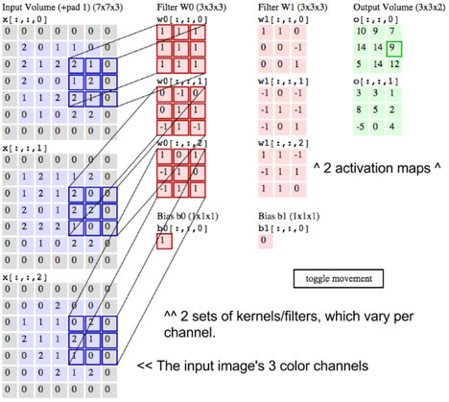
Each filter in this layer is randomly initialized to some distribution (Normal, Gaussian, etc.). By having different initialization criteria, each filter gets trained slightly differently. They eventually learn to detect different features in the image.
If they were all initialized similarly, then the chances of two filters learning similar features increase dramatically. Random initialization ensures that each filter learns to identify different features.
Since each conv2D filter learns a separate feature, we use many of them in a single layer to identify different features. The best part is that every filter is learnt automatically.
Each of these filters are used as inputs to the next layer in the neural network.
If there are 8 filters in the first layer and 32 in the second, then each filter in the second layer sees 8 filter inputs. Meaning that we get 32X8 feature maps in the second layer. Each of the 8 feature maps of a single filter are added to get a single output from each layer.
What the conv2D layer is doing: Each filter in the conv2D layer is a matrix of numbers. The matrix corresponds to a pattern or feature that the filter is looking for.
In the image below, the filter is looking for a curved line. That curved line could correspond to the back of a mouse, or a part of the numbers 8, 9, 0, etc. Whenever the filter comes across a pattern like that in the image, it gives a high output.
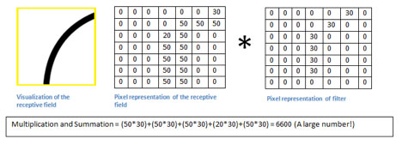
Although this may seem like a very simple example, most conv2D filters in the first layer of a CNN search for similar features. It also means that the same filter can be used to extract information from multiple types of images (mouse, numbers, faces and so on).

- Detailed Explanation of Working: -

MODEL

- Libraries installed:
(a)MNIST- This contains very large training and testing database of handwritten digit. The images are stored in the form of an array.
(b) keras- This is included as it contains various layers that is used for making up the model for the neural network.
- cv2- This library is used to read and for the resize and reshaping of images which are to be detected.
- TensorFlow- It is an open source artificial intelligence library, using data flow graphs to build models. It allows developers to create large-scale neural networks with many layers.
- NumPy- The NumPy array takes significantly less amount of memory as compared to python list. It is used to take the input or to show the output as a form of an array.

- train images and test images take images data from the MNIST dataset. train labels and test labels are the labels that is also taken from MNIST, these are labels given to the images.

- Normalisation is done for train images and test images to bring the range between 0-1.

- model=models.Sequential() creates object of sequential type and layers are added to it through model.add(layers.<layer_name>).

- The different layers are:
(a)Conv2D- Convolutional 2D layer is a deep learning algorithm which can take in an input image, assigns importance to various aspects in the image and be able to differentiate one from another.
(b)Dense- It’s a linear operation in which every input is connected to every output by a weight. These are densely connected; each neuron is connected from all the neurons present in the previous layer.

- The parameters in the function are: -
Conv2D(batch_size,(dimensions),activation function)

7. There are various activation functions but we have used:
(a)relu: It is analogous to have wave rectification in electrical engineering.
F(z) is zero if z<0;
F(z) is z for z>=0;
(b)softmax: It is a wonderful activation function that turns numbers aka logits into probabilities that sum to one. Softmax function outputs a vector that represents the probability distributions of a list of potential outcomes.

8. Dropout layer is used to reduce the overfitting problem. It skips the neurons randomly from the hidden layers and passes directly to the output by passing through remaining neurons. Max pooling is used to down-sample an input representation (image, hidden-layer output matrix, etc.), reducing its dimensionality and allowing for assumptions to be made about features contained in the sub-regions binned.
9. model. compile()- This is used to compile the model (neural layers). This function takes three parameters:
(a)optimizer: This is a function that minimises the loss in a neural network. The loss is the difference between the actual prediction with the actual label. We have used “adam optimizer” which is a type of stochastic gradient descent (SGD). To be precise it is difference in loss divide by difference in weights of each path multiplied by learning rate.
(b) The method we have used to find the loss is croosentropy as it gives better results compared to mean square method.

10. model.save(‘model_name’) saves the model and help us for further use of this model.

Testing a real handwritten image -

- Then we have to load our model so as to link it with this “predict code” so that when we pass the handwritten image to this “predict code” it will go through the model and yields the output. We load the model using the package “tf” that is imported from TensorFlow. It is achieved by the following syntax:
Model= tf.keras.models.load_model("model.h5")

- Image is given to the code with the image extension(image path).

- model.predict() is used the predict the output. The parameter of this function is the handwritten image that needs to be converted. The output of this is in the form of an array of size 10 in which the the index number is the output whose value is 1.

- Categories[np.argmax(prediction)] the last line check the output array of the model.predict() function, it searches the maximum argument in the array using the numpy library and prints the index number of that which is the required o

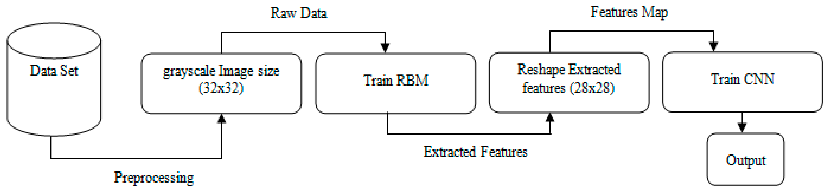

3. INSIGHTS
Problems we have faced during our model building:
The dilemma of constructing the layers. The construction of layer was time consuming. The problem was that that there are several types of layers and issues like overfitting and underfitting also arises if we get some errors in layers building.
So, this problem was overcome by taking references from websites of neural networks and GitHub.
Also, we came across several new libraries which are very new to us. We find difficult in understanding the methods and functions that are included in it.
We have taken the help from google and different sites for knowing different methods and functions of the libraries used.
Points of special mention:
The important instruction is that never ever forget to save your model. It takes a considerable amount of time to build the model and then only we can use this to test our handwritten digits. If you forgot to save the model then the software again will take that much time (which is approximately 40 minutes in our case).

4. PHOTOS
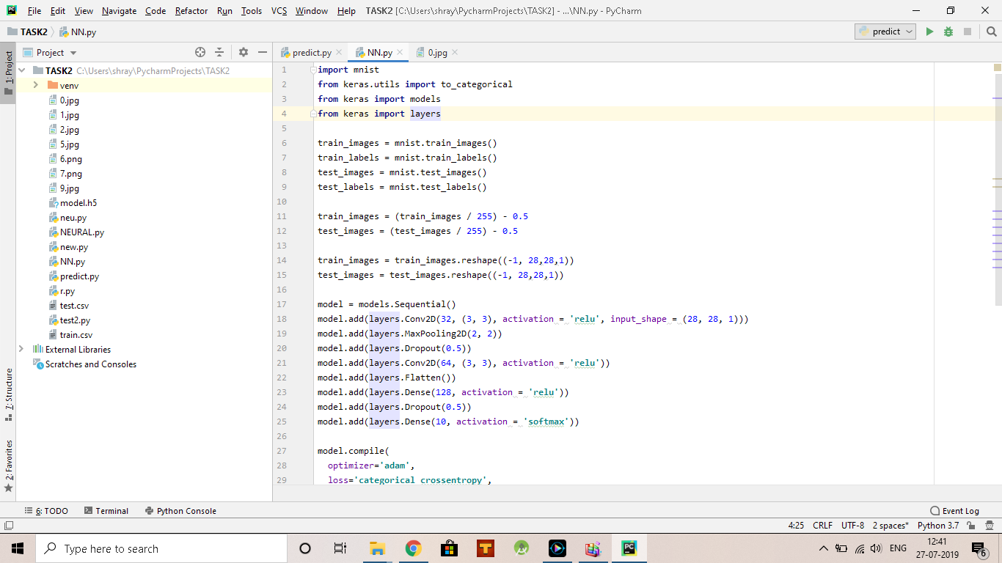
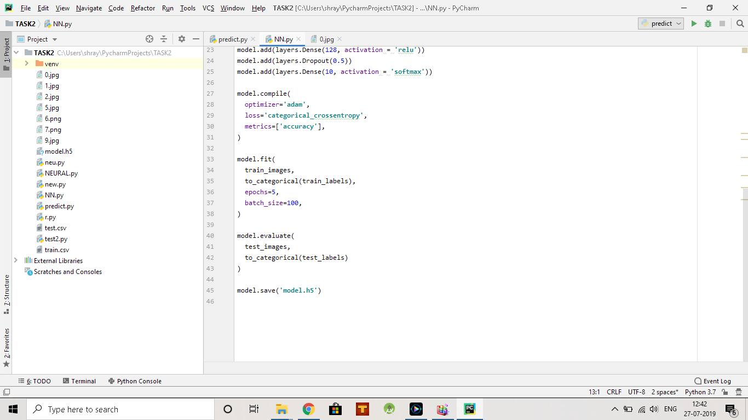
Output Screenshot-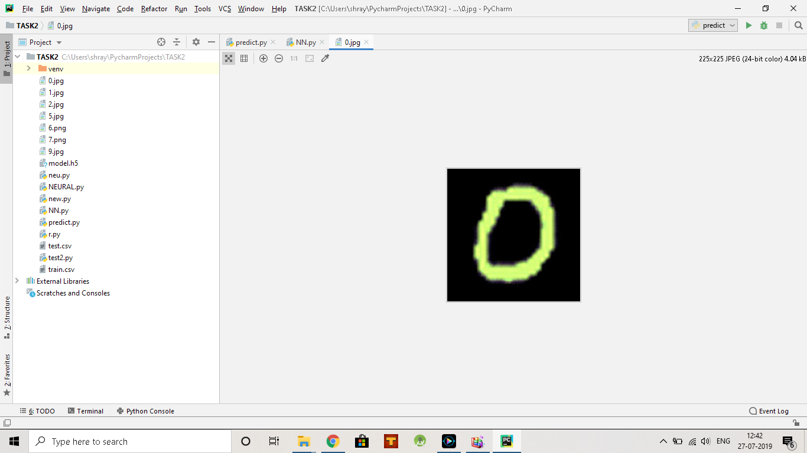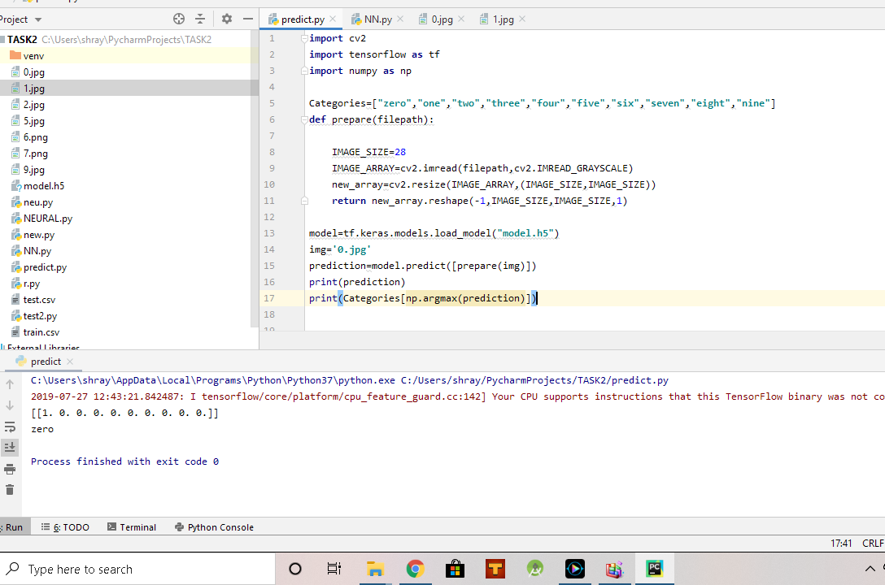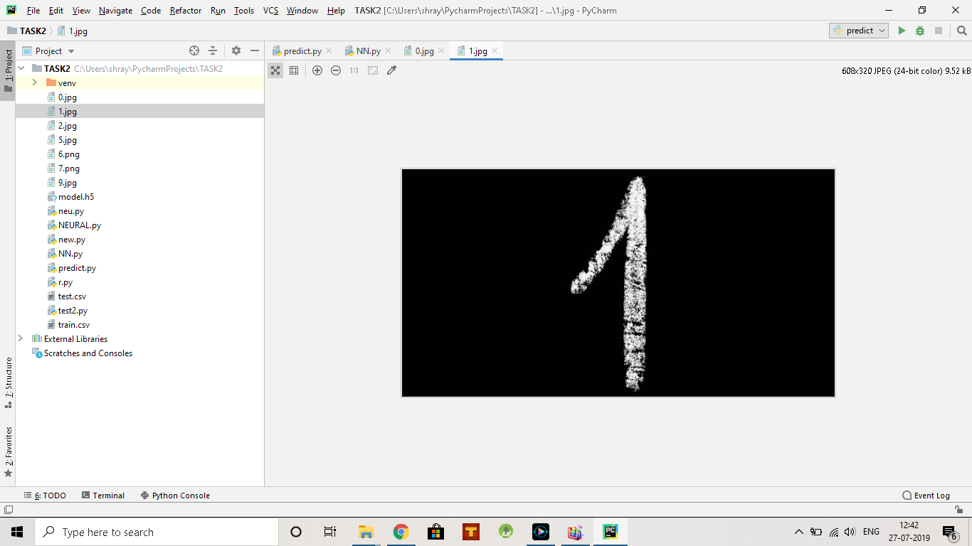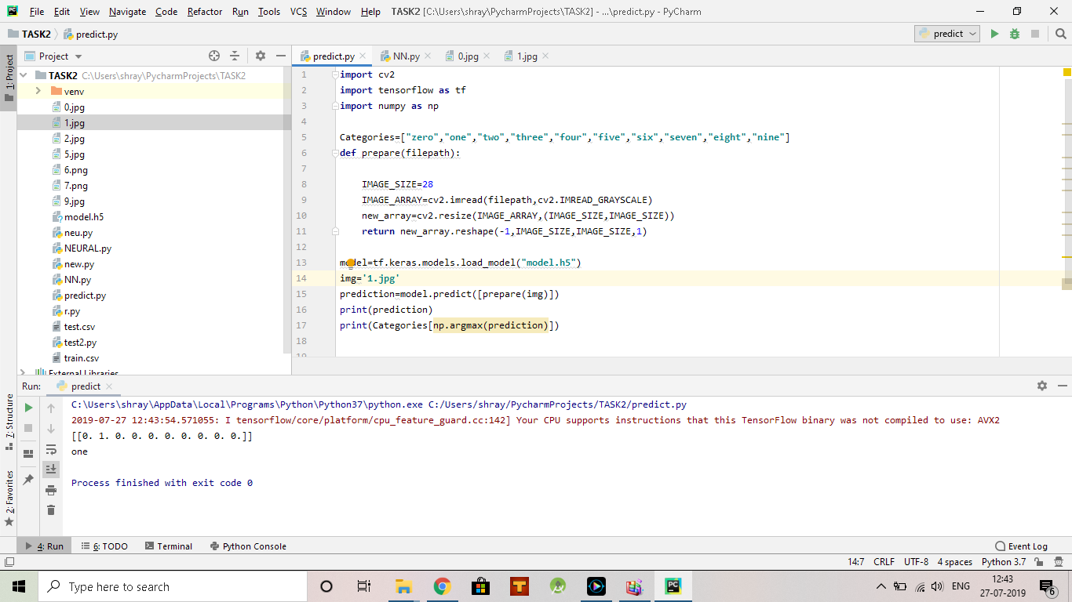

5.RESULTS:
Simulation result based on accuracy and time consumption.
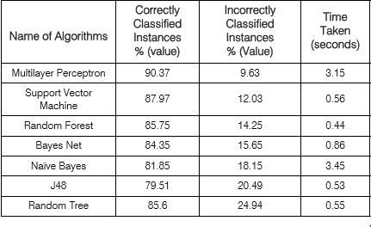

→Simulation result based on different error.
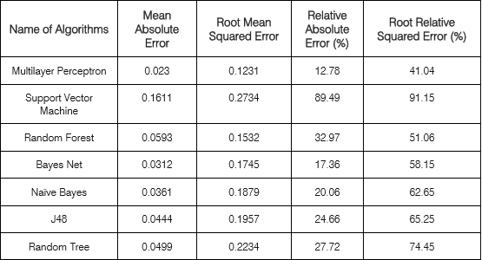
- The actual accuracy of our project is reached 98% and at the end it is 97% which is quite impressive, whose table is given below which is the actual simulation of model. 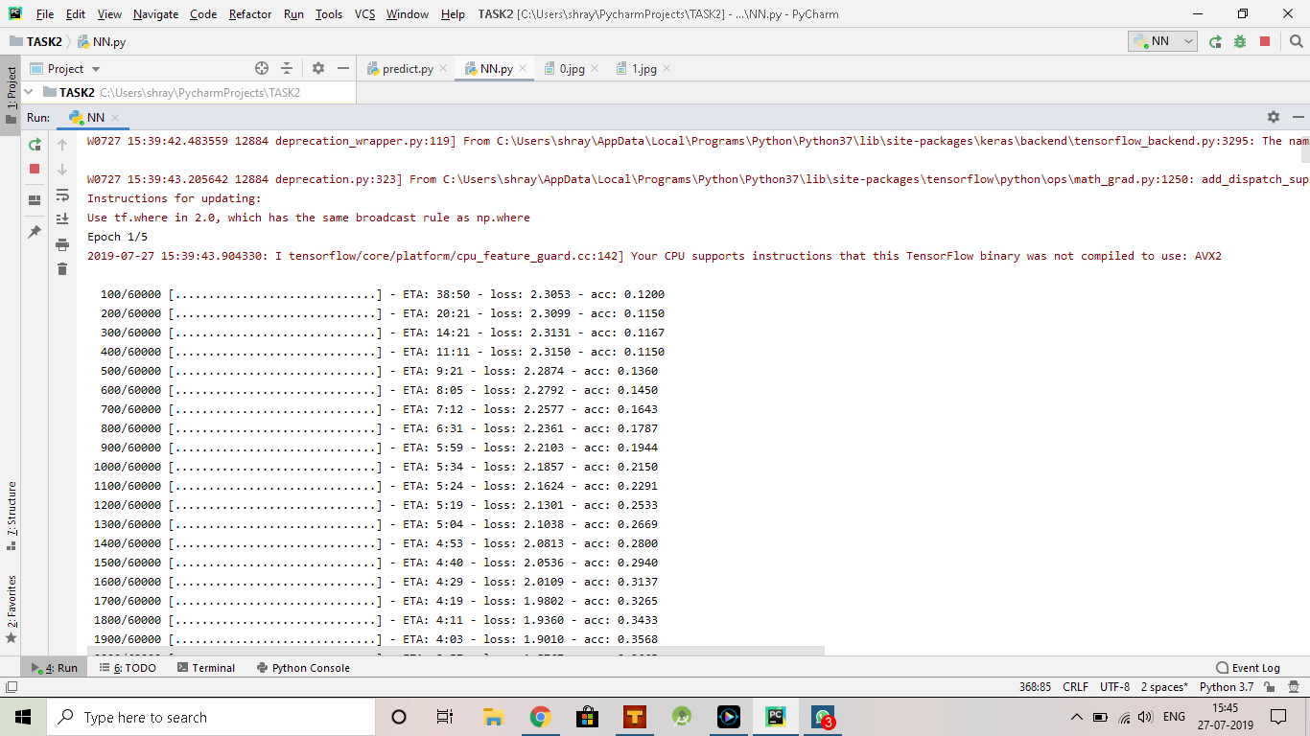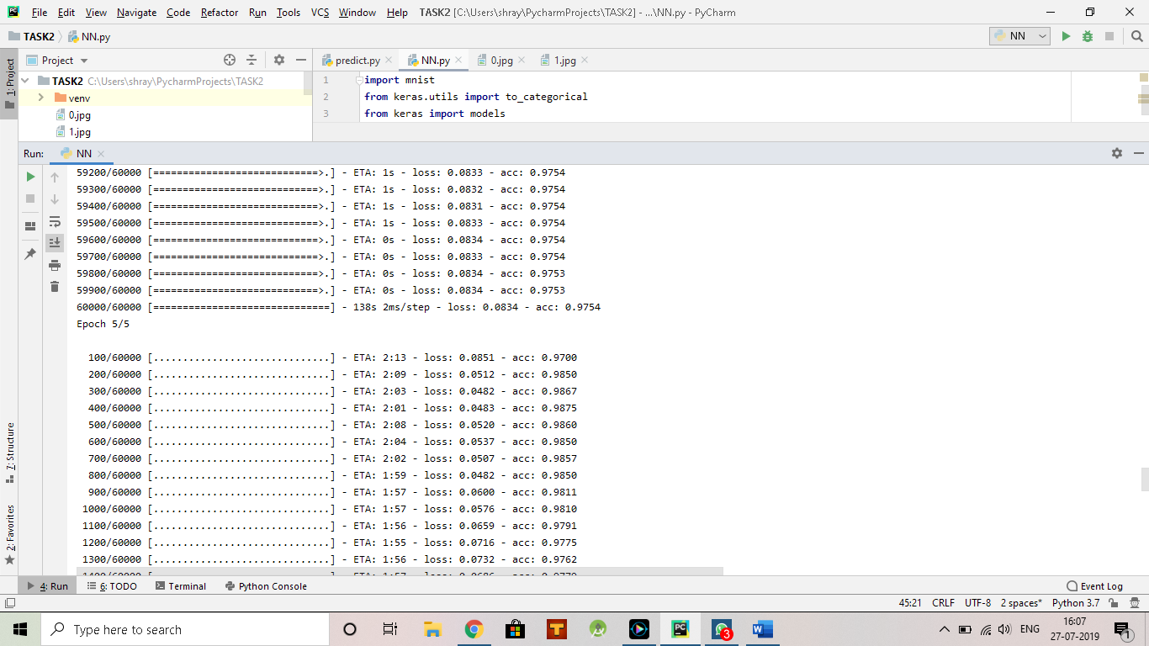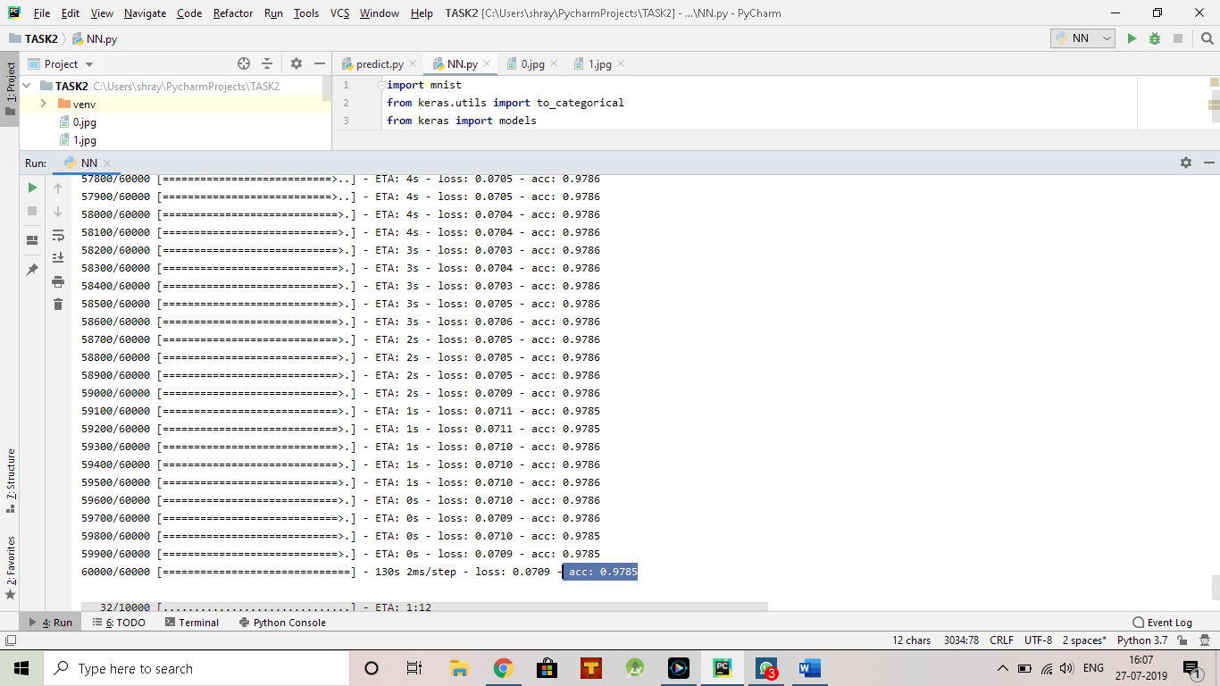

6. REFERENCES
https://www.youtube.com/watch?v=gZmobeGL0Yg&list=PLZbbT5o_s2xq7LwI2y8_QtvuXZedL6tQU
https://www.kaggle.com/raahat98/digit-classification-with-keras-99-accuracy
Neural networks and deep learning by Michael Nielsen

