A Mini Project Report
on
“Inventory Management”
by

Rushi Kothari (T-188001)
Shubham Morankar(T-188004)
Mithil Jobanputtra(T-188028)
Amol Garje(T-188037)

of
T.Y. BTech
Academic Year: 2018-2019

School of Computer Engineering & Technology

Contents

Sr. No. | Topic |  | Page No.
Chapter-1 | Introduction |  | 3
 | 1.1 | Objective | 3
 | 1.2 | Introduction to Project | 3
 | 1.3 | Literature Survey | 4
Chapter-2 | Theory
 | 2.1 | Features of Project. | 5
 | 2.2 | Architectural Review | 5
 | 2.3 | Database Theory | 6
 | 2.4 | Background Research | 8
 | 2.5 | Requirement Analysis | 8
 | 2.6 | IMS Requirement | 8
Chapter-3 | Software Requirement Specification
 | 3.1 | Hardware Requirements | 10
 | 3.2 | Software Requirements | 10
Chapter-4 | Results (Code + Screen shots)
Chapter-5 | Conclusion
 | References

Chapter 1
Introduction
Inventory management is the management of inventory and stock. As an element of supply chain management, inventory management includes aspects such as controlling and overseeing ordering inventory, storage of inventory, and controlling the amount of product for sale.
The definition of Inventory Management is easy to understand. Simply put, inventory management is all about having the right inventory at the right quantity, in the right place and at the right time.

  - Objective
- To supply the required materials continuously.
- To minimize the risk of under and over stocking of material.
- To maintain systematic record of inventory.

    - Reasons or motives of holding inventory
- Transaction motive.
- Precautionary motive
- Speculative motive

  - Introduction of Project
The project Inventory Management System is a complete desktop based application. The main aim of the project is to develop Inventory Management System Model software in which all the information regarding the stock of the organization will be presented. It is an intranet based desktop application which has admin component to manage the inventory and maintenance of the inventory system.
Inventory management is an important aspect of any school or college. It is the process of overseeing and controlling the flow of inventory units in a college. Inventories are usually made up of a combination of Projectors, Markers, Dusters, VGA-Cables, Mike’s etc and effective management of these items is essential to ensure optimal stock levels and to maintain the record of inventories. It helps to minimize the risk of under and over stocking of materials. Inventory management software is used by businesses for various reasons: it can track the costs of inventory throughout the manufacture and sales process, tell businesses when to replenish stock, and allow them to track profits. There is a provision of updating the inventory also. This application also provides the remaining stock as well as the details of the inventories.
Each new stock is created and entitled with the name and the details of that stock and it can also be update any time when required as per the requirement Here the login page is created in order to protect the management of the stock of organization in order to prevent it from the threads and misuse of the inventory.

  - Literature Survey
Products are considered as the business resources for the organization. This includes managing the product with appropriate way to review any time as per the requirement. Therefore it is important to have a computer based IMS which has the ability to generate reports, maintain the balance of the stock, details about the purchase and sales in the organization. Before developing this application we came up with 2 Inventory Management System existing in the market, which helps to give the knowledge for the development of our project. These application software are only used by the large organization but so we came up with the application which can be used by the small company for the management of their stock in the production houses.
After analyzing the other inventory management system we decided to include some of common and key features that should be included in every inventory management system. So we decided to include those things that help the small organization in a way or other.

Chapter 2
Theory

  - Features of Project
This application is used to show the stock remaining and details about the inventories . It gives the details about the stock on daily based and weekly based. The details components are described below :

Login page: As application starts the login page appears. Admin login is determined by the username and password that has all the authority to add, update and delete the stock of the organization as per the requirement.

SignUp Page : As the application starts the signup page occurs after successful signing
up then it directs it us to the login page.

User Dashboard : In Users Dashboard the all the details of the inventory which are with the particular user are displayed here .eg User A has 1 VGA-Cable , 1 Duster and 2 markers etc and also the issue date and the return date of the inventories are displayed here.

Admin Dashboard : In Admin Dashboard the admin can see the details about the inventories of all the users their issue dates and return dates also task of adding ,updating ,deleting of the inventories is held by admin.

  - Architectural Review
This desktop based application is based on 3-tier architecture. The 3-tier includes the three hierarchy of the flow of programming logic from user interface to database and again database to user interface with the desired information requested by the clients.
In between there involves the logic layer for effectively and correctly manipulating the request. The 3-tier includes the following:

Client tier
The main function of this tier is to display information to the user upon user’s request generated by user’s inputs such as firing button events. For example, inventory list will display when user click “display” button if he or she wants to know the list of stock remaining in the organization.

Admin tier
The middle tier is called by the client to make database queries. It provides core function of the system as well as connectivity to the data tier, which simplify tasks that were done by the clients tier.

Data tier
Data layer is also the class which gets the data from the Admin tier and sends it to the database or gets the data from the database and sends it to Admin tier. The database backend stores information which can be retrieved by using the mysql database Connectivity. Mysql database connectivity is used to manage the communication between the middle tier and the backend database by issuing database queries.

  - Database Theory
A database is a collection of information that is organizes so that it can easily be accessed, managed and updated. In computing, database are sometime classified according to their organizational approach.

Relational Database
IMS has the relational database model. relational database is a digital database whose organization is based on the relational model of data. This model organizes data into one or more tables of rows and columns. These tables here have the relation. The relation is maintained by the unique key defined in each row. The key can be primary and foreign depending on their nature of connection. The standard user and application program interface to a relational database is the structured query language (SQL). SQL statement are used both for interactive queries for information from relational database and for gathering data for reports.

Primary Key
The primary key of a relational table uniquely identifies each record in the table. It can either be a normal attribute that is guaranteed to be unique or it can be generated by the DBMS. A primary key’s main features are:
➢ It must contain a unique value for each row of data.
➢ It cannot contain null value.

Foreign Key
A foreign key is a column or group of column in a relational database table that provides a link between data in two tables. In foreign key reference, a link is created between two tables when the column or columns that hold the primary key value for one table are referenced by the column or column in another table thereby establishing a link between them. Creating a foreign key manually includes the following advantages:
➢ Changes to primary key constraints are checked with foreign key constraints in relation table.
➢ An index enables the Database Engine to quickly find related data in the foreign key tables.

  - Background Research
We started research by identifying the need of IMS in the organization. Initially we bounded our research to find the general reasons that emerged the needs of Inventory Management System. We used different techniques to collect the data that can clearly give us the overall image of the application. The techniques we used were interview with the developers, visiting online websites that are presented as the templates and visiting some organization to see their IMS application. Basically the following factors forced us to develop IMS application:

➢ Cost and affordability
➢ Lack of stock management.
➢ Effective flow of stock transfer and management.
➢ Difficulty in monitoring the stock management.

  - Requirement Analysis
We collected a number of requirements for project from our primitive research, website visits, and interview to the concerned personnel and their experiences regarding the concepts of its development. We have even visited some organization near MIT and analyze its importance and try to develop the project by fulfilling all the weakness that were found in the application. We then decided to bulid same type of application with different logic flow and new language which will be suitable for the small organization.

  - IMS Requirement
The goal for the application is to manage the inventory management function of the organization. Once it is automated all the functions can be effectively managed and the organization can achieve the competitive advantage.
Additional Details about IMS are :
  - Helps to search the specific product and remaining stock.
  - Details information about the product.
  - It helps to identify the total presented inventory in the organization.
  - There is proper management of inventory.

2.6.1 Users Requirement

Admin
Able to edit the entry as per entry.
Able to add , modify and delete the stock entry.

Inventory Management
Able to check the stock available.
Able to view the remaining sales stock.

Chapter 3
Software Requirement Specification

  - Hardware Requirements
The System should have these Hardware requirements
Processor : Any Processor that is compatible with browser ,apache server and database.
Ram : 512 MB or more
Hard Disk : 5 GB or more

  - Software Requirements
The software requires the support of the following software for the database and the other requirements.
- XAMPP / WAMP Server.
- SQL.
- phpMyAdmin.
- Apache Server.
Chapter 4
Results

.
Project Screenshots

- Sign up

- Login
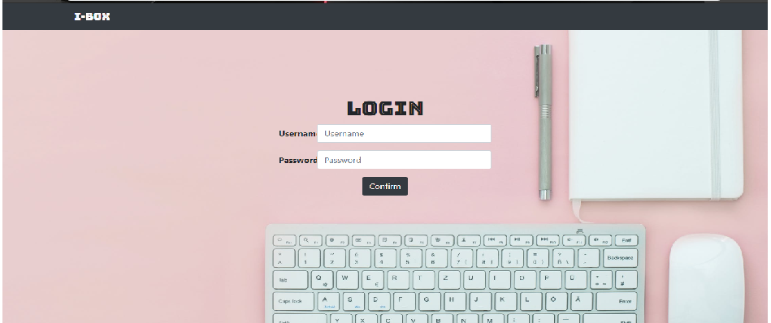
- Admin Dashboard
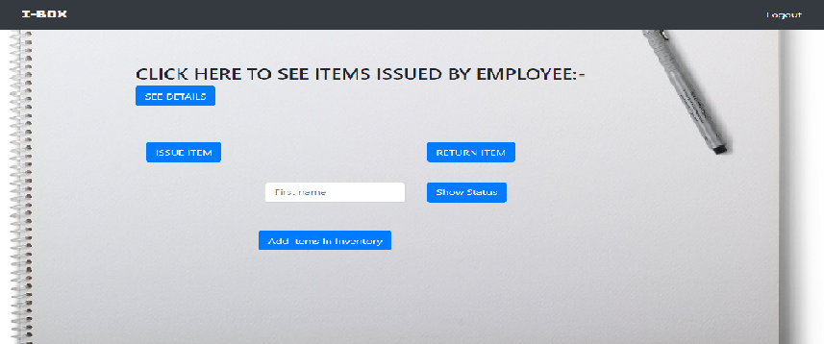

- User’s Dashboard

Chapter 5
Conclusion

To conclude, Inventory Management System is a simple desktop based application basically suitable for small organization. It has every basic items which are used for the small organization. Our team is successful in making the application where we can update, insert and delete the item as per the requirement. This application also provides a simple report on daily basis to know the daily issues and returns of the inventories.
Through it has some limitations, our team strongly believes that the implementation of this system will surely benefit the organization.

References

https://www.addmengroup.com/ecas/stock-and-inventory-management-software-for-college.htm

https://www.fishbowlinventory.com/inventory-management/

