THE CAPSTONE CHALLENGE
Your AI Project
StudyMate AI
Your Personal AI Study Companion
Submitted by
Prathamesh B. Patil
Computer Science (AI & ML) | 3rd Year

Project Overview
StudyMate AI is an AI-powered learning companion designed to help students understand concepts, practice questions, plan their studies, track progress, and receive personalized academic support. The capstone is a design and strategy blueprint rather than a coding assignment, as specified in the project brief. fileciteturn3file0L8-L15

Section 1: Project Name & The Problem

Project Name
StudyMate AI
Tagline: Learn Smarter. Grow Faster.

The Problem
Students often have access to many learning resources but struggle to turn them into a clear, personalized study process. Notes, videos, practice websites, textbooks, coaching resources, and career guidance are frequently scattered across different platforms. A student who is weak in a specific concept may also spend significant time searching for an explanation at the right level, finding suitable practice questions, deciding what to study next, and tracking whether the weak area is actually improving.
The problem affects school and college students, particularly learners who need affordable, on-demand academic support. Existing solutions may solve individual parts of the problem, such as video learning, question practice, or productivity planning, but the learner still has to connect these pieces manually. StudyMate AI addresses this fragmentation by bringing explanation, practice, planning, feedback, and progress tracking into one student-centered experience.

Why Existing Approaches Are Not Enough
- Learning resources are distributed across multiple websites and applications.
- Generic content does not always match a student's current level or learning goal.
- Students may know what subject they study but not what topic they should practice next.
- Progress tracking is often separate from the learning activity itself.
- Students can receive answers without understanding the reasoning behind them.

Section 2: The Solution (Your Mission)
StudyMate AI is an all-in-one AI-powered learning companion that gives students personalized explanations, step-by-step doubt solving, practice questions, study plans, and progress insights from one platform. A student can ask a question in text or image form, receive an explanation adapted to their level, practice related questions, and have the result reflected in a personal progress profile. The system can use AI to identify recurring weak areas and recommend what the student should learn or practice next. The goal is not to replace teachers, but to provide an accessible support layer that helps students learn independently and use their study time more effectively.

Section 3: The User (User Persona)
Name | Ananya Kulkarni
Age | 19
Role | Second-year engineering student
Bio | Ananya studies Computer Science and wants to improve her programming fundamentals and prepare for internships. She understands basic concepts but often gets stuck when solving unfamiliar questions.
Needs | Clear explanations, step-by-step doubt solving, topic-wise practice, a realistic study schedule, progress tracking, and guidance on what to learn next.
Frustrations | She finds resources scattered across platforms, sometimes gets explanations that are too advanced, and is unsure whether she is actually improving in weak topics.

User Goal
“I want to understand difficult topics without feeling lost, practice enough to improve, and know exactly what I should study next.”

Section 4: Key Features & User Flow
Feature | What It Does
1. AI Doubt Solver | Explains academic or programming questions step by step and can adapt the explanation to the student's level.
2. Personalized Study Plan | Creates a practical study schedule based on the student's goals, available time, subjects, and progress.
3. Practice & Assessment | Generates topic-wise quizzes and practice sets and provides feedback after completion.
4. Progress Tracker | Shows strengths, weak areas, completed topics, practice performance, and improvement over time.
5. AI Mentor | Provides study guidance, revision suggestions, motivation, and next-step recommendations.

Main User Flow: AI Doubt Solver
1. Ananya opens StudyMate AI and selects “Doubt Solver.”
2. She types a question or uploads an image of the question.
3. The system identifies the topic and analyzes the question.
4. The AI generates a step-by-step explanation using simple language and examples.
5. Ananya can ask a follow-up question if she does not understand a step.
6. The system recommends related practice questions.
7. Her practice result updates the progress tracker and contributes to future recommendations.

Section 5: The “AI Inside” (Core Components)
AI Component | Purpose | Connected Feature
Text Generation / LLM | Powers explanations, question answering, study guidance, quiz generation, and AI mentor conversations. | AI Doubt Solver, Study Plan, AI Mentor
Computer Vision | Reads questions or handwritten/printed notes from uploaded images and extracts relevant content. | Image-based Doubt Solver
Machine Learning / Recommendation | Learns from topic performance and recommends practice or learning areas based on the student's progress. | Personalized Study Plan, Practice & Assessment
Predictive Analytics | Uses historical performance trends to estimate readiness and identify topics that may need additional revision. | Progress Tracker
Speech-to-Text (Optional) | Converts spoken questions into text so students can interact through voice. | Voice Doubt Solver

High-Level System Architecture
Student → Web/Mobile Interface → Authentication → Backend API → AI Orchestration Layer → LLM / Vision / Recommendation Models → Student Data & Progress Database → Personalized Response
Suggested technology direction: React/Next.js for the interface, Node.js + Express.js for backend services, MongoDB for student and progress data, and suitable AI APIs/models for language, vision, and recommendations.

Section 6: Interface Sketches (The Blueprint)
The project brief asks for 2–3 important interface sketches and specifically recommends a home dashboard and the main feature screen. fileciteturn3file0L78-L89
The following concept sheet provides the core interface blueprint for StudyMate AI:
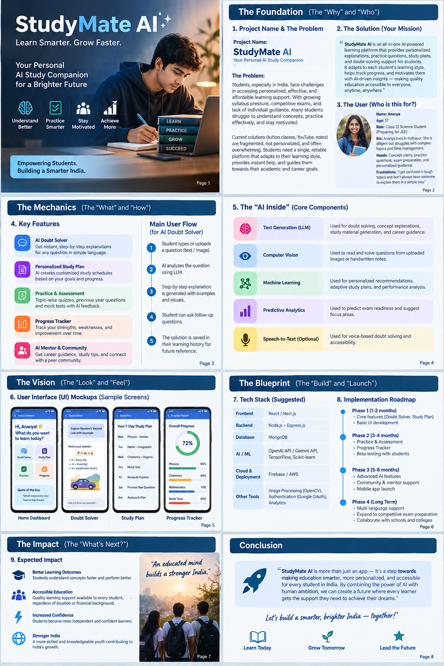
Concept UI mockups generated for the capstone blueprint

Screen 1: Home Dashboard
Displays the student's greeting, quick actions for Doubt Solver, Study Plan, Practice, and Progress, plus a small daily learning prompt.

Screen 2: AI Doubt Solver
Provides a question input area, image-upload option, step-by-step AI explanation, examples, and a follow-up question box.

Screen 3: Personalized Study Plan
Shows a day-by-day study plan based on the student's goals and current progress, with revision and practice activities.

Screen 4: Progress Tracker
Shows an overall progress percentage and topic-level performance so the learner can see strengths and areas requiring more practice.

Project Ideas & Inspiration
The concept is inspired by the capstone brief's emphasis on solving a real-world problem through an AI-powered application. It combines the personalization of an AI tutor with study planning, practice, and progress tracking. This directly follows the brief's requirement to create a detailed blueprint that an engineering and design team could use to build the vision. fileciteturn3file0L11-L17

Expected Benefits
- Makes personalized academic support available on demand.
- Reduces time spent searching across multiple learning resources.
- Encourages active learning through practice and follow-up questions.
- Helps students identify weak areas through progress data.
- Supports independent learning while complementing teachers and classroom instruction.

Future Scope
- Multilingual explanations for Indian learners.
- Voice-based learning and accessibility features.
- Integration with college learning-management systems.
- Competitive programming and placement preparation modules.
- Teacher/faculty dashboard for monitoring learning progress with appropriate privacy controls.

Conclusion
StudyMate AI turns the idea of an AI study assistant into a practical product blueprint. It begins with a clear student problem, defines a target persona, connects specific features to an end-to-end user flow, identifies the AI components required behind those features, and translates the concept into interface sketches. The result is a foundation that a product, design, and engineering team could use as the starting point for a real implementation.

Final Submission Checklist
☐ Section 1: Project Name & The Problem
☐ Section 2: The Solution (Your Mission)
☐ Section 3: The User (User Persona)
☐ Section 4: Key Features & User Flow
☐ Section 5: The AI Inside (Core Components)
☐ Section 6: Interface Sketches
☐ All six sections compiled into one document
☐ Student name and course details checked
☐ Document ready for submission to the portal

