Code Screenshot

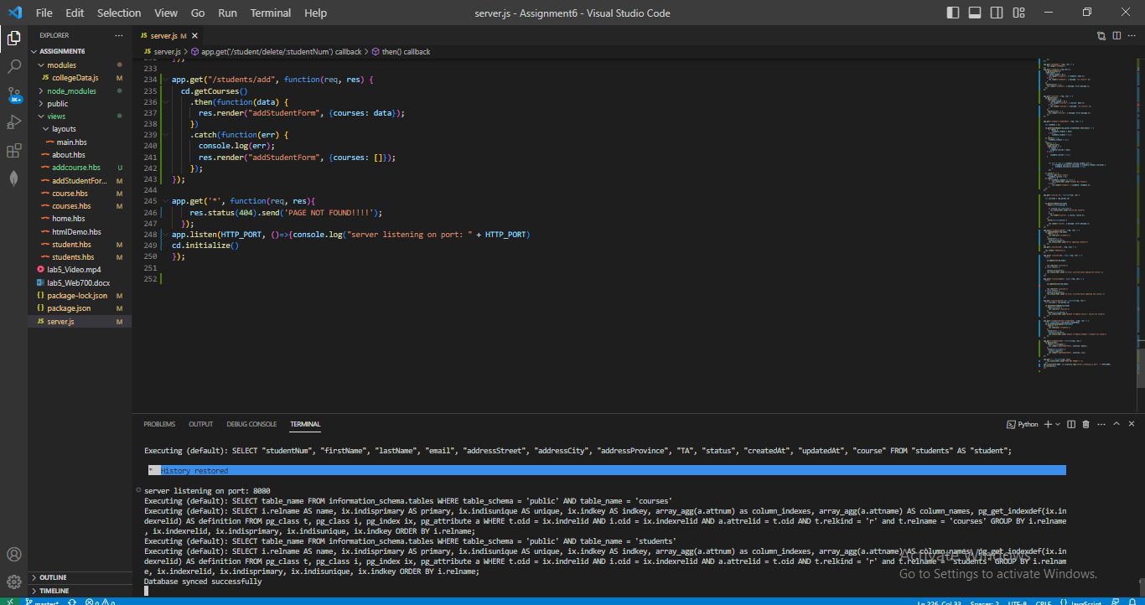

Github Screenshot

Broewser Sreenshot

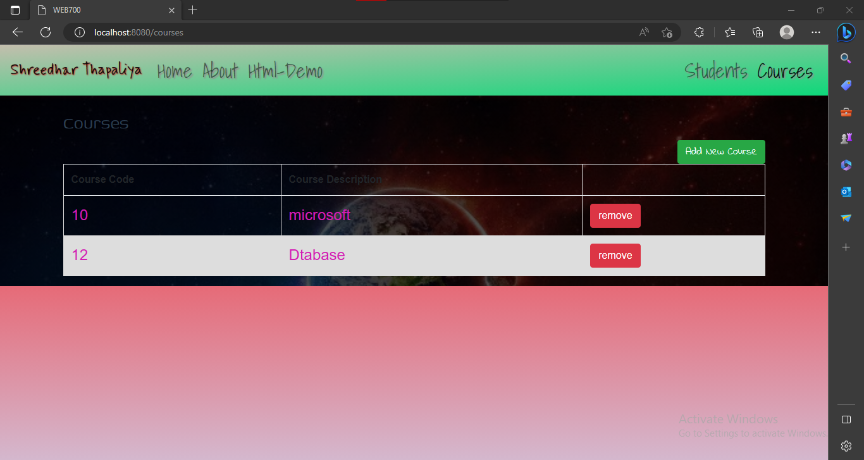

Postgres Screenshot

